Website: http://webdesign4.georgianc.on.ca/~200238257/comp2068/project1/Home.html

Submitted by Tommy

Date: November 6, 2013

A company logo:

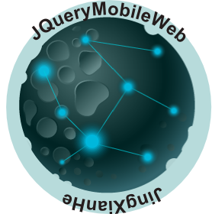

Table of contents: page:

Website Logo 1

Website description 1

Navigation Bar section 2

Colors section 3

Typography section 4

Wireframes section 5

Branding section 9

Optional site 10

Website description

Design web applications that suit you. This is the aim of the website. I offer free web templates and windows apps download for study. If you have any questions about my code, please feel free to contact me. This website is specified for website visitors using devices with small screens. As the number of people using smartphones and tablets grows, mobile websites are becoming important. This website is basically on JQUERY mobile and CSS. By Keep Connected panel, you can contact me in many ways. You can also go to GitHub to download the source code of this website. You can know a lot about me by this website. I have spent the last eight months cultivating my knowledge in Computer Programming Analyst focusing on website and software development at Georgian College. You can find more information about me in this website.

HOMEPAGE is about the purpose of this website.

ABOUT ME page is the information of me.

PROJECTS is the web page which you can download the apps I created.

SERVICE is the service which the company can offer.

GITHUB is the website of GitHub which you can download the template of this website.

CONTACT ME is the website which offers the information of me.

I use JavaScript documents to show the sliders on the website.

Navigation Bar section

The navigation bar consists of six sections. When the mouse is over a section, the color of this section

becomes gold. When the section is active, it turns black. The navigation bar uses navigationbar1.png as

its background picture. The section which you are reading is with another section picture, which is

box1.png

Colors section:

#0C696E

#323232

#