Website: http://webdesign4.georgianc.on.ca/~200238257/comp2068/Assignment1/index.html

Submitted by Tommy

Date September 25, 2013

A company logo:

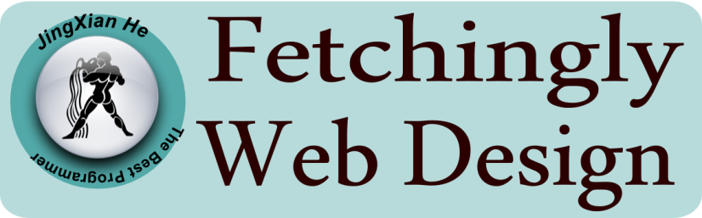

Table of contents: page:

Website Logo 1

Website description 1

Navigation Bar section 2

Colors section 3

Typography section 4

Wireframes section 5

Branding section 9

Website description

Design web applications that suit you. This is the aim of the website. I offer free web templates and windows apps download for study. If you have any questions about my code, please feel free to contact me. This is a fixed two columns website used dark color as its background. This website is basically on HTML5 and CSS. There is a small part of this web site using JQuery, which is the slider. By Keep Connected panel, you can contact me in many ways. You can also go to GitHub to download the source code of this website. You can know a lot about me by this website. I have spent the last eight months cultivating my knowledge in Computer Programming Analyst focusing on website and software development at Georgian College. You can find more information about me in this website.

HOMEPAGE is about the purpose of this website.

ABOUT ME page is the information of me.

PROJECTS is the web page which you can download the apps I created.

SERVICE is the service which the company can offer.

GITHUB is the website of GitHub which you can download the template of this website.

CONTACT ME is the website which offers the information of me.

I use JavaScript documents to show the sliders on the website.

Navigation Bar section



The navigation bar consists of six sections. When the mouse is over a section, the color of this section becomes gold. When the section is active, it turns black. The navigation bar uses navigationbar1.png as its background picture. The section which you are reading is with another section picture, which is box1.png

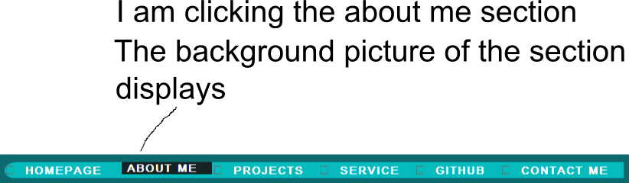

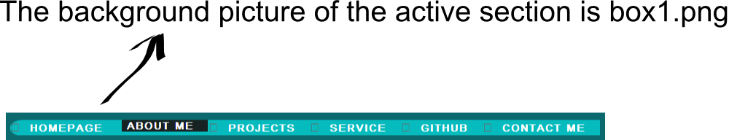

Colors section:

|  |  |
| --- | --- |
|  | #0C696E |
|  | #323232 |
|  | #6F6F6F |
|  | #6C6C6C |
|  | #454445 |
|  | #ACCFFF |
|  | #FF0D00 |
|  | #FF7400 |
|  | #34C6CD |
|  | #FFFFFF |

|  |  |
| --- | --- |
| Navigation bar | #0C696E, #323232, #6C6C6C, #34C6CD, #ff0D00 |
| Panel | #0C696E, #454445 |
| Logo | #34C6CD, #6C6C6C, #454445 |
| Copyright Section | #34C6CD, #0C696E |

Typography section:

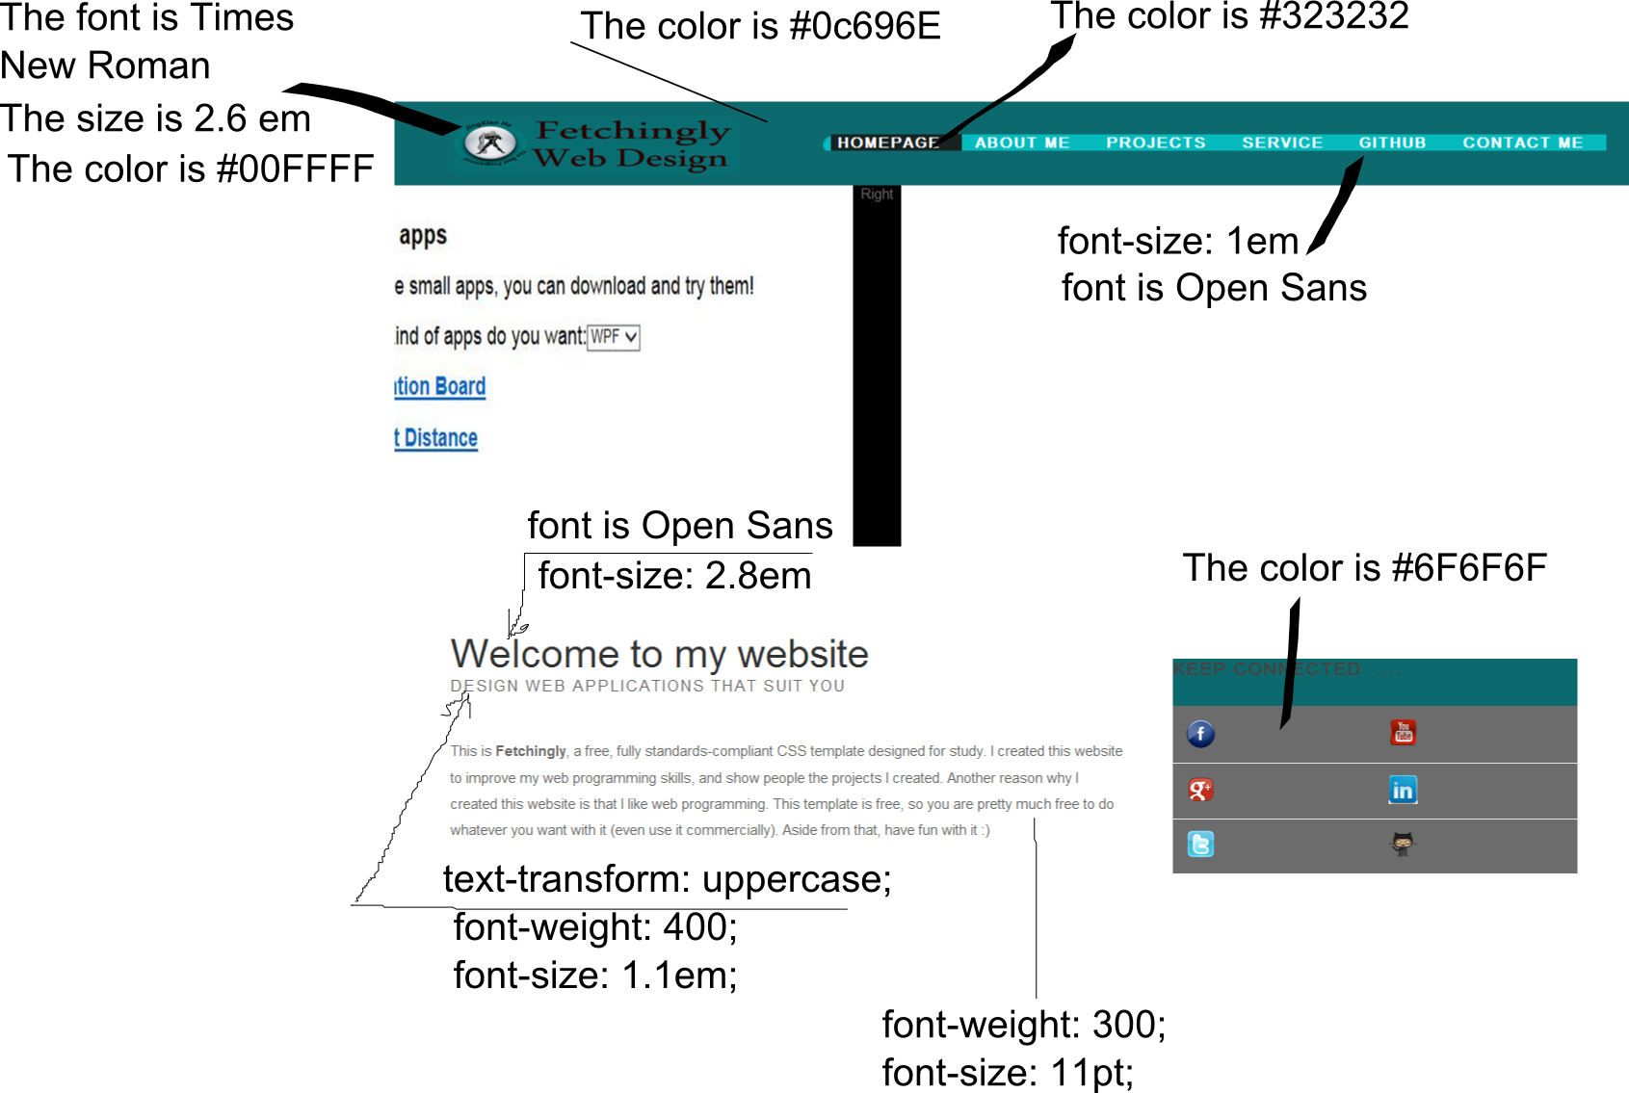

TABLE

|  |  |
| --- | --- |
| Logo | Font: Times New Roman, Size is 2.6 em  The color is #00FFF. The background of the logo is from LOGO.jpg |
| Navigation bar | The color is #0C696E, font is open sans, font size is 1 em. I use navigation bar1 as background picture. The active page uses box1.jpg as background picture. |
| H1, h2, h3 | The whole paragraph uses Open Sans as font type. Font-size is 2.8 em. |
| span | Test-transform is uppercase, font-weight is 400, font-size is 1.1 em. |
| body | Font-weight is 300, font-size is 11pt; |
| Connected panel | The color is #6F6F6F |

Wireframes section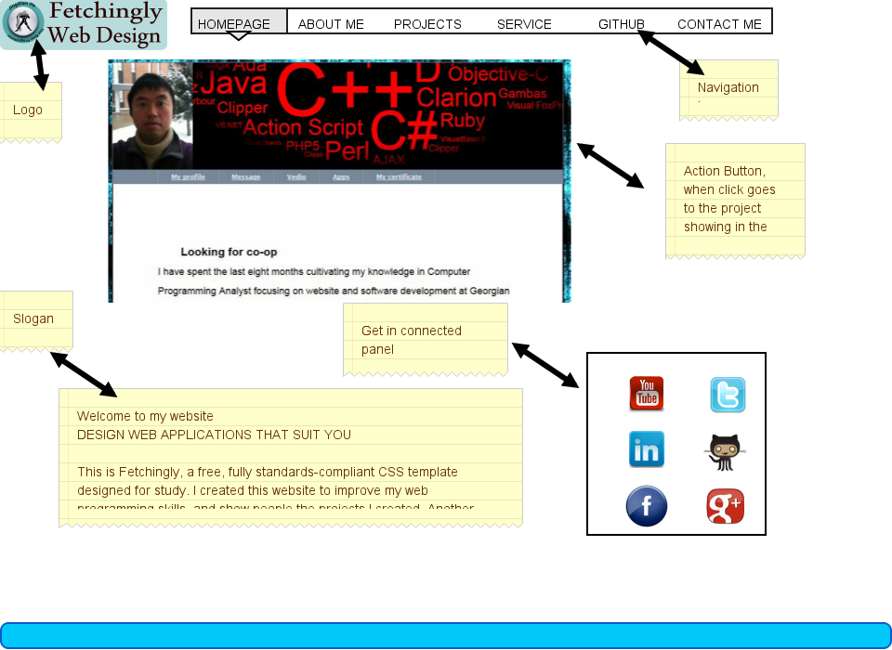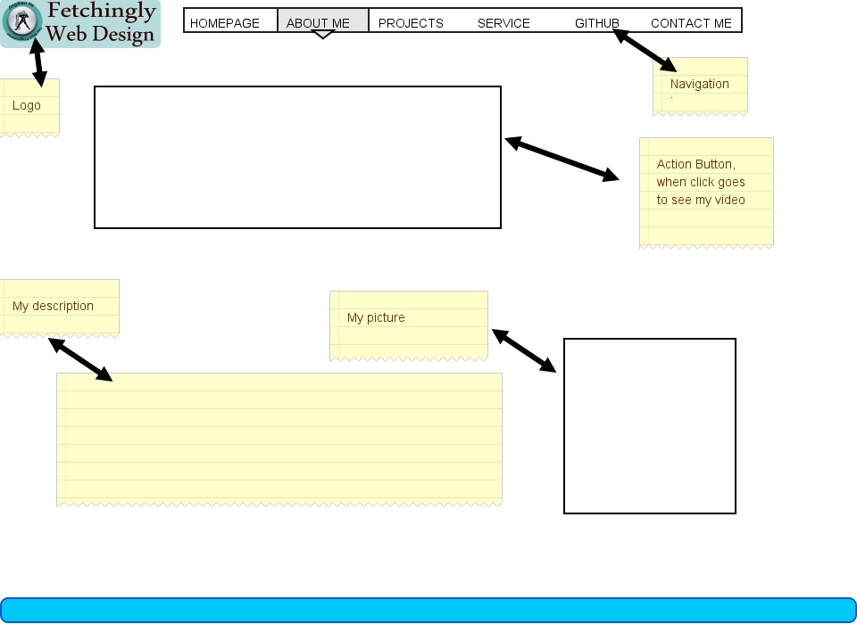

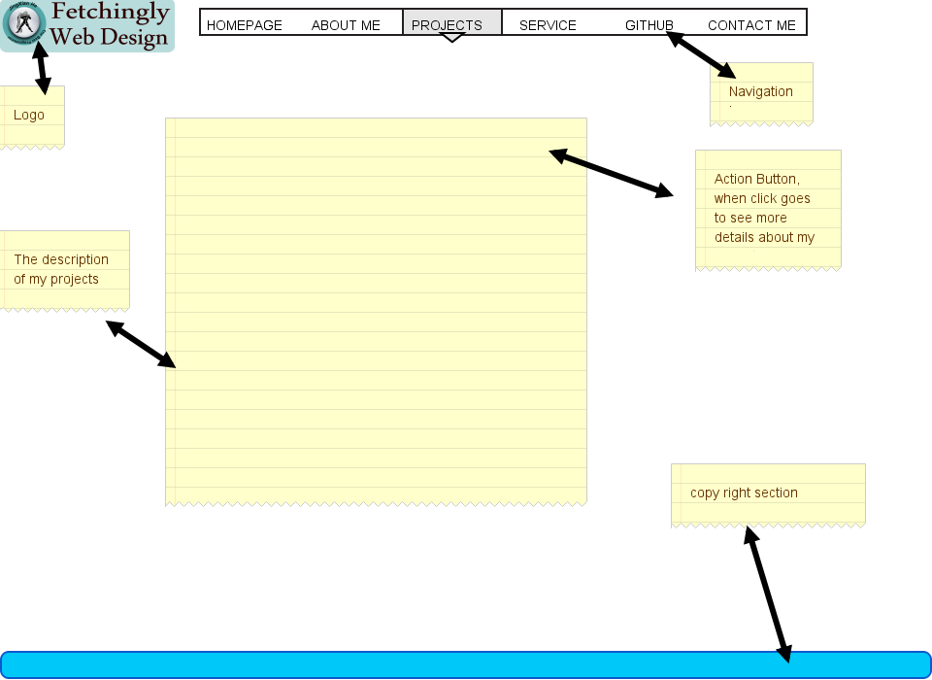

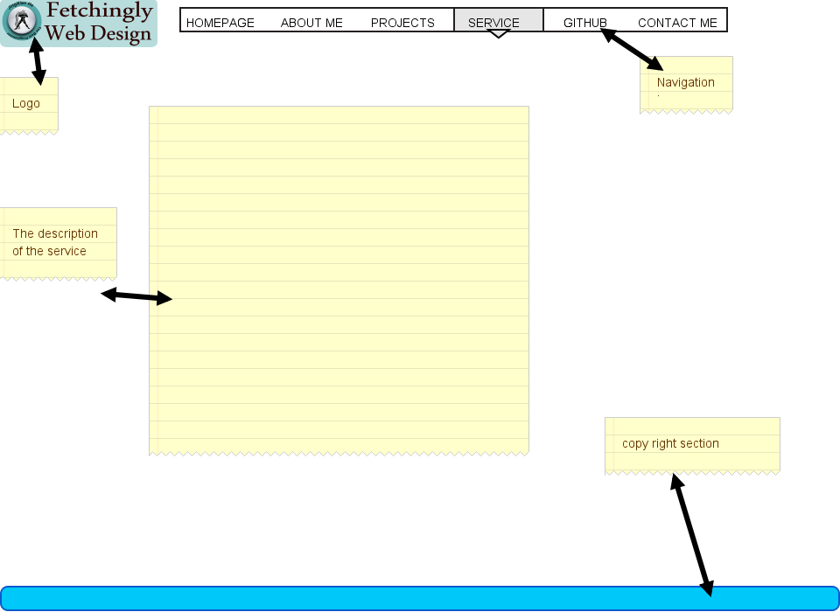

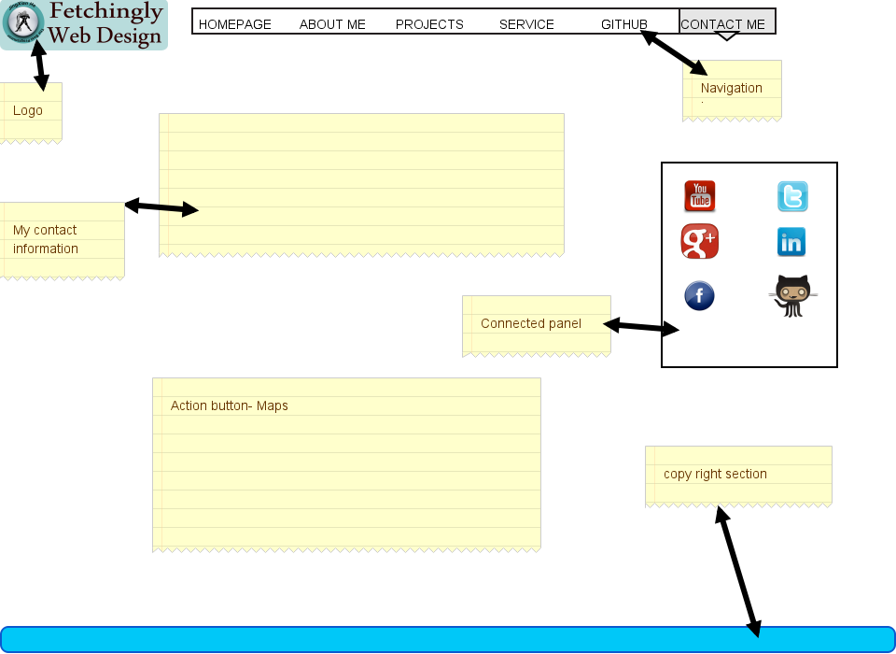

Branding section:



I use simple design for the logo of my company. First, it helps me get noticed and become memorable. Next it works with my tagline.

The logo reflects web programming technology, style, and preferences. People pay more attention to logo this time. Consider Apple, McDonalds, and AT&T. Each of these companies has updated its logo’s look and feel numerous times. As a result, these companies consistently reflect a modern sensibility.

Optional site:

1. Working in my contact me page
2. Site map in contact me page
3. Bread crumbs in navigation scheme
4. Include icons in my Nav Bar