# SwipeRefresh
这是 Google自己的下拉刷新组件SwipeRefreshLayout，简单实现

#如下为简答的实现效果
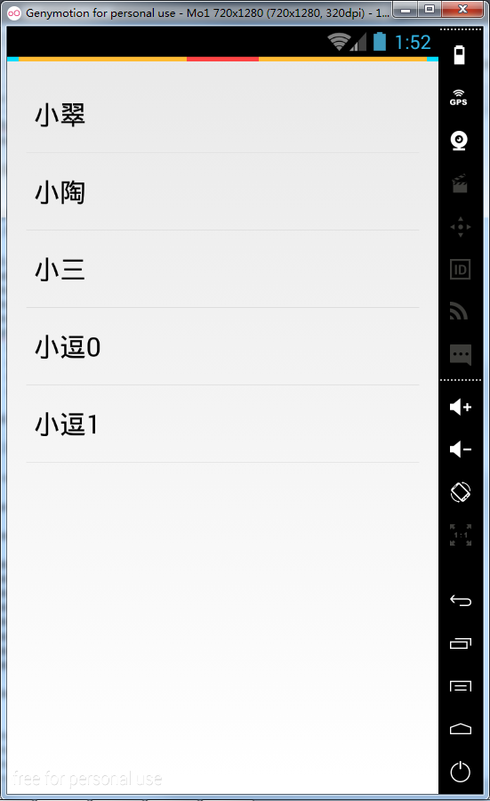

#需要完成的设计：
1.布局文件的设计 如下文件名为 swipe_view

<android.support.v4.widget.SwipeRefreshLayout xmlns:android="http://schemas.android.com/apk/res/android"
android:id="@+id/swipe_container"
android:layout_width="match_parent"
android:layout_height="match_parent" >
<ListView
android:id="@+id/listview"
android:layout_width="match_parent"
android:layout_height="wrap_content"
android:padding="16dp" />

</android.support.v4.widget.SwipeRefreshLayout>

2.对应Activity的代码实现

package com.finddreams.runningman;

import java.util.ArrayList;

import com.example.runningman.R;

import android.app.Activity;
import android.os.Bundle;
import android.os.Handler;
import android.support.v4.widget.SwipeRefreshLayout;
import android.view.Window;
import android.widget.ArrayAdapter;
import android.widget.ListView;
import android.widget.Toast;

public class MySwipeView extends Activity implements SwipeRefreshLayout.OnRefreshListener{

private SwipeRefreshLayout mSwipeLayout;
private ListView mListView;
private ArrayList<String> list = new ArrayList<String>();
private ArrayAdapter<String> myAdapter;
private int list_count = 0;
protected void onCreate(Bundle savedInstanceState) {
super.onCreate(savedInstanceState);
//去掉标题栏
requestWindowFeature(Window.FEATURE_NO_TITLE);
setContentView(R.layout.swipe_view);

mListView = (ListView) findViewById(R.id.listview);
myAdapter=new ArrayAdapter<String>(this, android.R.layout.simple_list_item_1,
getData());
//数据绑定
mListView.setAdapter(myAdapter);
//mSwipeLayout 相关属性设置
mSwipeLayout = (SwipeRefreshLayout) findViewById(R.id.swipe_container);
mSwipeLayout.setOnRefreshListener(this);
mSwipeLayout.setColorSchemeResources(android.R.color.holo_blue_bright,
android.R.color.holo_green_light, android.R.color.holo_orange_light,
android.R.color.holo_red_light);
}

private ArrayList<String> getData() {
list.add("小翠");
list.add("小陶");
list.add("小三");
return list;
}

/**
* 刷新功能代码
*/
public void onRefresh() {
new Handler().postDelayed(new Runnable() {
@Override
public void run() {
mSwipeLayout.setRefreshing(false);
Toast.makeText(getApplicationContext(), "Yes!", Toast.LENGTH_SHORT).show();

list.add("小逗"+list_count);
list_count++;
myAdapter.notifyDataSetChanged();
}
}, 3000);
}
}

3.PS：setColorScheme()已经弃用，使用setColorSchemeResources()来设置颜色。

