Final Project: Lego Car Design of Experiments

SCM 517

Professor Duarte

December 3, 2019

Noah Cornelius, Hui Li, Pranjal Maheshwary, Jing Zhou

**Executive Summary**

In this design of experiments (DOE) a full factorial design is run in order to determine significant factors of a Lego car with the response variable being distance traveled. Our team has determined that four factors will be tested with two replications. Factors were determined prior to any screening and experimentation in order to yield the most out of our DOE. Following a responsible DOE, a proper analysis has been used to refine and validate the model. Finally, a financial analysis was carried out.

**Objective and Goals**

The objective of this project is to utilize DOE in order to find the Lego car that travels the farthest when dropped from the top of an inclined ramp. Our goals include the following:

* carryout a responsible DOE and explain our decisions through it thoroughly
* modeling a top performing car by determining the best combination of our tested factors
* justify the finances and resources needed

**Experimental Setup**

The entirety of the experiment was carried out in a McCord study room. Thus, a total of 32 runs were carried out here. This includes 2 replications of 16 different factor combinations from 4 factors. These 32 runs were randomized and executed. Our team dropped our miniature vehicles from the top or a cardboard ramp. Standing at 11 inches tall and 16 inches long, the ramp stood at a 90 degree angle with a 40 degree incline on the carpeted floor. The first team member built the randomly chosen Lego car combination. The second team member was our operator. They let the car slide off the ramp every time. And finally, the last two teammates recorded the distance the car travelled it and recorded the results. None of these roles changed throughout the entire experiment.

**Factors**

1. Wheelbase: With an increase in the wheelbase length, there is an increase in stability, which helps minimize the chance of a crash on landing from the ramp. While, on the other hand, if we decrease the wheelbase length, there might be a loss in stability, but it makes the car more maneuverable. Since our aim here was to increase the distance, we thought that stability and maneuverability would turn out as significant factors in determining that.
2. Axle: In general, while designing a car, widening the distance between the tires i.e. increasing the length of the axle, helps to increase the stability of the car which would affect the speed, the distance and the direction in which it travels on landing. Hence, length of the axle became a factor which we wanted to test.
3. Back Wheel Size: The thought process behind choosing the wheel size as one of the factors was that generally larger LEGO wheels are faster than the smaller ones and hence, we arrived at this conclusion that the wheel size would be one of the important factors in determining the distance travelled by our car. We did experiment with the small front wheel size as well and observed that the car crashed every time. Hence, we fixed the front wheels to be always larger.
4. Weight: In general, the higher the weight of the car, the more energy is spent to increase the speed. But, since in our case we had to prepare for a downhill race, adding more weight to the car made sense because it would increase the speed of the car while moving down, which would in turn result in a larger distance that the car covers on landing.

The specific dimensions of each factor, low and high are displayed below:

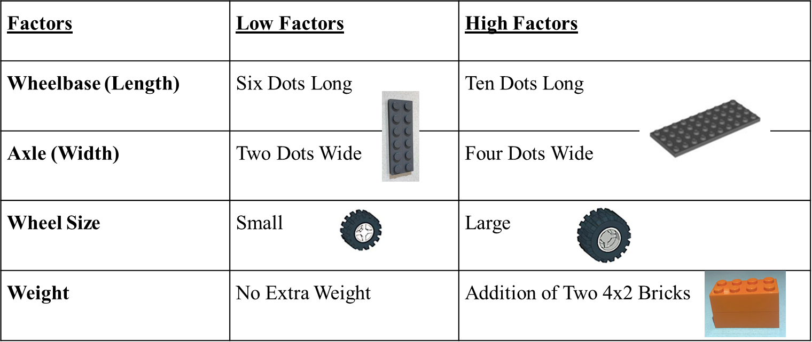

**Response Variable and Measurement**

The response variable in our experiment was the distance traveled by the Lego car. We took the perpendicular distance in inches from the end of ramp to the rear wheel of the car. A total of 32 measurements were made. Each experiment being a unique combination of our factors was measured twice (i.e. two replicates).

**Experimental Design and Blocking Noise**

A full factorial design was carried out. The main reason for this was our limited number of factors but more so the overall cost of each of the cars (discussed in Financial Analysis). When it came to blocking noise the first step was to maintain a consistent experiment, the only thing changing being our vehicle model. Some things we made sure to keep consistent were the operator, dimensions of our ramp, and the surface upon which our car rolled off on to. As far as uncontrollable factors such as temperature or wind, we took advantage of being able to conduct the experiment inside which helped keep the variance of those to a minimum.

**Data Analysis and Model Adequacy**

Upon running the DOE on the measurements we collected, we decided to invoke the sparsity effect, ignoring the small changes that higher interaction terms may affect. Below is the result of a factorial analysis with the individual factors and two-level interactions:

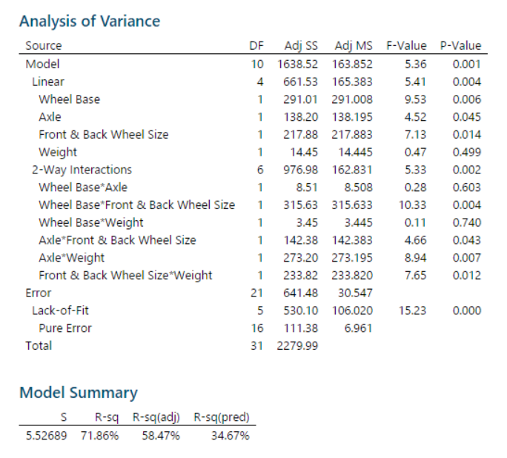 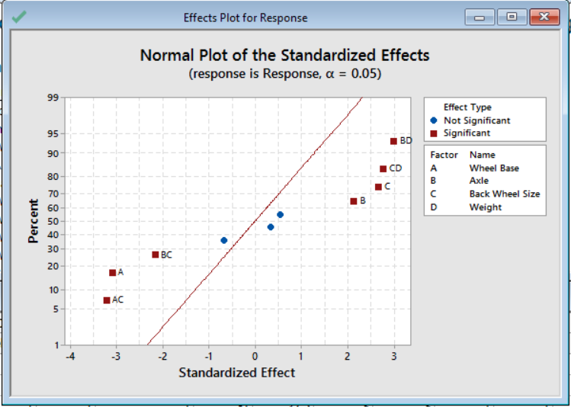

As depicted above it we evidently have three insignificant factors: weight, wheelbase and axle, wheelbase and weight. Further refining our model, we decided to remove two of three these factors. The factor we are not removing is weight. The reason being is if we are to not use this factor in our analysis, we must give up two significant interaction terms due to the hierarchy of this model. These two interaction terms are also our third and fourth most important factors, axle and weight as well as back wheel size and weight. The results of the refined model are depicted below:

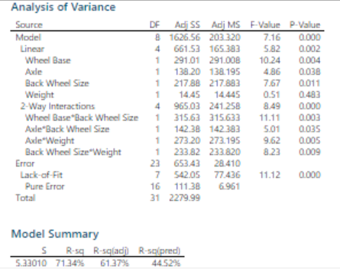

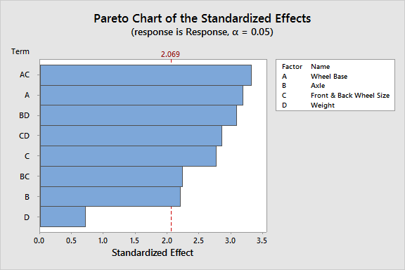 

It should also be noted that our predicted R-square did increase almost by ten percent. Having an improved rate of predictability is important if we are going to decide how to model our car based on these results.

As far as the validity of our model, it very much follows NID assumptions. The QQ – plot has almost no outliers, our residuals our heteroskedastic and even with our limited amount of runs we have an almost normally distributed histogram of residuals. See below:

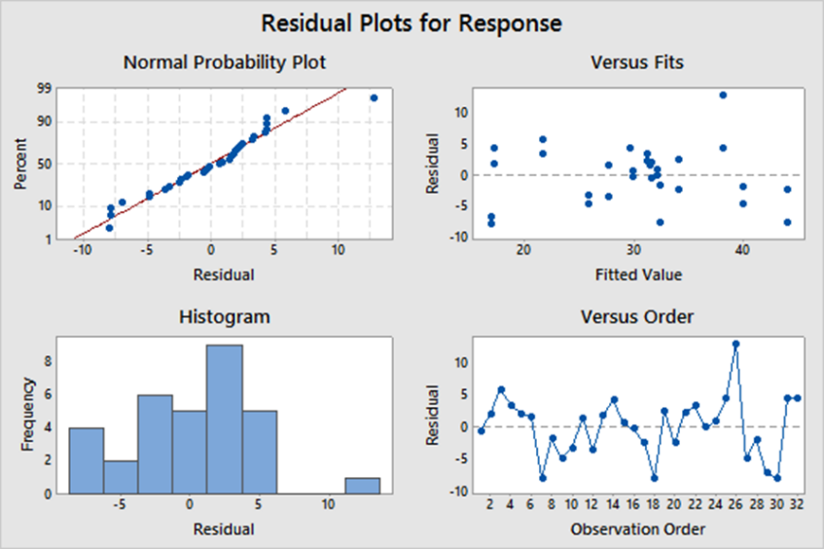

**Graphical Results**



As shown above it can be seen that the optimal Lego car from our experiment will reach 43.9219 inches with the given factors:

* A short wheelbase
* A wide axle
* Large back tires
* And extra weight added

One interesting thing to note is that this combination of factors did not give us the best run we had when performing our experiment. This could have been a one-off incident, possibly leading to the mistake of us choosing our end model. Had we chosen the result that yielded the overall fastest traveled run, it’s quite possible that we may never yield those results again.

**Financial Analysis**

In our final design, the overall cost of making such a Lego car is 12600 dollars. This price does not deviate far from the other combination of factors. No matter if we conduct a half factorial or even full factorial, we can always keep a relatively low experimental cost. We believe the production cost is well controlled based on what we have learned from the DOE analysis. The weight is not significant in the main effects plot and the interaction plot changed this finding, so we include weight in our final design. We end up with this combination of a short wheelbase, a wide axle, large back tires, and extra weight added. There are some trade-offs between the performance and the cost. We have designed an alternative model for price-sensitive consumers with a lower production cost. This model is built with a short wheelbase, a narrow axle, large back tires and extra weight added. It runs the second longest travelled distance with a lower cost, which makes it competitive in the market. On the other hand, as weight is now a significant factor, the change of weight might contribute to the change of traveled distance. Meanwhile, simply increasing or reducing the weight might cause the car to slow down or to lose some balance. Therefore, we would be able to explore some other ways to reduce some weight while maintaining a good performance.

**Conclusion and Recommendation**

Based on what we have learned from the DOE, the wheelbase, axle, back wheel size, weight and all but two interaction terms (i.e. wheelbase and axle, wheelbase and weight) are significant factors. Wheelbase is the most significant one-way term, while wheelbase and back wheel size are the most significant two-way interaction term. The optimal care has a short wheelbase, large axle, large back tire and extra weight added according to our DOE. This is the model we recommend. And although it may be tempting to choose the what ever Lego car had the overall best run, the data doesn’t lie and tells us otherwise.

In order to make our car cost-effective. We have tried various designs to control the production cost while maintaining a good performance. These are the components that are used in our final design. We end up with a total cost of 12600 which is quite competitive. The average cost of purchasing a new car in American is 37500 while the production cost of our car is only 12600 production.  As this is an economically affordable car targeting young people, we believe this car will sell at large volumes in the US, India and China. Therefore, we recommend that a car like this that performs well should be put into mass production.