1.Introduction:
This is the final project for EE-551 python. The topic and dataset was chosen from kaggle.com.
Author: Wang Jinge

Dogs vs Cats:https://www.kaggle.com/c/dogs-vs-cats-redux-kernels-edition

- Project Structure
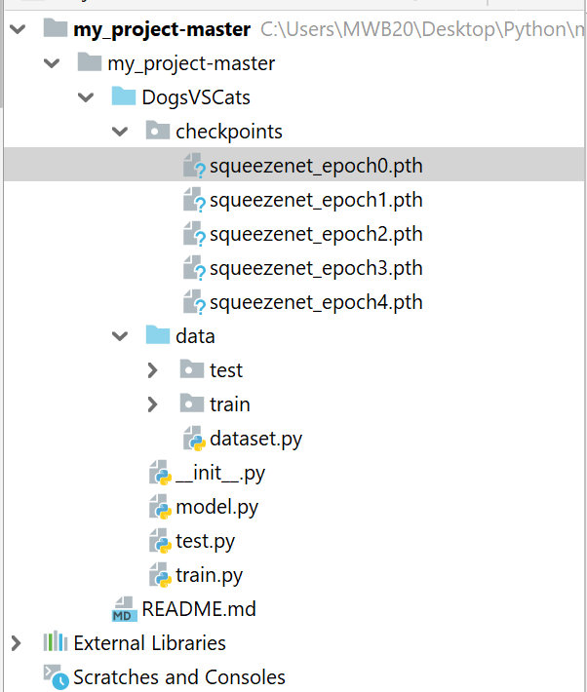
①Dataset: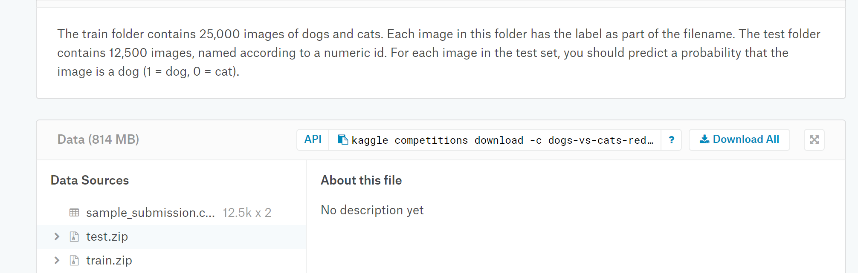
Dataset was download from kaggle.
Link is here: https://www.kaggle.com/c/dogs-vs-cats-redux-kernels-edition/data
The train folder contains 25,000 images of dogs and cats. Each image in this folder has the label as part of the filename. The test folder contains 12,500 images, named according to a numeric id. For each image in the test set, you should predict a probability that the image is a dog (1 = dog, 0 = cat).
I use two package(test , train )to save the images. And process them in dataset.py.
dataset.py:
For test set : process them with 3 steps, resize,centercrop and totensor. Such can make the images transform to same size with tensor form. And then use normalization.
For train set: classify all the images to train set and testset with 8:2. For train and validation set, almost do same thing with test set in above mentioned.
Finally, by the __getitem__()function and return the tensor and label(cat for 0, and dog for 1). Because the testset didn`t give me the label of images, so the return is the serial number of tensor and images in the testset.
②Model(model.py)
I used squeezenet which was pre-trained on the imagenet (import by torchvision.models).
The most important feature of squeezenet is that it is the lightweight network which means the main idea of lightweight model design is to design a more efficient "network computing method" (mainly for convolution), so that network parameters can be reduced without losing network performance.
For dog Vs cats , it is a binary classification. So i have changed the property(num_class )in pre-trained squeezenet. Making num_class = 2, and the training the data,this is equivalent to training only the last layer of fully connected layer parameters. Originally, I also tried to train the whole model with the cat and dog dataset, but the effect was very poor. I guess the reason is that the sample size is too small.

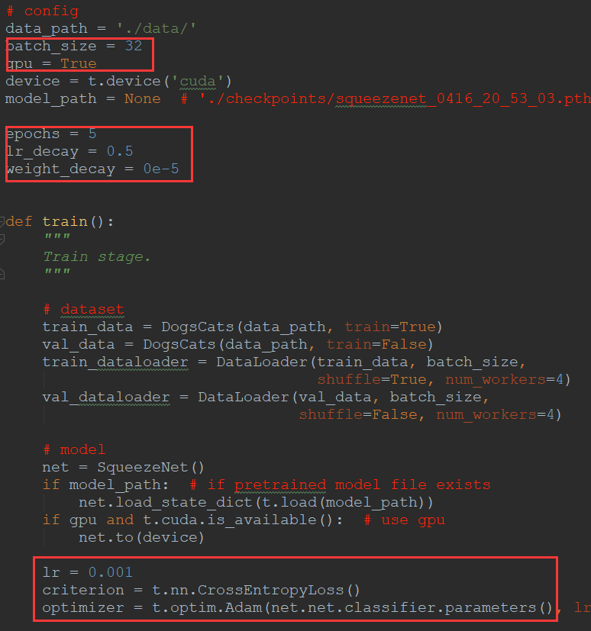
③Train(train.py)
Adjust parameter here and some important parameter is shown in the picture.
The hyperparameters of the training model are:
Batch=32;
Use gpu;
Number of iterations: 5
Learning rate decay rate: 0.5
Weight attenuation: 0.5
Initial learning rate: 0.001
Loss function: cross entropy
Optimization method: adam

The result of train.py is shown:
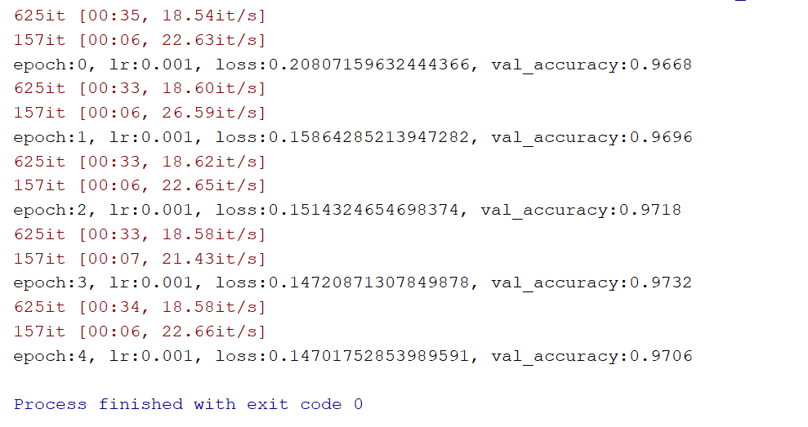
④Test.py
From this part, i used the best train model from train.py (epoch 3) to get the final test result and export the .csv file with serial number and label(result of classification)

- Environment:
IDE: Pycharm
Language: python 3.7
System: windows 10
Hardware: gpu: MSI Gaming Geforce 1080.
Library, frame and tools: Pytorch, squeezenet, CUDA10.0,
Github:https://github.com/JingeStevens/my_project

- Reference:
1.SqueezeNet: AlexNet-level accuracy with 50x fewer parameters and <0.5MB model size
Forrest N. Iandola, Song Han, Matthew W. Moskewicz, Khalid Ashraf, William J. Dally, Kurt Keutzer
Yegulalp, Serdar.
2.Facebook brings GPU-powered machine learning to Python. InfoWorld.19 January 2017 [11 December 2017].
3.Tianqi Chen, Mu Li, Yutian Li, Min Lin, Naiyan Wang, Minjie Wang, Tianjun Xiao, Bing Xu, Chiyuan Zhang, and Zheng Zhang. Mxnet: A flexible and efficient machine learning library for heterogeneous distributed systems. arXiv:1512.01274, 2015a.
4.CNN笔记：通俗理解卷积神经网络 https://blog.csdn.net/v_JULY_v/article/details/51812459
5.轻量级网络 | SqueezeNet、MobileNet、ShuffleNet、Xception 综述。https://blog.csdn.net/u012426298/article/details/80817788
6. Stanford Machine Learning Class from http://52opencourse.com/139/coursera
7.DataCastle［猫狗大战］冠军——Kuhung 思路及代码 https://blog.csdn.net/DataCastle/article/details/52189638
8.[PyTorch小试牛刀]实战六·准备自己的数据集用于训练（基于猫狗大战数据集
https://blog.csdn.net/xiaosongshine/article/details/85225873
9.使用pytorch完成kaggle猫狗图像识别https://blog.csdn.net/xcszjjh1991/article/details/79256576
10.pytorch之squeezenet的实现.https://blog.csdn.net/weixin_40123108/article/details/85799677

Date: 4/26/2019

