Proportion word problems

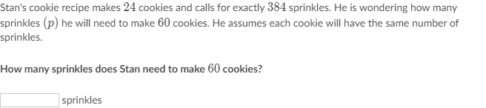

_________________________________________________________________________________________________________

Scratch paper:

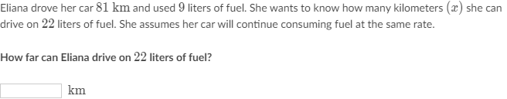

_________________________________________________________________________________________________________

Scratch paper:

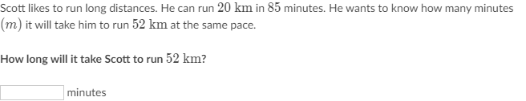

_________________________________________________________________________________________________________

Scratch paper:

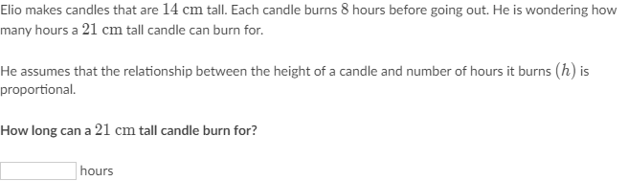

_________________________________________________________________________________________________________

Scratch paper: