Interpret constant of proportionality in graphs

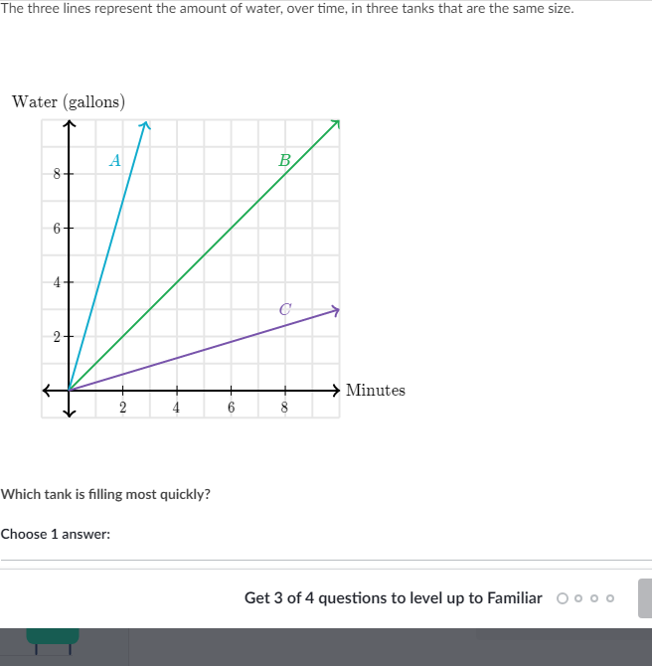

_________________________________________________________________________________________________________

Scratch paper:

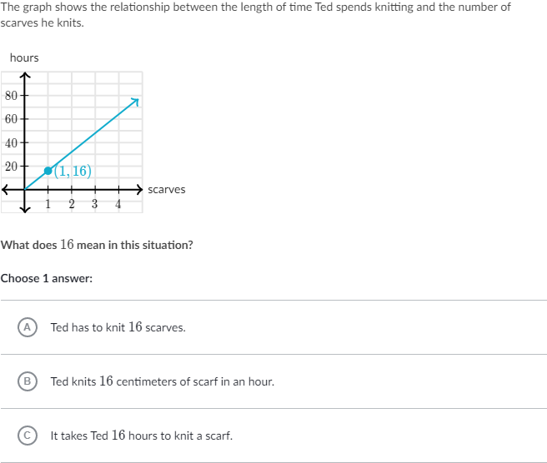

_________________________________________________________________________________________________________

Scratch paper:

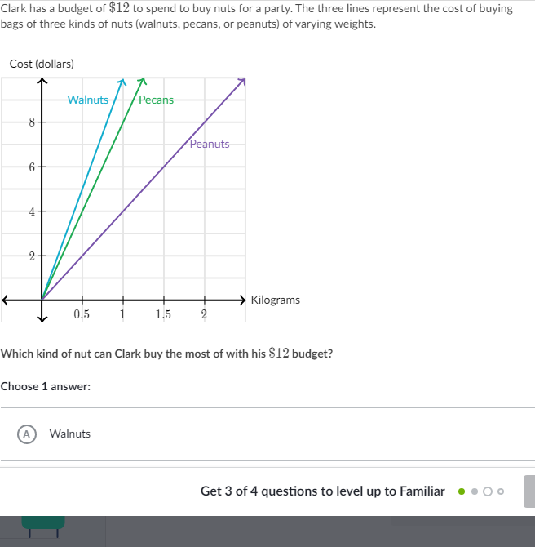

_________________________________________________________________________________________________________

Scratch paper:

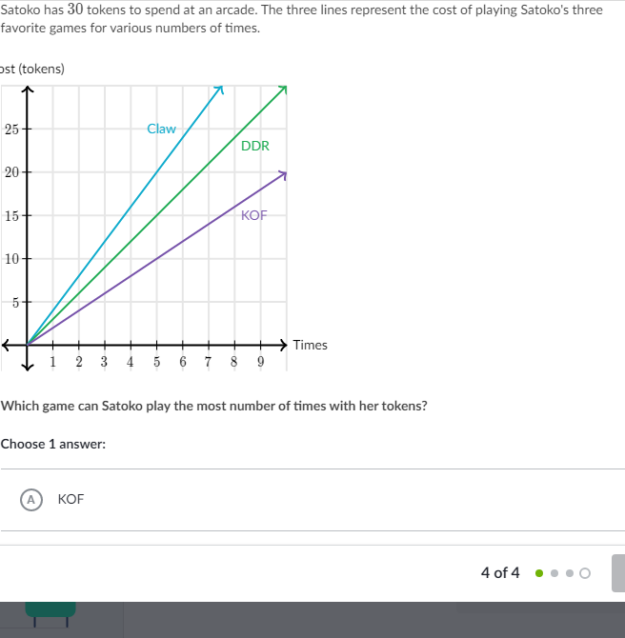

_________________________________________________________________________________________________________

Scratch paper: