Rates with fractions



_________________________________________________________________________________________________________

Scratch paper:

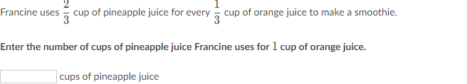

_________________________________________________________________________________________________________

Scratch paper:

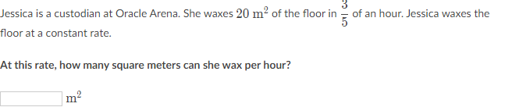

_________________________________________________________________________________________________________

Scratch paper:

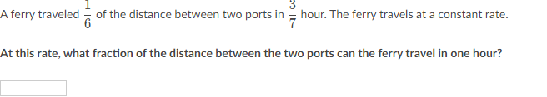

_________________________________________________________________________________________________________

Scratch paper: