Explore scale copies

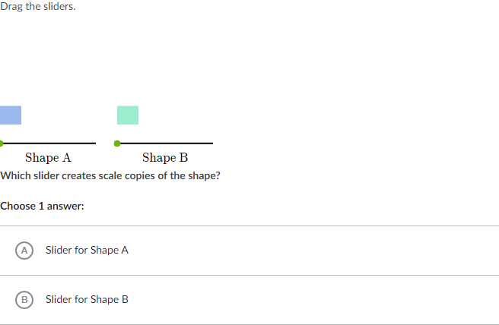

_________________________________________________________________________________________________________

Scratch paper:

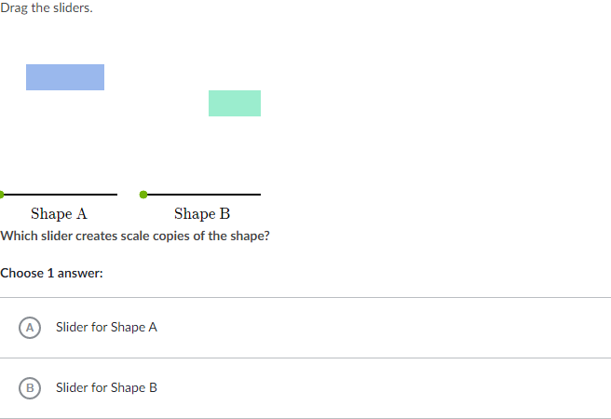

_________________________________________________________________________________________________________

Scratch paper:

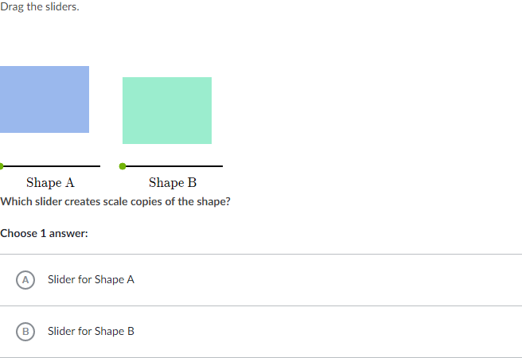

_________________________________________________________________________________________________________

Scratch paper:

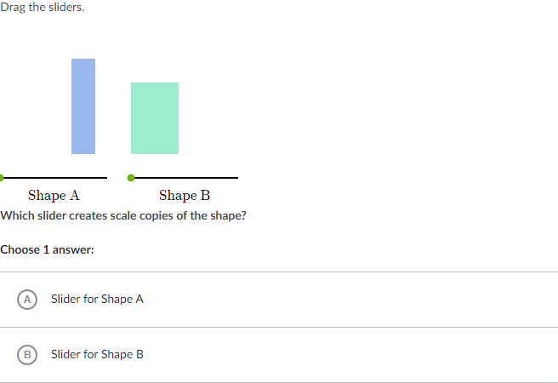

_________________________________________________________________________________________________________

Scratch paper: