Corresponding sides and points

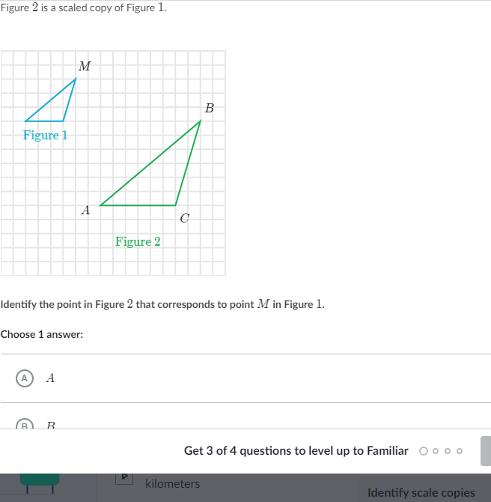

_________________________________________________________________________________________________________

Scratch paper:

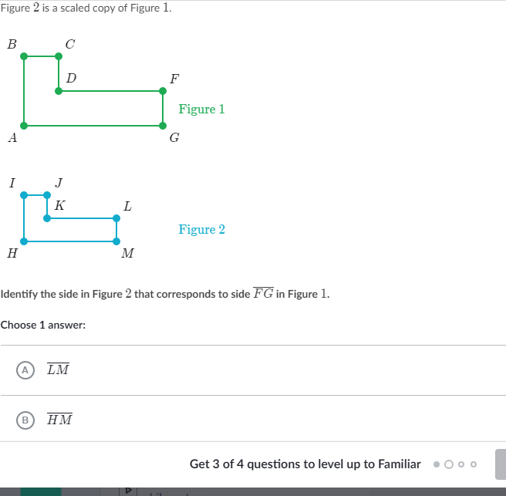

_________________________________________________________________________________________________________

Scratch paper:

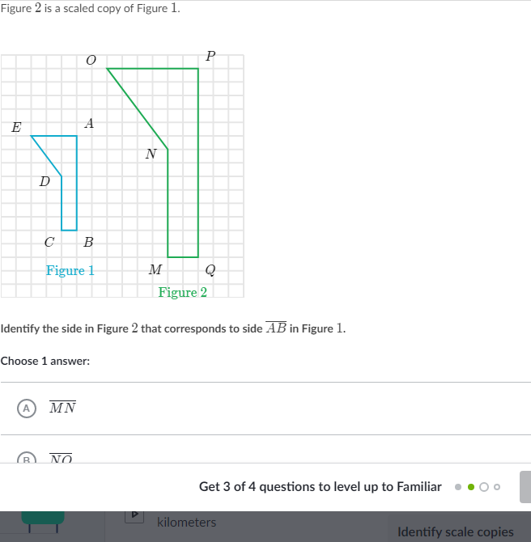

_________________________________________________________________________________________________________

Scratch paper:

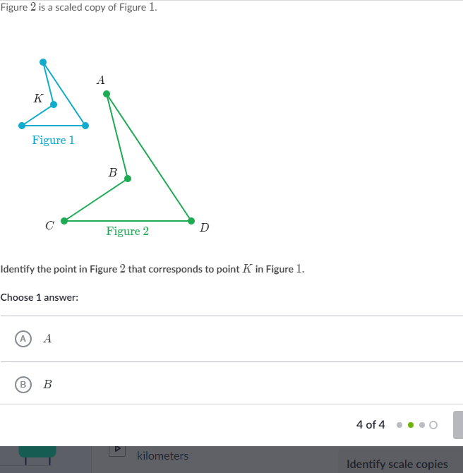

_________________________________________________________________________________________________________

Scratch paper: