Constant of proportionality from equations

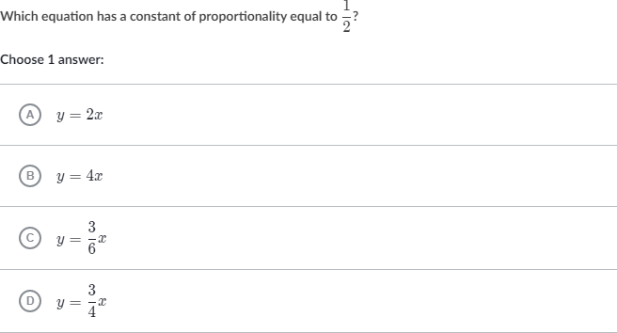

_________________________________________________________________________________________________________

Scratch paper:



_________________________________________________________________________________________________________

Scratch paper:

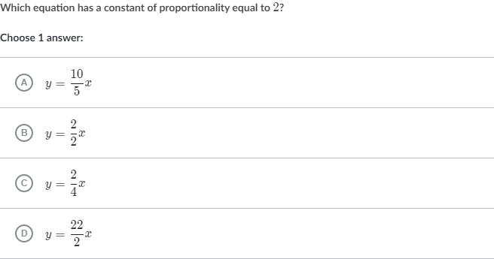

_________________________________________________________________________________________________________

Scratch paper:



_________________________________________________________________________________________________________

Scratch paper: