Constant of proportionality from graphs

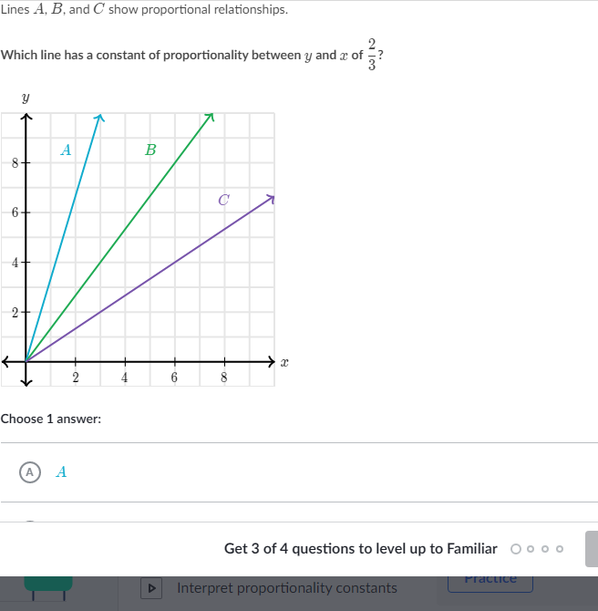

_________________________________________________________________________________________________________

Scratch paper:

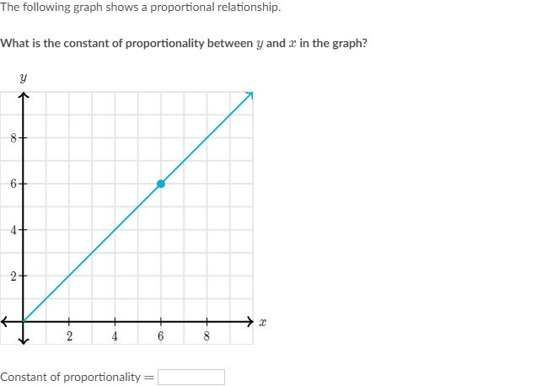

_________________________________________________________________________________________________________

Scratch paper:

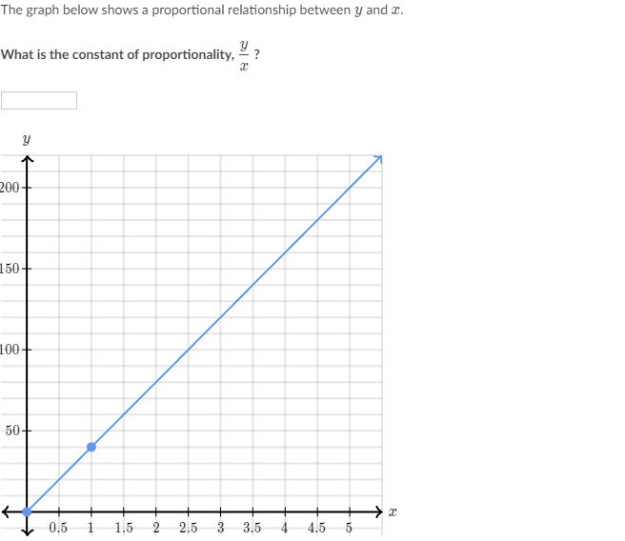

_________________________________________________________________________________________________________

Scratch paper:

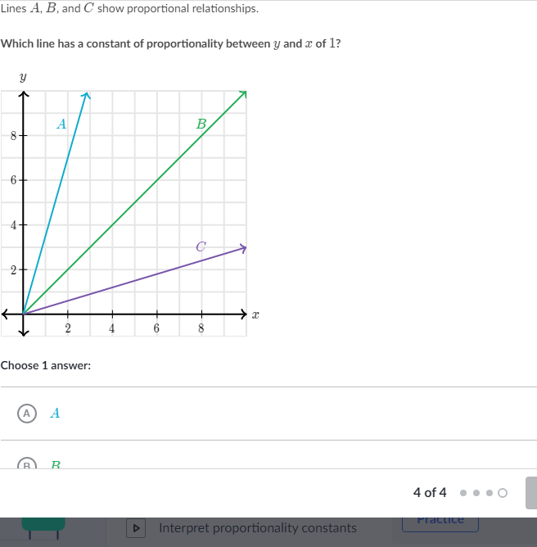

_________________________________________________________________________________________________________

Scratch paper: