Constant of proportionality from tables (with equations)

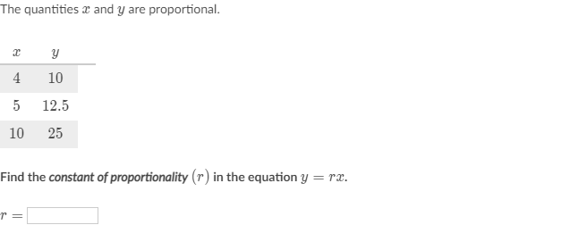

_________________________________________________________________________________________________________

Scratch paper:

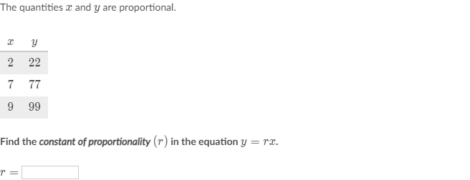

_________________________________________________________________________________________________________

Scratch paper:

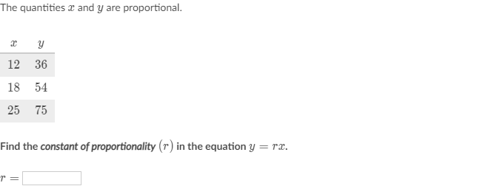

_________________________________________________________________________________________________________

Scratch paper:

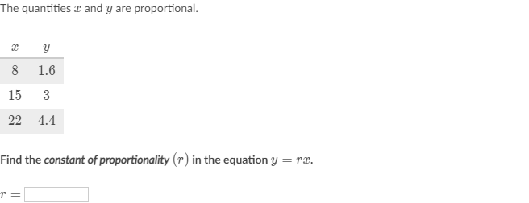

_________________________________________________________________________________________________________

Scratch paper: