Interpret constants of proportionality

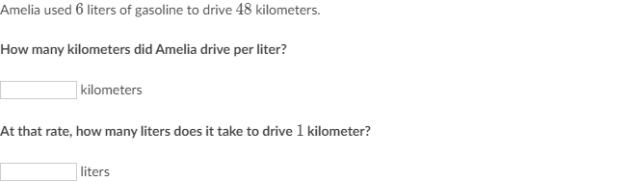

_________________________________________________________________________________________________________

Scratch paper:

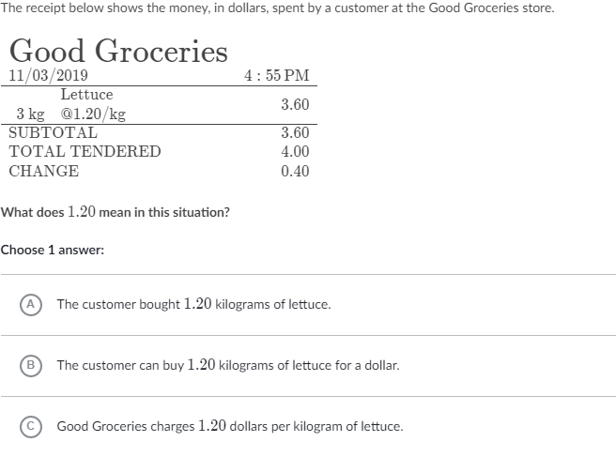

_________________________________________________________________________________________________________

Scratch paper:

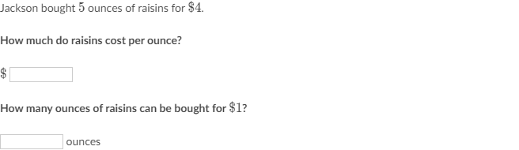

_________________________________________________________________________________________________________

Scratch paper:

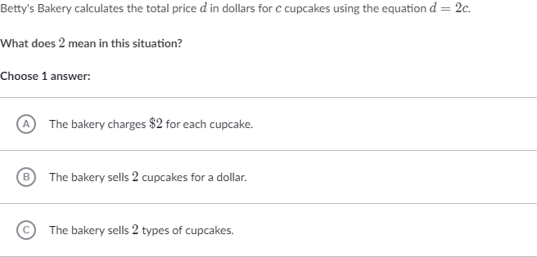

_________________________________________________________________________________________________________

Scratch paper: