

Thesis
Large-scale Autism Face Classification using Data Augmentation and Denoising Training

Author

Jing Li

29 October 2025

Acknowledgement

I would like to express my special thanks and deepest gratitude to Dr. Lianhua Chi for her invaluable guidance, continuous support, and insightful supervision through-out this thesis. Her constructive feedback, patience, and encouragement have been instrumental in helping me overcome challenges and complete this research success-fully.

Contents
Abbreviations 1
Abstract 2
- Introduction 3
- Related work 5
  - Autism Spectrum Disorder (ASD) screening – Image-based Approach 5
  - Data augmentation approach 7
    - Geometric Transformations 8
    - Kernel Filters 9
    - Mixing Images 9
    - Colour Space Translation 10
    - Random Erasing 10
    - Adversarial Training 11
    - GAN-based Data Augmentation 11
    - Neural Style Transfer 12
    - Meta learning Data Augmentations 12
- Methodology 13
  - Dataset and Processing 13
  - Baseline Model 14
  - Training Configuration 16
  - Data Augmentation, Denoising and SamplePairing 16
- Experiments 19
  - Overview of Experimental Setup 19
  - Data Scale Analysis 19
  - Data Augmentation Analysis 20
  - SamplePairing Analysis 22
  - Cross race Generalisation Test 25
- Discussion and Future work 26
  - Model Evaluation and Advantages 26
  - Future Work 27
- Conclusion 28

List of Figures

  - Classification accuracy of all the methods (reproduced from [18]). . . 6
  - The proposed ASD-FIC model for ASD disorder identification (repro-duced from [21]). 7
  - Image Data Augmentation structure (reproduced from [4]). 8
  - Validation error rates for CIFAR-10 with reduced number of samples
in training set (reproduced from [5]). 10
  - Example of random erasing on object tasks (reproduced from [32]). 11
  - The process in this study 14
  - The architecture of the proposed model for autism diagnosis (repro-duced from [18]). 15
  - ResNet-152 architecture (reproduced from [41]). 15
  - Overview of SamplePairing data augmentation for ILSVRC dataset (reproduced from [5]). 17
  - Small dataset (AD:500, TD:500) with data augmentation. 20
  - Small dataset (ASD:3556, Typically Developing (TD):4364) with data augmentation. 20
  - Large dataset (ASD:3556, TD:4364) with advance data augmentation applied during training. 21
  - Large dataset (ASD:3556, TD:4364) training and validation curves
with data augmentation and noise reduction. 21
  - Large dataset (ASD:3556, TD:4364) training and validation curves
with SamplePairing. 23
  - Changes in validation error rates for CIFAR-10 and ILSVRC datasets with and without our SamplePairing data augmentation (reproduced
from [5]). 23
  - Large dataset (ASD:1500, TD:1500) training and validation curves
with SamplePairing. 24
  - Large dataset (ASD:500, TD:500) training and validation curves with SamplePairing. 24

List of Tables
  - Comparative analysis of three approaches of this study 14
  - Model training parameters used in the ASDFace framework. 16
  - Comparative analysis of two different size dataset 20
  - Comparative analysis of three approaches of basic data augmentation. 22
  - Comparative SamplePairing analysis of three different size datasets. 24

Abbreviations

ASD Autism Spectrum Disorder

TD Typically Developing

ROIs Regions of Interest

AAL Automated Anatomical Labeling

GAN Generative Adversarial Networks

Abstract

ASD is a lifelong cognitive and developmental condition characterised by diffi-culties in social interaction and differences in learning and attention, which can be diagnosed at any age. Early diagnosis, often combined with behavioural intervention therapy, has been promoted for many years and can significantly improve patients’ quality of life. However, the high cost of early intervention places a heavy burden on young families. Autism facial recognition offers a potential solution to reduce costs and streamline the diagnostic workflow. However, the high cost of early inter-vention imposes a substantial burden on young families. Facial recognition based ASD screening offers a potential solution to reduce costs and streamline the diag-nostic process. This study aims to evaluate how dataset size, data augmentation, and denoising techniques affect the classification accuracy and generalisation ability of the ASDFace model for ASD detection. It also seeks to explore how variations in dataset scale influence model robustness and to assess cross ethnic performance to further examine the model’s generalisation capability.
The study uses ASDFace model and investigates the effects of data size, data augmentation, and cross race generalisation within the same model framework. Sev-eral experiments were conducted using modified versions of the ASDFace model without the original source domain input. Results show that limited data signifi-cantly reduced model performance; although feature based enhancement methods improved accuracy to 87%, small datasets alone were insufficient for stable learning. In contrast, the original ASDFace model achieved higher accuracy with limited data, suggesting that incorporating source domain information is beneficial for small-scale classification tasks. Applying denoising and data augmentation techniques further improved accuracy, while the SamplePairing image mixing approach produced strong results when trained on large datasets but inconsistent outcomes with smaller ones. A preliminary cross ethnic experiment revealed reduced generalisation, likely due to the scarcity of samples from underrepresented racial groups. Overall, the re-sults demonstrate that incorporating source domain features and sufficient dataset diversity significantly improves model performance and generalisation. While data augmentation and image mixing strategies enhance accuracy in large datasets, their effectiveness decreases with limited data. These findings highlight the importance of balanced, diverse datasets and domain adaptation in building reliable ASD facial recognition systems.

Chapter 1 Introduction
Given that approximately 1 in 36 children are diagnosed with ASD [1], research fo-cusing on facilitating communication and dialogue for individuals with ASD has be-come increasingly vital and prevalent. The one of research of Chiugo Okoye claimed that “the benefits of early diagnosis include the opportunity for early intervention, which has been shown to enhance developmental outcomes and improve adaptive skills [2].” Autism is not only a neurodevelopmental disorder but also a major public health concern. According to the World Health Organisation, the global prevalence of ASD has been steadily increasing over the past decade, posing significant social and economic challenges for families and healthcare systems. Early diagnosis plays a crucial role in reducing these burdens through timely intervention. Early diagnosis enhances the chances of family access support services, that could reduce parental stress and give more opportunities for families and patients to increase indepen-dence. Autism facial recognition by deep learning task is one of the methods that would benefit the families with early diagnostic.
“We are in the era of Industry 4.0.”Alam et al. [3] claims that diagnoses in real time with AI system could change how healthcare is delivered. AI-based diagnostic tools have shown promising results in various medical fields, such as detecting pneu-monia from chest X-rays and identifying skin cancer from images. These successes demonstrate AI’s potential to analyse subtle facial or behavioural patterns associated with ASD. Multiple studies have been conducted deep learning for autism screening, but “domain shift” occur when applied new and different data. Furthermore, most existing studies rely on large, homogeneous datasets, limiting model generalisation across diverse populations. Big data set helps to avoid over fitting in image deep learning task. It is wild know that the algorithms can significantly perform better with lower quality data. Deep convolution, the networks have been known to be very powerful in big image datasets for medical image analysis. However, collecting large-scale, high quality medical datasets is challenging due to privacy issues and data imbalances. Small datasets are easy to cause overfitting; they do not generalise well from the validation and test set [4]. Enhancing a model’s ability to generalise is one of the toughest tasks in machine learning. Overfitting occurs when a model fails to generalise beyond the training data set, it displays well on training data but observed worse performance on test data. Data Augmentation is very powerful method of achieving that continuing to decrease validation error with the training error [5].
Chandaliya et al. [6] stated that “Many FRS have exhibited lower accuracy

rates for certain demographic groups with established empirical evidence”. It is well established that humans tend to recognise faces of their own race more easily, a phenomenon known as the other race effect. This phenomenon suggests that model bias may arise from imbalanced datasets lacking ethnic diversity. Therefore, to evaluate the robustness and generalisation ability of the ASDFace model, this study includes a cross ethnic experiment designed to assess how the model performs when tested on facial images from deferent racial groups.
This research is mostly focused on data augmentation, denoising techniques, and image mixing strategies that can improve the accuracy and generalisation of the ASDFace model under limited data conditions. Data augmentation artificially increases dataset diversity by generating transformed versions of existing samples (e.g., rotation, flipping). This technique helps models learn invariant features and reduces overfitting, making it particularly valuable for small medical datasets. The other race effect, a well documented phenomenon in cognitive psychology refers to the human tendency to recognise faces of one’s own race more accurately than those of other races. Similar biases can emerge in AI systems trained on imbalanced data, leading to unfair or inaccurate predictions for underrepresented groups.
To address these challenges and improve the capacity of the model, this study aims to:
- Evaluate the performance of the ASDFace model under different dataset sizes without data augmentation.
- Examine the effects of data augmentation, denoising, and image mixing tech-niques on model performance across various dataset sizes.
- Assess the cross ethnic generalisation ability of the ASDFace model using datasets from diverse racial backgrounds.

Chapter 2 Related work
  - ASD screening – Image-based Approach
Image-based dataset to apply on ASD screening including MRI/fMRI, facial expres-sion or emotion feature, Skeleton feature, eye gaze, EEG, multi-modal feature, brain regions and more [7]. Three dimensional MRI and fMRI scans have been widely em-ployed in the analysis of ASD, as they capture multiple structural and functional layers of the brain. Numerous studies have revealed significant differences in neural connectivity patterns between individuals with ASD and TD controls. Typically, MRI/fMRI data are mapped into brain atlases, which divide the brain into multiple Regions of Interest (ROIs) for feature extraction and classification. Deep learning methods have been successfully applied to extract highly discriminative features from these ROIs to support ASD diagnosis [8].
Several brain atlases have been utilised in previous research, each defining differ-ent ROIs configurations. For instance, the Automated Anatomical Labeling (AAL) (Automated Anatomical Labelling) atlas defines 116 ROIs [9], while the BASC (Bootstrap Analysis of Stable Clusters) atlas includes sets of 36, 64, 122, 197, 325, and 444 ROIs [9]. Li et al. [10] adopted the AAL atlas; Heinsfeld et al. [11] and
Almuqhim and Saeed [12] used the Craddock atlas; Yin, Mostafa, and Wu [13] employed the Power atlas; Bayram, O¨ zer, and Temurta¸s [14] utilised the BASC at-las; and Cao et al. [15] implemented the HO atlas. These variations highlight the
diversity of brain parallelisation strategies in ASD detection research.
There is large dataset of biomarkers that were available to public, and biomarkers analyse became major resource for detecting ASD. However, obtaining such data is often challenging due to high collection costs. The development of facial feature diagnostic methods has arisen under such circumstances, given that they are cost effective and readily accessible. The distinctions that have been discovered between ASD and TD children are chiefly evident in the level of facial gesture activity and the correctness of facial demeanour response [7]. This approach involves aligning faces through CNN, using CECLM to detect, track, and extract facial features, and SVM has been employed to detect AU degree [16]. Lu and Perkowski [17] presented a practical deep learning based approach for ASD classification using facial images. By employing transfer learning with the VGG16 architecture on a clinically ciliated dataset, the model achieved accuracy of 95% and an F1-score of 0.95. These results validate clinical findings that facial structural differences exist between ASD and TD children. Compared to previous studies using low quality public datasets, this

research demonstrates that high quality, clinically verified data significantly enhance model reliability. Furthermore, the study highlights that racial and ethnic diversity are critical factors influencing the accuracy and generalisability of deep learning based ASD screening systems.
Various studies have produced encouraging outcomes. Wang et al. [18] addresses the challenges of diagnosing ASD, they proposed a heterogeneous domain adapta-tion model that leverages labelled behavioural and characteristic data as the source domain to assist facial image classification in the target domain. This approach re-duced the dependency on large, labelled facial image datasets. The model achieved 87% compared to other models. The high accuracy may be constrained by the small sample size, high data homogeneity, or lack of real world diversity, leaving the model’s generalisation performance across broader populations uncertain.

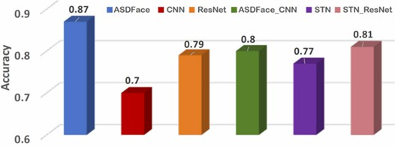

Figure 2.1: Classification accuracy of all the methods (reproduced from [18]).

Melinda et al. [19] claimed that the ResNet-101 model with data augmentation achieves the highest accuracy and recall in facial expression based ASD identifica-tion, highlighting its strong potential for early intervention and clinical applications. The dataset applied on this study, was primarily sourced from open platforms, which may lack diversity and rigorous clinical labelling, potentially limiting the model’s generalisability. Moreover, the study did not explicitly perform cross ethnic or de-mographic subgroup generalisation testing, which provides important insight and motivation for conducting cross ethnic experiments in this research.
Ahmad et al. [20] explored the use of various pre-trained convolution neural networks – including ResNet34, ResNet50, AlexNet, MobileNetV2, VGG16, and VGG19 – for the diagnosis of ASD through facial image analysis. By applying transfer learning, all models achieved improved accuracy, with ResNet50 performing the best at 92%. The finding highlights the potential of deep learning, particularly CNNbased architectures, to enhance early ASD detection by improving diagnostic accuracy while reducing computational cost. The research may still rely on relatively homogeneous or ethnically limited sample collections, which restricts the model’s generalisability across diverse populations.In addition, it does not sufficiently explore data augmentation, domain adaptation, or the differences between source and target domains — gaps that this study aims to address.
According to Sethi et al. (2024, as cited in [3]), the study compared five machine learning models on the Kaggle dataset and identified Random Forest as the best performer. However, the authors noted that the small dataset size, class imbalance, and lack of multi-modal data—such as MRI or facial imagery—limited the model’s generalisability.

Atlam et al. [21] proposes an automated framework called ASD-FIC , designed to improve the diagnosis of ASD using deep learning models. The framework analy-ses facial images and integrates multiple pre-trained convolutional neural networks (CNNs)—including VGG16, VGG19, InceptionV3, VGGFace, and MobileNet—to achieve efficient and accurate ASD detection.
The process as Figure 2.2.
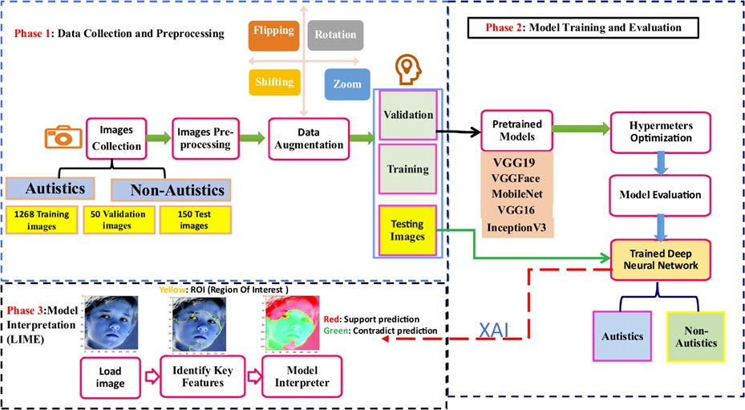

Figure 2.2: The proposed ASD-FIC model for ASD disorder identification (repro-duced from [21]).

The system structure like this: data collection and prepossessing with data aug-mentation, model training and evaluation, model interpretation that identifies key facial regions that influence predictions. The results show that the VGG19 model achieved the best performance, reaching an accuracy of 98.21% when data aug-mentation was applied. The high accuracy reported may reflect over fitting to the specific dataset or data augmentation strategy rather than guarantee performance in independent real world datasets.
Alam et al. [3] proposed a domain adaptive deep ensemble approach on facial images for ASD classification, achieving 96% accuracy on a combined domain and 90.6% on a previously unseen domain. This result confirms the importance of do-main adaptation and data source diversity when training ASD facial recognition models, which aligns with our observations regarding the necessity of source do-main input under limited data conditions. however, the study relied on relatively limited and demographically homogeneous datasets. It did not explicitly evaluate cross ethnic or subgroup generalisation, leaving questions about the model’s fairness and robustness across diverse populations. These limitations highlight the need for further research on dataset diversity and domain adaptation, which the future study aims to address.

Data augmentation approach
Data Augmentation approaches start solving the problem in the root of dataset, which means it is directly apply on train dataset. The basic image augmentations

include geometric transformations, kernel filters, colour space transformations, ran-dom erasing and mixing images.
The picture Figure 2.3 is showing the structure of data augmentations.

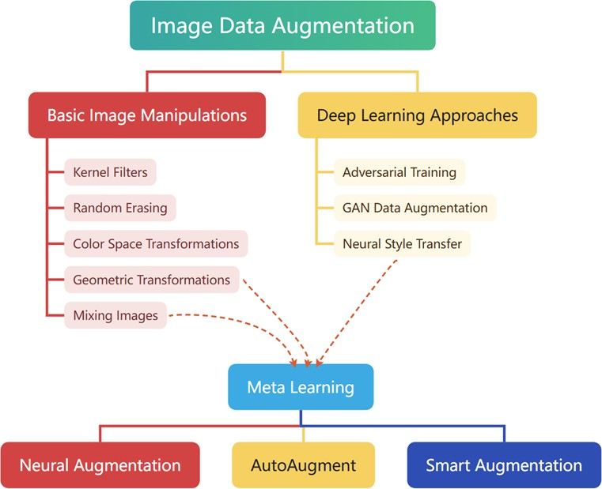

Figure 2.3: Image Data Augmentation structure (reproduced from [4]).

Geometric Transformations
Geometric transformations change the image’s position, size, or orientation of an images. Translation, rotation, scaling, flipping and shearing are mostly common methods of geometric transformation.
Flipping, horizontal axis flipping and vertical axis flipping apply on images are one of the easiest methods to performance on dataset.
Random cropping will reduce the input size for example change to 224 × 224, and translation, on the other hand, preserve the spatial dimensions of the image.
Rotating the image right or left from axis 1° to 359°. “Slight rotations such as between 1° and 20° or -1° to -20° could be useful on digit recognition tasks such as MNIST, but as the rotation degree increases, the label of the data is no longer preserved post transformation [4].”
Shorten and Khoshgoftaar [4] stated that the “safety” of data augmentation refers to whether a transformation preserves the original label — for example, flip-ping is safe for cat–dog classification but unsafe for digit recognition such as 6 versus
9. Although unsafe transformations may improve model robustness, generating re-fined labels for them is costly and complex. Therefore, the safety of augmentation methods is domain dependent, making the development of generalisable augmenta-tion strategies challenging.
Cubuk et al. [22] proposed AutoAugment, a reinforcement, learning-based method

that automatically searches for the optimal data augmentation policies directly from the training data, improving model generalisation and reducing the need for manual augmentation design.
AutoAugment [22] incorporates geometric transformations such as rotation, trans-lation, and flipping as part of its search space, automatically learning optimal combi-nations of both geometric and color-based augmentations to improve generalization.
Horizontal flipping is a simple and effective augmentation for images datasets but it is unsafe for text-base dataset. Vertical flipping is generally unsuitable for natural images, such as views, human face, as it breaks semantic orientation and thus fails to preserve labels.

Kernel Filters
For images, classic kernel filter methods are blurring and sharpening. Model could capture more details with objects by using image sharpening. There was not enough study in this area. However, Shorten and Khoshgoftaar [4] claimed, this technology is similar to the internal mechanisms of CNNs. “CNNs have parametric kernels that learn the optimal way to represent images layer-by-layer .”
Kernel filters play a foundational role in image processing, enabling operations such as blurring, edge detection, and sharpening by convolving a small matrix with the image. For example, Jung et al. [23] integrated 41 predefined kernels into a CNN architecture and observed significant training performances; Beaini et al.
[24] developed electromagnetic-based kernels for shape analysis with enhanced noise robustness; Liu et al. [25] employed a multi-kernel filtering framework to handle non-stationary noise by adapting kernel selection to image context. These works demonstrated that while kernels are often considered in classical image processing, their design and integration continue as feature extraction in deep learning models.

Mixing Images
Recent work on images mixing augmentation discovered combining various images to create novel training set and adjusting associated labels accordingly. Huang, Wang, and Tao [26] explored semantically proportional mixing with leveraging class activation maps, while Dabouei et al. [27] introduced the mixing process to preserve salient regions and enhance robustness. Chen, Sinha, and Kyrillidis [28] discovered token domain with mixing image process for Vision Transformers, and produced the new architectures.
Inoue [5] discovered new data augmentation method known as SamplePairing. They mixed two random images from train dataset cross different classes with equal weights, the new dataset used the first label. They used CIFAR-10 dataset that contained 5000 samples for each of 10 classes. They reduced to 100 samples for total 10 classes that means they only use 10 samples for each class. The result showed on fig 3, SamplePairing significantly reduced the validation error rate. See Figure 2.4.

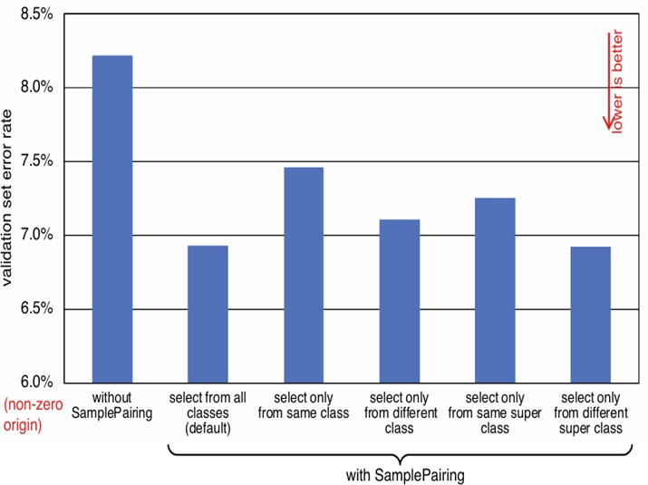

Figure 2.4: Validation error rates for CIFAR-10 with reduced number of samples in training set (reproduced from [5]).

Colour Space Translation
Digital images with tensor of the dimension(H × W × C), simply colour augmenta-tions include change to single colour channel with R, G, or B. Shorten and Khosh-goftaar [4] stated: “An image can be quickly converted into its representation in one colour channel by isolating that matrix and adding 2 zero matrices from the other colour channels.”
Shorten and Khoshgoftaar [4] pointed out that Chatfield et al. [29] conducted ex-periments using the ImageNet [30] and PASCAL VOC datasets to compare grayscale and RGB images, and found that accuracy decreased by about 3The disadvantage of colour space translation is ”increased memory, transformation costs, and training time” [4]. Recent work (Ballester et al. [31]) has shown that the choice of color space (e.g., RGB vs YUV vs Lab) in deep learning based image colorization can significantly affect performance, but no single color space is uniformly best; rather, effectiveness is highly data, and architecture dependent.

Random Erasing
Random erasing [32] is effectiveness reduced the error rate by randomly selecting an n × m patch of an image and erasing the pixel with 0 or 255 values, or instead with mean pixel values, or with random values. The best approach is selected random values, it provides richer noise, making the network more robust and improving generalisation across different samples. Zhang et al. [33] extends random erasing
[32] algorithm with random walk framework, preserving more image structure while performance robustness and classification.

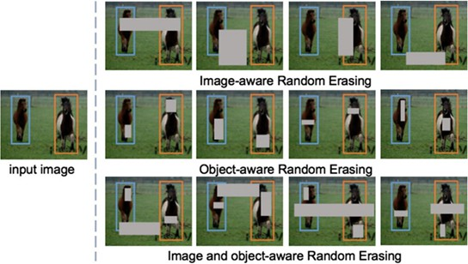
Figure 2.5: Example of random erasing on object tasks (reproduced from [32]). However, random erasing isn’t always label preserving, it can obscure class defin-
ing features, depending on the dataset and task, some manual intervention my be required.
In those discussed above, Shorten and Khoshgoftaar [4] stated that all these transformations com with an associated distortion magnitude parameter. That result in massively inflated dataset size, it will not always benefit Deep learning models, sometime might lead to overfitting.
Those data augmentations are directly applied to images before training. Neural nets can map complex, high dimensional imputs into concise lower dimensional en-codings. Based on the characteristics of neural networks, there are some interesting approaches can be applied on data augmentation.

Adversarial Training
Adversarial training frames learning as a contest between networks with contrasting loss driven goals [4]. Adversarial attacks – whether targeted or untargeted – can probe weak decision boundaries and thus serve as an effective data – augmentation strategy. This method helps the model learn to strengthen its decision boundaries. Engstrom et al. [34] stated, “even for a small random transformation, the accuracy can drop by up to 30%. Thes results demonstrate that robustness to rotations and translations should also be a concern in standard classification problems outside an adversarial security context.”

GAN-based Data Augmentation
Generative Adversarial Networks (GAN)is a machine learning framework where a generator creates fake data and a discriminator tries to distinguish it from real data, forcing the generator to produce increasingly realistic results.
The vanilla GAN products quality images in the MNIST dataset which image is only 28 × 28 × 1 for a total of 784 pixels. However, it failed on product quality results higher pixels than MNIST dataset. Many researchers developed new archi-tectures, such as DCGANs, Progressively Growing GANs, CycleGANs, Conditional GANs and more. DCGANs products images with 64 × 64 × 3, total 12,288 pixels.

Progressively Growing GANs trains progressive resolution from 4 × 4 to 8 × 8 till the result size 1024 × 1024.
GAN method is good at balance class. For example, in a classifier dogs and cats, we can achieve a balanced dataset since both classes have the same number and size of images, which is easy to get. In contrast, medical imaging datasets are often imbalanced due to factors such as limited data availability, patient diversity, and ethical constraints.
Frid-Adar et al. [35] improved sensitivity from 78.6% to 85.7% when demon-strated substantial gains in liver lesion classification with GAN generated samples. Yamaguchi, Kanai, and Eda [36] employed a ”Domain Fusion” multi-domain learn-ing GAN to enhancing image classification performance with a small number of target domain dataset. Dash and Swarnkar [37] claimed GAN is a powerful tools, it can generate synthetic medical images to enhance the performance of deep learning models. Multiple studies have shown that data augmentation effectively improves the performance of medical image analysis tasks.

Neural Style Transfer
Neural Style Transfer and its faster variants enhance data augmentation by transfer-ring artistic or environmental styles between images while preserving content. This technique helps models generalize better across simulated and real world conditions, especially in robotics and vision tasks. By introducing diverse styles rather than realistic replication, it reduces manual labelling costs and improves robustness in machine learning applications.

Meta learning Data Augmentations
Smart Augmentation and Auto Augment are meta learning approaches that auto-matically learn optimal data augmentation strategies to improve model generalisa-tion. Smart Augmentation uses two neural networks—one generating new images and another training on them—allowing the system to adaptively learn class spe-cific transformations and significantly boost accuracy on face recognition tasks. In contrast, Auto Augment employs reinforcement learning to search for the best aug-mentation policies among geometric transformations and distortion levels, achieving state-of-the-art results on datasets like CIFAR-10 and ImageNet. Later extensions, such as Augmented Random Search and instance specific learning, further improved performance. Despite their success, meta learning methods remain computationally expensive and complex to implement, facing challenges such as vanishing gradients and limited large-scale testing. For example, Irpan et al. [38] emphasised that data augmentation in meta learning should be applied at the task level rather than within individual tasks. This task level approach enhances the model’s generalisation to un-seen tasks. They also introduced CE increasing augmentations, which increase the conditional entropy H(Y |X) to prevent the meta learner from memorising training tasks or overfitting within the inner loop.
Ni et al. [39] identified four augmentation strategies—support, query, task, and shot augmentation—for improving few shot classification performance, and con-cluded that data augmentation is particularly effective in few shot learning scenar-ios.

Chapter 3 Methodology

Dataset and Processing
In this study, we constructed a customised dataset by combining several publicly available open source datasets from GitHub and other online repositories. During dataset preparation, we identified that some open source datasets contained multiple highly similar images of the same child, in some cases exceeding 20 to 30 nearly identical samples. To ensure data quality and diversity, we manually filtered the dataset by retaining no more than then representative images per child and removing the rest. This refinement step ensured that the dataset remained diverse while minimising over fitting to individual subjects.
The dataset includes both children with ASD and TD children. All images were standardised to a fixed resolution (224 × 224) and normalised before training. This mixed and refined dataset provides a more balanced and diverse sample set for evaluating deep learning based ASD classification models, while also mitigating the limitations of single-source datasets.
We created three datasets with different size. The original dataset included 1,778 autistic and 4,364 non-autistic images in the training set, 112 autistic and 120 non-autistic images in the validation set, and 172 autistic and 329 non-autistic images in the test set. To address the class imbalance issue, the autistic class was augmented by duplication to 3,556 images, resulting in a more balanced dataset for model training. Thus, we created large dataset with 3,556 autistic and 4,364 non-autistic images in the training set. Then, we created a medium sized dataset with the same validation and test set sizes as the larger one, while reducing the training set to 1,500 images per class. Additionally, a small dataset was constructed with 500 images per class in the training set, while keeping the validation and test set sizes the same as in the previous configurations.
Mahmood et al. [40] stated that deep learning successfully analyses medical im-ages, however, it faces several challenges when use for detecting ASD through facial recognition due to available data remains limited and imbalanced. Due to the dataset size limitations, it is hard to get balance of train, validation and test dataset in large numbers.
The main approaches display on Figure 3.1. We applied three kinds of data augmentation on dataset before implementing model.

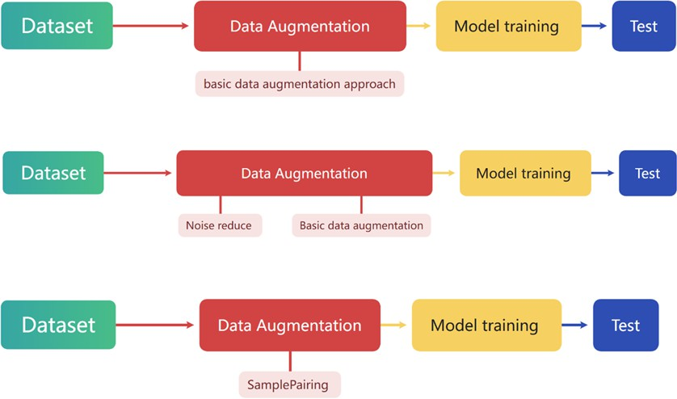

Figure 3.1: The process in this study.

Table 3.1: Comparative analysis of three approaches of this study

Approach | accuracy
Basic data augmentation | 0.97 to 0.99
Basic data augmentation + noise reduce | 0.98
SamplePairing with different size dataset | 1.00

Baseline Model
The baseline model ASDFace [18] used in this study extend the facial feature clas-sification framework developed in previous research on ASD.
The study introduced a new approach that employed heterogeneous domain adaptation to transfer knowledge from behavioural data to facial images, enabling accurate ASD classification even with limited labelled facial samples. The study “collected ten behavioural features from the AQ-10 Child Assessment plus ten in-dividuals’ characteristics that have proved to be effective in detecting ASD” [18]. Given that the source and target domains differ in feature representation, it is nec-essary to reduce the distribution gap between source domain and target domain. To achieve this, researchers used limited labelled training dataset applied to pre-trained ResNet-152 then applied to CNN, fine-tune the ResNet model using labelled sam-ples from the source domain while encouraging the alignment of feature distributions across domains. The Figure 3.2 shows the architecture of the ASDFace model.

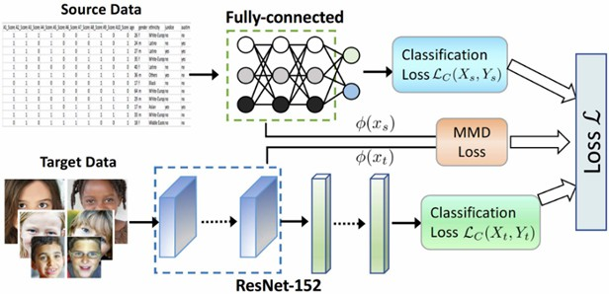

Figure 3.2: The architecture of the proposed model for autism diagnosis (reproduced from [18]).

ResNet-152 [41] is a deep convolution, the neural network that applies resid-ual learning to ease the training of networks with many layers. It begins with an initial convolution and pooling stage, followed by four bottleneck blocks that progressively extract hierarchical features. By addressing the degradation problem commonly seen in deep networks, ResNet-152 achieves higher classification accuracy while maintaining efficient and stable training.
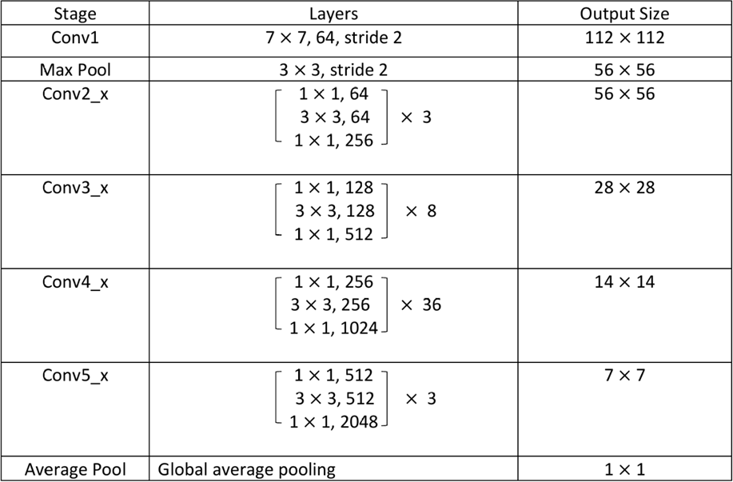

Figure 3.3: ResNet-152 architecture (reproduced from [41]).

While the original ASDFace study trained the model using only 100 facial images for training and 300 images for testing, our study significantly scales up the dataset to over 3000 images in Autistic and over 4000 images in non-Autistic, but we ignore the 10 behaviours features dataset, only applied images through the model. The facial images were collected from publicly available datasets and pre-processed to maintain consistent resolution and lighting conditions. Each image was resized to 224 × 224 pixels and normalised before being fed into the model. This substantial

increase in dataset size allows for more reliable evaluation of the model’s generalisa-tion ability and reduces the over fitting risk observed in small sample experiments.

Training Configuration
The experiments were implemented in TensorFlow using CUDA 12.4 and two NVIDIA GeForce RTX 4080 GPUs.
The model was initially trained for 25 epochs with a batch size of 32 and a learning rate of 0.001, using the Adam optimiser with cross entropy loss. To improve generalisation, several hyper parameter configurations were explored. The learning rate was adjusted between 0.0005 and 0.001, and the batch size was varied from 32 to 64 to find the optimal balance between training stability and convergence speed. To prevent over fitting and enhance convergence stability, a learning rate scheduler ReduceLROnPlateau was applied to automatically decrease the learning rate when the validation loss stopped improving. Specifically, the learning rate was reduced by a factor of 0.5 after 5 consecutive epochs without improvement in validation loss. Additionally, the ASDFace model’s margin based SoftMax parameters were tuned. The scaling factor s was varied between 32 and 64, while the margin m was ad-justed between 0.35 and 0.5 to analyse their influence on classification performance. The final configuration (50 epochs, batch size = 32, learning rate = 0.001)
achieved the best validation accuracy.

Table 3.2: Model training parameters used in the ASDFace framework.

Parameter | Value(s)
Epochs | 20 to 150
Batch size | 32, 64
Learning rate | 0.0005, 0.001
Optimiser | Adam
Loss function | Cross entropy
Scheduler | ReduceLROnPlateau
Minimum learning rate | 1 × 10⁻⁶
ASDFace parameter (s) | 32, 64
ASDFace parameter (m) | 0.35, 0.5
Final configuration | 50 epochs, batch size = 32, LR = 0.001, s = 64, m = 0.5

Data Augmentation, Denoising and Sample-Pairing
In the traditional data augmentation experiment, several common transformation techniques were applied to increase image diversity and reduce overfitting. Specifi-cally, horizontal flipping was enabled to simulate left right facial orientation changes, while vertical flipping was disabled to preserve natural facial structure. The bright-ness of each image was randomly adjusted within the range of 0.8 to 1.2, and rotation

was applied within a ± 10° range to mimic slight head tilts. Additionally, a zoom range of 0.1 was used to slightly scale images in or out, providing the model with variations in distance and perspective.
A median filtering denoising method was implemented to enhance image quality prior to training. Specifically, the OpenCV function cv2.medianBlur(image, 5) was applied to each input image. This non-linear filtering technique replaces each pixel’s value with the median value of its local neighbourhood (5×5 kernel in this case). Compared with mean filtering, median filtering is more effective at removing impul-sive or salt-and-pepper noise while maintaining edge sharpness, making it suitable for facial image prepossessing.
To enhance local contrast and improve illumination uniformity, Contrast Limited Adaptive Histogram Equalisation (CLAHE) was applied on the L-channel of the LAB colour space. Specifically, each denoised image was converted from the BGR to LAB colour space, and the CLAHE operator was applied with a clip limit of 2.0 and a tile grid size of 8×8 using OpenCV’s cv2.createCLAHE() function. This process effectively enhanced local brightness and contrast while preventing over amplification of noise, producing visually balanced and high quality inputs for subsequent model training.
Additionally, we explored one of mixing image method, named SamplePair-ing.This research based on the research from Inoue, H. (2018), Data Augmenta-tion by Pairing Samples for Images Classification. In this research, the authors introduced a simple but surprisingly effective data augmentation technique named SamplePairing [5].
They mixed two random images from train dataset cross different classes, the new dataset used the first label. For example, they randomly selected one image from class A and mixed with another randomly selected image from class B, crop them as same size, averaging the mean pixel intensity across all images. The re-sults show that SamplePairing enhances more robust generalisation with superior accuracy outcomes. See Figure 3.4.
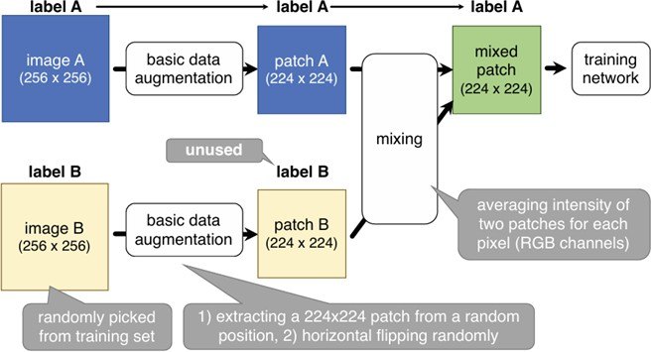

Figure 3.4: Overview of SamplePairing data augmentation for ILSVRC dataset (reproduced from [5]).

In this experiment, we followed the methodology was introduced by this paper.

Here are the detailed steps:
Step 1 prepare a train dataset without SamplePairing data augmentation, a basic data augmentation applied on this plain train dataset with horizontal flip.
Step 2 enable SamplePairing dataset with averaged two images for each pixel that mean with equal weights. We randomly choose each image from autistic train dataset and non-autistic train dataset, mixed images but use Autistic label.
Step 3 Used the model named ASDFace that introduced by Wang et al. [18]. Initial the first epoch with plain train dataset. Started 5 cycles from second epoch, we applied 8 epochs with mixed train dataset and 2 epochs with plain dataset, then fine tuning stage ended the whole train process with last 2 epochs that applied with plain train dataset. Furthermore, to improve performance on the small dataset, we increased the number of training epochs from 50 to 150.

Chapter 4 Experiments

Overview of Experimental Setup
The problem-solving approaches in this study were carefully designed to align with the research aim of evaluating the ASDFace [18] model’s performance under varying data conditions. Each experiment, ranging from dataset size variation to augmen-tation and cross ethnic validation—was systematically structured to isolate and measure the effect of specific factors on model accuracy and generalisation.
Evaluation methods were clearly defined and justified: classification accuracy and validation loss were used as key performance indicators, while consistent hyper-parameter settings ensured comparability across experiments. This methodological design provided a reliable framework to assess the model’s robustness and effective-ness.

Data Scale Analysis
Building upon the baseline ASDFace model introduced in Chapter 2, this section describes the implementation of traditional data augmentation techniques.
The original ASDFace model was first retrained on a small dataset that contain 500 ASD images and 500 TD images, and an expanded version of dataset, only horizontal flip applied on both datasets.
In addition to increasing the overall number of samples, the dataset was refined to address class imbalance between autistic and non-autistic categories. Initially, the dataset contained approximately 1,778 autistic and 4,364 non-autistic facial images, which led to a significant imbalance and poor classification results. To solve this issue, the autistic images was duplicated to approximately 3,556 images, creating a more balanced distribution between the two categories. The model trained by using this new dataset with the same hyperparameters as the original ASDFace framework. The accuracy dropped to 68% with small dataset, and the resulting classification accuracy reached 94%, which higher than the performance reported in the original small sample study, still indicated that class imbalance and limited variation within the autistic class affected the model’s ability to generalise effectively, only horizontal flipping was enabled for this attempt. Training curve shows on Figure 4.1 and Figure 4.2.

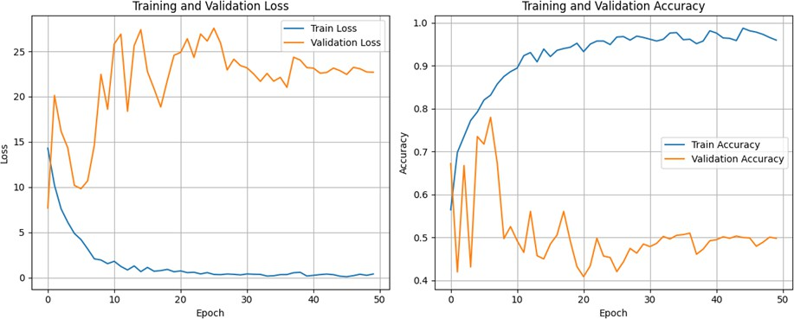

Figure 4.1: Small dataset (AD:500, TD:500) with data augmentation.

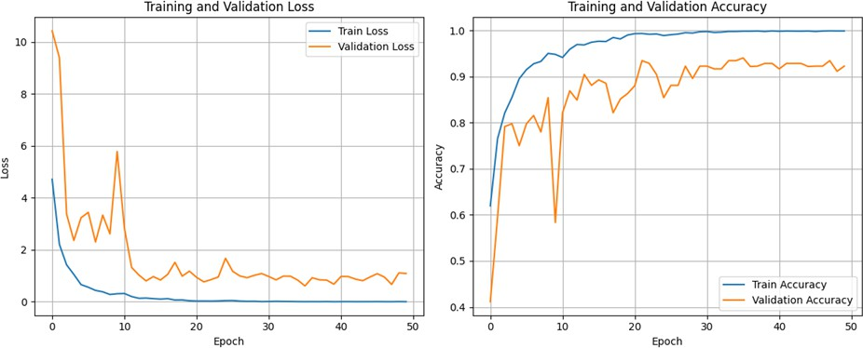
Figure 4.2: Small dataset (ASD:3556, TD:4364) with data augmentation.

Table 4.1: Comparative analysis of two different size dataset

Dataset Size | accuracy
ASD:500, TD:500 | 0.68
ASD: 3556, TD:4364 | 0.94

From the experimental results, the ASDFace model that used only facial images without incorporating the source domain performed poorly, achieving an accuracy of only 68%. In contrast, the original paper’s model, which utilised the source domain, achieved significantly better performance of 87% accuracy [18], even though it was trained with only about 100 facial images for each class. These results suggest that using source domain can yield better performance, making it more suitable for real time diagnostic applications.

Data Augmentation Analysis
Used same expanded data set (ASD 3556, TD 4364) with advance data augmentation technologies, the accuracy was achieved 97% in the first attempt; the second attempt the accuracy was hit on 99%. Training curve shows on Figure 4.3.

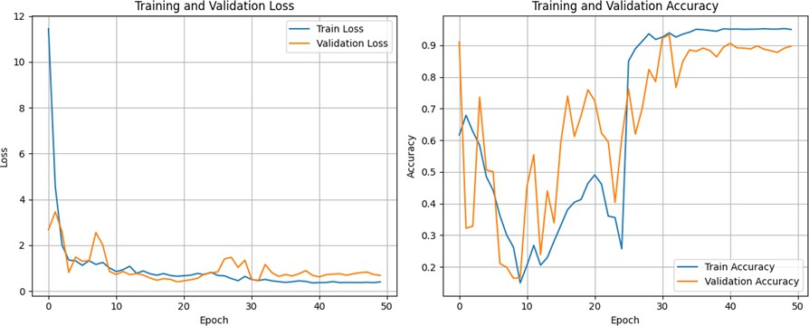
Figure 4.3: Large dataset (ASD:3556, TD:4364) with advance data augmentation applied during training.

Although the model achieved an accuracy of 0.94 (without advance data aug-mentation) and 0.99, the validation curve in Figure 4.2 and Figure 4.3 exhibits noticeable oscillations, especially during the second experiment, indicating possible instability or overfitting.
To achieve the better results, we added on noise reduction on the top of the advance data augmentation. In this step, a median filter with a 5 × 5 kernel was applied to the image to reduce impulsive noise (salt-and-pepper noise). Unlike mean filtering, the median operation preserves edge details while smoothing out isolated noisy pixels.
Our model achieved a final accuracy of 0.98. The training and validation losses dropped sharply at the beginning and gradually plateaued, accompanied by a rapid increase in accuracy. Some fluctuations were observed in the validation curve during the early training phase, but the curve became smooth and stable after about 30 epochs. It showed on Figure 4.4.
However, the accuracy dropped 10% when the learning rate reduced to 0.0005, and by 7% when illumination uniformity was applied. The decrease in accuracy with the lower learning rate is likely due to the local minima rather than reaching a better global optimum. The decline observed after applying illumination uniformity may be related to changes in image contrast and brightness distribution – the prepossessing might have removed subtle texture or shading cues that were informative for facial feature discrimination in ASD classification.
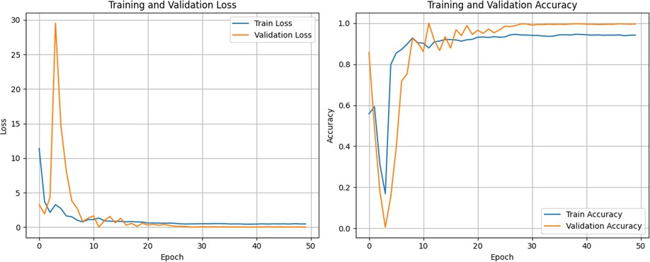

Figure 4.4: Large dataset (ASD:3556, TD:4364) training and validation curves with data augmentation and noise reduction.

Table 4.2: Comparative analysis of three approaches of basic data augmentation.

Group | Basic data augmentation approach | Accuracy
1 | Horizontal flip | 0.94
2 | Horizontal flip, brightness range [0.8, 1.2], rotation range 10, zoom range 0.1 | 0.99
3 | Noise reduction plus method used on second group | 0.98

In summary, the first series of experiments demonstrated the progressive im-provement of model performance through data expansion, augmentation, and de-noising. Increasing the dataset size significantly enhanced accuracy from 68% to 94%, confirming that a larger and more diverse dataset improves the model’s learn-ing capability. Applying data augmentation further increased accuracy to 99%, although the validation curve showed notable fluctuations, indicating minor insta-bility. After integrating a denoising step using median filtering, the final model achieved 98% accuracy with smoother and more stable curves, effectively reducing noise and preventing overfitting. These results suggest that data quality and prepos-sessing play a crucial role in achieving consistent and reliable model performance, forming a solid foundation for the next phase of experiments. Compared with the original ASDFace model, the use of a larger dataset with data augmentation can improve accuracy. However, collecting large-scale medical data remains challenging and costly, as also noted by Wang et al. [18], which addressed this limitation through a heterogeneous domain adaptation strategy.

SamplePairing Analysis
This experiment investigates the effectiveness of the SamplePairing data augmenta-tion technique, which mixes two randomly selected images to generate new training samples. The goal is to evaluate whether combining samples from different classes can improve generalisation and model robustness on limited datasets.
Figure 4.5 showed the stage of train processing. Trained with mixed dataset curve showed on the blue block, trained with plain dataset curve displayed on the white block. The result with very good accuracy that was achieved 1.00 with small test dataset. The curve was very similar to the paper. See the original training curve with Figure 4.6. In the cycles stage, the validation error was sharply shocking in those cycles, but in the fine tuning stage, validation error displayed much better than cycle stage.

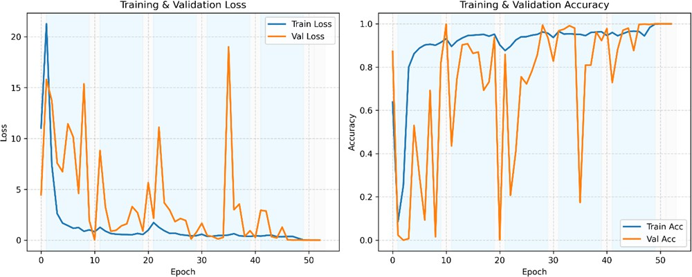

Figure 4.5: Large dataset (ASD:3556, TD:4364) training and validation curves with SamplePairing.

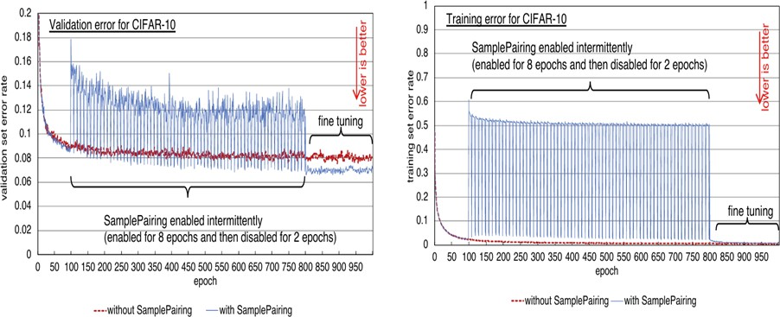
Figure 4.6: Changes in validation error rates for CIFAR-10 and ILSVRC datasets with and without our SamplePairing data augmentation (reproduced from [5]).

In summary, SamplePairing is a simple method that can easily applied on small dataset. In our experience, the origin plain dataset with 1778 autistic images and 4364 non-autistic images. To balanced two classes, we simply copied autistic im-ages to reach 3556 images that applied on the experience 2.2. We used the plain dataset from experience 2.2 and only applied horizon flip. The result showed us this technology was effectively improve the accuracy, higher than we only use basic data augmentation technology.
To test ASDFace model further, we reduced the dataset size to 1500 images for each class. Feed to model with horizon flip and train cycle epochs as 50 (8 epochs applied with SamplePairing dataset and 2 epochs applied with plain dataset). The accuracy was stable and achieved 99.8%. Training curve shows on Figure 4.7.

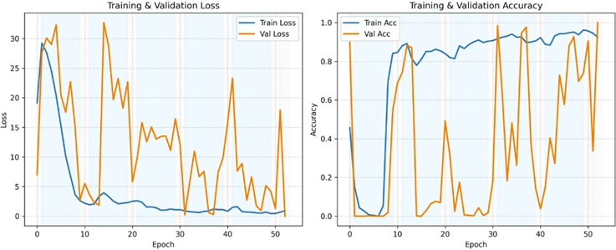
Figure 4.7: Large dataset (ASD:1500, TD:1500) training and validation curves with SamplePairing.

We further decreased the dataset size to 500 images each class for test the model’s generalisation ability, while increasing the number of cycle epochs. Now, the cycle epochs increased from 50 to 150 with 8 epochs applied SamplePairing dataset and 2 epochs applied plain dataset. However, the result was dropped down to 39%. Training curve shows on Figure 4.8.
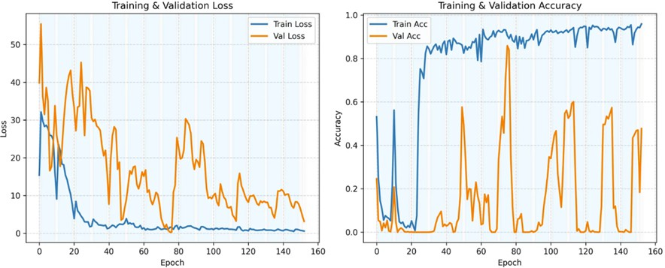
Figure 4.8: Large dataset (ASD:500, TD:500) training and validation curves with SamplePairing.

Table 4.3: Comparative SamplePairing analysis of three different size datasets.

Group | Dataset size | Accuracy
1 | ASD: 500, TD:500 | 0.390
2 | ASD: 1500, TD:1500 | 0.998
3 | ASD: 3556, TD:4364 | 1.000

From curves displayed on Figure 4.7 and Figure 4.8, we can conclude that the fi-nal fine-tuning stage didn’t have a significant impact, and additional training epochs may be required to achieve meaningful improvement. The performance observed in Figure 4.8 might simply be due to random variation rather than actual model en-hancement.

Cross race Generalisation Test
In addition, we conducted a preliminary cross ethnic test to examine the model’s generalisation ability cross different racial groups. We conducted the customisa-tion dataset with train and valid dataset only contain Caucasian; test dataset only contains African descent. Although only a single test was performed, the results pro-vided initial insight into the model’s potential sensitivity to demographic variation. The model achieved 90%. This observation highlights the importance of considering racial and ethnic diversity when developing and evaluating deep learning based ASD screening systems. However, only one test performed, and the number of samples from each group was highly imbalanced – while the training set contained many im-ages, the test set more less than training set. Therefore, the excellent performance observed in this test is likely coincidental and should be interpreted with caution. Further experiments with larger and more balanced datasets are required to confirm the model’s generalisability across diverse ethnic groups.

Chapter 5
Discussion and Future work

Model Evaluation and Advantages
In this study, several experiments were conducted to evaluate the performance and generalisation ability of the proposed ASDFace model under different data condi-tions.
Firstly, experiments using small (500 images per class) and large (over 3000 images per class) datasets demonstrated that limited data significantly reduced model performance. Although the accuracy reached 87% after introducing addi-tional feature-based enhancement methods, using only a small dataset alone proved insufficient for stable learning. Compared with our modified model, the original ASDFace approach [18] achieved better performance with limited data, suggesting that incorporating source-domain information is beneficial for small-scale classifica-tion tasks.
Secondly, when trained with a large dataset and multiple data augmentation techniques, the model’s accuracy improved substantially, confirming that both data volume and diversity play key roles in enhancing performance.
Thirdly, SamplePairing approach was tested, showing that with a sufficiently large dataset, satisfactory results could be achieved in as few as 53 epochs. How-ever, when trained on smaller datasets, additional training cycles were required, and the results were less consistent. The original study of SamplePairing trained for over 950 epochs which is time consuming and computationally expensive. Such extensive training makes the approach impractical for real time or clinical diagnostic applications. In constrast, ASDFace model [18] achieved comparable performance on the small dataset with significantly fewer training epochs This makes our model more suitable for real time or clinical diagnostic use.
Finally, a preliminary cross ethnic experiment was performed, but due to dataset limitations particularly the small number of samples from certain groups, the out-comes, including those of the previous experiment, may have been influenced by random factors.
Overall, these findings suggest that quantity, diversity and balance are critical for achieving robust and generalisable performance in ASD facial image classification. Future work will focus on expanding the dataset, improving ethnic diversity, and conducting cross-validation to validate the model’s reliability more comprehensively. The results demonstrate that the proposed model framework effectively lever-ages source domain information to enhance classification performance, particularly

when training data are limited. When the source domain input was disable, the model required a substantially larger dataset to reach a comparable level of accu-racy. Specifically, accuracy dropped to 0.68 when only 500 images per class was trained the model, indicating that source domain features play a crucial role in improving representation learning and generalisation.
Even with several data augmentation techniques applied, satisfactory accuracy could only be achieved when the dataset contained more than 3500 ASD images and 4000 TD images. In contrast, the ASDFace model with source domain supported limited dataset and achieved 0.87 accuracy, highlighting its robustness and efficiency in small data scenarios.
In the mixing image experiment, where only ten images per class (a total of 100 samples) were used, the model achieved a reasonable level of accuracy after several hundred training epochs. This suggests that the SamplePairing approach may still enable meaningful learning from extremely limited data. However, in the experiment with 500 images per class, the model was trained for only 150 epochs, and the results were less satisfactory — potentially due to insufficient training iterations. This finding will be further validated in future experiments with extended training schedules and additional hyperparameter tuning.

Future Work
Future research will aim to extend this work through more comprehensive cross eth-nic analysis, as dataset diversity remains a critical factor affecting generalisation. Another direction is to reconstruct and enhance the base model by introducing alter-native source domains — such as brain imaging data (MRI/fMRI) or eye-tracking gaze patterns — to integrate multi modal information. These additional modali-ties may provide richer representations of behavioural and neurophysiology traits, potentially improving model interpret ability and diagnostic reliability for autism spectrum disorder.

Chapter 6 Conclusion
This study explored the potential of the ASDFace model for ASD facial classification, focusing on the effects of dataset size, data augmentation, and the use of source domain information. The experiments were conducted under various configurations to evaluate how these factors influence model accuracy and generalisation.
The results demonstrated that source domain plays a important role in improving model accuracy, especially dataset size was limited. The model’s accuracy dropped to 0.68 when disable the source domain input with only 500 images per class, high-lighting the challenge of small sample learning. In contrast, the complete ASDFace model achieved an accuracy of 0.87 on a smaller dataset, confirming the effectiveness of integrating domain adaptation. Denoising and data augmentation techniques en-hanced model robustness, and SamplePairing approach displayed promising results in large-scale dataset, but failed to generalise limited data, indicating further study is required. However, cross ethnic experiments require further investigation, and additional model regularisation may be needed to ensure stable performance across different demographic groups.
Overall, the research contributes to the understanding of data efficiency and domain adaptation in autism facial recognition. It emphasises the importance of dataset diversity and balanced representation across demographic groups. In the future, integrating various data as source domain input – such as neuroimaging or eye-tracking images data or textual data – to further improve classification robust-ness and the generalisation ability of ASD screening models.

Bibliography

- Centers for Disease Control and Prevention. Data and Statistics on Autism Spectrum Disorder (ASD). Accessed: 29 October 2025. U.S. Department of Health and Human Services. 2024. url: https://www.cdc.gov/autism/ data-research/index.html.
- C. Okoye et al. “Early diagnosis of autism spectrum disorder: a review and analysis of the risks and benefits”. In: Cureus 15.8 (2023). doi: 10.7759/ cureus.43226.
- M. S. Alam et al. “Robust Autism Spectrum Disorder Screening Based on Facial Images (For Disability Diagnosis): A Domain-Adaptive Deep Ensemble
Approach”. In: Diagnostics 15.13 (2025), p. 1601. doi: 10.3390/diagnostics15131601.
- C. Shorten and T. M. Khoshgoftaar. “A survey on image data augmentation for deep learning”. In: Journal of Big Data 6.1 (2019), pp. 1–48. doi: 10. 1186/s40537-019-0197-0.
- H. Inoue. “Data augmentation by pairing samples for image classification”. In: arXiv preprint arXiv:1801.02929 (2018). url: https://arxiv.org/abs/ 1801.02929.
- P. K. Chandaliya et al. “Towards Inclusive Face Recognition through Synthetic Ethnicity Alteration”. In: Proceedings of the 2024 IEEE 18th International Conference on Automatic Face and Gesture Recognition (FG). IEEE, 2024,
pp. 1–8. doi: 10.1109/FG57868.2024.000XX.
- J. Li. “Autism Spectrum Disorder Screening by Machine Learning and Deep Learning Approach: A Review”. Unpublished student research paper. 2025.
- M. Z. Uddin et al. “Deep learning with image-based autism spectrum disor-der analysis: A systematic review”. In: Engineering Applications of Artificial Intelligence 127 (2024), p. 107185. doi: 10.1016/j.engappai.2023.107185.
- S. Huda et al. “Advancements in Automated Diagnosis of Autism Spectrum Disorder through Deep Learning and Resting-State Functional MRI Biomark-ers: A Systematic Review”. In: Cognitive Neurodynamics 18.6 (2024), pp. 3585–3601. doi: 10.1007/s11571-024-10119-5.
- H. Li et al. “Analysis of SiC MOSFET dI/dt and its Temperature Depen-dence”. In: IET Power Electronics 11.3 (2018), pp. 491–500. doi: 10.1049/ iet-pel.2017.0521.
- A. S. Heinsfeld et al. “Identification of Autism Spectrum Disorder Using Deep Learning and the ABIDE Dataset”. In: NeuroImage: Clinical 17 (2018),
pp. 16–23. doi: 10.1016/j.nicl.2017.08.017.

- F. Almuqhim and F. Saeed. “ASD-SAENet: A Sparse Autoencoder and Deep Neural Network Model for Detecting Autism Spectrum Disorder (ASD) Using fMRI Data”. In: Frontiers in Computational Neuroscience 15 (2021), p. 654315. doi: 10.3389/fncom.2021.654315.
- W. Yin, S. Mostafa, and F.-X. Wu. “Diagnosis of Autism Spectrum Disorder Based on Functional Brain Networks with Deep Learning”. In: Journal of Computational Biology 28.2 (2021), pp. 146–165. doi: 10.1089/cmb.2020.
0468.
- M. A. Bayram, I˙. O¨ zer, and F. Temurta¸s. “Deep Learning Methods for Autism Spectrum Disorder Diagnosis Based on fMRI Images”. In: Sakarya University Journal of Computer and Information Sciences 4.1 (2021), pp. 142–155.
- M. Cao et al. “Using DeepGCN to Identify Autism Spectrum Disorder from Multi-Site Resting-State Data”. In: Biomedical Signal Processing and Control 70 (2021), p. 103015. doi: 10.1016/j.bspc.2021.103015.
- S.-J. Jia, J.-Q. Jing, and C.-J. Yang. “A Review on Autism Spectrum Disorder Screening by Artificial Intelligence Methods”. In: Journal of Autism and De-velopmental Disorders (2024), pp. 1–17. doi: 10.1007/s10803-024-06258-4.
- A. Lu and M. Perkowski. “Deep Learning Approach for Screening Autism Spectrum Disorder in Children with Facial Images and Analysis of Ethnoracial Factors in Model Development and Application”. In: Brain Sciences 11.11 (2021), p. 1446. doi: 10.3390/brainsci11111446.
- H. Wang et al. “ASDFace: Face-Based Autism Diagnosis via Heterogeneous Domain Adaptation”. In: Proceedings of the 31st ACM International Confer-ence on Information and Knowledge Management (CIKM). New York, NY, USA: Association for Computing Machinery, 2022. doi: 10.1145/3511808. 3557642.
- M. Melinda et al. “Deep Learning Performance Analysis for Facial Expression-Based Autism Spectrum Disorder Identification”. In: Radioelectronic and Com-puter Systems 2024.2 (2024), pp. 30–40. doi: 10.32620/reks.2024.2.03.
- I. Ahmad et al. “Autism Spectrum Disorder Detection Using Facial Images: A Performance Comparison of Pretrained Convolutional Neural Networks”. In: Healthcare Technology Letters 11.4 (2024), pp. 227–239. doi: 10.1049/htl2.
12156.
- E.-S. Atlam et al. “Automated Identification of Autism Spectrum Disorder from Facial Images Using Explainable Deep Learning Models”. In: Scientific Reports 15.1 (2025), p. 26682. doi: 10.1038/s41598-025-26682-2.
- Ekin D. Cubuk et al. “AutoAugment: Learning Augmentation Strategies from Data”. In: Proceedings of the IEEE/CVF Conference on Computer Vision and Pattern Recognition (CVPR). 2019, pp. 113–123. doi: 10.1109/CVPR.2019. 00020.
- Hyung Il Jung et al. “Extension of Convolutional Neural Network with General Image Processing Kernels”. In: arXiv preprint arXiv:1901.07375 (2019). url: https://arxiv.org/abs/1901.07375.

- Dominique Beaini et al. “Novel Convolution Kernels for Computer Vision and Shape Analysis Based on Electromagnetism”. In: arXiv preprint arXiv:1806.07996 (2018). url: https://arxiv.org/abs/1806.07996.
- Yuqi Liu et al. “Multi-Kernel Filtering for Nonstationary Noise: An Extension of Bilateral Filtering Using Image Context”. In: arXiv preprint arXiv:1908.06307 (2019). url: https://arxiv.org/abs/1908.06307.
- Shaoli Huang, Xinchao Wang, and Dacheng Tao. “SnapMix: Semantically Proportional Mixing for Augmenting Fine-grained Data”. In: arXiv preprint arXiv:2012.04846 (2020). url: https://arxiv.org/abs/2012.04846.
- Ali Dabouei et al. “SuperMix: Supervising the Mixing Data Augmentation”. In: Proceedings of the IEEE/CVF Conference on Computer Vision and Pattern Recognition (CVPR). 2021.
- John Chen, Samarth Sinha, and Anastasios Kyrillidis. “TokenMix: Rethinking Image Mixing for Data Augmentation in Vision Transformers”. In: Proceedings of ??? 2023.
- Ken Chatfield et al. “Return of the Devil in the Details: Delving Deep into Convolutional Nets”. In: Proceedings of the British Machine Vision Conference (BMVC). BMVA Press, 2014. doi: 10.5244/C.28.6.
- Jia Deng et al. “ImageNet: A Large-Scale Hierarchical Image Database”. In: Proceedings of the IEEE Conference on Computer Vision and Pattern Recog-nition (CVPR). 2009, pp. 248–255. doi: 10.1109/CVPR.2009.5206848.
- Coloma Ballester et al. “Study on the Influence of Color Spaces for Deep-Learning Image Colorization”. In: arXiv preprint arXiv:2204.02850 (2022). url: https://arxiv.org/abs/2204.02850.
- Zhun Zhong et al. “Random Erasing Data Augmentation”. In: arXiv preprint arXiv:1708.04896 (2017). url: https://arxiv.org/abs/1708.04896.
- Chao Zhang et al. “Random Walk-based Erasing Data Augmentation for Deep Learning”. In: Signal, Image and Video Processing 17.2447–2454 (2023). doi: 10.1007/s11760-022-02461-3.
- Logan Engstrom et al. “A Rotation and a Translation Suffice: Fooling CNNs with Simple Transformations”. In: arXiv preprint arXiv:1712.02779 (2017). url: https://arxiv.org/abs/1712.02779.
- Maayan Frid-Adar et al. “GAN-based Synthetic Medical Image Augmenta-tion for increased CNN Performance in Liver Lesion Classification”. In: arXiv preprint arXiv:1803.01229 (2018). url: https://arxiv.org/abs/1803. 01229.
- Shin’ya Yamaguchi, Sekitoshi Kanai, and Takeharu Eda. “Effective Data Aug-mentation with Multi-Domain Learning GANs”. In: arXiv preprint arXiv:1912.11597 (2019). url: https://arxiv.org/abs/1912.11597.
- Archana Dash and Tripti Swarnkar. “Data-GAN Augmentation Techniques in Medical Image Analysis: A Deep Survey”. In: SN Computer Science 6 (2025),
p. 348. doi: 10.1007/s42979-025-03867-9.

- Jana Irpan et al. “Meta-Learning Requires Meta-Augmentation”. In: Advances in Neural Information Processing Systems (NeurIPS). 2020. url: https:// arxiv.org/abs/2007.05549.
- Renkun Ni et al. “Data Augmentation for Meta-Learning”. In: Proceedings of the 38th International Conference on Machine Learning (ICML). Vol. 139. PMLR, 2021, pp. 8152–8161. url: https://proceedings.mlr.press/v139/ ni21a.html.
- M. A. Mahmood et al. “Leveraging Artificial Intelligence for Diagnosis of Chil-dren Autism through Facial Expressions”. In: Scientific Reports 15.1 (2025),
p. 11945. doi: 10.1038/s41598-025-11945-1.
- Kaiming He et al. “Deep Residual Learning for Image Recognition”. In: Pro-ceedings of the IEEE Conference on Computer Vision and Pattern Recognition (CVPR). 2016, pp. 770–778. doi: 10.1109/CVPR.2016.90.

