

THE ECONOMIC IMPACT OF THE AUGUST 2016

FLOODS ON THE STATE OF LOUISIANA

A REPORT COMMISSIONED BY LOUISIANA ECONOMIC DEVELOPMENT AND PREPARED BY DEK TERRELL, PH. D.

LEWIS TERRELL AND ASSOCIATES, LLC

Contents

Executive Summary ......................................................................................................................................2 Introduction .................................................................................................................................................4 Business Interruption ...................................................................................................................................7 Property Damages: Business......................................................................................................................11 Property Damages: Automobile.................................................................................................................12 Property Damages: Housing.......................................................................................................................13 Agricultural Losses......................................................................................................................................15 Appendix 1: Summary of USGS Streamgage Data......................................................................................16 Appendix 2: LSU AgCenter Report on Agricultural Losses..........................................................................19

1

Executive Summary

This document summarizes preliminary findings with regard to the economic impact of the August 2016 floods in south Louisiana based on available sources and our computations. The primary economic damages consist of lost economic activity, property damages to residences, autos and businesses, and damage to government infrastructure. Table 1 presents a summary of our preliminary estimates of damages from the August 2016 Louisiana flooding.

Table 1: Summary of Damages by Category

**Damages Category Loss in**

**Millions**

**Residential Housing Structures** $3,844.2

**Residential Housing Contents** $1,279.8

**Automobiles** $378.8

**Agriculture** $110.2

**Business Structures** $595.6

**Business Equipment** $262.8

**Business Inventories** $1,425.5

**Business Interruption Loss** $836.4

**Public Infrastructure** TBD

**Total $8,733.3**

Key details are:

• At the peak, we estimate that operations at 19,900 Louisiana businesses or close to 20% of all Louisiana businesses were disrupted by the flooding event.

• This translates into a peak disruption of 278,500 workers or 14% of the Louisiana workforce

• We estimate an economic loss of just over $300 million in labor productivity and an $836 million loss in terms of value added during the period immediately surrounding the storm.

• We estimate that just over 6,000 businesses experienced flooding.

2

• Structural damages to businesses are estimated at $590 million. Equipment losses add another $260 million in losses and businesses experienced over $1.4 billion in lost inventory.

• We estimate that over 109,000 housing units flooded in Louisiana.

• Of these, just over 77,000 were owner occupied homes, 22,000 were renter occupied units and roughly 10,000 were vacant units.

• The hardest hit parishes were East Baton Rouge and Livingston with 41,000 and 38,000 housing units damaged respectively. In Livingston parish, this translates into 74% of the housing stock experiencing flood damages.

• The extent and severity of flooding translates into $3.8 billion in residential property damages with $1.3 billion occurring in Livingston Parish and $1.0 billion in East Baton Rouge Parish.

• We estimate that over 90,000 automobiles were damaged in the flood event with almost $380 million in damages.

• The LSU Ag Center estimates Louisiana agricultural losses of over $110 million stemming from the August 2016 Louisiana flooding event.

3

Introduction

On Thursday, August 11, an extreme yet slow-moving low-pressure weather system moved across the Gulf Coast, with the heaviest concentration of rainfall in southern Louisiana. Areas around Baton Rouge received rainfall in excess of two feet over multiple days, with as much as 31 inches of rain recorded in Watson, northeast of the capital city.

As the rain water flowed into streams and rivers, the Comite River, Amite River, Tickfaw River, and Tangipahoa Rivers all rose to record heights. Governor John Bel Edwards declared a statewide state of emergency and President Obama declared a major disaster in 20 parishes. Rising waters flooded houses and businesses across a wide swath of southern Louisiana. Houses and businesses that had never seen water before flooded, including many outside of the 100- year flood plain FEMA uses to estimate flood risk.

At least 13 deaths were reported across the state, and tens of thousands of residents were rescued or evacuated from their homes or sought refuge in shelters. Many roadways, including both interstates in the Baton Rouge area, I-10 and I-12, were closed at points with water over the road. Businesses in many of the hardest-hit parishes closed on Friday and through the weekend and beyond as employees and customers prepared for flooding, evacuated their homes or were closed in by flooded roads, and gutted ruined homes in the aftermath. Cellular network outages made it difficult to contact family and friends and for businesses to communicate with employees.

The flooding also extended to Acadiana where the Vermillion and Mermentau rivers substantially exceeded flood stage in some areas. Youngsville, Lake Arthur and a number of

4

other areas of Acadiana experienced significant flooding. The following figures show aerial photos of flooding in Louisiana.

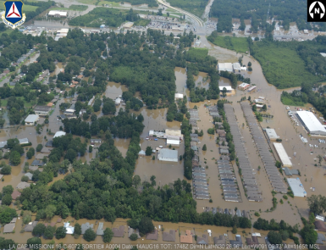*Figure 1 Flooding in East Baton Rouge Parish*

5

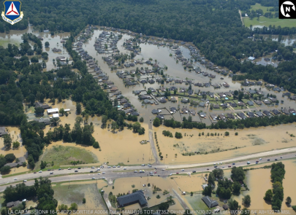*Figure 2 Flooding in Livingston Paris*

*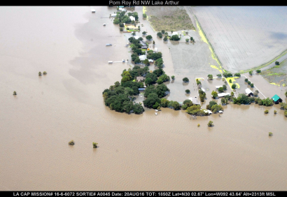Figure 3 Flooding in Jefferson Davis Paris*

6

Business Interruption

Throughout this event, severe weather, flooding and resources redirected to response efforts led to business interruption losses across the region. To characterize these losses, we estimated the percent of businesses closed each day based on the extent of flooding drawn from GOHSEP and FEMA flood maps as well as the duration of flooding based on flood level exceedances from USGS streamgages along rivers and bayous across the impacted area (a summary of streamgage data is provided in Appendix 1). However, closures extended beyond those businesses directly impacted by flooding due to road closures and the severe weather that disrupted travel for both employees and customers. To assess these broader disruptions, we reviewed situation reports from the Governor’s Office of Homeland Security and Emergency Preparedness, school closures, and government closures.

We adjusted our estimated closures by industry sector to account for the fact that some sectors were closed entirely while other sectors (e.g. large manufacturing facilities) generally continued to operate at normal, or close to normal capacity. To characterize these business interruption losses, we estimate the number of businesses and employees impacted each day as well as the lost worker productivity, which is measured in terms of wages. While a number of these employees will get paid even if they were not working, the worker’s productivity is lost to the employer thus creating losses to the region. Finally, it should be noted that these are the gross disruptions of the storm and these estimates do not account for the increase in response and recovery activity that are expected to bring new resources into the economy to help offset (at least partially) the loss of value to residents (homes and other possessions) and businesses (assets and inventory) caused by the storm and ensuing flood.

7

Businesses Impacted by Day

25,000

20,000

15,000

10,000

5,000

-

Figure 1: Businesses Impacted by Day

The daily estimate of the number of businesses experiencing business interruption losses is depicted in the figure above. These numbers include flooded businesses as well as our estimate of those businesses not operating, or operating at significantly reduced capacity due to severe weather and flooding across Louisiana. We estimate peak disruption to have occurred during the first weekend as floodwaters began to rise and residents in many areas were told to stay home. There were widespread closures of roads, businesses, schools and government offices as well as numerous flash flood warnings. The business impacts peaked at different times in different areas with some areas experiencing more acute impacts later as the floodwaters moved down river.

East Baton Rouge Parish has the highest concentration of businesses and was also severely impacted driving the overall peak on August 13. However, in terms of percentage impacts, Livingston was the most acutely impacted with the peak impacts in those areas

8

occurring later as floodwaters continued to rise and also receded more slowly in some areas. Livingston Parish was most acutely impacted with a large majority of businesses disrupted to some degree and more than half of businesses potentially flooded according to preliminary estimates. The severity of flooding creates a greater risk of long term closures, which can lead to business failure and potentially create long-term negative impacts to the region’s economy.

Table 2: Peak Disruption by Parish

**PARISH NUMBER OF BUSINESSES**

**NUMBER OF EMPLOYEES**

ACADIA 400 3,900

ASCENSION 1,200 17,100

AVOYELLES 100 1,200

EAST BATON ROUGE 8,000 143,700

EAST FELICIANA 100 800

EVANGELINE 200 1,500

IBERIA 600 8,200

IBERVILLE 100 2,000

JEFFERSON DAVIS 300 2,200

LAFAYETTE 3,100 40,000

LIVINGSTON 1,800 18,700

POINTE COUPEE 100 400

ST. HELENA <100 200

ST. LANDRY 600 6,300

ST. MARTIN 400 3,100

ST. TAMMANY 900 8,000

TANGIPAHOA 1,500 17,000

VERMILION 400 3,700

WASHINGTON <100 300

WEST FELICIANA <100 200

**TOTAL 19,900 278,500**

Because flooding impacted different areas at different times, the peak number of businesses and employees impacted by the storm and flooding is larger than was seen at any specific point in time. In total, approximately 19,900 businesses in Louisiana experienced temporary closures, or significant operational reductions. These businesses employ approximately 278,500 workers. While many employers may have continued paying employees during closures, some hourly workers may have

9

experienced reduced pay. We estimate that 45,000 to 75,000 of these employees work at businesses that experienced flooding and may now face extended periods without pay, or with reduced pay.

Table 3: Lost Productivity and Value Added by Parish

**PARISH**

**LOST LABOR PRODUCTIVITY (IN MILLIONS$)**

**LOST VALUE ADDED**

**(IN MILLIONS$)**

ACADIA $0.6 $2.4

ASCENSION $24.9 $68.5

AVOYELLES $0.4 $1.6

EAST BATON ROUGE $213.0 $540.2

EAST FELICIANA $0.3 $0.9

EVANGELINE $0.2 $0.9

IBERIA $1.8 $8.0

IBERVILLE $1.1 $2.9

JEFFERSON DAVIS $0.3 $1.7

LAFAYETTE $8.6 $31.1

LIVINGSTON $27.0 $97.8

POINTE COUPEE $0.1 $0.5

ST. HELENA $0.1 $0.2

ST. LANDRY $1.0 $3.3

ST. MARTIN $0.5 $2.5

ST. TAMMANY $2.9 $8.4

TANGIPAHOA $17.4 $62.2

VERMILION $0.7 $2.7

WASHINGTON $0.1 $0.4

WEST FELICIANA $0.1 $0.2

**TOTAL $300.9 $836.4**

We characterize accumulated impacts in terms of lost labor productivity (wages) and lost value added. Total impacts to the region are presented for the first three weeks of this event (including our projection through September 2), which provides a rough picture of the gross negative impacts of disruptions to the area up to a point where most short-term losses are likely to have ended even though a non-negligible amount of ongoing long-term losses will continue well past this initial three-week time horizon. Lost labor productivity during this period is estimated to be $300 million and lost value added is

10

estimated to be $836 million. During this three-week period, this amount of damage represents approximately 6% of economic activity in the state.

Property Damages: Business

To estimate damage to businesses, we relied on the most recent GOHSEP flood map available and reviewed FEMA flood maps as well as flood maps published by parishes in the flooded area. We overlayed infoUSA point level data on business locations for the impacted parishes to estimate the extent of business flooding in each parish. The total number of

businesses estimated to have flooded is 6,100 across the 20 parish area. It is worth noting that 60% of businesses in Livingston parish are estimated to have experienced some flooding and 19% of those in Ascension as well as 15% of those in East Baton Rouge, the parish with by far the largest overall number of businesses in the impacted area.

Data from the Bureau of Economic Analysis are used to estimate the value of business structures and equipment based on the size of employer and industry. We estimate that damage to business structures totals $595.6 million and damage to fixed equipment will add another $262.8 million to business losses.

Many businesses experiencing flooding lost substantial inventories, which we estimate based on the sales of impacted businesses and data from the Bureau of Economic Analysis that relates average inventories to sales for businesses in manufacturing, wholesale trade and retail trade. We estimate that a total of $1.4 billion in inventory was damaged by flooding. This figure represents an average of over $200,000 in inventory for each flooded business. While many impacted businesses are likely smaller businesses that would have significantly lower

11

inventories, a relatively small number of large wholesalers and retailers with substantial inventories can heavily skew the average relative to the typical loss. For example, the Dixie RV Superstore, an RV dealership in Hammond estimated as much as $30 million in damage thanks to a large portion of their inventory being flooded. Similarly, stores like the Walmart and Home Depot in Denham Springs flooded and would have lost inventory values much higher than what is typical across the 6,000 firms that flooded.

Property Damages: Automobile

We estimate that over 90,000 automobiles were damaged in the August 2016 Louisiana floods with a total loss of $378.8 million. Table 4 presents the calculations used to compute this estimate. The estimate begins with 17,600 claims reported by Louisiana’s largest auto insurer, State Farm, on August 24, 2016. Accounting for the 31.7% market share of State Farm provided by the Louisiana Department of Insurance and a small amount of late claims leads to just under 62,000 estimated insured claims. We estimate total claims using Insurance Information Institute statistics. In particular, 78% of autos insured for liability also carry comprehensive insurance and an estimated 13.9% of Louisiana autos are uninsured. This leads to an estimate just under 92,000 automobiles damaged in the flood event.

We then apply an average insured loss from prior events ($4,412) using data obtained from the Louisiana Department of Insurance and websites for other states. A 25% discount is applied to uninsured autos to account for a likely lower values of these autos. The result is an estimated $378.8 million in auto loss, 71.9% of which is estimated to be insured. It is worth noting that this will understate losses to the extent that prior payments per claim understate actual damages per claim.

Table 4: Estimated Automobile Damages

State Farm Claims as of 8/24 17,600

State Farm market share 31.7%

12

Estimated insured claims as of 8/24 55,591

Estimated late claims 6,115

Estimated insured claims 61,706

% of insured drivers with comprehensive insurance 78.0%

Number of damage 79,110

Percent of Uninsured Motorists 13.9%

Estimated number of damaged autos 91,881 Avg. insured loss prior storms $4,412

Estimated Insured loss ($millions) $272.3

Estimated uninsured loss ($millions) $106.5

Estimated total loss ($millions) $378.8

Property Damages: Housing

Conceptually, our methodology in estimating damages is to overlay census data on the number of housing units flooded and the latest GOHSEP flood maps. We then checked the basic results using GOHSEP and FEMA maps estimating point inundation of structures, aerial photos, and personal accounts of flooding. Modifications were made when observations deviated from predictions of the GIS maps. The largest change from the original flood maps came in Tangipahoa parish where on-the-ground accounts indicated that flooding did not occur in areas of Hammond that were shown as flooding on the maps.

Table 5 contains estimates of number of housing units flooded by parish. Results are rounded to hundreds to emphasize that these computations are based on estimated flooded, not a full count of homes flooded by parish. Not surprisingly the largest number of housing units impacted were in East Baton Rouge and Livingston parishes. As a ratio of housing stock, the largest impact by far occurred in Livingston Parish where an estimated 74% of housing units sustained flood damage.

13

Table 5: Estimated Housing Units Flooded by Parish

**Parish 2015 Housing Units Estimated Housing**

**Units Flooded**

Acadia 25,634 600

Ascension 42,471 13,100

Avoyelles 18,238 <100

East Baton Rouge 189,353 41,000

East Feliciana 8,093 300

Evangeline 14,766 <100

Iberia 30,169 400

Iberville 13,097 <100

Jefferson Davis 13,642 200

Lafayette 95,373 1,900

Livingston 52,104 38,300

Pointe Coupee 11,214 600

St. Helena 5,154 400

St. Landry 35,940 400

St. Martin 22,250 800

St. Tammany 100,061 <100

Tangipahoa 51,363 9,900

Vermilion 25,588 700

Washington 21,345 <100

West Feliciana 5,293 100

**Total 781,148 109,100**

Breaking the housing stock down further, 71% of flooded units or just over 76,000 were owner occupied. 20% of flooded housing units were rental units and 9% were vacant. These statistics closely mirror the total Lousiana housing stock where 69% are owner occupied, 19% rental units, and 12% vacant. It is important to note that vacant housing units are often homes on the market, but also may be in disrepair. We discount the value of these properties later to reflect both the slightly lower selling price of some vacant properties and poor condition of others. A comparison of this estimated number of units flooded with National Flood Insurance Program claims suggests that a large portion of flood losses are not covered by insurance.

14

The next step consists of estimating property damages from flooding. We begin with the average NFIP loss per claim during Tropical Storm Isaac of $46,073. For comparison, average loss per NFIP claim in major flooding events since 2012 has varied from $23,867 during Tropical Storm Debbie to $67,463 per claim for Superstorm Sandy. The average across all events is $44,818 and Isaac is the median claim for all large events post-2012. The estimated damage value was reduced to isolate structure damages by removing an estimated portion of content claims. Damages were then adjusted to reflect estimated flood depth and property values in the area. Table 6 presents estimated residential property damages by type of property.

The results indicate $3.8 billion of damages divided between $2.9 billion in owner occupied housing, almost $600 million in rental housing and just under $290 million in vacant units. The largest estimated damages to residential housing are $1.3 billion in Livingston Parish and $1.0 billion in East Baton Rouge Parish.

Table 6: Residential Property Damages by Type

(millions of $)

**ITEM DAMAGES**

RESIDENTIAL HOUSING $2,964.6

RENTAL PROPERTY $590.2

VACANT UNITS $289.4

**TOTAL $3,844.2**

Agricultural Losses

Appendix 2 contains Kurt Guidry’s full report on the LSU Ag Center’s preliminary estimates of economic impacts of the flooding on Louisiana’s agricultural sector. He observes

15

that the estimates should be viewed as conservative because they only consider the impact of production reductions. For convenience, Table 7 replicates the LSU Ag Center results by commodity.

The LSU Ag Center estimates over $110 million in agricultural damages stemming from the 2016 Louisiana flooding event. The losses are heavily concentrated in Rice with an estimated $33.6 million in losses and Soybeans with $46.7 million in losses.

Table 7: Preliminary Estimates of Agricultural Losses

(millions of $)

**COMMODITY ESTIMATED IMPACT**

RICE $33.6

SOYBEANS $46.8

SUGARCANE $3.2

SWEET POTATOES $4.5

GRAZING $2.0

FRUITS/VEGETABBLES $5.2

CORN $10.9

GRAIN SORGHUM $0.4

COTTON $3.7

**TOTAL $110.2**

Source: Kurt Guidry, LSU Ag Center

Appendix 1: Summary of USGS Streamgage Data

The duration of flooding in different parts of the state was approximated using the timing of when different streamgages rose above and subsequently fell below flood stage. Examples of how these data were used and interpreted are provided below for the Amite, Tangipahoa and Vermillion River Basins.

16

**e**

**g**

**a**

**t**

**S**

**do**

**o**

**l**

**F**

**e**

**v**

**o**

**b**

**A**

**t**

**e**

**e**

**F**

**Streamgages in Amite River Basin**

20

Amite River near Darlington

Amite River at Magnolia LA

Amite River near Denham Springs

15

Amite River near French Settlement

Amite at Hwy 22 near Maurepaus

Amite at Grageville

Bayou Manchac near Little Prairie, LA

10

Amite River at Port Vincent

5

0

6

1

/

0

1

/8

6

1

/

1

1

/8

6

1

/

2

1

/8

6

1

/

3

1

/8

6

1

/

4

1

/8

6

1

/

5

1

/8

6

1

/

6

1

/8

6

1

/

7

1

/8

6

1

/

8

1

/8

6

1

/

9

1

/8

6

1

/

0

2/

8

6

1

/

1

2/

8

**e**

**g**

**a**

**t**

**S**

**do**

**o**

**l**

**F**

**e**

**v**

**o**

**b**

**A**

**t**

**e**

**e**

**F**

**Streamgages in Tangipahoa River Basin**

14

Tangipahoa River near Kentwood, LA

12

Tangipahoa River near Amite, LA

10

Tangipahoa River at Robert, LA

Natalbany River at Baptist, LA

8

Tchefuncte River near Folsom, LA

6

4

2

0

6

1

/0

1

/8

6

1

/1

1

/8

6

1

/2

1

/8

6

1

/3

1

/8

6

1

/4

1

/8

6

1

/5

1

/8

6

1

/6

1

/8

6

1

/7

1

/8

6

1

/8

1

/8

6

1

/9

1

/8

6

1

/0

2/

8

6

1

/1

2/

8

17

e

g

a

t

S

d

o

o

l

F

e

v

o

b

A

t

e

e

F

**Streamgages Along Vermillion River**

6

5

4

3

2

Vermilion River near Carencro, LA

Vermilion River at Hwy 733 near Lafayatte, LA

1

Vermilion River near Lafayatte, LA

0

6

1

/0

1

/8

6

1

/1

1

/8

6

1

/2

1

/8

6

1

/3

1

/8

6

1

/4

1

/8

6

1

/5

1

/8

6

1

/6

1

/8

6

1

/7

1

/8

6

1

/8

1

/8

6

1

/9

1

/8

6

1

/0

2/

8

6

1

/1

2/

8

18

Appendix 2: LSU AgCenter Report on Agricultural Losses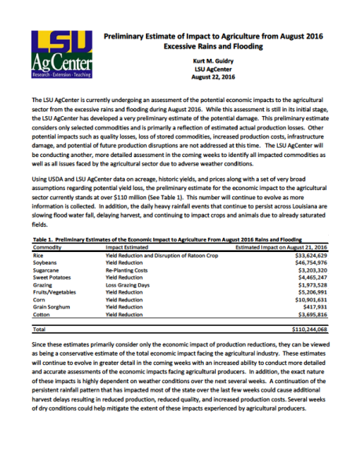19

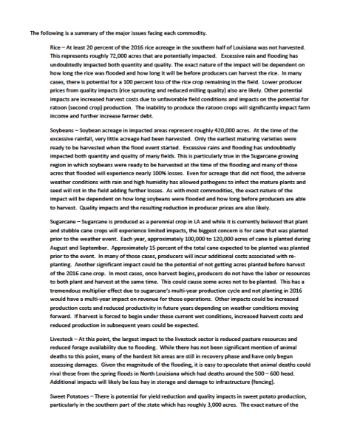20

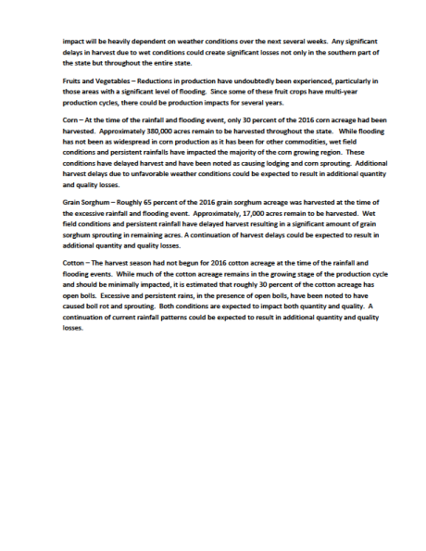21

About the Author

Dek Terrell is the Freeport McMoRan Professor of Economics at Louisiana State University and Executive Director of the Economics and Policy Research Group at LSU. He has published extensively in both academic and practitioner publications and has served as a co-editor or associate editor of the *Southern Economic Journal*, *Journal of Labor Research*, and three volumes of *Advances in Econometrics*. He worked extensively on a number of projects related to the recovery from Hurricane Katrina, including a major grant funded by the Department of Homeland Security. He has also worked on economic damage assessments for numerous Louisiana events ranging from small events affecting a few parishes to Hurricanes Gustav and Isaac and the BP Oil Spill.

22