《数据库原理
及应用开发》

实验报告2

班 级 21级综合实验班
姓 名 任精普
学 号 5903121107

数学与计算机学院计算机
一、实验目的
1.加深对SQL数据更新语句的基本语法格式的掌握。
2.掌握单个元组及多个元组的插入、修改及删除操作的实现过程。
3.加深对约束条件在数据更新操作执行中的作用问题的了解。
4.加深对更新操作时数据库中数据一致性问题的了解。
二、实验要求
1.了解SQL 数据库表的结构；
2. 独立完成实验内容，并提交书面实验报告。
3. 提交以下每一条操作的sql语句放进实验报告中（eg：一问中插入数据需要每一条插入操作的insert语句）。
4. 每个命令结束后的结果都要在数据库下截图放进实验报告中。
三、实验内容及结果(PS:使用SQLyog Community 64完成)
1.在实验一中的三个表中添加数据，要求student表中插入不少于30条数据，course表中插入不少于10条数据，grade表中不少于90条数据。（数据见附件）
(1)学生表(Student表)插入不少于30条数据
-- 学生表插入30条语数据
INSERT INTO Student VALUES('001','李春刚','男','计算机应用','计算机','2019-09-01','02','12345678910','2000-09-01','呼和浩特市','无','汉族','shen','团员',132);
INSERT INTO Student VALUES('002','董雪婷','女','计算机应用','计算机','2019-09-01','03','12345678910','2000-09-01','呼和浩特市','无','汉族','shen','团员',132);
INSERT INTO Student VALUES('003','陈男','男','电子商务','管理系','2019-09-01','01','12345678910','2000-09-01','呼和浩特市','无','汉族','shen','团员',132);
INSERT INTO Student VALUES('004','刘波','男','电子商务','管理系','2019-09-01','02','12345678910','2000-09-01','呼和浩特市','无','汉族','shen','团员',132);
INSERT INTO Student VALUES('005','吴辉','男','计算机应用','计算机','2019-09-01','03','12345678910','2000-09-01','呼和浩特市','无','汉族','shen','团员',132);
INSERT INTO Student VALUES('006','陈惠惠','女','软件开发','软件','2019-09-01','02','12345678910','2000-09-01','呼和浩特市','无','汉族','shen','团员',132);
INSERT INTO Student VALUES('007','陈慧','女','软件开发','软件','2019-09-01','01','12345678910','2000-09-01','呼和浩特市','无','汉族','shen','团员',132);
INSERT INTO Student VALUES('008','王涛','男','计算机应用','计算机','2019-09-01','03','12345678910','2000-09-01','呼和浩特市','无','汉族','shen','团员',132);
INSERT INTO Student VALUES('009','郭凤丽','女','应用电子','电子','2019-09-01','01','12345678910','2000-09-01','呼和浩特市','无','汉族','shen','团员',132);
INSERT INTO Student VALUES('010','贾慧','女','应用电子','电子','2019-09-01','03','12345678910','2000-09-01','呼和浩特市','无','汉族','shen','团员',132);
INSERT INTO Student VALUES('011','陈小琴','女','计算机应用','计算机','2019-09-01','03','12345678910','2000-09-01','呼和浩特市','无','汉族','shen','团员',132);
INSERT INTO Student VALUES('012','钟志','男','计算机应用','计算机','2019-09-01','02','12345678910','2000-09-01','呼和浩特市','无','汉族','shen','团员',132);
INSERT INTO Student VALUES('013','彭志勇','男','计算机应用','计算机','2019-09-01','02','12345678910','2000-09-01','呼和浩特市','无','汉族','shen','团员',132);
INSERT INTO Student VALUES('014','熊小胖','男','计算机应用','计算机','2019-09-01','02','12345678910','2000-09-01','呼和浩特市','无','汉族','shen','团员',132);
INSERT INTO Student VALUES('015','魏泽丽','女','计算机应用','计算机','2019-09-01','01',(Null),'2000-09-01','呼和浩特市','无','汉族','shen','团员',132);
INSERT INTO Student VALUES('016', '刀妹', '女', '计算机应用','计算机','2019-09-01','02',(Null),'2000-09-01','呼和浩特市','无','汉族','shen','团员',132);
INSERT INTO Student VALUES('017', '陈雪', '女', '计算机应用','计算机','2019-09-01','02',12345678910,'2001-09-01','呼和浩特市','无','汉族','shen','团员',132);
INSERT INTO Student VALUES('018', '陈艾克', '男', '计算机应用','计算机','2019-09-01','01',(Null),'2000-09-01','呼和浩特市','无','汉族','shen','团员',132);
INSERT INTO Student VALUES('019', '卡萨丁', '男', '计算机应用','计算机','2019-09-01','03',(Null),'2000-09-01','呼和浩特市','无','汉族','shen','团员',132);
INSERT INTO Student VALUES('020', '莫甘娜', '女', '计算机应用','计算机','2019-09-01','01',(Null),'2000-09-01','呼和浩特市','无','汉族','shen','团员',132);
INSERT INTO Student VALUES('021', '基兰', '女', '计算机应用','计算机','2019-09-01','02',(Null),'2000-09-01','呼和浩特市','无','汉族','shen','团员',132);
INSERT INTO Student VALUES('022', '寒冰', '女', '计算机应用','计算机','2019-09-01','02',(Null),'2000-09-01','呼和浩特市','无','汉族','shen','团员',132);
INSERT INTO Student VALUES('023', '塔姆', '男', '计算机应用','计算机','2019-09-01','02',(Null),'2000-09-01','呼和浩特市','无','汉族','shen','团员',132);
INSERT INTO Student VALUES('024', '蛮王', '男', '计算机应用','计算机','2019-09-01','02',(Null),'2000-09-01','呼和浩特市','无','汉族','shen','团员',132);
INSERT INTO Student VALUES('025', '寡妇', '女', '计算机应用','计算机','2019-09-01','02',(Null),'2000-09-01','呼和浩特市','无','汉族','shen','团员',132);
INSERT INTO Student VALUES('026', '炸弹人', '男', '计算机应用','计算机','2019-09-01','01',(Null),'2000-09-01','呼和浩特市','无','汉族','shen','团员',132);
INSERT INTO Student VALUES('027', '维克多', '男', '计算机应用','计算机','2019-09-01','02',(Null),'2000-09-01','呼和浩特市','无','汉族','shen','团员',132);
INSERT INTO Student VALUES('028', '狐狸', '女', '计算机应用','计算机','2019-09-01','02',(Null),'2000-09-01','呼和浩特市','无','汉族','shen','团员',132);
INSERT INTO Student VALUES('029', '蕾欧娜', '女', '计算机应用','计算机','2019-09-01','01',(Null),'2000-09-01','呼和浩特市','无','汉族','shen','团员',132);
INSERT INTO Student VALUES('030', '卡莎', '女', '计算机应用','计算机','2019-09-01','01',(Null),'2000-09-01','呼和浩特市','无','汉族','shen','团员',132);

效果如下：
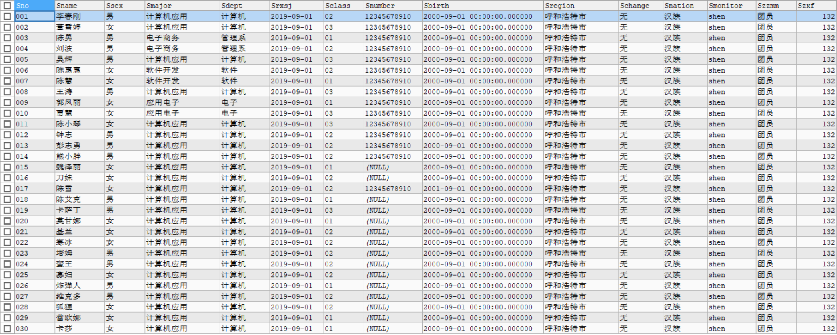
(2)课程表(Course表)插入不少于10条数据
-- 课程表插入10条数据
INSERT INTO Course VALUES('01','计算机基础','王晓梅','101',4,60,1);
INSERT INTO Course VALUES('02','电子商务','李丽','102',6,80,2);
INSERT INTO Course VALUES('03','网页制作','张铁柱','103',6,NULL,NULL);
INSERT INTO Course VALUES('04','软件工程','付大鹏','104',4,NULL,4);
INSERT INTO Course VALUES('05','数据库原理','白一阁','105',6,90,3);
INSERT INTO Course VALUES('06','软件测试','白展堂','201',4,NULL,5);
INSERT INTO Course VALUES('07','安卓应用设计','魏小雨','201',2,NULL,4);
INSERT INTO Course VALUES('08','UML','陈乾','201',5,70,6);
INSERT INTO Course VALUES('09','编译原理','熊军','207',5,NULL,7);
INSERT INTO Course VALUES('10','计算机网络','白一阁','207',4,60,4);
效果如下：
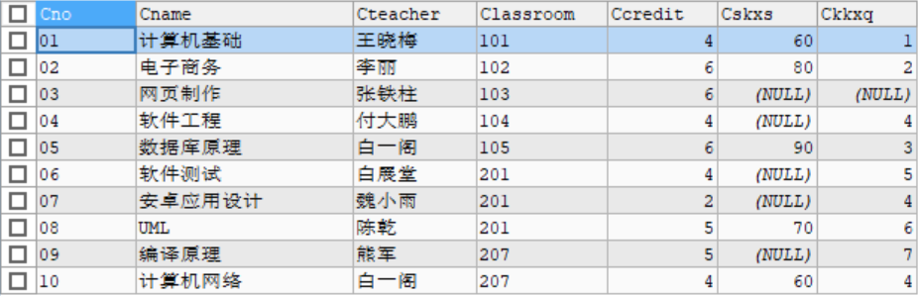
(3)成绩表(Grade表)插入不少于90条数据
-- 成绩表插入90条数据
INSERT INTO grade VALUES("001", "05", 82, NULL);
INSERT INTO grade VALUES("011", "05", 96, NULL);
INSERT INTO grade VALUES("003", "05", 97, NULL);
INSERT INTO grade VALUES("004", "05", 65, NULL);
INSERT INTO grade VALUES("017", "05", 76, NULL);
INSERT INTO grade VALUES("017", "01", 86, NULL);
INSERT INTO grade VALUES("017", "02", 96, NULL);
INSERT INTO grade VALUES("017", "03", 88, NULL);
INSERT INTO grade VALUES("017", "04", 89, NULL);
INSERT INTO grade VALUES("017", "06", 92, NULL);
INSERT INTO grade VALUES("017", "07", 90, NULL);
INSERT INTO grade VALUES("017", "08", 75, NULL);
INSERT INTO grade VALUES("017", "09", 84, NULL);
INSERT INTO grade VALUES("017", "10", 83, NULL);
INSERT INTO grade VALUES("012", "01", 86, NULL);
INSERT INTO grade VALUES("012", "02", 96, NULL);
INSERT INTO grade VALUES("012", "03", 88, NULL);
INSERT INTO grade VALUES("012", "04", 89, NULL);
INSERT INTO grade VALUES("012", "05", 89, NULL);
INSERT INTO grade VALUES("012", "06", 92, NULL);
INSERT INTO grade VALUES("012", "07", 90, NULL);
INSERT INTO grade VALUES("012", "08", 88, NULL);
INSERT INTO grade VALUES("012", "09", 84, NULL);
INSERT INTO grade VALUES("012", "10", 83, NULL);
INSERT INTO grade VALUES("007", "01", 52, NULL);
INSERT INTO grade VALUES("007", "02", 52, NULL);
INSERT INTO grade VALUES("007", "03", 52, NULL);
INSERT INTO grade VALUES("007", "04", 52, NULL);
INSERT INTO grade VALUES("007", "05", 53, NULL);
INSERT INTO grade VALUES("007", "06", 59, NULL);
INSERT INTO grade VALUES("007", "07", 56, NULL);
INSERT INTO grade VALUES("007", "08", 52, NULL);
INSERT INTO grade VALUES("007", "09", 52, NULL);
INSERT INTO grade VALUES("007", "10", 52, NULL);
INSERT INTO grade VALUES("014", "05", 52, NULL);
INSERT INTO grade VALUES("014", "06", 59, NULL);
INSERT INTO grade VALUES("014", "07", 58, NULL);
INSERT INTO grade VALUES("014", "08", 59, NULL);
INSERT INTO grade VALUES("030", "05", 52, NULL);
INSERT INTO grade VALUES("030", "06", 59, NULL);
INSERT INTO grade VALUES("030", "07", 58, NULL);
INSERT INTO grade VALUES("002", "01", 88, NULL);
INSERT INTO grade VALUES("002", "02", 78, NULL);
INSERT INTO grade VALUES("002", "03", 92, NULL);
INSERT INTO grade VALUES("002", "04", 96, NULL);
INSERT INTO grade VALUES("002", "05", 83, NULL);
INSERT INTO grade VALUES("002", "06", 91, NULL);
INSERT INTO grade VALUES("002", "07", 70, NULL);
INSERT INTO grade VALUES("002", "08", 68, NULL);
INSERT INTO grade VALUES("002", "09", 58, NULL);
INSERT INTO grade VALUES("002", "10", 88, NULL);
INSERT INTO grade VALUES("001", "02", 58, NULL);
INSERT INTO grade VALUES("001", "03", 68, NULL);
INSERT INTO grade VALUES("001", "08", 78, NULL);
INSERT INTO grade VALUES("004", "10", 88, NULL);
INSERT INTO grade VALUES("004", "09", 88, NULL);
INSERT INTO grade VALUES("004", "08", 88, NULL);
INSERT INTO grade VALUES("006", "09", 88, NULL);
INSERT INTO grade VALUES("006", "10", 88, NULL);
INSERT INTO grade VALUES("006", "05", 88, NULL);
INSERT INTO grade VALUES("006", "04", 88, NULL);
INSERT INTO grade VALUES("005", "07", 83, NULL);
INSERT INTO grade VALUES("005", "08", 98, NULL);
INSERT INTO grade VALUES("005", "09", 86, NULL);
INSERT INTO grade VALUES("005", "05", 59, NULL);
INSERT INTO grade VALUES("005", "02", 88, NULL);
INSERT INTO grade VALUES("005", "10", 88, NULL);
INSERT INTO grade VALUES("008", "04", 83, NULL);
INSERT INTO grade VALUES("008", "05", 79, NULL);
INSERT INTO grade VALUES("008", "10", 66, NULL);
INSERT INTO grade VALUES("009", "01", 66, NULL);
INSERT INTO grade VALUES("009", "03", 86, NULL);
INSERT INTO grade VALUES("009", "06", 96, NULL);
INSERT INTO grade VALUES("009", "08", 86, NULL);
INSERT INTO grade VALUES("009", "10", 86, NULL);
INSERT INTO grade VALUES("010", "10", 66, NULL);
INSERT INTO grade VALUES("010", "05", 79, NULL);
INSERT INTO grade VALUES("010", "06", 89, NULL);
INSERT INTO grade VALUES("010", "07", 80, NULL);
INSERT INTO grade VALUES("010", "09", 75, NULL);
INSERT INTO grade VALUES("013", "02", 75, NULL);
INSERT INTO grade VALUES("013", "04", 85, NULL);
INSERT INTO grade VALUES("013", "05", 55, NULL);
INSERT INTO grade VALUES("013", "06", 65, NULL);
INSERT INTO grade VALUES("013", "08", 75, NULL);
INSERT INTO grade VALUES("013", "09", 95, NULL);
INSERT INTO grade VALUES("015", "05", 75, NULL);
INSERT INTO grade VALUES("015", "10", 75, NULL);
INSERT INTO grade VALUES("015", "09", 75, NULL);
INSERT INTO grade VALUES("015", "03", 75, NULL);
效果如下：
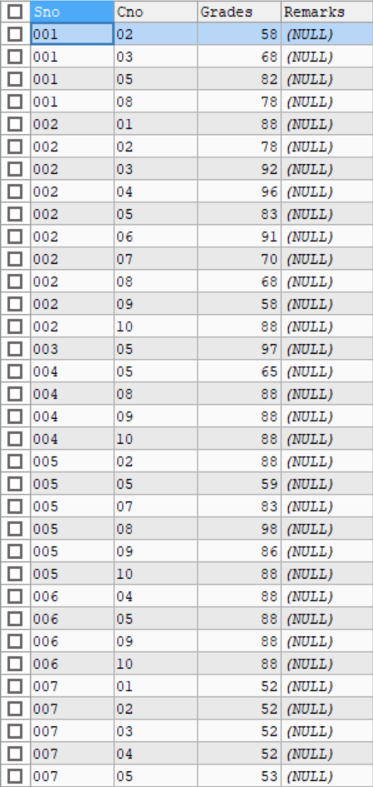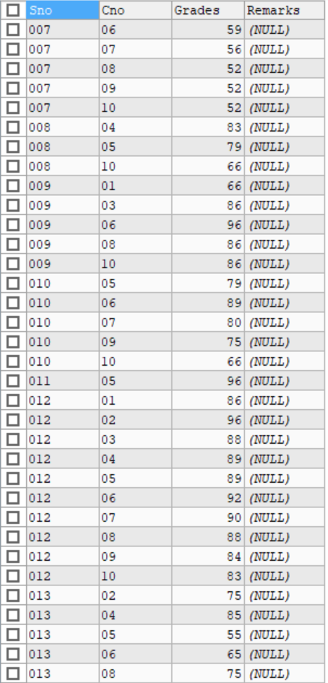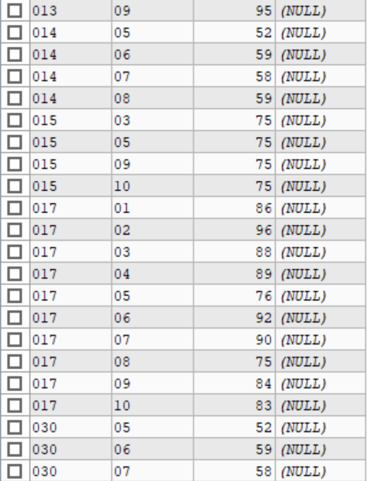
2. 求选修了“数据库原理”课程的学生姓名
-- 求选修了“数据库原理”课程的学生姓名
SELECT Student.Sname
FROM Student,Grade
WHERE Student.Sno = Grade.Sno AND Grade.Cno = '05';
效果如下：
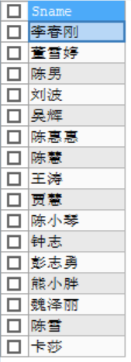
3.查询“陈雪”所选修的课程的课程号，课程名称以及成绩
-- 查询“陈雪”所选修的课程的课程号，课程名称以及成绩
SELECT Course.Cno,Course.Cname,Grade.Grades
FROM Student,Course,Grade
WHERE Student.Sno = Grade.Sno AND Grade.Cno = Course.Cno AND Student.Sname = '陈雪';
效果如下：
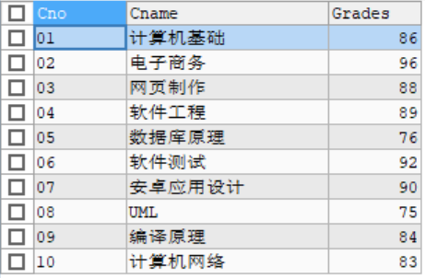
4.查询参与了所有课程选修的学生学号、姓名和学生所在的系别
-- 查询参与了所有课程选修的学生学号、姓名和学生所在的系别
select Sno,Sname,Sdept
from Student
where Sno in (
select Sno
from Grade
Group by Sno
having count(Grades) = (
select count(Cno)
from Course
)
)
效果如下：
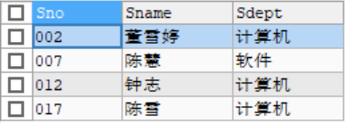
5.查询没有选修任何一个课程的学生学号、姓名和所在系别
-- 查询没有选修任何一个课程的学生学号、姓名和所在系别
SELECT Sno,Sname,Sdept
FROM Student
WHERE Sno NOT IN(
SELECT DISTINCT(Sno)
FROM Grade
)
效果如下：
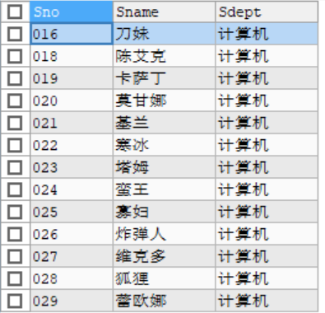
6.查询课程没有学生选修的课程号、课程名称
-- 查询课程没有学生选修的课程号、课程名称
select Cno,Cname
from Course
where Cno not in(
select distinct(Cno)
from Grade
)
效果如下：
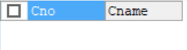
查的结果表明，不存在没有学生选修的课程。
7.查询选修了“白一阁”老师的所有课程的学生学号、姓名和所在系别
-- 查询选修了“白一阁”老师的所有课程的学生学号、姓名和所在系别
SELECT Student.Sno, Student.Sname, Student.Sdept
FROM Student
JOIN Grade ON Student.Sno = Grade.Sno
JOIN Course ON Grade.Cno = Course.Cno
WHERE Course.Cteacher = '白一阁'
GROUP BY Student.Sno, Student.Sname, Student.Sdept
HAVING COUNT(DISTINCT Course.Cno) = (
SELECT COUNT(*)
FROM Course
WHERE Course.Cteacher = '白一阁'
);
效果如下：
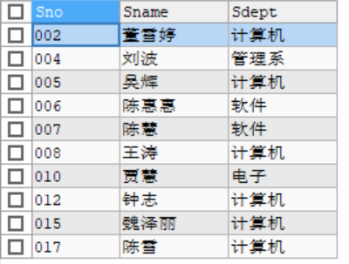
8.列出每门课程的平均分、最高分、最低分
-- 列出每门课程的平均分、最高分、最低分
SELECT Cno,AVG(grades) AS average,MAX(grades) AS highest,MIN(grades) AS lowest
FROM Grade
GROUP BY Cno
效果如下：
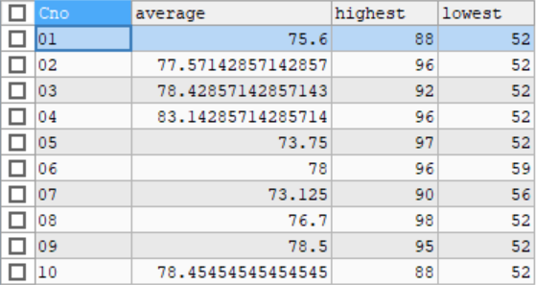
9.对所有学生求出所选修课程的最高分、平均分
-- 对所有学生求出所选修课程的最高分、平均分
SELECT Sno,MAX(grades) AS high,AVG(grades) AS average
FROM Grade
GROUP BY Sno
效果如下：
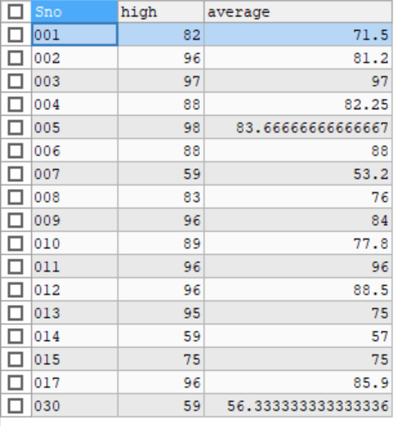

10.对“付大鹏”老师的授课的课程的分数增加1分
-- 对“付大鹏”老师的授课的课程的分数增加1分
UPDATE Grade
SET Grades = Grades + 1
WHERE Cno IN (
SELECT Cno
FROM Course
WHERE Cteacher = '付大鹏'
)
效果如下：
操作前
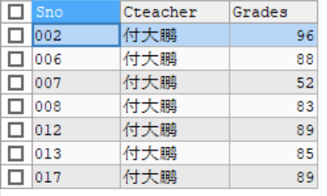
操作后：
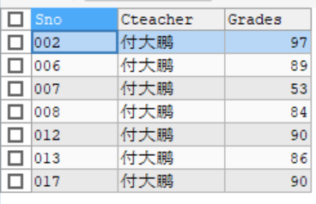
11.查询全体学生的学号、姓名、性别和年龄
-- 查询全体学生的学号、姓名、性别和年龄
SELECT Sno, Sname, Ssex, TIMESTAMPDIFF(YEAR, Sbirth, CURDATE()) as age
FROM Student;
效果如下：
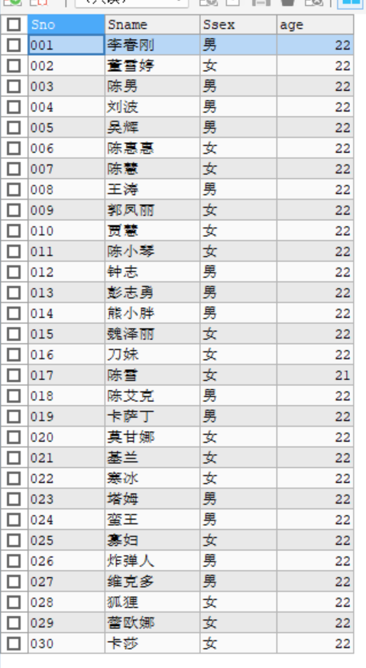
12.查询姓“陈”的且全名为两个字的学生的学号、姓名和系别
-- 查询姓“陈”的且全名为两个字的学生的学号、姓名和系别
SELECT Sno,Sname,Sdept
FROM Student
WHERE Sname LIKE '陈_'
效果如下：
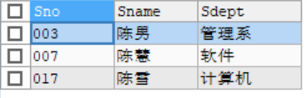
13.查询没有选修“数据库原理”课程编号的学生的学号、姓名和系别
-- 查询没有选修“数据库原理”课程编号的学生的学号、姓名和系别
SELECT Sno,Sname,Sdept
FROM Student
WHERE Sno NOT IN(
SELECT Sno
FROM Grade
WHERE Grade.Cno = '05'
)
效果如下：
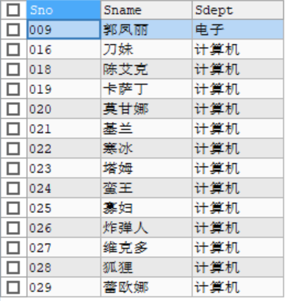
14.查询“数据库原理”课程在80分以上的学生的学号和姓名以及分数
-- 查询“数据库原理”课程在80分以上的学生的学号和姓名以及分数
SELECT Student.Sno,Student.Sname,Grade.Grades
FROM Student,Grade
WHERE Student.Sno = Grade.Sno AND Grade.Cno = '05' AND Grade.grades > 80
效果如下：
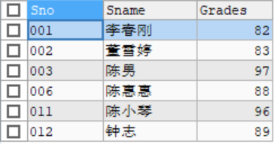
15.统计各门课程的平均分、最高分、最低分，结果集按平均分降序排列
-- 统计各门课程的平均分、最高分、最低分，结果集按平均分降序排列
SELECT Cno,AVG(Grades) AS average,MAX(Grades) AS highest,MIN(Grades) AS lowest
FROM Grade
GROUP BY Cno
ORDER BY average DESC
效果如下：
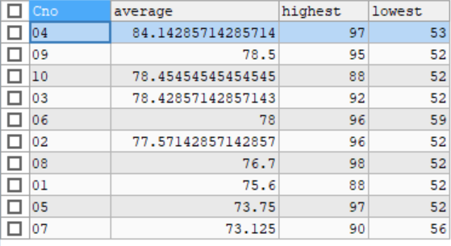
16.查询有三门以上的不及格的学生，列出学号、姓名和不及格的门数
-- 查询有三门以上的不及格的学生，列出学号、姓名和不及格的门数
SELECT Student.Sno,Student.Sname,COUNT(*) AS failcount
FROM(
SELECT Sno,Cno,Grades
FROM Grade
WHERE Grades < 60
) AS failcount
JOIN Student ON failcount.Sno = Student.Sno
GROUP BY Student.Sno
HAVING COUNT(*) > 3
效果如下：
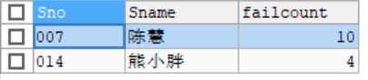
17.查询选修了“数据库原理”且成绩比此门课程的平均分要高的学生的学号、姓名和成绩
-- 查询选修了“数据库原理”且成绩比此门课程的平均分要高的学生的学号、姓名和成绩
SELECT Student.Sno,Student.Sname,Grade.Grades
FROM Student,Grade
WHERE Student.Sno = Grade.Sno AND Grade.Cno = '05' AND Grade.Grades > (
SELECT AVG(grades)
FROM Grade
WHERE Grade.Cno = '05'
)
效果如下：
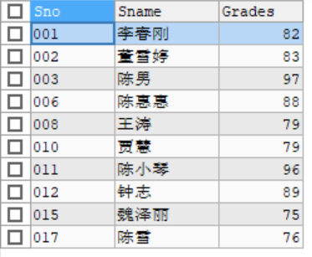
18.列出选修了“数据库原理”课程编号的成绩在前三名的学生的学号、姓名、成绩。（如果第三名有多个学生都列出）
-- 列出选修了“数据库原理”课程编号的成绩在前三名的学生的学号、姓名、成绩。（如果第三名有多个学生都列出）
SELECT Student.Sno,Student.Sname,Grade.Grades
FROM Student,Grade
WHERE Student.Sno = Grade.Sno AND Grade.Cno = '05'
ORDER BY Grade.Grades DESC
LIMIT 3
效果如下：
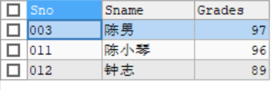
19.查询出所有课程中60分以下的同学相关信息
-- 查询出所有课程中60分以下的同学相关信息
SELECT *
FROM Student
WHERE Student.Sno IN(
SELECT Grade.Sno
FROM Grade
WHERE Grade.Grades < 60
)
效果如下：
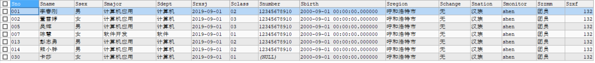
20.删除grade表中分数为空的学生信息
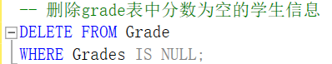
效果如下：
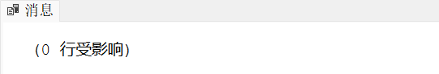
该结果表明，Grade表中没有分数为空的情况
四、实验心得
本次实验的主题是数据库的CRUD操作，即数据库的创建、查询、修改和删除。在实验一创建表之后，本实验以实验一的表为基础，进行了一系列的相关操作。在实验的过程中，回忆了课堂所学知识，巩固了SQL语句的相关内容，进一步加深了我对SQL数据更新语法格式的理解以及约束条件在更新操作执行中的作用，收获良多。

