Report

Jingqing, Tianrun

1. Learning
   1. Read Graphical Model and Factor Graph Model
   2. Fixed bugs in Wenbin’s code
2. Topic Extraction Update
   1. 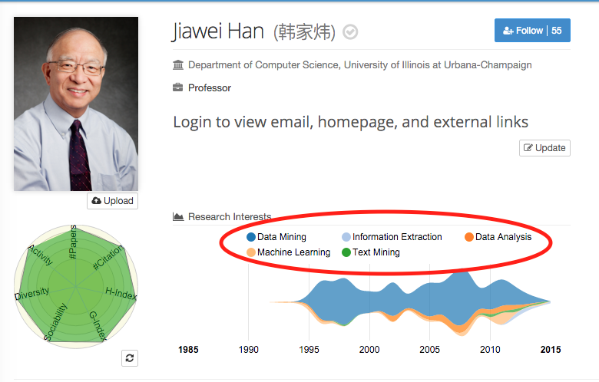Use topic extracted from people (professors)
   2. Problems: topics extracted from people cannot completely match with the topics extracted from papers (8/100 miss)
   3. Solution ?: find Zhilin’s code (use LDA or word2vec to extract topics from papers’ abstract)
3. Pattern Detection

|  |  |  |
| --- | --- | --- |
| Pattern | Sample Evolution | Sample Graph |
| 屏幕快照%202015-11-05%20下午2  both complete lifecycle | large database  🡪  frequent itemset | 屏幕快照%202015-11-09%20下午10 |
| 屏幕快照%202015-11-09%20下午10  one complete one stable | ? | ? |
| 屏幕快照%202015-11-05%20下午2  (main pattern)  one complete one growing | association rule  🡪  text mining | 屏幕快照%202015-11-09%20下午10 |
| **屏幕快照%202015-11-09%20下午10**  one stable one growing | pattern_recognition  🡪  big_data | 屏幕快照%202015-11-09%20下午10 |
| **屏幕快照%202015-11-05%20下午2**  both stable | ? | ? |
| **屏幕快照%202015-11-09%20下午10**  both growing | information retrieval  🡪  big data | 屏幕快照%202015-11-09%20下午10 |
| **屏幕快照%202015-11-10%20上午12**  **grow at the same time at first, then the former one decreases and the latter one continues to grow** | frequent itemset  🡪  text mining | 屏幕快照%202015-11-10%20上午12 |
| **屏幕快照%202015-11-05%20下午2**  one growing again because of the growing of the latter topic | pattern classification  🡪  big data | 屏幕快照%202015-11-09%20下午10 |

1. Triad Detection on Candidates

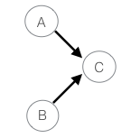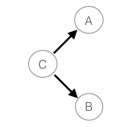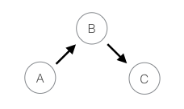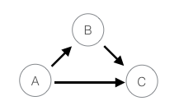

op1 op2 op3 cl6

* 1. Problems: cl6 too few, which means network cannot provide enough support to correlation/constraint on relationships
  2. Too many op1, may because there are some topics like big_data (machine_learning -> big_data) (data_mining -> big_data) (cloud_computing->big_data) ......

1. Current Results:
   1. artificial_intelligence/views.html
   2. Problems: ground truth too subjective, not persuasive, the labeling results of Tianrun and Jingqing differ a lot.