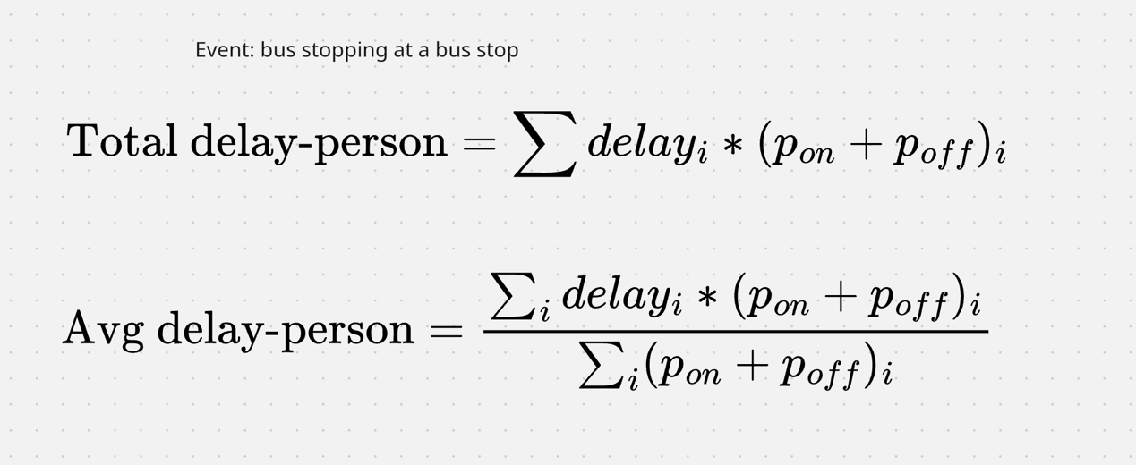

The second formula to replace the median calculation

Find the trips with highest delay