Project: Visual Dictionary backend for exam -- Smart Application –
Project Description: the project is a mobile application that allows a user to take a picture, selects a language in which the object is translated to and sees the translation. The application offers users the possibility to customize their word list, through which they can review the words and reinforce the vocabulary by flashcards.
Goal: the goal of this document is to provide a comprehensive view of the API of the project; this includes the technologies, dependencies for the backend implementation and database, together with the commands to startup the project.

Database
For database, we decided to use Firebase’s NoSQL database, Firestore, with the support of Firebase’ User Authentication service.

Structure
Three top level collections {USERS, WORDS, SHAREDLISTS}.
Under USERS, there are two sub-collections {LISTS, IMAGES}
Under LISTS, there is one sub-collection {ITEMS}
The primary key is underlined

USERS top level collection
Store the information on user
- uid: string - managed by firebase
- displayName: string
- email: string
- preferredLang: string - examples: “it,” “en,” “es”
- avatarId: num – must be between 1 and 8
- createdAt: timestamp
- lastSeen: timestamp
note: to create a user and allow Firebase to manage the user authentication, the fields [email, password, displayName] are used to create the unique uid by using Firebase’s creation flow. While other fields are inserted into the database by custom flow

IMAGES sub-collection to USERS
Store the information on the pictures that user captures and wishes to translate.
- imageId: string – format <img_{objectName}_{targetLang}_{uid}>
- uid: string
- objectName: string
- targetLang: string – examples: “it”, “en”, “es”
- accuracy: num – the accuracy of the model on recognizing the object
- imageMimeType: mime or null
- imageSizeBytes: num
- imageBase64: base64 – image encoding base 64
- status: “pending_translation” or “translated”
- createdAt: timestamp
- wordRed: string – reference to the word
- translatedWord: string
- updated: timestamp
note: the imageSize should be less than 700kb

LISTS sub-collection to USERS
Store the information on a user’s word lists
- listId: string – format <{listName}_{uid}>
  - format variations:
    - <lang_list_{targetLang}_{uid}>
    - <default_favourite_{uid}>
    - <import_{listId}>
- listName: string
- isDefault: Boolean
- visibility: “private” by default or “public”
- imported: Boolean – false by default
- createdAt: timestamp
- updatedAt: timestamp
- wordCount: num – number of items in the given list
- imageMimeType: mime or null
- imageSizeBytes: num
- imageBase64: base64
note: the list has a cover image and therefore stores the information on the image

ITEMS sub-collection to LISTS
Store all the words added to a given list
- wordId: string – reference to the word
- originalWord: string
- translatedWord: string
- translatedLang: string - examples: “it”, “en”, “es”
- imageId: string – reference to image
- addedAt: timestamp

WORDS top level collection
Stores all the words passed by users
- wordId: string – format <id_{originalWord}>
- originalWord: string
- translations: array of couples [targetLang: translatedWord]
  - targetLang: string - examples: “it”, “en”, “es”
  - translatedWord: string
note: originalWord is passed by the object recognition model which always return the object’s name in English language

SHAREDLISTS top level collection
Stores the information on the shared lists by the users for a fast retrieval
- sharedId: string – format <share_{token}_{listId}>
- sharedCode: base64 – 6 alphanumeric letters that encodes the uid and listId
- shareURL: URL – format <{baseURL}/shared/list>
- ownerId: string – list owner’s uid
- listId: string – reference to the list
- createdAt: timestamp

BACKEND
Language: Javascript
Technologies:
- Node.js with Express framework
- Firebase admin
- Translation API: github @iamtraction/google-translate
- Render for deployment after submitting the code in github repo
Dependencies:
- @iamtraction/google-translate
- axois
- bcrypt
- cors
- dontev
- express
- firebase-admin
- firebase
- multer
To initiate a new node project by creating the package.json, run [npm init -y]
Then install the express framework by running [npm install express]
Optionally install nodemon for auto-restart the server during the development, run command [npm install nodemon –save-dev]
To install all other dependencies, use the command [npm install <package name>]
Note: for windows users, use command prompt terminal instead of powershell to allow the use of npm

GITHUB & deployment
The project can be found in a public github repo: https://github.com/Jingrui-Zhu/smart_app
Render automatically fetches the latest version of the project and deploys it.
To push the code into the main branch of the repository, open a git bash and then run the code in sequence:
[git add .] to add all the updates into the repository
[git commit -m “<update message>”] to commit the change
[git push] to push and merge the code in the repo
To deploy the project in local environment, run the command [npm start]. The server will run on localhost:8080
To deploy the project in development mode, run the command [npm run dev]
For render deployment connect to https://smart-app-u3of.onrender.com

FILE STRUCTURE
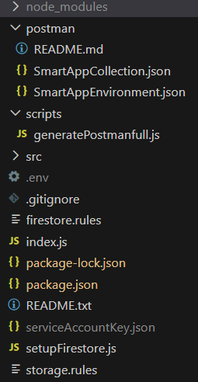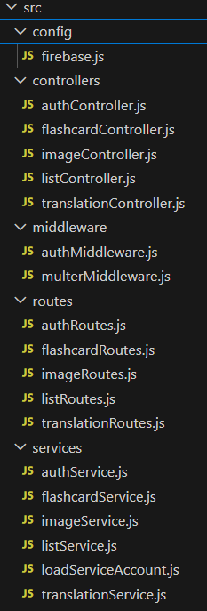
Note: files name start with flashcard are not used

FIREBASE
In order to use Firebase services, first create a Firebase project in Firebase’s web service. In setting, Service Account section, click on generate new private key, to generate a json file containing all the information needed to access Firebase. Rename the file to serviceAccountKey.json for simplicity and never explicitly share the file.
firebase.json file is used to load the serviceAccountKey.json to get access to Firebase services. In this project, only authentication and database are used.
setupfirebase.json file is used to populate the database, to set an initial structure. It is called once using command [npm run seed].
firestore.rules and storage.rules files are created when setting up the corresponding services in the Firebase (custom security rules possible).

POSTMAN
generatePostmanFull.js file implements a script that generates the necessary postman endpoints and environmental variables.
To run the script, run command [npm run setup-postman] that creates 2 json files, smartAppCollection.json contains the endpoint and smartAppEnvironment.json contains the environment variables.

ARCHITECTURE – Components & endpoints
The Model-View-Control software architecture is used for this project.
The main components are {AUTH, IMAGE, LIST, TRANSLATION} each with their services.js, controllers.js and routes.js file
Additionally, loadServiceAccount.js implements the logic to load the ServiceAccountKey.js
The authMiddleware.js file implements the control of the user authentication logic it checks the presence of the Bearer idToken that will be used by most of the services.
The multerMiddleware.js file provides support for image uploading.

AUTH
The component contains all the services pertaining to user. It handles [signup, login, resetPassword, getUserProfile, updateUserProfile, logout]

Signup – POST /auth/signup
----------Creates a new user by providing all the necessary information
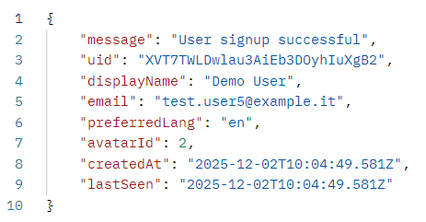
Requires in the request body the fields:
- email
- password
- name
- preferredLang
- avatarId between 1 and 8
If user creation is successful, the service will also automatically create a default favorite list with list id of format <default_favourite_{uid}>.
Upon successful call, the function returns a success message and the created user information.

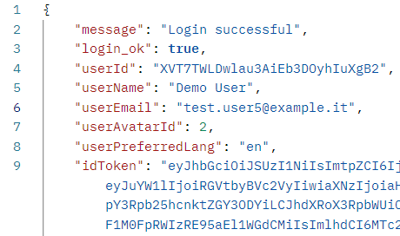
Login – POST /auth/login
----------Login to the Firebase client service
Requires in the request body the fields:
- email
- password
By using axios, the function asynchronously logs in to the Firebase service.
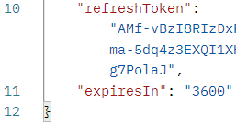
Upon successful completion, the function returns the user data [email, displayName, avatarId, preferredLang, idToken, refreshToken, expiresIn]
refreshToken allows the Firebase SDK to automatically fetch a new idToken without developer intervention.

resetPassword – POST /auth/change-password
----------Allows user to change the password *User idToken required
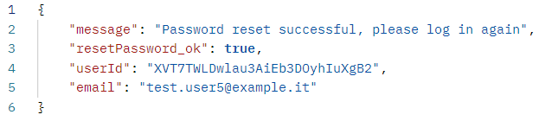
Requires in the request body the fields:
- oldPassword
- newPassword
When called, the backend tries to re-authenticate the user with the oldPassword; if successful, update the user password by calling the auth module provided by firebase for security reasons.
Upon successful completion, the system attempts to revoke the existing session and asks users to authenticate themselves again with newPassword. The function returns a success message together with uid and email.
The password is still updated even if the session revoking fails.

getUserProfile – GET /auth/profile
----------Retrieves all the stored user information *User idToken required
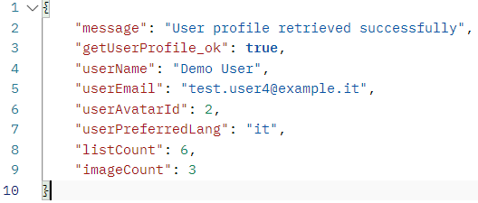
Upon successful completion, the function returns all the stored user information together with [listCount, imageCount] that counts the number of associated lists and images to that user

UpdateUserProfile – PUT /auth/profile
----------Modify user information *User idToken required
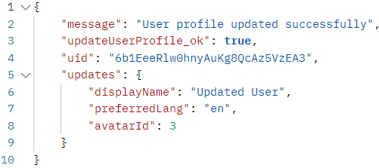
May contains in the request body the fields:
- displayName
- preferredLang
- avatarId between 1 and 8
upon successful completion, the function returns a success message, the uid and the updated fields with updated values

logout – POST /auth/logout
----------logout *User idToken required
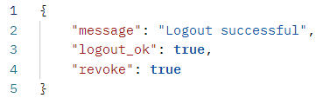
The function attempts to safely log out an authenticated user
Upon success, the function returns a success message

TRANSLATION
The components handles translation service

translate – POST /translate
----------translate the given word in the target language *User idToken required
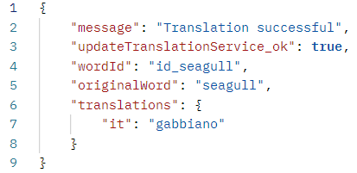
Requires in the request body the fields:
- originalText
- targetLang
the service works as follows:
- Given the originalText and targetLang, check if the translation already exists
  - If so, return a message stating the translation exists and the stored information on originalText
- Otherwise, perform the translation by calling an external translation API
  - This returns the translation of originalText in targetLang
- save the translation by calling updateTranslationService, that takes input the (originalText, translatedWord, targetLang)
  - This function is always called, whether it is to add a new translation in the corresponding document or create a new one
Upon successful completion, the function returns a success message and the stored information on the originalText

IMAGES
The component pertains all the services to image (user capture) handling, including functions [createImage, getImage, deleteImage, (optional) updateImage]

createImage – POST /images
----------Store the user uploaded image in the database *User idToken required
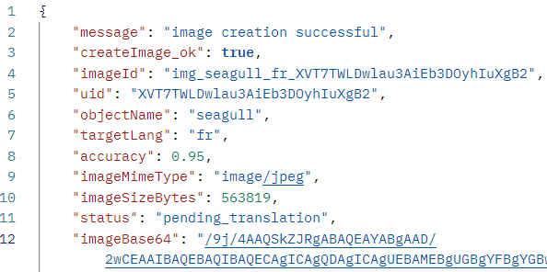
Requires in request body the fields:
- Image
- objectName
- targetLang
optionally, may contain in body fields:
- accuracy
The allowed uploaded image is one per request, and its size needs to be less than 700kb
The service has 2 “success” outcomes:
- First, check if the uploaded image in the targetLang already exists
  - If so, return the stored information on the image and return a createImage fail message
- Otherwise, create a new document containing the information on the image
  - return a createImage success message together with information on the image

getImage – GET /images/:imageId
----------Fetches an image given its imageId *User idToken required
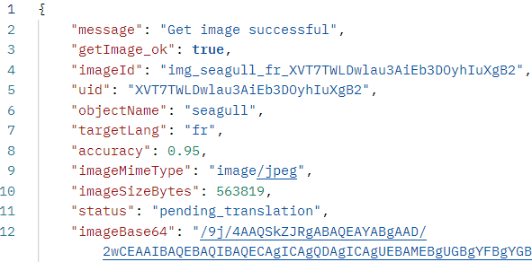
Requires in the parameters the field:
- imageId
Upon successful completion, the function returns a success message with the stored information on the given image

deleteImage – DELETE /images/:imageId
----------Detele an image given its imageId *User idToken required
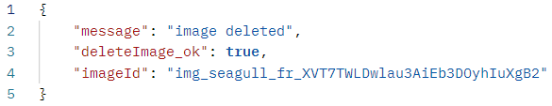
Requires in the parameters the field:
- imageId
Upon successful completion, the function returns a success message with the deleted imageId

(optional) updateImage – PUT /images/:imageId
----------Update an image by retrieving translation-related fields *User idToken required
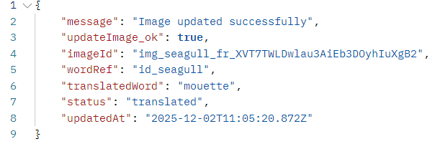
Requires in the parameters the field:
- imageId
Upon successful completion, the function returns a success message with the updated image information

LISTS
The component contains all the services regarding the user’s lists, and the services on lists item handling, including components [createUserList, getUserList, addItemToMultipleUserLists, getAllItemsInUserListm, updateUserList, createSharedUserList, getSharedUserList, getSharedUserListPublic, importSharedUserList, removeItemFromUserList, deleteUserList]

createUserList – POST /lists
----------create a custom user list *User idToken required
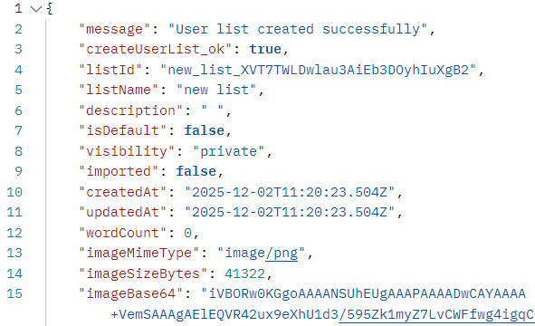
Requires in the request body the fields:
- listName
and optionally, may contain the cover image under the filed:
- image
If the user wishes to upload a cover image for the list, upload one only image, and its size is less than 700kb
Upon successful completion, the function returns a success message with the created list information
Reminder: at user creation, a default favorite list is automatically created for the user. It has the list Id of format <default_favourite_{uid}>

getUserList – GET /lists
----------Fetches all lists belong to a user *User idToken required
Upon successful completion, the function returns a success message and an array of the lists with their information
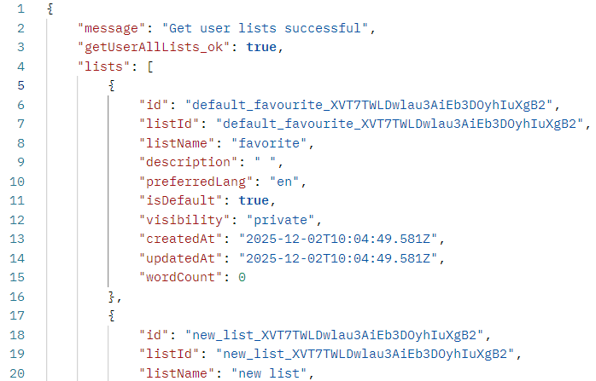

addItemToMultipleUserLists – POST /lists/items
----------Add an item in multiple user lists *User idToken required
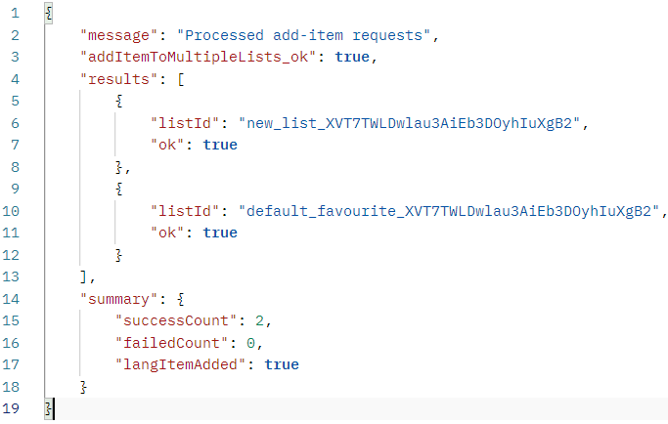
Requires in the request body the fields:
- listIds
- wordId
- imageId
Important: the listIds is a list of strings separated by comma, it also accepts a single string of listId – the maximum number of lists is 5.
The service flow follows:
- First, given the image’s targetLang, check if the language list exists
  - If not, create the targetLang language list automatically without user nor frontend developer’s intervention
  - The created language list has Id of format <lang_list_{targetLang}_{uid}>
- Add the item to the corresponding language list once
- Side over the array of lists, try to add the word to each given list
  - Store in the result of each attempt (fail or success)
  - A failed adding will not stop the service from attempting to add in other lists
- Upon successful completion, the function returns a success message with the results of each adding (fail or success)

getAllItemsInUserListm – GET /lists/:listId/items
----------Fetches all items in a given listId *User idToken required
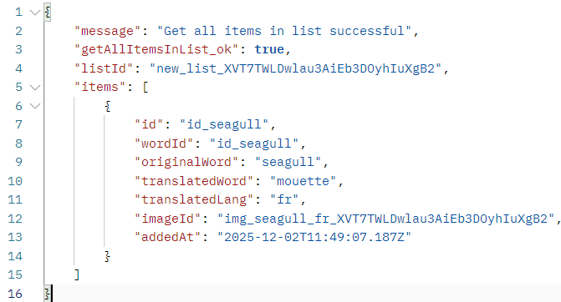
Requires in the request parameter the field:
- listId
Upon successful call, the function returns a success message with an array of items with their stored information

updateUserList – PUT /lists/:listId
----------Update a list fields for a given listId *User idToken required
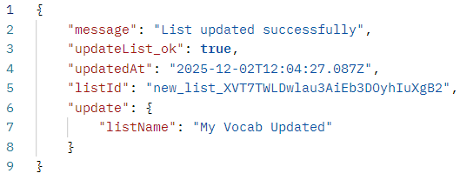
Requires in the request parameter the field:
- listId
may contain in the request body the fields:
- listName
- image
- removeImage
User has the possibility to update the list name and the cover image
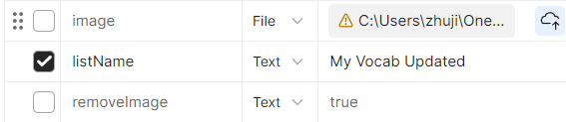
Important: removeImage flag must be explicitly included in the request body and set its value to true if user wants to eliminate the cover image, as default, the flag is set to false in the function parameter.
In the example request, only listName is explicitly included in the body
Upon successful completion, the function returns a success message together with the updated fields values

createSharedUserList – POST /lists/share
----------Create a list sharing service *User idToken required
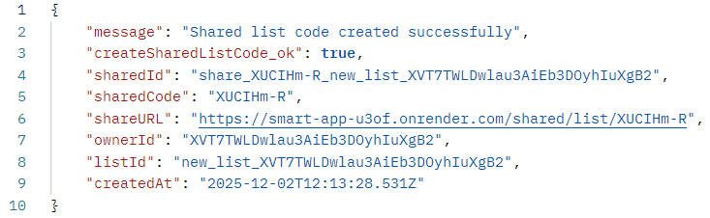
Requires in the request body the fields:
- listId
The service generates a token that is used for list sharing, containing the information on the list and on the list owner. It then creates a document in the top-level collection, SHAREDLIST, that stores references to the related fields to achieve a fast retrieval.
The shareURL can be used to access directly the sharedList
Upon successful completion, the function returns a success message with the information on the newly created shredList document

getSharedUserList – GET /lists/share/:sharedCode
----------Retrieves the shared code by the token *User idToken required
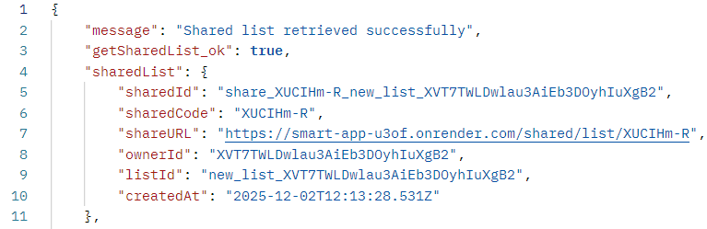
Require in the request parameter the field:
- sharedCode
Upon successful call, the function returns a success message and the information on the shared List, the referenced list and items belonging to the list
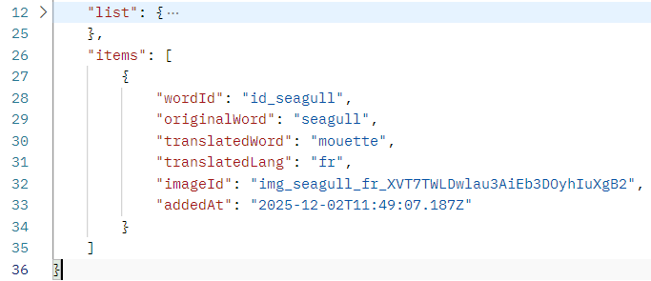
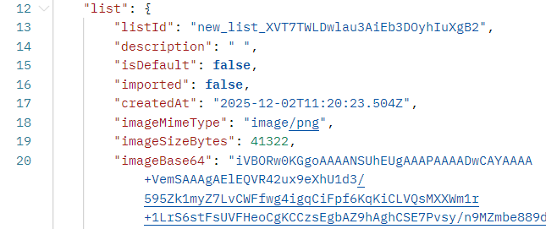

getSharedUserListPublic – GET /share/list/:sharedCode
----------Retrieves the shared code by the token, NO idToken required
Require in the request parameter the field:
- sharedCode
The service is identical to getSharedUserList service, except this one does not require the user idToken
Note: the shareURL stored in the SHAREDLIST document redirects to this endpoint, be careful of different endpoints
Upon successful call, the function returns a success message and the information on the shared List, the referenced list and items belonging to the list

importSharedUserList – POST /lists/import
----------Import a shared list as the user’s own list *User idToken required
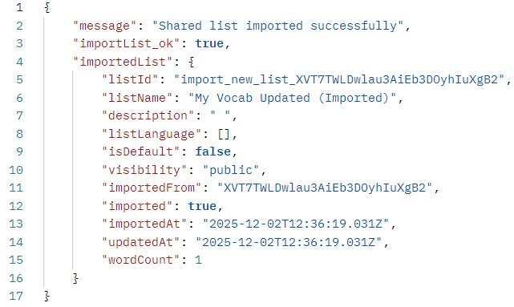
Requires in the request body the fields:
- sharedCode
The imported list has the Id of format <import_{listId}>
Upon successful call, the function returns a success message with the imported list information and its items

removeItemFromUserList – DELETE /lists/:listId/items/:wordId
----------Deletes an item from the given list *User idToken required
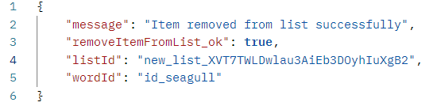
Requires in the request parameter the fields:
- listId
- wordId
The function first checks if the required parameters exist in the database. If deleted successfully, the function decrements by 1 the wordCount field in the corresponding document
Upon successful completion, the function returns a success message with the review of the parameters

deleteUserList – DELETE /lists/:listId
----------Deletes a given user list *User idToken required
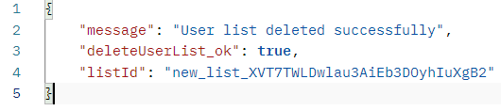
Requires in the request parameter the field:
- listId
Upon successful call, the function returns a success message with the review of the parameter

