编程小作业1

要求：

1. 小作业1上交的截止时间：2020年7月17日20:00。
2. 在学习通上提交一个word文件，文件名为

hw1-20200717-xxxx（队伍编号）-xxx-xxx-xxx(三名队员)

1. 同时将该word文件发送至邮箱sx_jmpxzy@163.com，且邮件主题为

hw1-20200717-xxxx（队伍编号）-xxx-xxx-xxx(三名队员)

1. 该word文件需包括：程序、数据、结果、对问题的明确回答。
2. 中文作答即可。

第一题：拟合

*In 1976, Marc and Helen Bornstein studied the pace of life.* *To see if life becomes more hectic as the size of the city becomes larger, they systematically observed the mean time required for pedestrians to walk 50 feet on the main streets of their cities and towns. In Table 4.5, we present some of the data they collected. The variable* P *represents the population of the town or city, and the variable* V *represents the mean velocity of pedestrians walking the 50 feet. Problems 1–5 are based on the data in Table 4.5.*

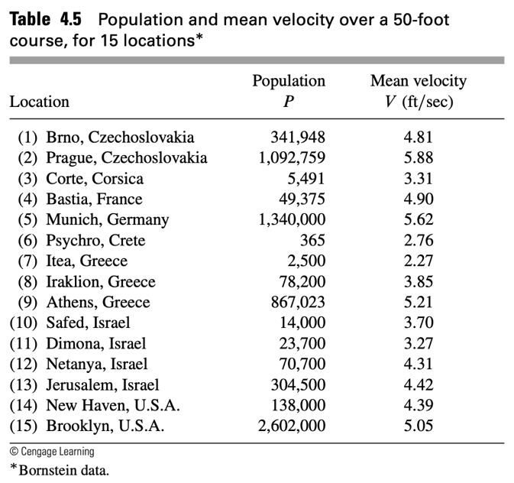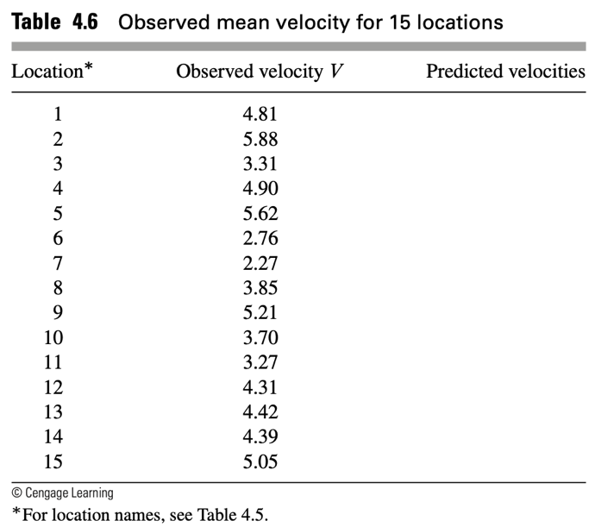

1. Fit the model $V=CP^{a}$ to the “pace of life” data in Table 4.5. Use the transformation $logV=alog P +log C$. Plot $log V$ versus $log P$. Does the relationship seem reasonable?
2. Make a table of $log P$ versus $log V$.
3. Construct a scatter plot of your log–log data.
4. Eyeball a line l onto your scatterplot.
5. Estimate the slope and the intercept.
6. Find the linear equation that relates $log V$ and $log P$.
7. Find the equation of the form $V=CP^{a}$ that expresses V in terms of P .
8. Graph the equation you found in Problem 1f superimposed on the original scatterplot.
9. Using the model you determined for V (Problem1f), complete Table 4.6.
10. From the data in Table4.6, calculate the mean (i.e., the average) of the Bornstein errors ${|V}_{predict}-V_{observed}|$ What do the results suggest about the merit of the model?

第二题：多项式插值

Consider fitting a 14th- order polynomial to the data in Table4.5. Discuss the disadvantages of using the polynomial to make predictions. Determine and graph the polynomial.

第三题：三次样条插值

Find the natural cubic splines that pass through the given data points.



1. Estimate the derivative evaluated at $x=3.45$. Compare your estimate with the derivative of $e^{x}$ evaluated at $x=3.45$.
2. Estimate the area under the curve from 3.3 to 3.6. Compare with $\int_{3.3}^{3.6}{e^{x}}dx$

参考书籍

1. A First Course in Mathematical Modeling by Frank R. Giordano, William P. Fox, Steven B. Horton
2. Numerical Analysis 10th Edition by Richard L. Burden, J. Douglas Faires, Annette M. Burden