Admin System Management Module

(1) Admin Dashboard
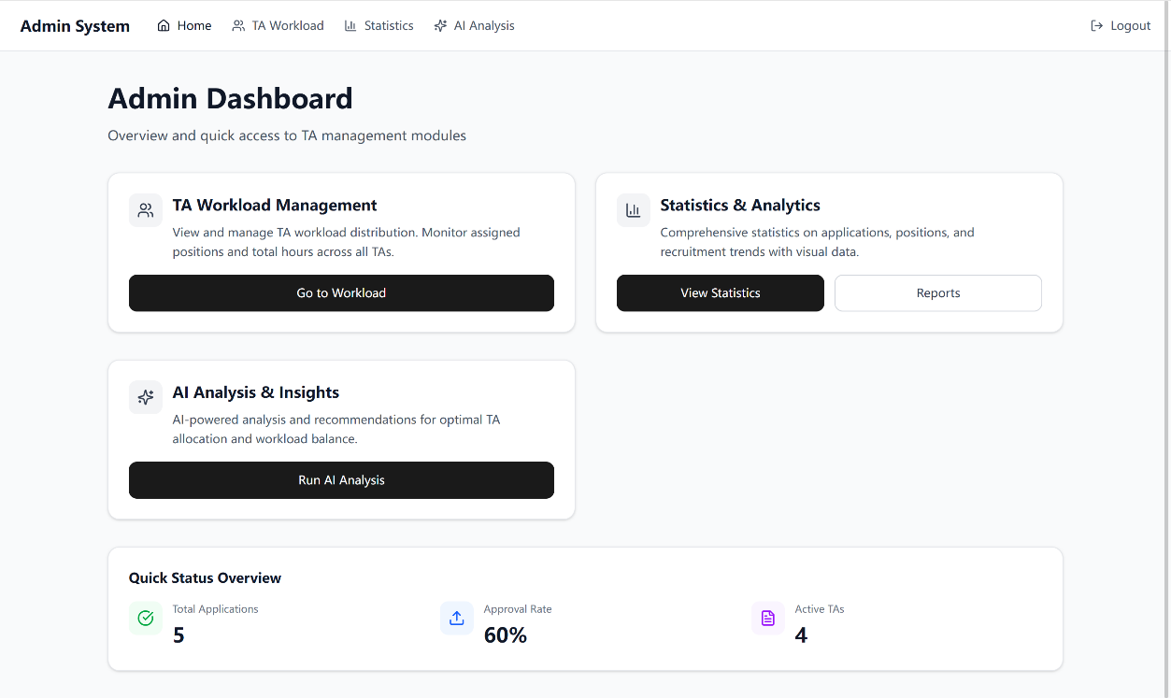
After logging into the system, the administrator is directly directed to the Admin Dashboard, the homepage of this module. The system automatically performs three key tasks:
It fetches all basic data from the database in one go, including job postings, TA application records, and TA personal profiles.
It pre-calculates core statistical results, such as the total number of TAs, total job openings, recruitment completion rate, and the approximate workload of each TA.
It presents these data through concise cards and charts on the dashboard, allowing the administrator to grasp the overall system status at a glance and navigate directly to more detailed views.

(2) Checking TA Workload
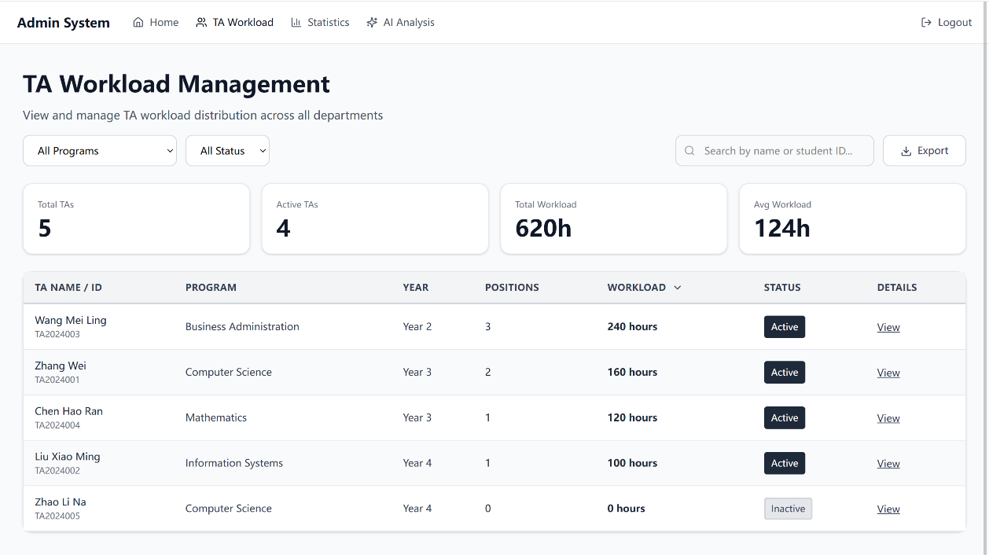

When the administrator needs to understand the exact workload assigned to each TA, they can click to enter the TA Workload Page from the dashboard.

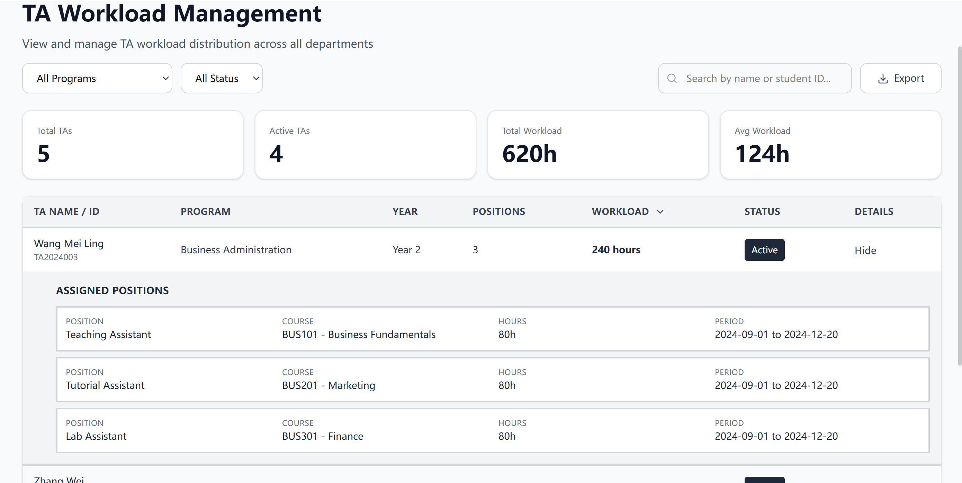
The system reorganizes the data based on TA names, affiliated departments, and time periods. It compiles a clear breakdown of each TA’s assigned job count, processed applications, and task completion status, then displays this information in structured lists and visual charts. The administrator can use filtering tools to quickly locate specific TAs, clearly identifying who is overloaded or underutilized, and use this insight to adjust job allocations accordingly.

(3) Reviewing Job Allocation and Overall Data
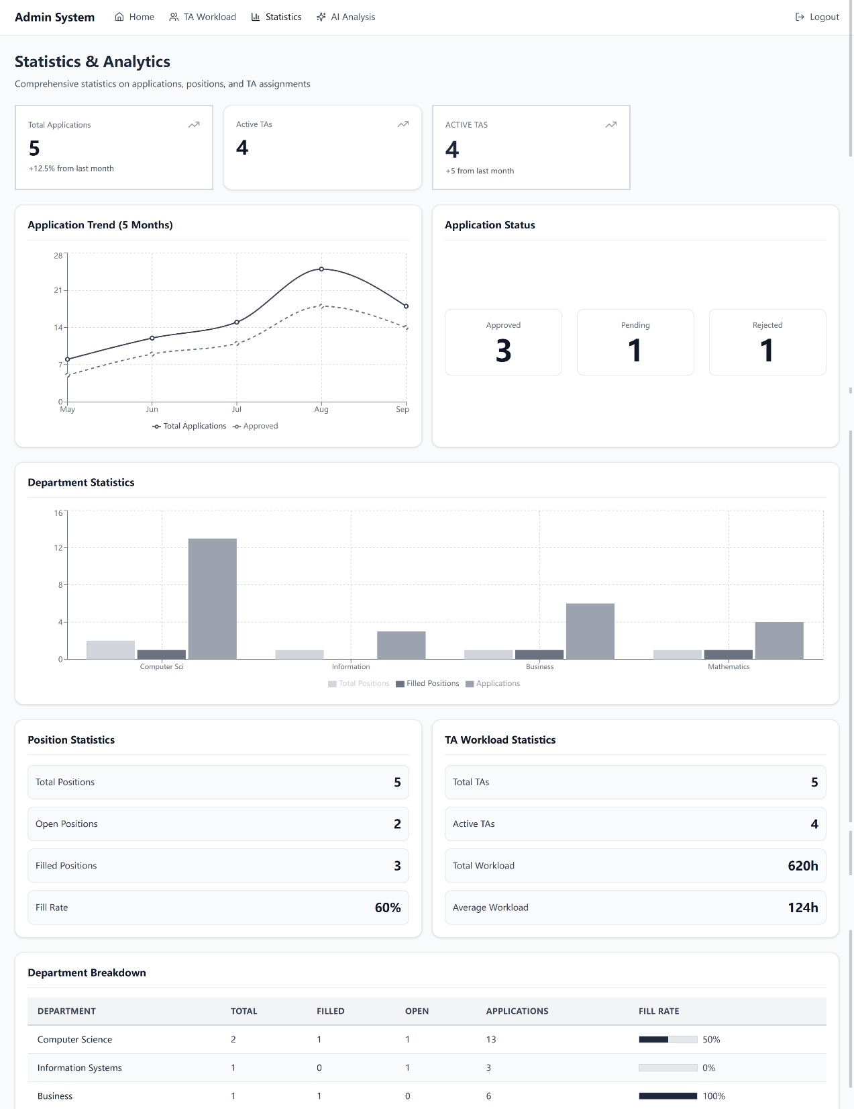

If the administrator wants to focus on job allocation and the overall recruitment progress, they can navigate to the Statistics Page from the dashboard.
The system presents data in two distinct dimensions:
Job Allocation Statistics: It calculates the required headcount for each position, the number of TAs already assigned, recruitment gaps, and the distribution of jobs across departments, clearly illustrating whether job allocation is balanced.
Overall Recruitment Data: It tracks the full recruitment lifecycle from job posting to resume receipt, interviews, offer issuance, and onboarding. It also calculates conversion rates at each stage, helping the administrator identify bottlenecks, inefficiencies, and areas that require additional resources.

(4) Reviewing Job AI Expansion Process 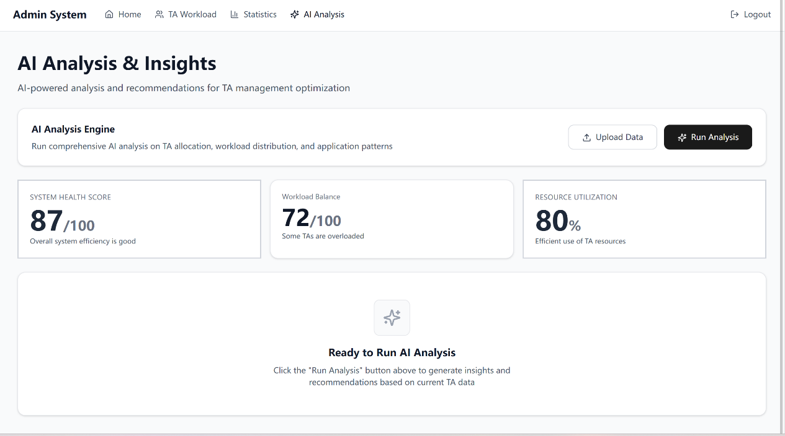
This module has pre-built entry points for AI analysis, which will simplify operations once the corresponding features are launched:
The administrator clicks the corresponding function button on the AI Analysis Entry Page. The system automatically attaches the current filtering criteria (such as time range, department, or TA name) to call the AI interface. Once the AI analysis is completed, the results are displayed directly on the page, including TA skill matching scores, suitable job recommendations, and workload optimization suggestions. The administrator can directly apply these insights to adjust job allocations or TA work arrangements, making management more efficient.

