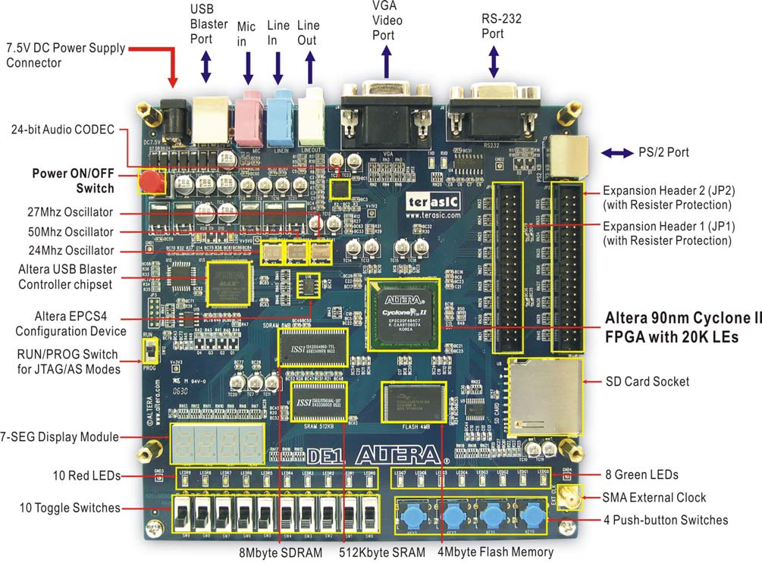

On peut voir sur la DE1 qu'elle possède « Altera Serial Configuration device – EPCS4 » et qu'un bouton permet de switcher entre les modes JTAG et Active Serial

Active Serial : You can perform an active serial (AS) configuration using EPCS or EPCQ devices. During AS configuration, the FPGA device is the master and the EPCS or EPCQ device is the slave. Configuration data is transferred one bit per clock cycle.

USB Blaster (on board) for programming and user API control; both JTAG and Active Serial (AS) programming modes are supported

You can select a Cyclone FPGA configuration scheme by driving its MSEL1 and MSEL0

Selecting Cyclone Configuration Schemes
MSEL1 MSEL0 Configuration Scheme
0 0 AS
0 1 PS
0 1 JTAG-based (1)

After configuration, Cyclone FPGAs will initialize registers and I/O pins, then enter user mode and function as per the user design

You can configure Cyclone FPGAs using the 3.3-, 2.5-, 1.8-, or 1.5-V LVTTL I/O standard on configuration and JTAG input pins. These devices do not feature a VCCSEL pin; therefore, you should connect the VCCIO pins of the I/O banks containing configuration or JTAG pins according to the I/O standard specifications.

Serial configuration devices have a four-pin interface: serial clock input
(DCLK), serial data output (DATA), AS data input (ASDI), and an
active-low chip select (nCS).

During system power up, both the Cyclone FPGA and serial
configuration device enter a power-on reset (POR) period. As soon as the
Cyclone FPGA enters POR, it drives nSTATUS low to indicate it is busy
and drives CONF_DONE low to indicate that it has not been configured.
After POR, which typically lasts 100 ms, the Cyclone FPGA releases
nSTATUS and enters configuration mode when this signal is pulled high
by the external 10-kΩ resistor. Once the FPGA successfully exits POR, all
user I/O pins are tri-stated. Cyclone devices have weak pull-up resistors
on the user I/O pins which are on before and during configuration.

In an AS configuration, the FPGA acts as the configuration master in the configuration flow and provides the clock to the EPCS device. The FPGA enables the EPCS device by pulling the nCS signal low using the nCSO signal as shown in Figure 2 and Figure 3. Then, the FPGA sends the instructions and addresses to the EPCS device using the ASDO signal. The EPCS device responds to the instructions by sending the configuration data to the FPGA’s DATA0 pin on the falling edge of DCLK. The data is latched into the FPGA on the next DCLK signal’s falling edge.

USB Blaster

The USB-Blaster™ download cable interfaces a USB port on a host computer to an Altera® FPGA mounted on a printed circuit board. The cable sends configuration data from the host computer to a standard 10-pin header connected to the FPGA. You can use the USB-Blaster download cable to iteratively download configuration data to a system during prototyping or to program data into the system during production.

AS PROGRAMMING

AS programming: In this method, called Active Serial programming, the configuration bit
stream is downloaded into the Altera EPCS4 serial EEPROM chip. It provides non-volatile
storage of the bit stream, so that the information is retained even when the power supply to
the DE1 board is turned off. When the board's power is turned on, the configuration data in
the EPCS4 device is automatically loaded into the Cyclone II FPGA.

ON QUARTUS

On the File menu, click Convert Programming Files.
- Under Output programming file, select the format of the programming file you want to create.
If you select Programmer Object File (.pof) and EPC4, EPC8, EPC16, or CFI devices from the Configuration device list and you want to set up a POF for the configuration device, perform one of the following steps:
- SOF Data—Add a SOF Data item to the Input files to convert list, by clicking Add Sof Data.

