Orchestration Platform
System Design & Architecture Document

Version 1.0 · 2026-03

Table of Contents
1. System Overview
2. Technology Stack
3. Project Structure
4. Backend Architecture
4.1. API Routers
4.2. Services (Business Logic)
4.3. Data Models
4.4. Provenance & Audit
4.5. Middleware
5. Frontend Architecture
5.1. Application Entry Point
5.2. Admin Dashboard
5.3. Live Tab (HITL Workflow)
5.4. Client Chat Panel
5.5. Provenance Tab
5.6. Policy Knowledge Library
5.7. Log Tab
5.8. Registry Tab
6. Core Data Flows
6.1. Auto Mode Flow
6.2. Manual (HITL) Mode Flow
6.3. Real-Time Event Stream
7. Policy Engine
8. MCP Tool Integration
9. Deployment
1. System Overview
The Orchestration Platform is a Human-In-The-Loop (HITL) AI orchestration system that mediates communication between end-users and large language models (LLMs). Every message passes through a structured governance pipeline — including input/output policy evaluation, optional manual admin review, and full provenance tracking — before a response is returned to the user.

The platform supports two operating modes:
- Auto Mode — Messages are evaluated by the policy engine and, if compliant, forwarded to Claude automatically without human intervention.
- Manual (HITL) Mode — Messages are queued for admin review before and after AI processing, giving human operators full control over every interaction.

Core capabilities:
- Policy-driven governance of both incoming (input) and outgoing (output) messages
- Human-In-The-Loop review with optional message override and regeneration
- MCP (Model Context Protocol) tool integration for extending Claude with external capabilities
- Real-time audit trail stored in MongoDB with cryptographic event chaining
- Live SSE event stream for real-time admin dashboard updates
- External component registry for routing messages to non-Claude AI backends

2. Technology Stack

2.1 Backend
Component | Technology | Version | Role
Web Framework | FastAPI | 0.128+ | REST API & SSE streaming
LLM Client | Anthropic SDK | 0.75+ | Claude API integration
Database Driver | Motor (async) | 3.7+ | Async MongoDB access
Tool Protocol | MCP SDK | 1.25+ | Model Context Protocol
Validation | Pydantic | 2.12+ | Data models & validation
Server | Uvicorn | ASGI | Async HTTP server

2.2 Frontend
Component | Technology | Version | Role
UI Framework | React | 19.2 | Component-based UI
Language | TypeScript | 5.x | Type safety
Build Tool | Vite | 7.2+ | Fast dev & production build
Styling | Tailwind CSS | 3.x | Utility-first CSS
Component Lib | Radix UI | latest | Accessible headless components
Icons | Lucide React | latest | Icon set

2.3 Infrastructure
Component | Technology | Notes
Database | MongoDB 7 | Provenance event storage
Container | Docker Compose | MongoDB + API + Web (Nginx) services
Web Server | Nginx | Serves compiled React frontend
Process Mgr | Uvicorn / ASGI | FastAPI async runtime

3. Project Structure
The repository is organised into two top-level directories:

orchestration/
├── apps/
│ └── web-admin/ # React + TypeScript admin frontend
│ ├── src/
│ │ ├── components/ # UI components
│ │ ├── lib/ # Utilities & status codes
│ │ └── App.tsx # Root application
│ └── package.json
├── services/
│ └── api/ # FastAPI backend
│ ├── routers/ # API endpoint handlers
│ ├── services/ # Business logic layer
│ ├── models/ # Pydantic data models
│ ├── db/ # Database layer
│ ├── provenance/ # Audit event functions
│ ├── middleware/ # HTTP logging middleware
│ ├── utils/ # Shared helpers
│ ├── main.py # Application entry point
│ └── config.py # Environment configuration
├── docker-compose.yml # Container orchestration
└── .env.example # Environment variable template

4. Backend Architecture
The backend is a FastAPI application structured in layers: routers handle HTTP endpoints, services contain business logic, and models define data contracts. All major services (message queue, event bus, policy engine, MCP manager) are singletons shared across requests.

4.1 API Routers
Each router handles a specific domain. All routers are registered in main.py via app.include_router().

Router File | URL Prefix | Responsibility
client.py | /api/client | Receives messages from the client chat; handles auto and manual mode submission
admin.py | /api/admin | Admin decisions: allow/deny input, secondary review, regenerate AI responses
stream.py | /api/stream | Server-Sent Events (SSE) endpoint — pushes real-time events to the frontend
policy.py | /api/policies | CRUD for policies and rules in the Policy Knowledge Library
registry.py | /api/registry | Component registry for viewing registered external AI components
external_registry.py | /api/external | Routing messages to registered external components (non-Claude backends)
provenance.py | /api/provenance | Querying and storing provenance / audit events in MongoDB
mcp.py | /api/modules | MCP server management: list, register, and inspect available tools
logs.py | /api/logs | Retrieve HTTP logs for debugging
comm_logs.py | /api/comm-logs | Communication logs (OpenClaw / external system interactions)
config.py | /api/config | Read and update runtime configuration
health.py | /api/health | Health check — used by Docker / load balancers

4.2 Services (Business Logic)
Services are singleton instances that encapsulate core logic, decoupled from HTTP routing.

chat_service.py
Executes calls to the Claude API. Implements the MCP tool-use loop: if Claude requests a tool, it calls the appropriate MCP server, returns the result, and continues the conversation up to MAX_TOOL_ROUNDS (5) iterations. Accepts an optional admin_prompt to inject system-level context.

policy_engine.py
Singleton service responsible for evaluating content against configured policies. Supports three evaluation types: input (user messages), output (AI responses), and system. Returns a PolicyEvaluationResult with a decision (ALLOW / WARN / BLOCK) and a list of violations.

message_queue.py
In-memory store for the HITL workflow lifecycle. Stores messages, responses, policy evaluations, and chat responses indexed by message_id. Provides get/update/store methods used by both the client and admin routers.

event_bus.py
Pub/sub system that powers the SSE stream. When any component calls event_bus.publish(event), the event is broadcast to all connected frontend clients via the /api/stream endpoint.

mcp_manager.py
Manages MCP server connections. Discovers and registers servers from configuration, provides get_tools_for_claude() to retrieve available tools for injection into Claude requests, and execute_tool() to call a specific tool and return its result.

openclaw_gateway_client.py / openclaw_local_reader.py
Optional integrations with the OpenClaw external system. The local reader monitors workspace files and transcripts via mDNS discovery. The gateway client maintains a WebSocket connection to a remote OpenClaw endpoint for workspace and event synchronisation.

meta_enrichment.py
Builds enriched metadata envelopes for LLM responses — attaches model info, token usage, timing data, and policy evaluation summaries for storage in provenance records.

4.3 Data Models (Pydantic)
Model File | Key Models | Purpose
client.py | ClientMessage, ClientMessageRequest, ClientResponse | Message lifecycle: incoming request → final response
chat.py | ChatRequest, ChatResponse, HistoryItem | Claude API request/response contracts
admin.py | AdminDecision, SecondaryReviewDecision, RegenerateRequest | Admin action payloads
policy.py | Policy, PolicyRule, PolicyEvaluationResult, PolicyViolation | Policy definitions and evaluation results
provenance.py | ProvEvent, Citation, PolicyViolationRef | Audit trail records with cryptographic linking
envelopes.py | ClaudeRequestEnvelope, ClaudeResponseEnvelope | JSON-RPC wrappers for Claude requests
mcp.py | MCPServerInfo, MCPServerDetailedInfo | MCP server metadata

4.4 Provenance & Audit Trail
Every significant event in the message lifecycle is recorded in MongoDB's prov_events collection. Events are cryptographically linked — each event stores a hash of the previous event, creating a tamper-evident chain.

Event Function | Trigger | Stored Data
store_initial_message_prov_event | Message received | Original message, history, mode (auto/manual)
store_policy_evaluation_prov_event | Input policy evaluated | Decision, violations, policy binding ID
store_hitl_decision_prov_event | Admin allow/deny | Reviewer, decision, reason, override message
store_llm_result_prov_event | Claude responds | LLM response, model, timing
store_final_response_prov_event | Secondary review complete | Final response text, edit type, reviewer

4.5 Middleware
The HTTP logging middleware (middleware/http_logging.py) intercepts every inbound HTTP request and outbound response. It records URL, method, status code, headers, and body, making all API calls visible in the Logs tab of the admin dashboard.

5. Frontend Architecture
The frontend is a React 19 + TypeScript single-page application built with Vite. It renders a split-panel layout: the left panel hosts the client chat simulation, the right panel is the full admin dashboard. All real-time updates flow through a persistent EventSource (SSE) connection to /api/stream.

5.1 Application Entry Point — App.tsx
The root component sets up the two-column layout and manages shared state passed between the ClientChat and AdminDashboard panels (e.g. selected trace ID for cross-panel highlighting, sync-scroll toggle, auto-mode flag).
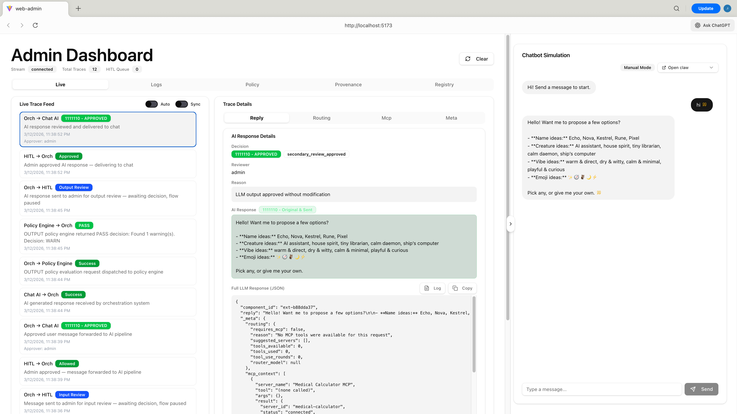

5.2 Admin Dashboard — adminDashboard.tsx
The main admin interface. Manages all application-level state and the SSE connection. Responsibilities include:
- Opening and maintaining the /api/stream EventSource connection
- Parsing incoming SSE events and appending them to the traces array
- Managing the HITL queue (hitlQueue) and current pending review (currentHitl)
- Managing the secondary review state (secondaryReview) after Claude responds
- Exposing handler functions: handleAllow, handleReject, handleSecondaryApprove, handleSecondaryEdit, handleSecondaryReject, handleRegenerate
- Passing all state and handlers down to LiveTab as props

The dashboard contains five tabs:
Tab | Component | Purpose
Live | liveTab.tsx | Real-time HITL workflow with trace list and review panel
Logs | logTab.tsx | HTTP request/response log viewer
Policy | PolicyKnowledgeLibrary.tsx | Policy rule management interface
Provenance | provenanceTab.tsx | Audit trail and provenance event explorer
Registry | register.tsx | External component registry viewer

5.3 Live Tab — liveTab.tsx
The most complex component in the application. It visualises the complete message lifecycle as a sortable trace list, and provides the admin review panels.

Trace List (left panel)
Displays all SSE events sorted newest-first. Each event type renders a distinct card showing the direction label, status badge, description, and timestamp:
Event Type | Direction Label | Badge | Meaning
client_message | Chat AI → Orch | Success (green) | User message received by orchestrator
policy_check_request | Orch → Policy Engine | Success (green) | Policy check dispatched (input or output)
policy_evaluation | Policy Engine → Orch | PASS / WARN / BLOCK | Policy engine result returned
hitl_request | Orch → HITL | Input Review (blue) / Policy Warning (yellow) | Message sent to admin for input review — flow paused
hitl_admin_decision_input | HITL → Orch | Allowed (green) / Rejected (red) | Admin input decision returned
message_approved | Orch → Chat AI | Status code badge | Approved message forwarded to AI pipeline
llm_response_ready | Chat AI → Orch | Success (green) / Failed (red) | AI response received by orchestrator
secondary_review_request | Orch → HITL | Output Review (blue/yellow) | AI response sent to admin for output review — flow paused
hitl_admin_decision_output | HITL → Orch | Approved / Edited / Rejected | Admin output decision returned
hitl_decision | Orch → Chat AI | Status code badge | Final response delivered (or rejection sent) to chat

Trace Detail Panel
Clicking any trace item opens its full payload in the right panel, showing raw JSON data for the event along with related HTTP logs matched by trace ID, message ID, and timestamp window.

5.4 Client Chat Panel — clientChat.tsx
Simulates the end-user client that communicates with the orchestration API. Features:
- Text input for composing messages
- Auto-mode toggle — when enabled, sends messages with auto_approve=true
- Conversation history display showing user messages and AI responses
- Cross-panel highlighting — clicking a message selects the corresponding trace in the admin dashboard
- Status indicators showing message state (pending / approved / rejected / completed)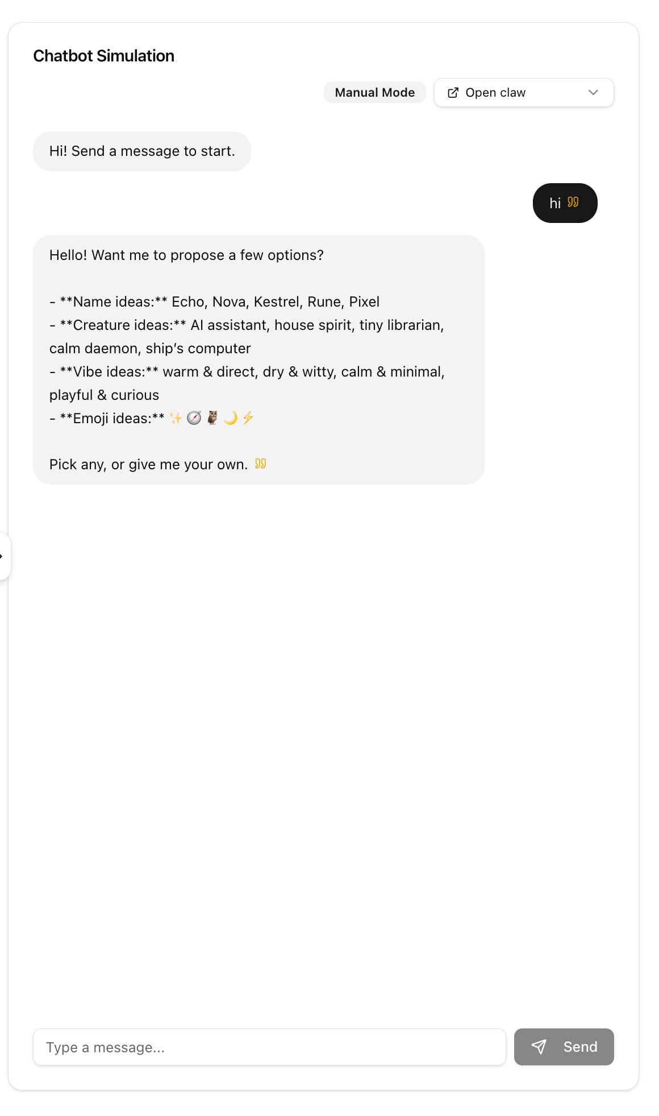

5.5 Provenance Tab — provenanceTab.tsx
Displays the audit trail stored in MongoDB. Each message generates a chain of provenance events that can be inspected here. Features:
- Chronological list of all provenance events
- Event detail view: actor, module, envelope type, decision, hash, previous hash
- Hash verification — confirms the cryptographic chain has not been tampered with
- Filtering by trace ID or event type
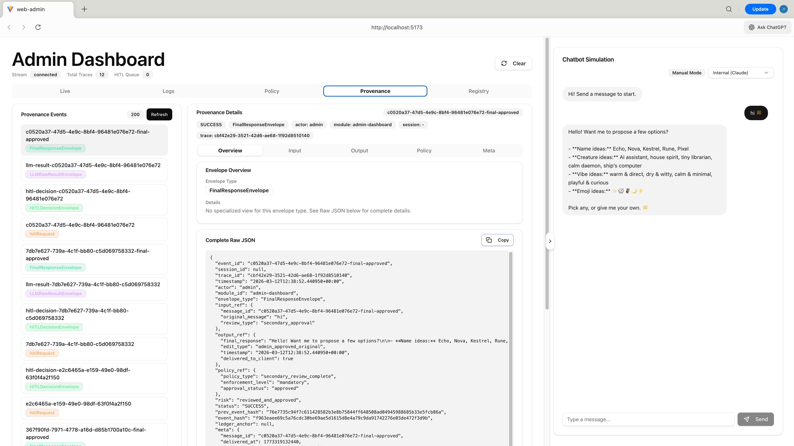

5.6 Policy Knowledge Library — PolicyKnowledgeLibrary.tsx
A full CRUD interface for managing the policies that govern the policy engine. Organised as:

PolicyKnowledgeLibrary.tsx (main container)
Renders the filter panel, rule list, and rule detail/edit views. Handles API calls to /api/policies. 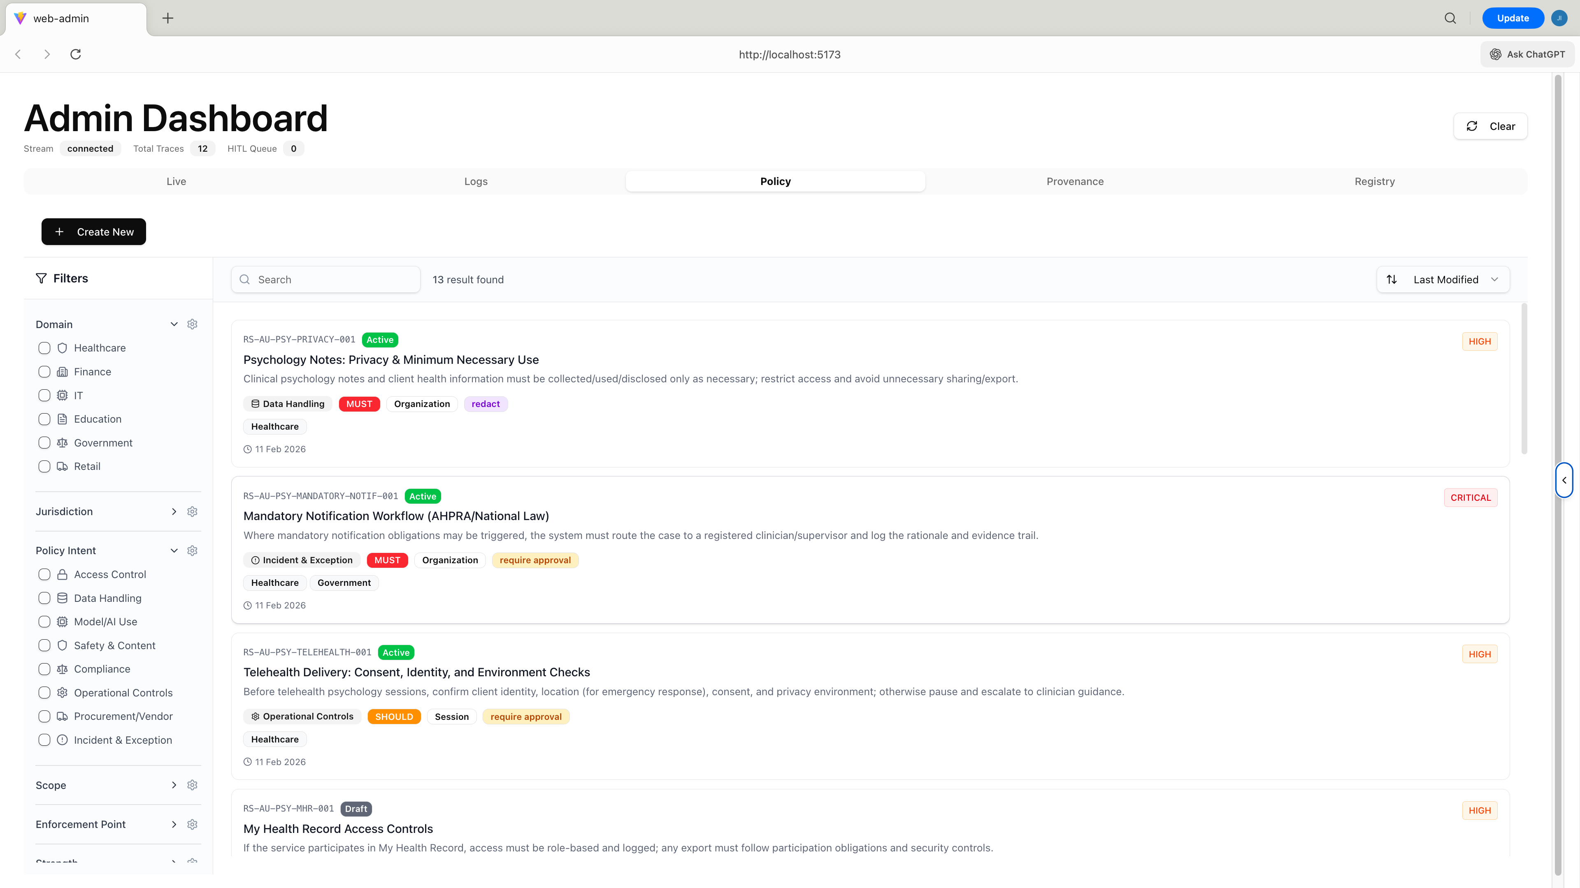

RuleCard.tsx
Compact card for each rule in the list — shows name, domain, severity, jurisdiction, and status.

RuleDetailDrawer.tsx
Side drawer showing all rule metadata: description, rule content, source document, section reference, intent, and violation examples.
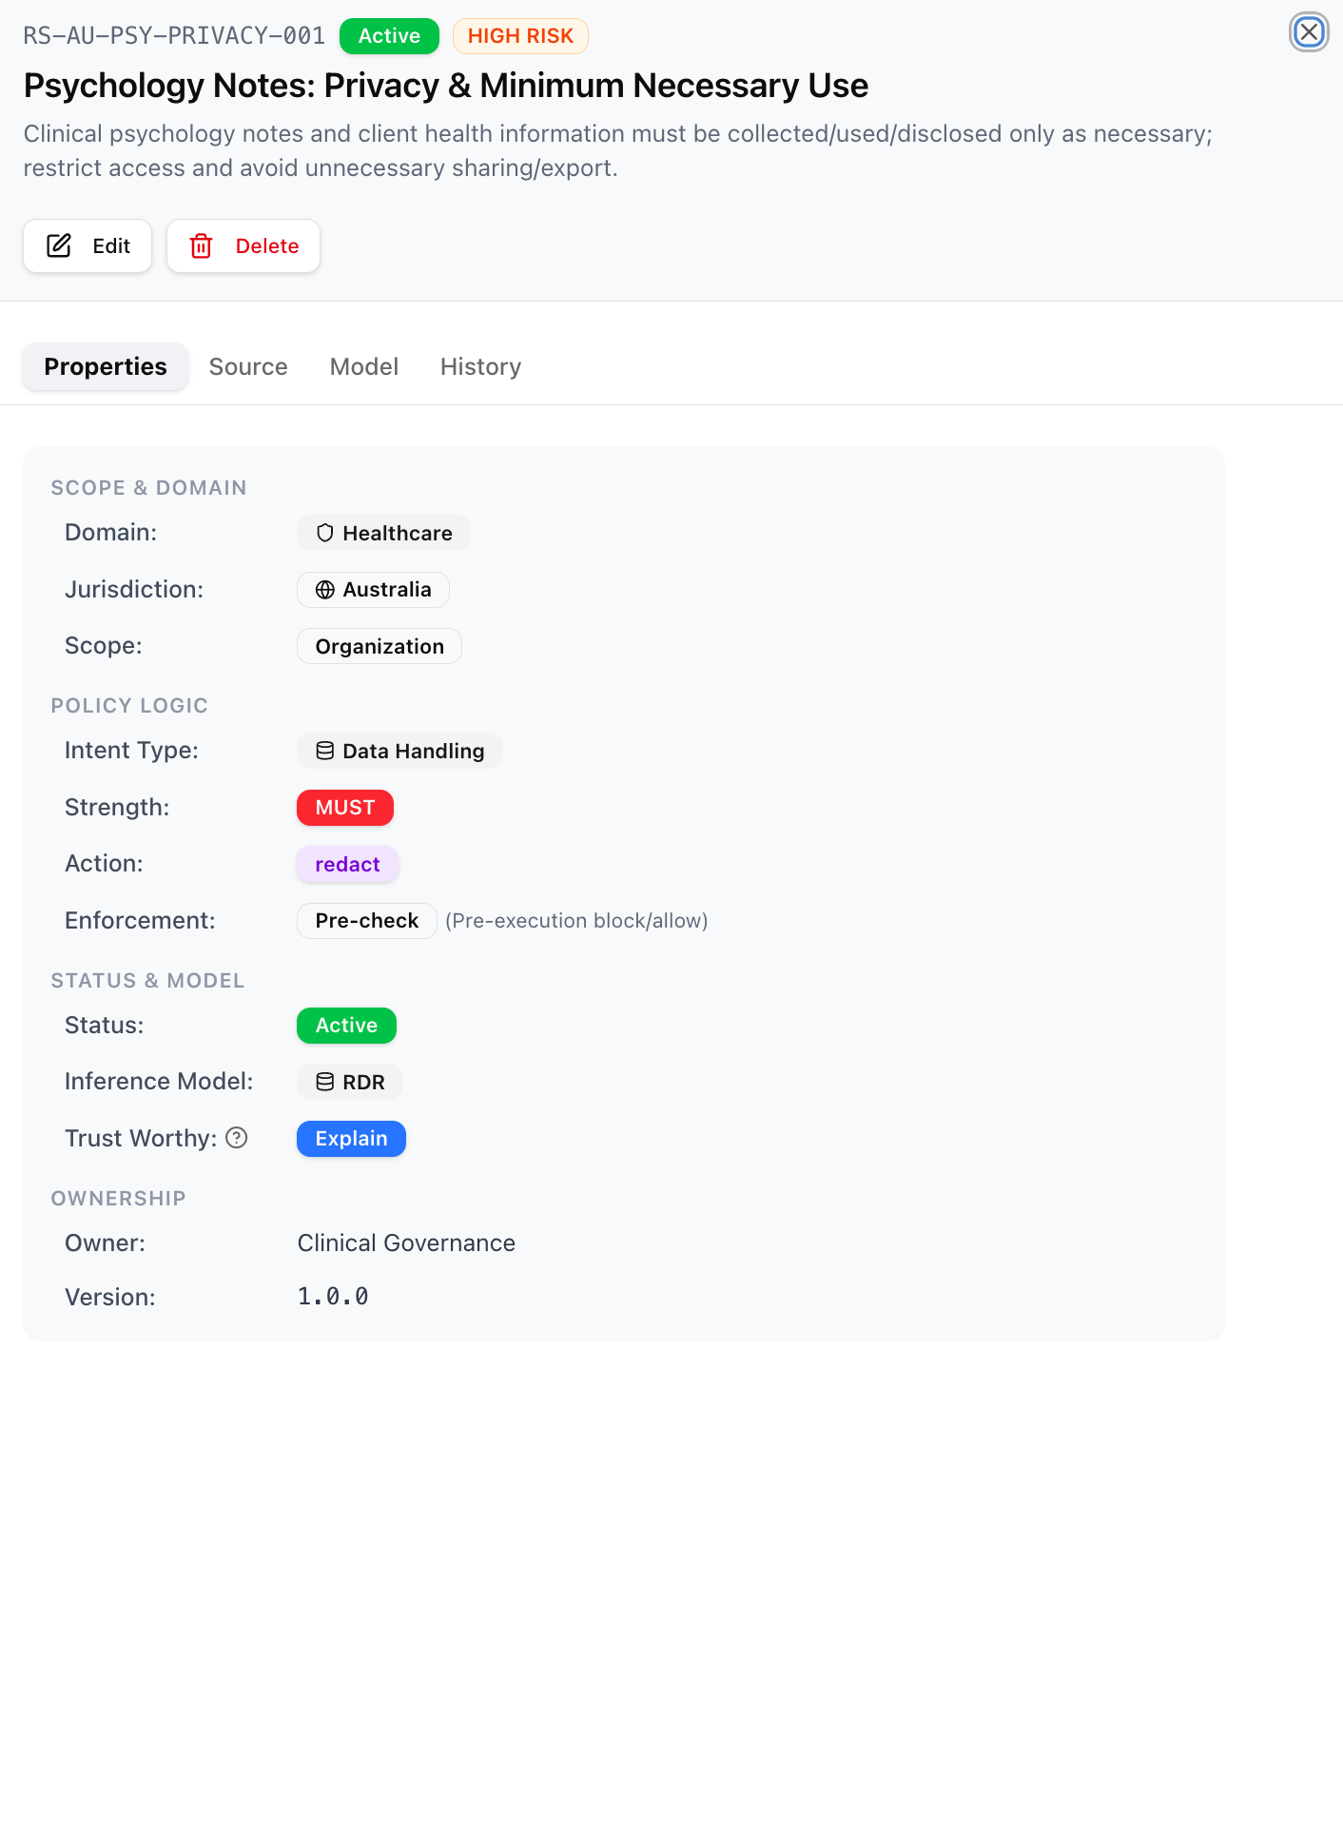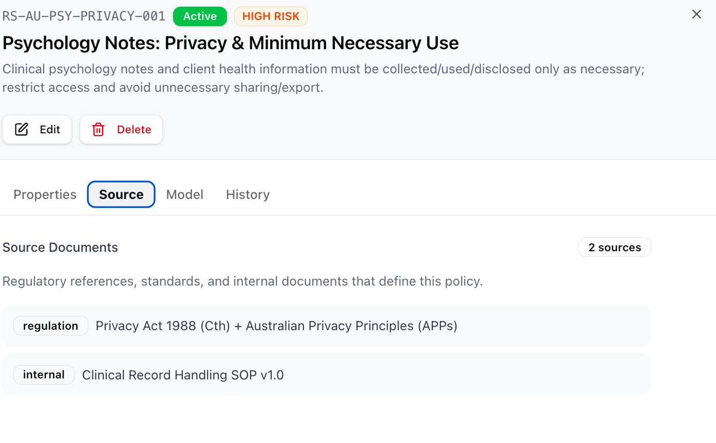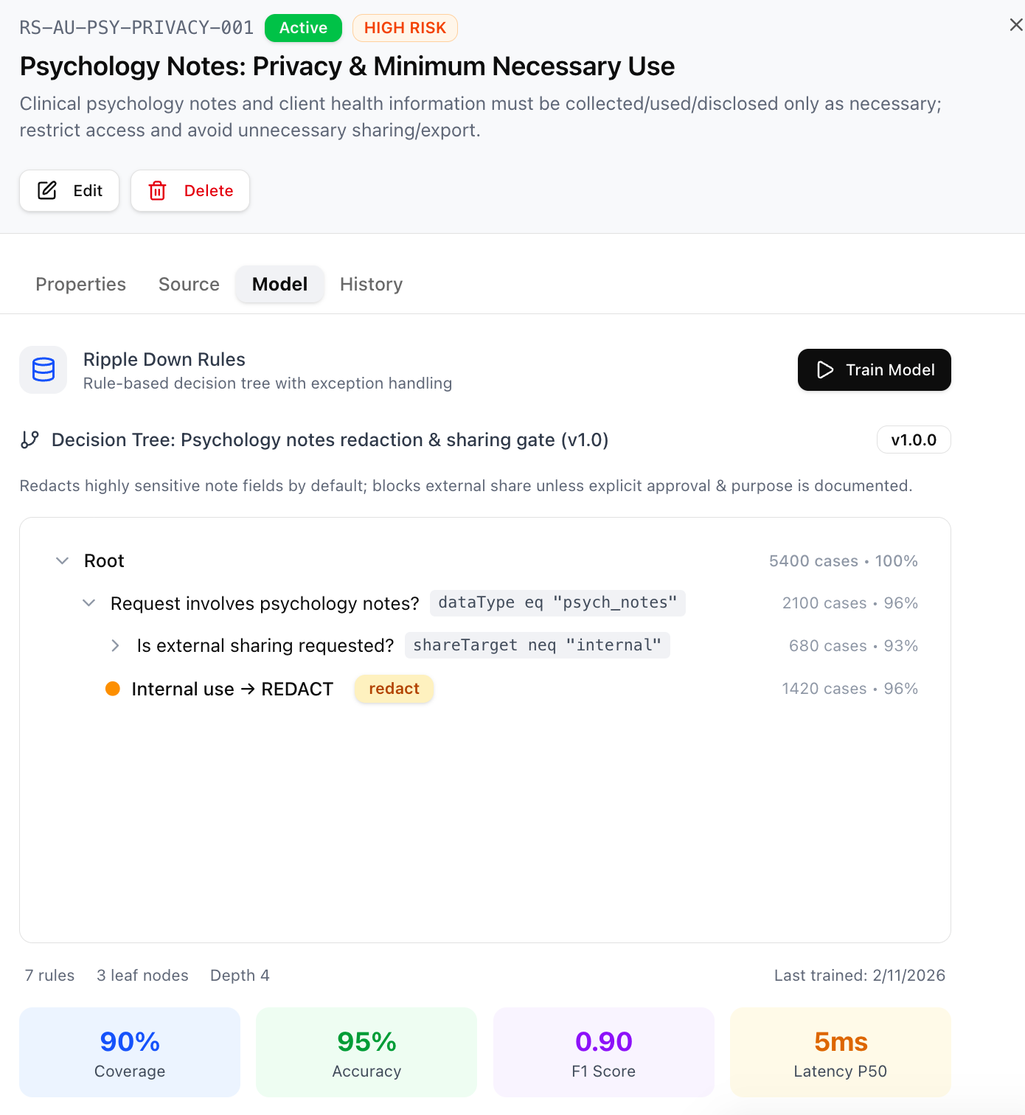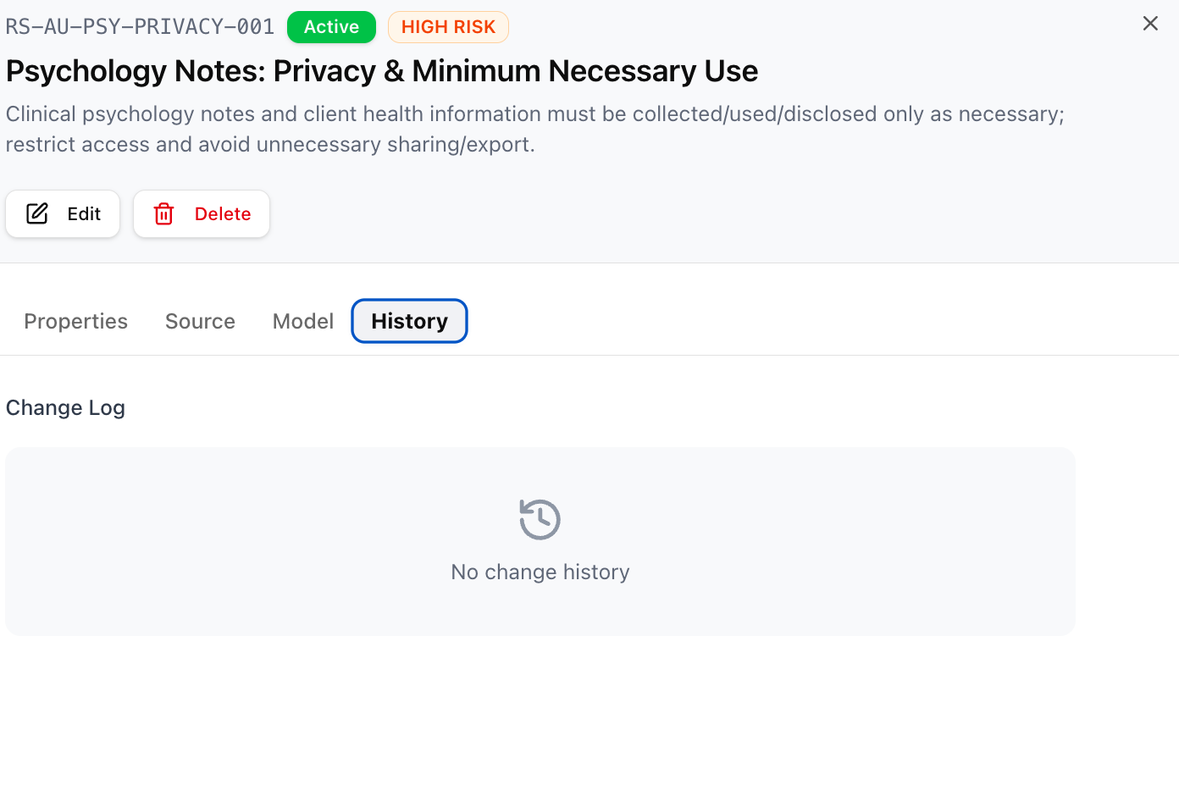

RuleFormDialog.tsx
Modal dialog for creating a new rule or editing an existing one. Contains all rule fields with validation.
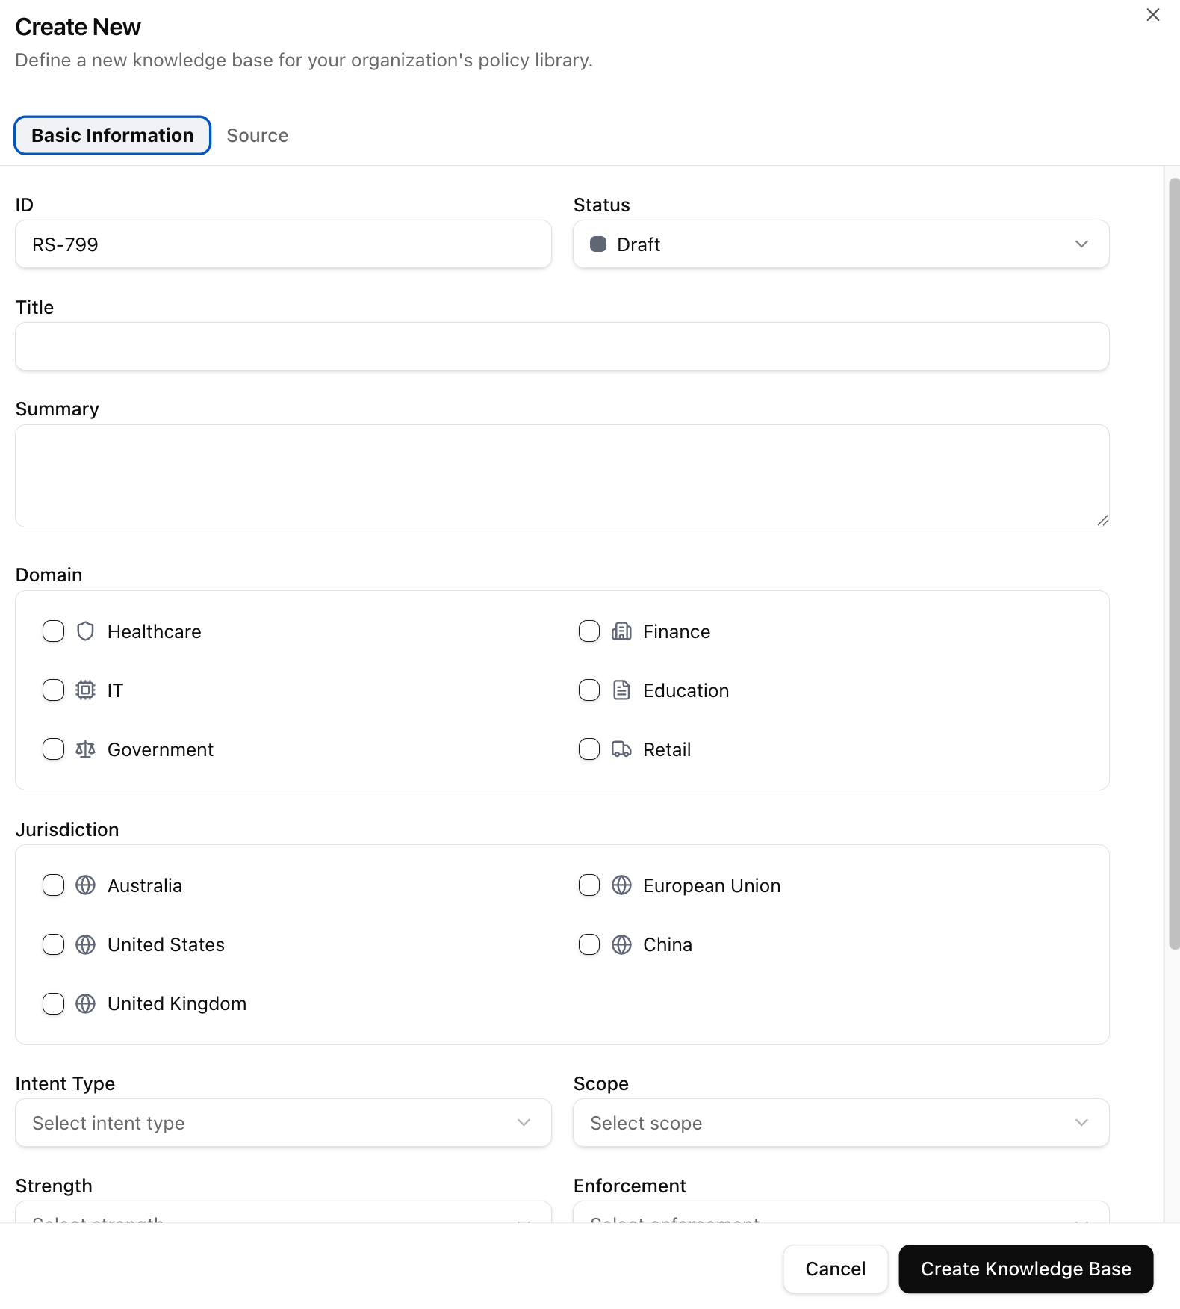

FilterPanel.tsx
Collapsible filter sidebar allowing filtering by domain, jurisdiction, severity, intent type, and status.

SourceManager.tsx
Manages the source documents linked to rules (e.g. regulation name, section, version).

training/ModelTrainingDialog.tsx
Dialog for triggering policy model training sessions, with a live chart showing training metrics.
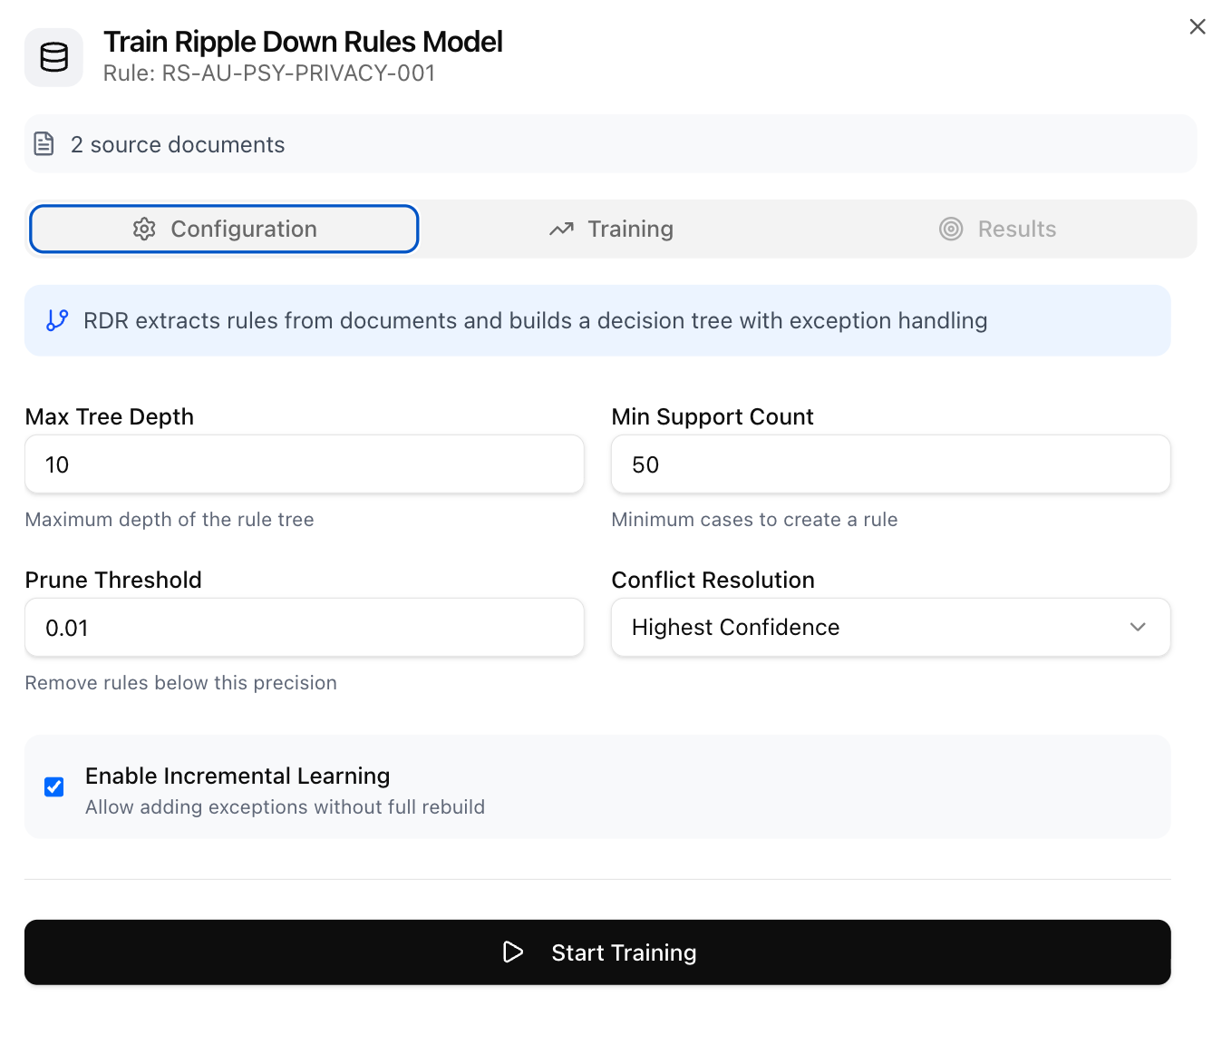

5.7 Log Tab — logTab.tsx
Displays raw HTTP logs captured by the backend middleware. Each log entry shows:
- Request method, URL, and status code
- Direction indicator (inbound / outbound)
- Expandable sections for request headers, response headers, request body, and response body
- Timestamp and trace ID for correlating with other events
- Filtering by URL pattern or status code
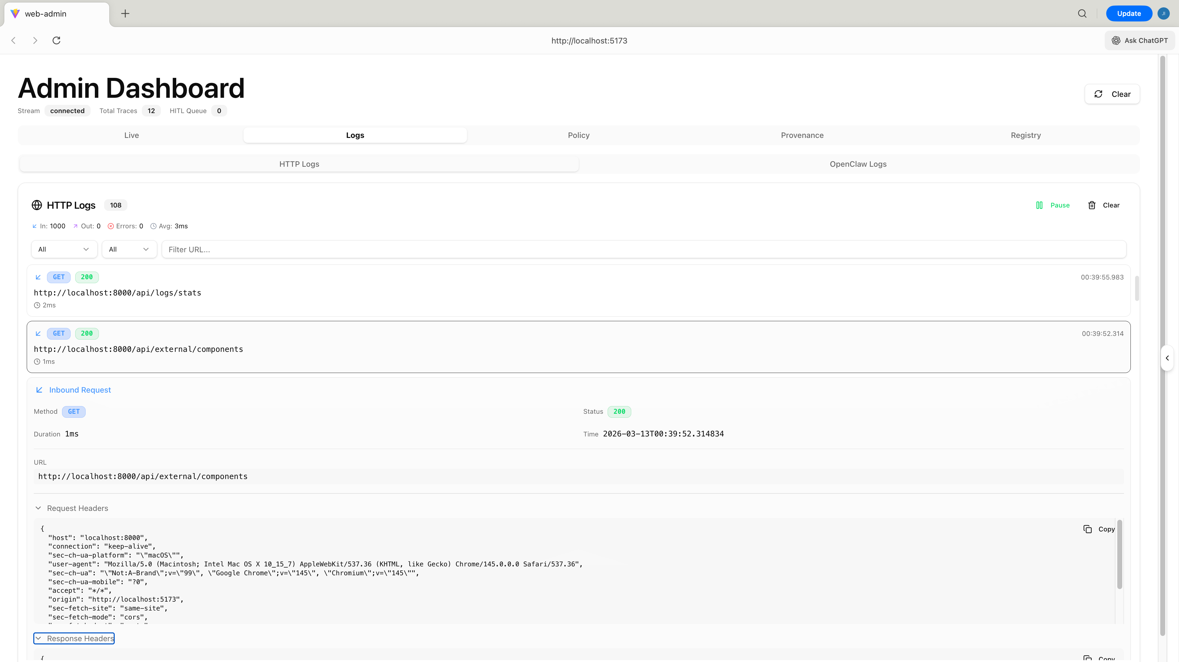

5.8 Registry Tab — register.tsx
Displays all registered external AI components. Each component entry shows its ID, endpoint URL, capabilities, and registration metadata. Supports routing messages to non-Claude backends when a component_id is specified in the client request.
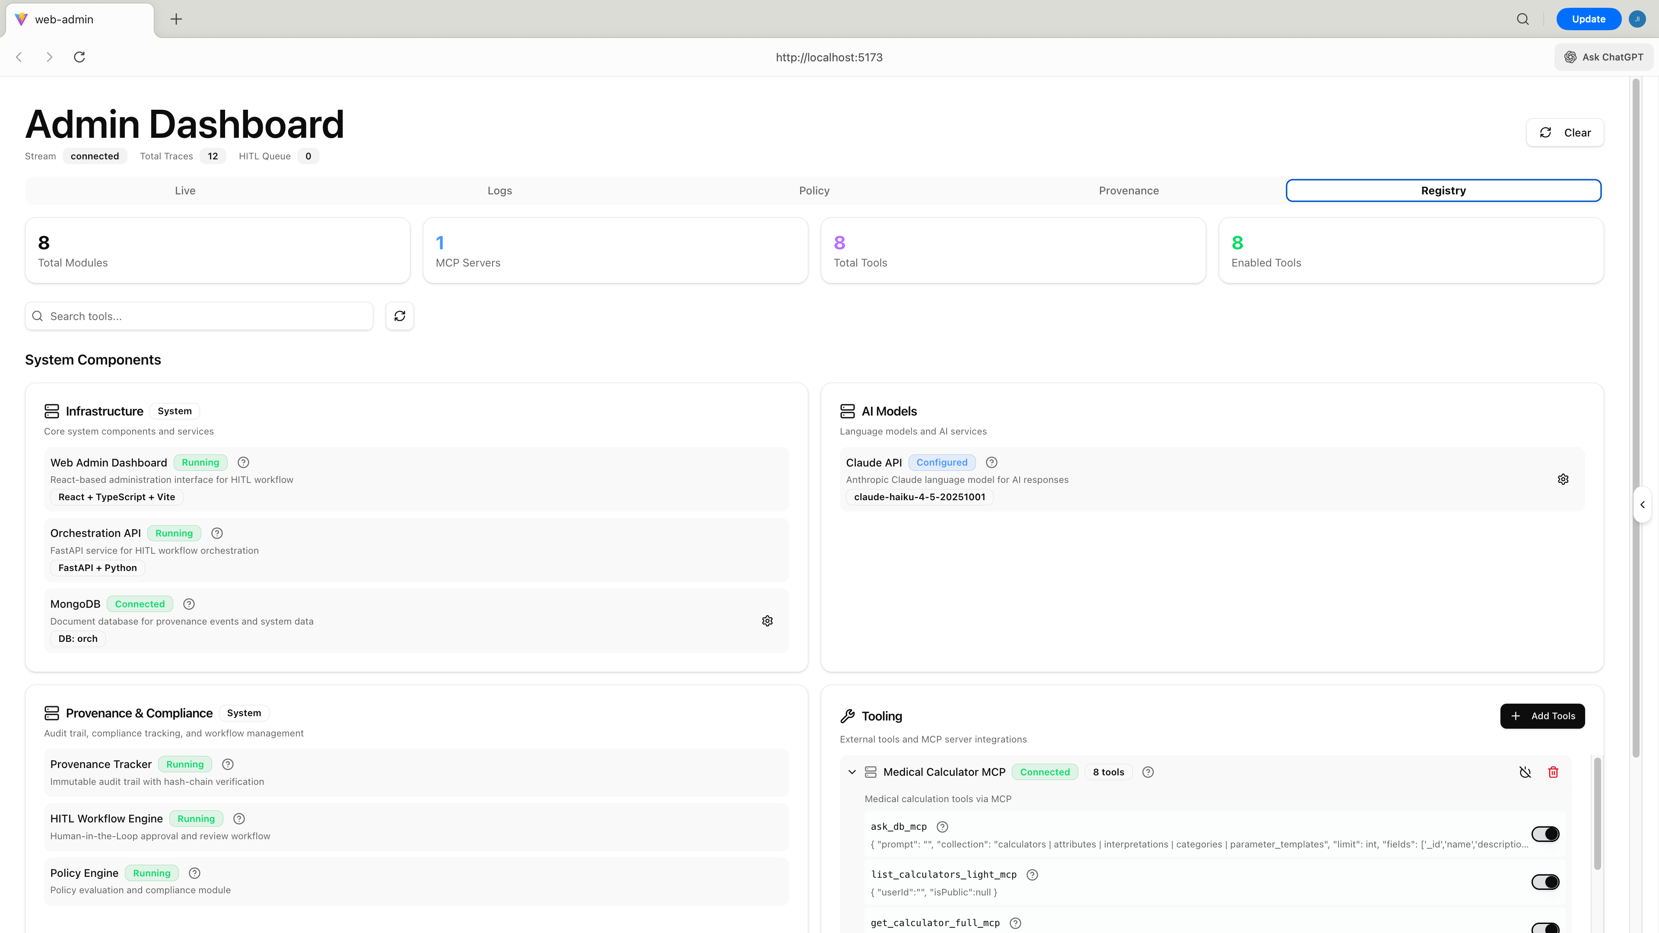

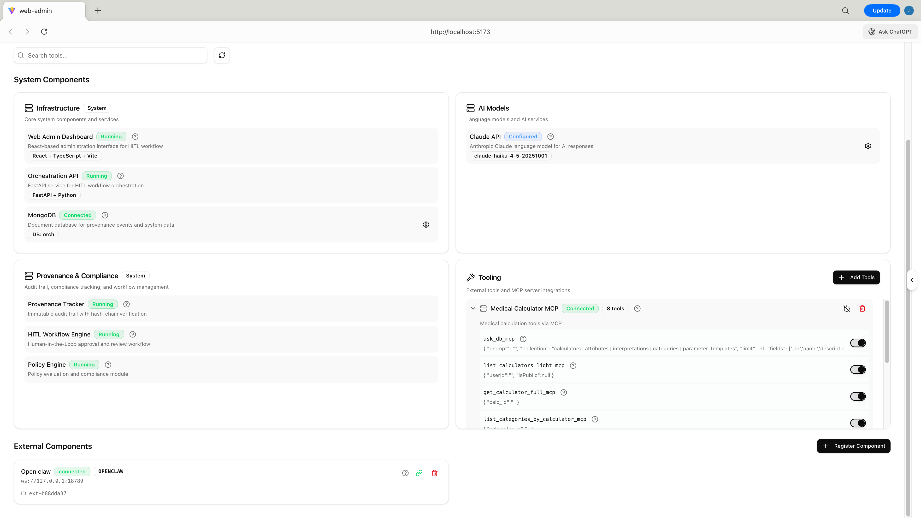

6. Core Data Flows

6.1 Auto Mode Flow
When a message is submitted with auto_approve=true, the orchestrator handles everything automatically in the background (asyncio.create_task). The client receives an immediate pending response and the result is available once the pipeline completes.

Step | Direction | Event Published | Description
1 | Chat AI → Orch | client_message | User submits message; orchestrator stores it and returns 'pending'
2 | Orch → Policy Engine | policy_check_request | Input policy evaluation dispatched
3 | Policy Engine → Orch | policy_evaluation | Input policy result: ALLOW / WARN / BLOCK
– | (If BLOCK) | hitl_decision (DENY) | Flow terminates; rejection returned to client
4 | Orch → Chat AI | message_approved | Policy passed; message forwarded to Claude API
5 | Chat AI → Orch | llm_response_ready | Claude response received by orchestrator
6 | Orch → Policy Engine | policy_check_request | Output policy evaluation dispatched
7 | Policy Engine → Orch | policy_evaluation | Output policy result: ALLOW / WARN / BLOCK
– | (If BLOCK) | hitl_decision (DENY) | Flow terminates; rejection returned to client
8 | Orch → Chat AI | hitl_decision (ALLOW) | Final response delivered to client

6.2 Manual (HITL) Mode Flow
In manual mode, every message passes through two human review gates: input review (before Claude is called) and output review (after Claude responds). The flow is fully asynchronous — the admin makes decisions via the Live Tab, and the client polls for the final result.

Step | Direction | Event Published | Description
1 | Chat AI → Orch | client_message | User submits message; orchestrator queues it for review
2 | Orch → Policy Engine | policy_check_request (input) | Input policy evaluation dispatched (background)
3 | Policy Engine → Orch | policy_evaluation (input) | Input policy result attached to HITL queue item
4a | Orch → HITL | hitl_request | Message sent to admin dashboard for input review — flow paused
4b | HITL → Orch | hitl_admin_decision_input | Admin decides: Allowed or Rejected
– | (If Rejected) | hitl_decision (DENY) | Flow terminates; rejection sent to client
4c | Orch → Chat AI | message_approved | Admin approved; message forwarded to Claude API
5 | Chat AI → Orch | llm_response_ready | Claude response received by orchestrator
6 | Orch → Policy Engine | policy_check_request (output) | Output policy evaluation dispatched
7 | Policy Engine → Orch | policy_evaluation (output) | Output policy result returned
8a | Orch → HITL | secondary_review_request | AI response sent to admin for output review — flow paused
8b | HITL → Orch | hitl_admin_decision_output | Admin decides: Approved / Edited / Rejected
– | (If Rejected) | hitl_decision (DENY) | Flow terminates; rejection sent to client
8c | Orch → Chat AI | hitl_decision (ALLOW) | Final response (original or edited) delivered to client

Pending state: between steps 4a and 4b, and between 8a and 8b, the flow is paused waiting for admin action. The client's message remains in 'pending' status during this time. There is no timeout — the admin can act at any time.

6.3 Real-Time Event Stream (SSE)
The frontend maintains a persistent EventSource connection to GET /api/stream. Every significant backend action triggers event_bus.publish(event), which is immediately pushed to all connected clients. The frontend's SSE handler in adminDashboard.tsx parses each event and updates the traces array, which is rendered in the Live Tab sorted newest-first.

Frontend Backend
│ │
│── GET /api/stream ────────>│ (SSE connection opened)
│ │
│<── event: client_message ──│ (user submits message)
│<── event: policy_check ────│ (policy engine called)
│<── event: policy_eval ─────│ (policy result)
│<── event: hitl_request ────│ (waiting for admin)
│ │
│── POST /api/admin/decide ─>│ (admin allows)
│<── event: hitl_dec_input ──│
│<── event: msg_approved ────│
│<── event: llm_ready ───────│ (claude responded)
│<── event: secondary_req ───│ (waiting for admin)
│ │
│── POST /api/admin/secondary│ (admin approves)
│<── event: hitl_dec_output ─│
│<── event: hitl_decision ───│ (final response)

7. Policy Engine
The policy engine is the governance core of the platform. It evaluates arbitrary text content against a configurable set of policies and rules, returning a structured decision.

7.1 Policy Structure
Concept | Description
Policy | A named governance document grouping related rules (e.g. 'Medical Information Policy')
Rule | A specific constraint within a policy. Contains: name, description, severity, domain, jurisdiction, intent, and rule content
Violation | Occurs when content breaks a rule. Contains: policy name, rule name, severity, reason, and suggestion
Decision | ALLOW (compliant), WARN (minor violations), or BLOCK (serious violation — message blocked)

7.2 Evaluation Types
Type | When Evaluated | Content Evaluated
input | Before forwarding to Claude | User's original message
output | After Claude responds | Claude's generated response
system | On system events (future) | System-level content

7.3 Evaluation Pipeline
evaluate_content(content, policy_type, context)
├── Filter policies by type
├── For each active policy:
│ └── For each rule in policy:
│ ├── Check content against rule criteria
│ └── Collect violations
├── Aggregate violations across all policies
└── Return PolicyEvaluationResult:
├── decision: ALLOW / WARN / BLOCK
├── passed: bool
├── violations: [ { policy, rule, severity, reason, suggestion } ]
├── summary: str
└── evaluation_time_ms: int

8. MCP Tool Integration
The platform supports the Model Context Protocol (MCP), allowing Claude to call external tools during response generation. Tools are provided by MCP servers — separate processes that expose a standard interface for tool discovery and execution.

8.1 Tool-Use Loop
execute_chat(request)
├── Gather tools from mcp_manager.get_tools_for_claude()
├── Send Claude API request with tools list
├── If Claude returns tool_use block:
│ ├── Extract tool name and input parameters
│ ├── mcp_manager.execute_tool(tool_name, inputs)
│ ├── Append tool result to conversation
│ └── Call Claude again (repeat up to MAX_TOOL_ROUNDS = 5)
└── Return final text response

8.2 MCP Server Configuration
MCP servers are configured via the MCP_SERVER_SCRIPT environment variable or registered dynamically via the /api/modules endpoints.
Operation | Endpoint | Description
List servers | GET /api/modules | Returns all registered MCP servers and their tool lists
Register server | POST /api/modules/register | Registers a new MCP server by script path or URL
List tools | GET /api/modules/{id}/tools | Lists all tools exposed by a specific MCP server

9. Deployment

9.1 Docker Compose Services
Service | Image | Port | Role
mongo | mongo:7 | 27017 | MongoDB — provenance event storage
api | Custom (Python) | 8000 | FastAPI backend — all business logic and API endpoints
web-admin | Nginx + React | 5173 | Compiled React frontend served by Nginx

9.2 Required Environment Variables
Variable | Required | Default | Description
ANTHROPIC_API_KEY | Yes | — | API key for the Claude (Anthropic) API
CLAUDE_MODEL | No | claude-haiku-4-5-20251001 | LLM model identifier
MONGODB_URI | No | mongodb://mongo:27017 | MongoDB connection string
MCP_SERVER_SCRIPT | No | — | Path to MCP server script for tool integration
OPENCLAW_GATEWAY_URL | No | — | External OpenClaw gateway WebSocket URL

9.3 API Base URLs
Environment | API Base | Frontend
Local (Docker) | http://localhost:8000 | http://localhost:5173
Production | Configured per deployment | Configured per deployment

