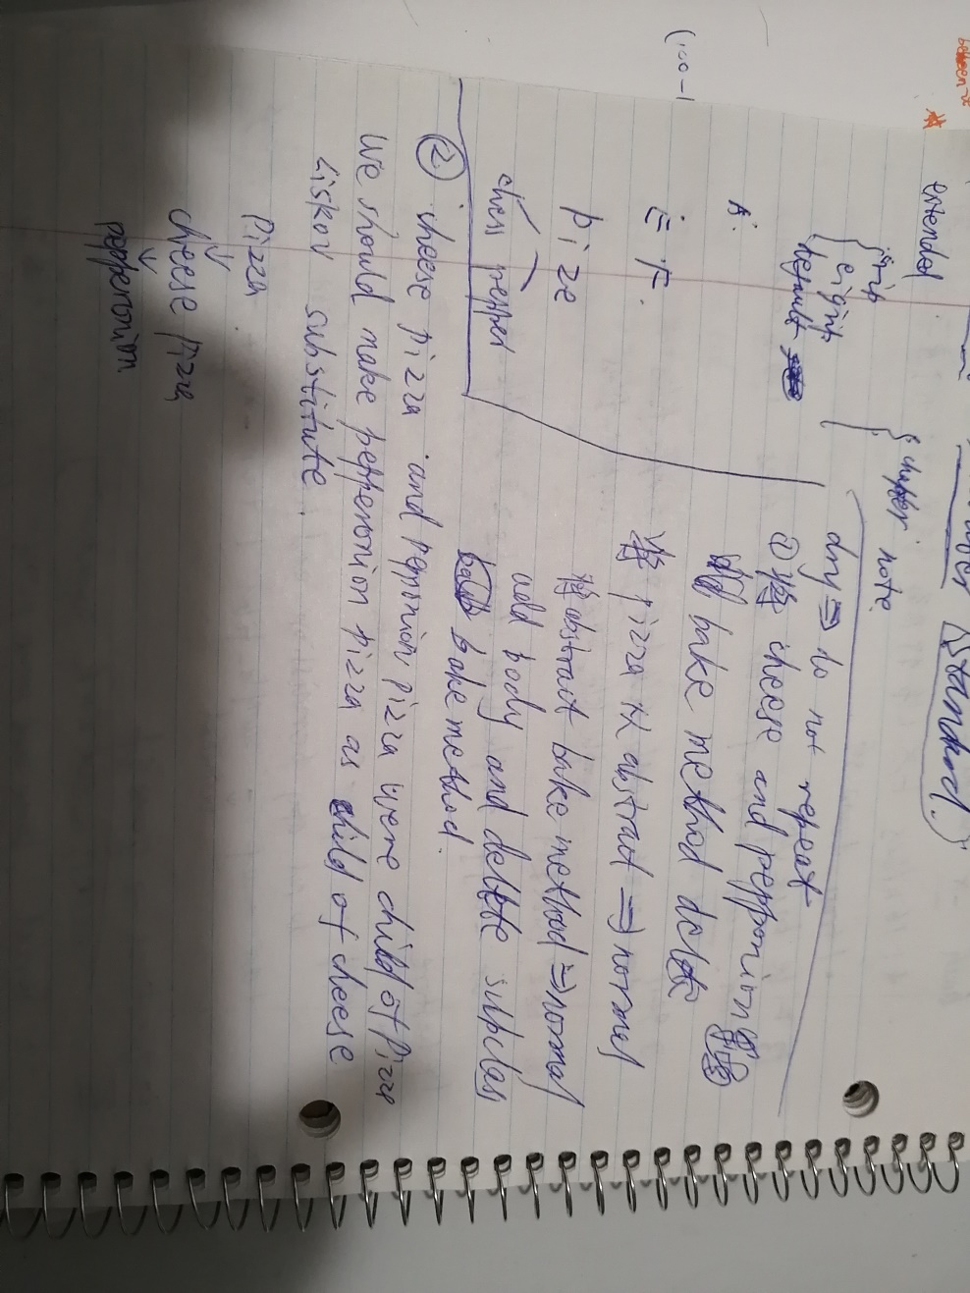

1.

E:\term2\softwareDesign\FinalExamReviewPartD-master-accordingprofModify

2. singleton have error