哈尔滨工业大学（深圳）

机械设计大作业设计说明书

设计题目： | V带传动电算
院系： | 机电工程与自动化学院
班级： | 机械二班
设计者： | 杨敬轩
学号： | SZ160310217
指导教师： | 胡泓
设计日期： | 2018年12月09日




哈尔滨工业大学（深圳）

机械设计大作业设计任务书
题目： V带传动电算

带式运输机的传动方案如下图所示，机器工作平稳、单向回转、成批生产，其他数据见下表。
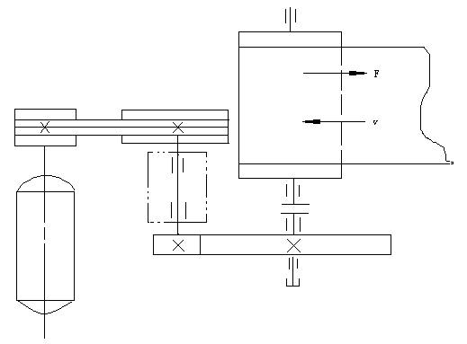
带式运输机的传动方案示意图

带式运输机中V带传动的已知数据
方案 | 电动机工作功率P_{d}/kW | 电动机满载转速n_{m}/(r/min) | 工作机的转速n_{w}/(r/min) | 第一级传动比i₁ | 轴承座中  心高H/mm | 最短工作年限 | 工作环境
5.1.4 | 2.2 | 940 | 80 | 2.1 | 160 | 5年2班 | 室内清洁

目 录
目 录 I
一、设计思路 1
二、变量说明 1
三、程序框图 2
四、MATLAB源代码 3
五、程序运行结果 18
六、总结 21
七、参考文献 21

- 设计思路
输入原始数据：P，n₁，i ，包括已给定和人为假定的数据。人为给定的一些条件代号，如Z、A、B、C、D、E六种带型号可使用变量TYPE来表示，分别对应六种型号，然后使用MATLAB进行GUI编程计算出其余参数值并显示出来。
- 变量说明
表 1 V带电算程序变量标识符
序号 | 名称 | 代号 | 标识符 | 单位
1 | 名义功率 | P | P | kW
2 | 设计功率 | P_{d} | Pd | kW
3 | 工作情况系数 | K_{A} | Ka
4 | 小带轮转速 | n₁ | n1 | r/min
5 | 工作机载荷特性 |  | GZJ
6 | 原动机类型 |  | YDJ
7 | 带型号 | Z、A—E | TYPE
8 | 小带轮基准直径 | d_{d1} | dd1 | mm
9 | 大带轮基准直径 | d_{d2} | dd2 | mm
10 | 最小带轮直径 | d_{dmin} | ddMIN | mm
11 | 带速 | v | V | m/s
12 | 最大带速 | v_{max} | Vmax | m/s
13 | 中心距 | a | a | mm
14 | 基准长度 | L_{d} | Ld | mm
15 | 小带轮包角 |  | alf1 | °
16 | V带根数 | Z | Z
17 | 额定功率 | P₀ | P0 | kW
18 | 弯曲影响系数 | K_{b} | Kb
19 | 传动比系数 | K_{i} | Ki
20 | 长度系数 | K_{L} | KL
21 | 包角系数 | K_{α} | KALF
22 | 初拉力 | F₀ | F0 | N
23 | 压轴力 | F_{Q} | FQ | N

- 程序框图
程序框图如图1所示。

图1 程序框图

- MATLAB源代码
1  2  3  4  5  6  7  8  9  10  11  12  13  14  15  16  17  18  19  20  21  22  23  24  25  26  27  28  29  30  31  32  33  34  35  36  37  38  39  40  41  42  43  44  45  46  47  48  49  50  51  52  53  54  55  56  57  58  59  60  61  62  63  64  65  66  67  68  69  70  71  72  73  74  75  76  77  78  79  80  81  82  83  84  85  86  87  88  89  90  91  92  93  94  95  96  97  98  99  100  101  102  103  104  105  106  107  108  109  110  111  112  113  114  115  116  117  118  119  120  121  122  123  124  125  126  127  128  129  130  131  132  133  134  135  136  137  138  139  140  141  142  143  144  145  146  147  148  149  150  151  152  153  154  155  156  157  158  159  160  161  162  163  164  165  166  167  168  169  170  171  172  173  174  175  176  177  178  179  180  181  182  183  184  185  186  187  188  189  190  191  192  193  194  195  196  197  198  199  200  201  202  203  204  205  206  207  208  209  210  211  212  213  214  215  216  217  218  219  220  221  222  223  224  225  226  227  228  229  230  231  232  233  234  235  236  237  238  239  240  241  242  243  244  245  246  247  248  249  250  251  252  253  254  255  256  257  258  259  260  261  262  263  264  265  266  267  268  269  270  271  272  273  274  275  276  277  278  279  280  281  282  283  284  285  286  287  288  289  290  291  292  293  294  295  296  297  298  299  300  301  302  303  304  305  306  307  308  309  310  311  312  313  314  315  316  317  318  319  320  321  322  323  324  325  326  327  328  329  330  331  332  333  334  335  336  337  338  339  340  341  342  343  344  345  346  347  348  349  350  351  352  353  354  355  356  357  358  359  360  361  362  363  364  365  366  367  368  369  370  371  372  373  374  375  376  377  378  379  380  381  382  383  384  385  386  387  388  389  390  391  392  393  394  395  396  397  398  399  400  401  402  403  404  405  406  407  408  409  410  411  412  413  414  415  416  417  418  419  420  421  422  423  424  425  426  427  428  429  430  431  432  433  434  435  436  437  438  439  440  441  442  443  444  445  446  447  448  449  450  451  452  453  454  455  456  457  458  459  460  461  462  463  464  465  466  467  468  469  470  471  472  473  474  475  476  477  478  479  480  481  482  483  484  485  486  487  488  489  490  491  492  493  494  495  496  497  498  499  500  501  502  503  504  505  506  507  508  509  510  511  512  513  514  515  516  517  518  519  520  521  522  523  524  525  526  527  528  529  530  531  532  533  534  535  536  537  538  539  540  541  542  543  544  545  546  547  548  549  550  551  552  553  554  555  556  557  558  559  560  561  562  563  564  565  566  567  568  569  570  571  572  573  574  575  576  577  578  579  580  581  582  583  584  585  586  587  588  589  590  591  592  593  594  595  596  597  598  599  600  601  602  603  604  605  606  607  608  609  610  611  612  613  614  615  616  617  618  619  620  621  622  623  624  625  626  627  628  629  630  631  632  633  634  635  636  637  638  639  640  641  642  643  644  645  646  647  648  649  650  651  652  653  654  655  656  657  658  659  660  661  662  663  664  665  666  667  668  669  670  671  672  673  674  675  676  677  678  679  680  681  682  683  684  685  686  687  688  689  690  691  692  693  694  695  696  697  698  699  700  701  702  703  704  705  706  707  708  709  710  711  712  713  714  715  716  717  718  719  720  721  722  723  724  725  726  727  728  729  730  731  732  733  734  735  736  737  738  739  740  741  742  743  744  745  746  747  748  749  750  751  752  753  754  755  756  757  758  759  760  761  762  763  764  765  766  767  768  769  770  771  772  773  774  775  776  777  778  779  780  781  782  783  784  785  786  787  788  789  790  791  792  793  794  795  796  797  798  799  800  801  802  803  804  805  806  807  808  809  810  811  812  813  814  815  816  817  818  819  820  821  822  823  824  825  826  827  828  829  830  831  832  833  834  835  836  837  838  839  840  841  842  843  844  845  846  847  848  849  850  851  852  853  854  855  856  857  858  859  860  861  862  863  864  865  866  867  868  869  870  871  872  873  874  875  876  877  878  879  880  881  882  883  884  885  886  887  888  889  890  891 | function varargout = VBC(varargin)  % VBC MATLAB code for VBC.fig  % VBC means V Belt Calculation  % Designer: JingXuan Yang  % Date: 2018/12/08  % VBC, by itself, creates a new VBC or raises the existing  % singleton*.  % H = VBC returns the handle to a new VBC or the handle to  % the existing singleton*.  %  % VBC('CALLBACK',hObject,eventData,handles,...) calls the local  % function named CALLBACK in VBC.M with the given input arguments.  %  % VBC('Property','Value',...) creates a new VBC or raises the  % existing singleton*. Starting from the left, property value pairs are  % applied to the GUI before VBC_OpeningFcn gets called. An  % unrecognized property name or invalid value makes property application  % stop. All inputs are passed to VBC_OpeningFcn via varargin.  %  % *See GUI Options on GUIDE's Tools menu. Choose "GUI allows only one  % instance to run (singleton)".  %  % See also: GUIDE, GUIDATA, GUIHANDLES  % Edit the above text to modify the response to help VBC  % Last Modified by GUIDE v2.5 08-Dec-2018 19:15:20  % Begin initialization code - DO NOT EDIT  gui_Singleton = 1;  gui_State = struct('gui_Name', mfilename, ...  'gui_Singleton', gui_Singleton, ...  'gui_OpeningFcn', @VBC_OpeningFcn, ...  'gui_OutputFcn', @VBC_OutputFcn, ...  'gui_LayoutFcn', [] , ...  'gui_Callback', []);  if nargin && ischar(varargin{1})  gui_State.gui_Callback = str2func(varargin{1});  end  if nargout  [varargout{1:nargout}] = gui_mainfcn(gui_State, varargin{:});  else  gui_mainfcn(gui_State, varargin{:});  end  % End initialization code - DO NOT EDIT  % --- Executes just before VBC is made visible.  function VBC_OpeningFcn(hObject, eventdata, handles, varargin)  % This function has no output args, see OutputFcn.  % hObject handle to figure  % eventdata reserved - to be defined in a future version of MATLAB  % handles structure with handles and user data (see GUIDATA)  % varargin command line arguments to VBC (see VARARGIN)  global Pd yilei erlei chuandongbi zhuansu TYPE Dd1array Dd1 MINMAX P0array...  Narray Vmax Ldarray Dd1pos Kaarray Klarray Dd2array DSPcellarray CELLDSP TABLEPOS HEADMES;  Vmax = 25;  %Basic rated power of common V-belt  P0array = [  0.00 0.04,0.06,0.09,0.10,0.12,0.14,0.16,0.17,0.20,0.22,0.26,0.28,0.30,0.32,0.33,0.34,0.33,0.31;  0.00 0.05,0.08,0.13,0.15,0.18,0.22,0.25,0.27,0.32,0.37,0.41,0.45,0.47,0.49,0.50,0.50,0.49,0.48;  0.00 0.06,0.09,0.17,0.20,0.23,0.27,0.30,0.33,0.39,0.46,0.50,0.54,0.58,0.61,0.62,0.62,0.61,0.58;  0.00 0.10,0.14,0.20,0.22,0.26,0.30,0.35,0.39,0.44,0.50,0.56,0.61,0.64,0.67,0.67,0.66,0.64,0.00;  0.00 0.15,0.26,0.40,0.45,0.51,0.60,0.68,0.73,0.84,0.92,1.00,1.04,1.08,1.09,1.07,1.02,0.96,0.80;  0.00 0.22,0.39,0.61,0.68,0.77,0.93,1.07,1.05,1.34,1.50,1.64,1.73,1.83,1.87,1.88,1.82,0.00,0.00;  0.00 0.26,0.47,0.74,0.83,0.95,1.14,1.32,1.42,1.66,1.87,2.05,2.19,2.28,2.34,2.33,0.00,0.00,0.00;  0.00 0.37,0.67,1.07,1.19 1.37 1.66 1.92 2.07 2.44 2.74 2.98 3.16 3.26 0.00 0.00 0.00 0.00 0.00;  0.00 0.48 0.84 1.30 1.44 1.64 1.93 2.19 2.33 2.64 2.85 2.96 2.94 2.80 0.00 0.00 0.00 0.00 0.00;  0.00 0.59 1.05 1.64 1.82 2.08 2.47 2.82 3.00 3.42 3.70 3.85 3.83 0.00 0.00 0.00 0.00 0.00 0.00;  0.00 0.74 1.32 2.09 2.32 2.66 3.17 3.62 3.86 4.40 4.75 4.89 0.00 0.00 0.00 0.00 0.00 0.00 0.00;  0.00 0.88 1.59 2.53 2.81 3.22 3.85 4.39 4.68 5.30 5.67 0.00 0.00 0.00 0.00 0.00 0.00 0.00 0.00;  0.00 1.39 2.41 3.69 4.07 4.58 5.29 5.84 6.07 6.34 6.02 0.00 0.00 0.00 0.00 0.00 0.00 0.00 0.00;  0.00 2.03 3.62 5.64 6.23 7.04 8.21 9.04 9.38 9.62 0.00 0.00 0.00 0.00 0.00 0.00 0.00 0.00 0.00;  0.00 2.84 5.14 8.09 8.92 10.05 11.53 12.46 12.72 0.00 0.00 0.00 0.00 0.00 0.00 0.00 0.00 0.00 0.00;  0.00 3.91 7.06 11.02 12.10 13.48 15.04 0.0 0.000 0.00 0.00 0.00 0.00 0.00 0.00 0.00 0.00 0.00 0.00;  3.01 5.31 9.24 13.70 14.83 16.15 17.25 16.77 15.63 0.00 0.00 0.00 0.00 0.00 0.00 0.00 0.00 0.00 0.00;  3.66 6.52 11.45 17.07 18.46 20.06 21.20 0.00 0.000 0.00 0.00 0.00 0.00 0.00 0.00 0.00 0.00 0.00 0.00;  4.37 7.90 13.85 20.63 22.25 24.01 24.84 0.00 0.000 0.00 0.00 0.00 0.00 0.00 0.00 0.00 0.00 0.00 0.00;  5.08 9.21 16.20 23.99 25.76 27.50 0.000 0.00 0.000 0.00 0.00 0.00 0.00 0.00 0.00 0.00 0.00 0.00 0.00;  6.21 10.86 18.55 26.21 27.57 28.32 0.00 0.00 0.000 0.00 0.00 0.00 0.00 0.00 0.00 0.00 0.00 0.00 0.00;  7.32 13.09 22.49 31.59 33.03 33.40 0.00 0.00 0.000 0.00 0.00 0.00 0.00 0.00 0.00 0.00 0.00 0.00 0.00;  8.75 15.65 26.95 37.26 38.62 0.000 0.00 0.00 0.000 0.00 0.00 0.00 0.00 0.00 0.00 0.00 0.00 0.00 0.00;  10.31 18.52 31.83 42.87 43.52 0.00 0.00 0.00 0.000 0.00 0.00 0.00 0.00 0.00 0.00 0.00 0.00 0.00 0.00;  ];  %range of n1 for every specific belt  MINMAX = [950,6000;800,6000;700,6000;700,6000;200,600;200,6000;200,6000;  200,5500;200,6000;200,5000;200,4500;200,3600;200,3600;200,3200;  200,2800;200,2400;200,2400;200,2000;200,1600;200,1200;  100,1600;100,1200;100,1200;100,950;100,950;100,950;100,800;100,800;];  %basic n1 values  Narray = [100,200,400,700,800,950,1200,1450,1600,2000,2400,2800,3200,3600,4000,4500,5000,5500,6000];  %Datum length  Ldarray = [200,224,250,280,315,355,400,450,500,560,630,710,800,900,1000,1120,1250,1400,1600,1800,2000,2240,2500,2800,3150,3550,4000,4500,5000];  %Optimum selection of pulley diameter series  Dd2array = [20,28,31.5,35.5,40,45,50,56,63,71,80,90,100,112,125,140,150,160,180,200,224,250,280,315,355,400,425,450,500,560,600,630,710,800];  %two classes for Ka  yilei = [1:0.1:1.2; 1.1:0.1:1.3; 1.2:0.1:1.4; 1.3:0.1:1.5];%I-class  erlei = [1.1:0.1:1.3; 1.2:0.1:1.4; 1.4:0.1:1.6; 1.5,1.6,1.8];%II-class  %atually this Ka is K\alpha  Kaarray = [220,210,200,190,180,170,160,150,140,130,120,110,100,90;  1.20,1.15,1.10,1.05,1.00,0.98,0.95,0.92,0.89,0.86,0.82,0.78,0.73,0.68];  %  Klarray = [  200 zeros(1,6);  224 zeros(1,6);  250 zeros(1,6);  280 zeros(1,6);  315 zeros(1,6);  355 zeros(1,6);  400 0.87 zeros(1,5);  450 0.89 zeros(1,5);  500 0.91 zeros(1,5);  560 0.94 zeros(1,5);  630 0.96 0.81 zeros(1,4);  710 0.99 0.83 zeros(1,4);  800 1.00 0.85 zeros(1,4);  900 1.03 0.87 0.82 zeros(1,3);  1000 1.06 0.89 0.84 zeros(1,3);  1120 1.08 0.91 0.86 zeros(1,3);  1250 1.10 0.93 0.88 zeros(1,3);  1400 1.14 0.96 0.90 zeros(1,3);  1600 1.16 0.99 0.92 0.83 0 0;  1800 1.18 1.01 0.95 0.86 0 0;  2000 0 1.03 0.98 0.88 0 0;  2240 0 1.06 1.00 0.91 0 0;  2500 0 1.09 1.03 1.93 0 0;  2800 0 1.11 1.05 0.95 0.83 0;  3150 0 1.13 1.07 0.97 0.86 0;  3550 0 1.17 1.09 0.99 0.89 0;  4000 0 1.19 1.13 1.02 0.91 0;  4500 0 0 1.15 1.04 0.93 0.90;  5000 0 0 1.18 1.07 0.96 0.92];  %Minimum datum diameter of V-belt pulley  Dd1array = [50 63 71 80 75 90 100 125 140 160 180 200 250 315 400 355 400 450 500 560 630 710];  TABLEPOS = 1;  %clear table results  changetabledsp(handles.uitable1,'deleteall',TABLEPOS,TYPE);  %clear a0 value  set(handles.edit9,'string','');  % Choose default command line output for VBC  handles.output = hObject;  % Update handles structure  guidata(hObject, handles);  % UIWAIT makes VBC wait for user response (see UIRESUME)  % uiwait(handles.figure1);  % --- Outputs from this function are returned to the command line.  function varargout = VBC_OutputFcn(hObject, eventdata, handles)  % varargout cell array for returning output args (see VARARGOUT);  % hObject handle to figure  % eventdata reserved - to be defined in a future version of MATLAB  % handles structure with handles and user data (see GUIDATA)  % Get default command line output from handles structure  varargout{1} = handles.output;  function edit1_Callback(hObject, eventdata, handles)  % hObject handle to edit1 (see GCBO)  % eventdata reserved - to be defined in a future version of MATLAB  % handles structure with handles and user data (see GUIDATA)  % Hints: get(hObject,'String') returns contents of edit1 as text  % str2double(get(hObject,'String')) returns contents of edit1 as a double  % --- Executes during object creation, after setting all properties.  function edit1_CreateFcn(hObject, eventdata, handles)  % hObject handle to edit1 (see GCBO)  % eventdata reserved - to be defined in a future version of MATLAB  % handles empty - handles not created until after all CreateFcns called  % Hint: edit controls usually have a white background on Windows.  % See ISPC and COMPUTER.  if ispc && isequal(get(hObject,'BackgroundColor'), get(0,'defaultUicontrolBackgroundColor'))  set(hObject,'BackgroundColor','white');  end  function edit2_Callback(hObject, eventdata, handles)  % hObject handle to edit2 (see GCBO)  % eventdata reserved - to be defined in a future version of MATLAB  % handles structure with handles and user data (see GUIDATA)  % Hints: get(hObject,'String') returns contents of edit2 as text  % str2double(get(hObject,'String')) returns contents of edit2 as a double  % --- Executes during object creation, after setting all properties.  function edit2_CreateFcn(hObject, eventdata, handles)  % hObject handle to edit2 (see GCBO)  % eventdata reserved - to be defined in a future version of MATLAB  % handles empty - handles not created until after all CreateFcns called  % Hint: edit controls usually have a white background on Windows.  % See ISPC and COMPUTER.  if ispc && isequal(get(hObject,'BackgroundColor'), get(0,'defaultUicontrolBackgroundColor'))  set(hObject,'BackgroundColor','white');  end  function edit3_Callback(hObject, eventdata, handles)  % hObject handle to edit3 (see GCBO)  % eventdata reserved - to be defined in a future version of MATLAB  % handles structure with handles and user data (see GUIDATA)  % Hints: get(hObject,'String') returns contents of edit3 as text  % str2double(get(hObject,'String')) returns contents of edit3 as a double  % --- Executes during object creation, after setting all properties.  function edit3_CreateFcn(hObject, eventdata, handles)  % hObject handle to edit3 (see GCBO)  % eventdata reserved - to be defined in a future version of MATLAB  % handles empty - handles not created until after all CreateFcns called  % Hint: edit controls usually have a white background on Windows.  % See ISPC and COMPUTER.  if ispc && isequal(get(hObject,'BackgroundColor'), get(0,'defaultUicontrolBackgroundColor'))  set(hObject,'BackgroundColor','white');  end  % --- Executes on selection change in popupmenu1.  function popupmenu1_Callback(hObject, eventdata, handles)  % hObject handle to popupmenu1 (see GCBO)  % eventdata reserved - to be defined in a future version of MATLAB  % handles structure with handles and user data (see GUIDATA)  % Hints: contents = cellstr(get(hObject,'String')) returns popupmenu1 contents as cell array  % contents{get(hObject,'Value')} returns selected item from popupmenu1  % --- Executes during object creation, after setting all properties.  function popupmenu1_CreateFcn(hObject, eventdata, handles)  % hObject handle to popupmenu1 (see GCBO)  % eventdata reserved - to be defined in a future version of MATLAB  % handles empty - handles not created until after all CreateFcns called  % Hint: popupmenu controls usually have a white background on Windows.  % See ISPC and COMPUTER.  if ispc && isequal(get(hObject,'BackgroundColor'), get(0,'defaultUicontrolBackgroundColor'))  set(hObject,'BackgroundColor','white');  end  % --- Executes on selection change in popupmenu2.  function popupmenu2_Callback(hObject, eventdata, handles)  % hObject handle to popupmenu2 (see GCBO)  % eventdata reserved - to be defined in a future version of MATLAB  % handles structure with handles and user data (see GUIDATA)  % Hints: contents = cellstr(get(hObject,'String')) returns popupmenu2 contents as cell array  % contents{get(hObject,'Value')} returns selected item from popupmenu2  % --- Executes during object creation, after setting all properties.  function popupmenu2_CreateFcn(hObject, eventdata, handles)  % hObject handle to popupmenu2 (see GCBO)  % eventdata reserved - to be defined in a future version of MATLAB  % handles empty - handles not created until after all CreateFcns called  % Hint: popupmenu controls usually have a white background on Windows.  % See ISPC and COMPUTER.  if ispc && isequal(get(hObject,'BackgroundColor'), get(0,'defaultUicontrolBackgroundColor'))  set(hObject,'BackgroundColor','white');  end  % --- Executes on selection change in popupmenu3.  function popupmenu3_Callback(hObject, eventdata, handles)  % hObject handle to popupmenu3 (see GCBO)  % eventdata reserved - to be defined in a future version of MATLAB  % handles structure with handles and user data (see GUIDATA)  % Hints: contents = cellstr(get(hObject,'String')) returns popupmenu3 contents as cell array  % contents{get(hObject,'Value')} returns selected item from popupmenu3  % --- Executes during object creation, after setting all properties.  function popupmenu3_CreateFcn(hObject, eventdata, handles)  % hObject handle to popupmenu3 (see GCBO)  % eventdata reserved - to be defined in a future version of MATLAB  % handles empty - handles not created until after all CreateFcns called  % Hint: popupmenu controls usually have a white background on Windows.  % See ISPC and COMPUTER.  if ispc && isequal(get(hObject,'BackgroundColor'), get(0,'defaultUicontrolBackgroundColor'))  set(hObject,'BackgroundColor','white');  end  % --- Executes on button press in pushbutton2.  function pushbutton2_Callback(hObject, eventdata, handles)  % hObject handle to pushbutton2 (see GCBO)  % eventdata reserved - to be defined in a future version of MATLAB  % handles structure with handles and user data (see GUIDATA)  global Pd yilei erlei chuandongbi zhuansu TYPE Dd2array Dd1 Dd2 TABLEPOS HEADMES;  for i=1:1  p = get(handles.edit1,'string'); %power  n1 = get(handles.edit3,'string'); %spin speed  cd = get(handles.edit2,'string'); %ratio of movement  gonglv = eval(p);%the next three line maybe of no use  zhuansu = eval(n1);  chuandongbi = eval(cd);  GZJ=get(handles.popupmenu2,'value'); %working machine  SJ=get(handles.popupmenu1,'value'); %working time hour per day  YDJ=get(handles.popupmenu3,'value'); %type of prime mover  if(YDJ == 1 || YDJ == 3 || YDJ == 4 || YDJ == 6)  leibie = 1; %I-class  else  leibie = 2; %II-class  end  if(leibie == 1)  Ka = yilei(GZJ,SJ);  else  Ka = erlei(GZJ,SJ);  end  check1 = get(handles.checkbox1,'value');  check2 = get(handles.checkbox2,'value');  check3 = get(handles.checkbox3,'value');  gongzuochanghe = check1 | check2 | check3;  if(gongzuochanghe == 1)%existing 1 is 1  Ka = Ka*1.2;  end  Pd=Ka*gonglv;  xianshi=sprintf('%0.2f %s',Pd);  set(handles.edit6,'string',xianshi);  end  function edit6_Callback(hObject, eventdata, handles)  % hObject handle to edit6 (see GCBO)  % eventdata reserved - to be defined in a future version of MATLAB  % handles structure with handles and user data (see GUIDATA)  % Hints: get(hObject,'String') returns contents of edit6 as text  % str2double(get(hObject,'String')) returns contents of edit6 as a double  % --- Executes during object creation, after setting all properties.  function edit6_CreateFcn(hObject, eventdata, handles)  % hObject handle to edit6 (see GCBO)  % eventdata reserved - to be defined in a future version of MATLAB  % handles empty - handles not created until after all CreateFcns called  % Hint: edit controls usually have a white background on Windows.  % See ISPC and COMPUTER.  if ispc && isequal(get(hObject,'BackgroundColor'), get(0,'defaultUicontrolBackgroundColor'))  set(hObject,'BackgroundColor','white');  end  % --- Executes on button press in checkbox1.  function checkbox1_Callback(hObject, eventdata, handles)  % hObject handle to checkbox1 (see GCBO)  % eventdata reserved - to be defined in a future version of MATLAB  % handles structure with handles and user data (see GUIDATA)  % Hint: get(hObject,'Value') returns toggle state of checkbox1  % --- Executes on button press in checkbox2.  function checkbox2_Callback(hObject, eventdata, handles)  % hObject handle to checkbox2 (see GCBO)  % eventdata reserved - to be defined in a future version of MATLAB  % handles structure with handles and user data (see GUIDATA)  % Hint: get(hObject,'Value') returns toggle state of checkbox2  % --- Executes on button press in checkbox3.  function checkbox3_Callback(hObject, eventdata, handles)  % hObject handle to checkbox3 (see GCBO)  % eventdata reserved - to be defined in a future version of MATLAB  % handles structure with handles and user data (see GUIDATA)  % Hint: get(hObject,'Value') returns toggle state of checkbox3  % --- Executes on button press in pushbutton3.  function pushbutton3_Callback(hObject, eventdata, handles)  % hObject handle to pushbutton3 (see GCBO)  % eventdata reserved - to be defined in a future version of MATLAB  % handles structure with handles and user data (see GUIDATA)  h0 = figure('toolbar','auto','name','ddmin','NumberTitle','off','menubar','none');  I = imread('select.png');  imshow(I);  %guidata(hObject, eventdata);  % --- Executes on selection change in popupmenu4.  function popupmenu4_Callback(hObject, eventdata, handles)  % hObject handle to popupmenu4 (see GCBO)  % eventdata reserved - to be defined in a future version of MATLAB  % handles structure with handles and user data (see GUIDATA)  % Hints: contents = cellstr(get(hObject,'String')) returns popupmenu4 contents as cell array  % contents{get(hObject,'Value')} returns selected item from popupmenu4  global TYPE Dd1pos Dd1array Dd1 Dd2 Dd2array chuandongbi Vmax;  %obtain belt type, Z-1, A-2, B-3, C-4, D-5, E-6  TYPE = get(handles.popupmenu4,'value');  switch(TYPE)  case 1  set(handles.popup,'string','50|63|71|80|75|90');  case 2  set(handles.popup,'string','75|90|100|125|140|160');  case 3  set(handles.popup,'string','125|140|160|180|200|250');  case 4  set(handles.popup,'string','200|250|315|400|450|500');  case 5  set(handles.popup,'string','355|400|450|500|560|630');  Vmax = 30;  case 6  set(handles.popup,'string','500|560|630|710');  Vmax = 30;  end  Dd1pos = get(handles.popup,'value'); %È·¶¨popupÖÐDd1Ñ¡ÔñµÄÎ»ÖÃ  Dd1 = Dd1array((TYPE - 1) * 4 + Dd1pos);  Dd22 = chuandongbi*Dd1;  Dd2 = nearest(Dd22,Dd2array);  a01 = 0.7*(Dd1+Dd2);  a02 = 2*(Dd1+Dd2);  pa1 = num2str(a01);  pa2 = num2str(a02);  set(handles.edit7,'string',pa1);  set(handles.edit8,'string',pa2);  % --- Executes during object creation, after setting all properties.  function popupmenu4_CreateFcn(hObject, eventdata, handles)  % hObject handle to popupmenu4 (see GCBO)  % eventdata reserved - to be defined in a future version of MATLAB  % handles empty - handles not created until after all CreateFcns called  % Hint: popupmenu controls usually have a white background on Windows.  % See ISPC and COMPUTER.  if ispc && isequal(get(hObject,'BackgroundColor'), get(0,'defaultUicontrolBackgroundColor'))  set(hObject,'BackgroundColor','white');  end  % --- Executes on selection change in popup.  function popup_Callback(hObject, eventdata, handles)  % hObject handle to popup (see GCBO)  % eventdata reserved - to be defined in a future version of MATLAB  % handles structure with handles and user data (see GUIDATA)  % Hints: contents = cellstr(get(hObject,'String')) returns popup contents as cell array  % contents{get(hObject,'Value')} returns selected item from popup  global Dd1 TYPE Dd1array Dd1pos Dd2 Dd2array chuandongbi;  Dd1pos = get(handles.popup,'value'); %È·¶¨popupÖÐDd1Ñ¡ÔñµÄÎ»ÖÃ  Dd1 = Dd1array((TYPE - 1) * 4 + Dd1pos);  Dd22 = chuandongbi * Dd1;  Dd2 = nearest(Dd22, Dd2array);  a01 = 0.7*(Dd1 + Dd2);  a02 = 2*(Dd1 + Dd2);  pa1 = num2str(a01);  pa2 = num2str(a02);  set(handles.edit7, 'string', pa1);  set(handles.edit8, 'string', pa2);  % --- Executes during object creation, after setting all properties.  function popup_CreateFcn(hObject, eventdata, handles)  % hObject handle to popup (see GCBO)  % eventdata reserved - to be defined in a future version of MATLAB  % handles empty - handles not created until after all CreateFcns called  % Hint: popupmenu controls usually have a white background on Windows.  % See ISPC and COMPUTER.  if ispc && isequal(get(hObject,'BackgroundColor'), get(0,'defaultUicontrolBackgroundColor'))  set(hObject,'BackgroundColor','white');  end  function edit7_Callback(hObject, eventdata, handles)  % hObject handle to edit7 (see GCBO)  % eventdata reserved - to be defined in a future version of MATLAB  % handles structure with handles and user data (see GUIDATA)  % Hints: get(hObject,'String') returns contents of edit7 as text  % str2double(get(hObject,'String')) returns contents of edit7 as a double  % --- Executes during object creation, after setting all properties.  function edit7_CreateFcn(hObject, eventdata, handles)  % hObject handle to edit7 (see GCBO)  % eventdata reserved - to be defined in a future version of MATLAB  % handles empty - handles not created until after all CreateFcns called  % Hint: edit controls usually have a white background on Windows.  % See ISPC and COMPUTER.  if ispc && isequal(get(hObject,'BackgroundColor'), get(0,'defaultUicontrolBackgroundColor'))  set(hObject,'BackgroundColor','white');  end  function edit8_Callback(hObject, eventdata, handles)  % hObject handle to edit8 (see GCBO)  % eventdata reserved - to be defined in a future version of MATLAB  % handles structure with handles and user data (see GUIDATA)  % Hints: get(hObject,'String') returns contents of edit8 as text  % str2double(get(hObject,'String')) returns contents of edit8 as a double  % --- Executes during object creation, after setting all properties.  function edit8_CreateFcn(hObject, eventdata, handles)  % hObject handle to edit8 (see GCBO)  % eventdata reserved - to be defined in a future version of MATLAB  % handles empty - handles not created until after all CreateFcns called  % Hint: edit controls usually have a white background on Windows.  % See ISPC and COMPUTER.  if ispc && isequal(get(hObject,'BackgroundColor'), get(0,'defaultUicontrolBackgroundColor'))  set(hObject,'BackgroundColor','white');  end  function edit9_Callback(hObject, eventdata, handles)  % hObject handle to edit9 (see GCBO)  % eventdata reserved - to be defined in a future version of MATLAB  % handles structure with handles and user data (see GUIDATA)  % Hints: get(hObject,'String') returns contents of edit9 as text  % str2double(get(hObject,'String')) returns contents of edit9 as a double  % --- Executes during object creation, after setting all properties.  function edit9_CreateFcn(hObject, eventdata, handles)  % hObject handle to edit9 (see GCBO)  % eventdata reserved - to be defined in a future version of MATLAB  % handles empty - handles not created until after all CreateFcns called  % Hint: edit controls usually have a white background on Windows.  % See ISPC and COMPUTER.  if ispc && isequal(get(hObject,'BackgroundColor'), get(0,'defaultUicontrolBackgroundColor'))  set(hObject,'BackgroundColor','white');  end  % --- Executes on button press in pushbutton4.  function pushbutton4_Callback(hObject, eventdata, handles)  % hObject handle to pushbutton4 (see GCBO)  % eventdata reserved - to be defined in a future version of MATLAB  % handles structure with handles and user data (see GUIDATA)  global Pd yilei erlei chuandongbi zhuansu TYPE Dd1 Dd2 MINMAX P0array Narray Vmax Ldarray Dd1pos Kaarray Dd2array Klarray TABLEPOS data datafront;  clc;  for i = 1:1  Dd22 = chuandongbi*Dd1;  Dd2 = nearest(Dd22,Dd2array);  V = pi*Dd1*zhuansu/(60*1000); %velocity  a0 = str2double(get(handles.edit9,'string')); %central distance  Ldpie = 2*a0 + 1.57*(Dd1 + Dd2) + (Dd2 - Dd1)^2/(4*a0); %initial Datum length  Ld = nearest(Ldpie,Ldarray); %final Datum length  a = round(a0 + (Ld-Ldpie)/2); %final central distance  alf1 = 180 - (Dd2 - Dd1)/a*57.3;  P0 = P0func(zhuansu,MINMAX,P0array,Narray,TYPE,Dd1pos);  Ka = baojiao(alf1,Kaarray);  Kl = daichangxiuzheng(Ld,TYPE,Klarray);  Kb = wanquyingxiang(TYPE);  Ki = chuandongbixishu(chuandongbi);  dietaP0 = Kb*zhuansu*(1 - 1/Ki);  Zfront = Pd/(P0 + dietaP0)/Ka/Kl;  Z = ceil(Zfront);  m = mass(TYPE);  if(Z<1)  Z=1;  end  F0=500*Pd/(V*Z)*((2.5-Ka)/Ka)+m*V^2;  Fq=2*F0*Z*sin(alf1/360*pi);  %update result table  data={Z,Ld,a,alf1,V,Dd2,F0,Fq};  changetabledsp(handles.uitable1,'write',TABLEPOS,TYPE,data);  TABLEPOS = TABLEPOS + 1;  end  % --- Executes on selection change in listbox3.  function listbox3_Callback(hObject, eventdata, handles)  % hObject handle to listbox3 (see GCBO)  % eventdata reserved - to be defined in a future version of MATLAB  % handles structure with handles and user data (see GUIDATA)  % Hints: contents = cellstr(get(hObject,'String')) returns listbox3 contents as cell array  % contents{get(hObject,'Value')} returns selected item from listbox3  % --- Executes during object creation, after setting all properties.  function listbox3_CreateFcn(hObject, eventdata, handles)  % hObject handle to listbox3 (see GCBO)  % eventdata reserved - to be defined in a future version of MATLAB  % handles empty - handles not created until after all CreateFcns called  % Hint: listbox controls usually have a white background on Windows.  % See ISPC and COMPUTER.  if ispc && isequal(get(hObject,'BackgroundColor'), get(0,'defaultUicontrolBackgroundColor'))  set(hObject,'BackgroundColor','white');  end  function Ka = baojiao(alf1,Kaarray)  %calculate Small round bag angle  [a,b]=lookforpos(alf1,Kaarray(1,:));  Ka=interp1([Kaarray(1,a),Kaarray(1,b)],[Kaarray(2,a),Kaarray(2,b)],alf1);  function changetabledsp(tableh,s,pos,TYPE,data)  %update table  global DSPcellarray HEADMES;  switch(TYPE)  case 1  xingbie = 'Z';  case 2  xingbie = 'A';  case 3  xingbie = 'B';  case 4  xingbie = 'C';  case 5  xingbie = 'D';  case 6  xingbie = 'E';  end  switch(s)  case 'deleteall'  DSPcellarray = initcell();  case 'write'  DSPcellarray = write(DSPcellarray,pos,xingbie,data);  end  DSP={  DSPcellarray{1}{1:end};  DSPcellarray{2}{1:end};  DSPcellarray{3}{1:end};  DSPcellarray{4}{1:end};  DSPcellarray{5}{1:end};  DSPcellarray{6}{1:end};  DSPcellarray{7}{1:end};  DSPcellarray{8}{1:end};  DSPcellarray{9}{1:end};  DSPcellarray{10}{1:end};  };  set(tableh,'data',DSP);  DSQ={  1 DSPcellarray{1}{1:end};  2 DSPcellarray{2}{1:end};  3 DSPcellarray{3}{1:end};  4 DSPcellarray{4}{1:end};  5 DSPcellarray{5}{1:end};  6 DSPcellarray{6}{1:end};  7 DSPcellarray{7}{1:end};  8 DSPcellarray{8}{1:end};  9 DSPcellarray{9}{1:end};  10 DSPcellarray{10}{1:end};  };  function DSP = write(DSParray,pos,xingbie,data)  %write data into the table  DSParray{pos} = {xingbie data{1:end}};  DSP=DSParray;  function DSPce = initcell()  %Initialize the cell array used to display the table  for i = 1:10  dsp{i} = {'',[],[],[],[],[],[],[],[]};  end  DSPce = dsp;  function Ki = chuandongbixishu(chuandongbi)  %find Ki  i = chuandongbi;  if(i >= 1 && i < 1.01)  Ki = 1;  elseif(i >= 1.01 && i < 1.04)  Ki = 1.0136;  elseif(i >= 1.04 && i < 1.08)  Ki = 1.0276;  elseif(i >= 1.08 && i < 1.12)  Ki = 1.0419;  elseif(i >= 1.12 && i < 1.18)  Ki = 1.0567;  elseif(i >= 1.18 && i < 1.24)  Ki = 1.0719;  elseif(i >=1.24 && i < 1.34)  Ki = 1.0875;  elseif(i >= 1.34 && i < 1.51)  Ki = 1.1036;  elseif(i >= 1.51 && i < 1.99)  Ki = 1.1202;  elseif(i >= 1.99)  Ki = 1.1373;  end  function Kl = daichangxiuzheng(Ld,TYPE,Klarray)  %fix the length of belt  p = find(Klarray(:,1) == Ld);  Kl=Klarray(p,(TYPE+1));  function [a,b]=lookforpos(k,shuzu)  %Used to find which two numbers of an array are sandwiched between  %If not found, a and b are -1  a1 = find(shuzu >= k);  a2 = find(shuzu <= k);  if(isempty(a1) || isempty(a2))  a = -1;  b = -1;  else  a = a1(1);%Note: Just locate, not the number of locations  b = a2(end);  if(abs(a - b) > 1)  a = a1(end);  b = a2(1);  end  end  function m = mass(TYPE)  %Calculate band quality  p = [0.06,0.1,0.17,0.3,0.6,0.9];  m = p(TYPE);  function back = nearest(a,p)  %Find the closest value to a in the array p, and assign it to back  pp = p - a.*ones(size(p));  k = find(abs(pp) == min(abs(pp)));  %Note that when the difference between the two values is the same here,  %the number at the top of P is chosen according to the order of arrangement.  back=p(k(1));  function P0=P0func(zhuansu,minmax,P0array,Narray,TYPE,Dd1pos)  %Used to find rated power P0 in the table, if not found, return to - 1;  %The above data correspond to the global variable names in the GUI  weizhix=(TYPE-1)*4+Dd1pos;  if(zhuansu > minmax(weizhix,2) || zhuansu < minmax(weizhix,1))  P0 = -1;  else  [a,b] = lookforpos(zhuansu,Narray);  P0 = interp1([Narray(a),Narray(b)],[P0array(weizhix,a),P0array(weizhix,b)],zhuansu);  end  function plotline(a,b,s,area)  %Draw a straight line according to two points [a, b].  %Area is the range of independent variables.  %If there is no range of input variables,  %the default values a and B are endpoint coordinates, respectively.  if(a(1) > b(1))  c = a;  a = b;  b = c;  end  if(nargin == 2)  s = '-';  area = [a(1),b(1)];  end  if(nargin == 3)  area = [a(1),b(1)];  end  p = polyfit([a(1),b(1)],[a(2),b(2)],1);  x = linspace(area(1),area(2),ceil((b(1)-a(1))*500));  x1 = log(x);  y = polyval(p,x);  plot(x1,y,s);  function Kb = wanquyingxiang(TYPE)  %find Kb  table = [0.2915 0.7725 1.9875 5.625 19.95 37.35]/1000;  Kb = table(TYPE);  %-------------------------------------------------------------------  %------------------------------end----------------------------------  %-------------------------------------------------------------------

- 程序运行结果
- 第一步，打开程序界面，如图2所示，程序的名称为VBC，其具体含义是：V-Belt Calculation。
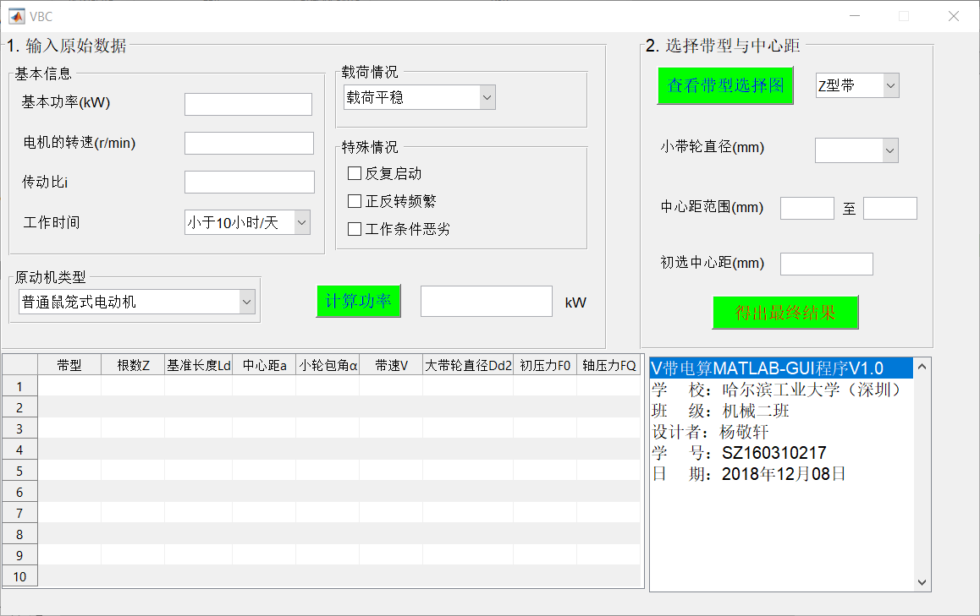
图2 程序初始界面

- 第二步，输入基本功率，电机转速，传动比，工作时间，原动机类型，载荷情况以及特殊情况，点击计算功率，得到设计功率，如图3所示。
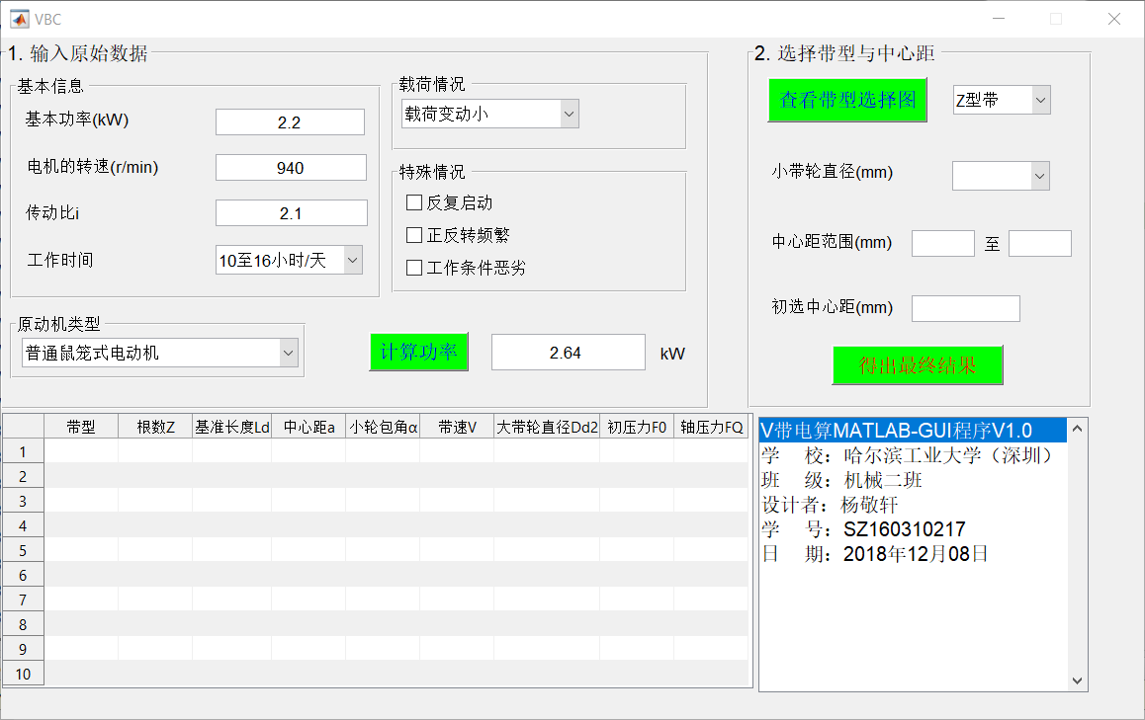
图3 程序运行第二步
- 第三步，点击查看带型选择图，则会弹出选型图片，如图4所示。选好带型后，关闭图片，将带型输入程序，程序自动匹配可供选择的小带轮直径，可以直接点选小带轮直径，如图5所示。
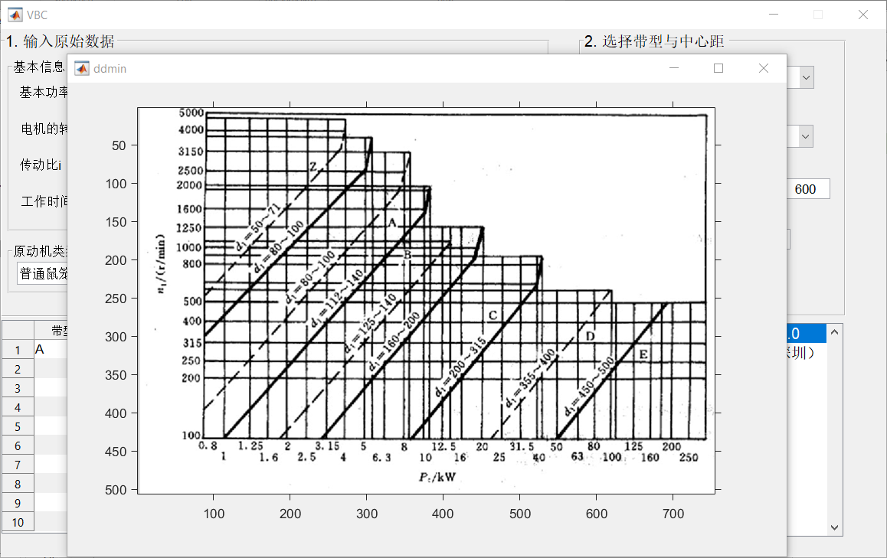
图4 程序运行第三步(a)

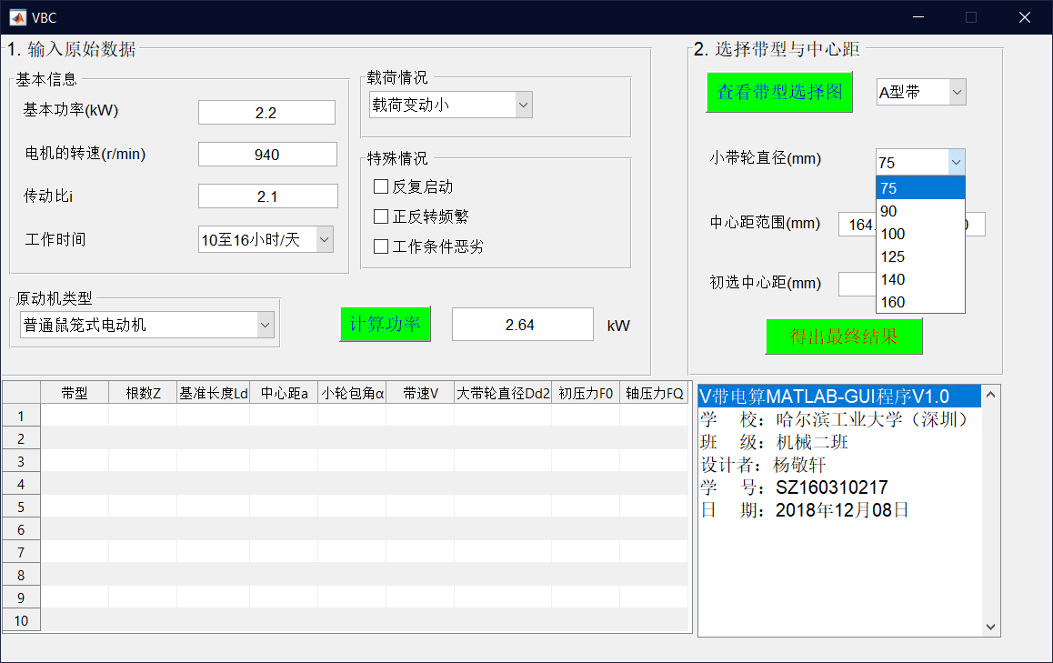
图5 程序运行第三步(b)
- 第四步，选好小带轮直径后，程序自动计算出中心距范围，在此范围选择合适的中心距输入程序，点击“得出最终结果”，则可以在程序左下方显示小带轮的各个参数，如图6所示。经检验，与大作业三手动计算的出的结果一致。
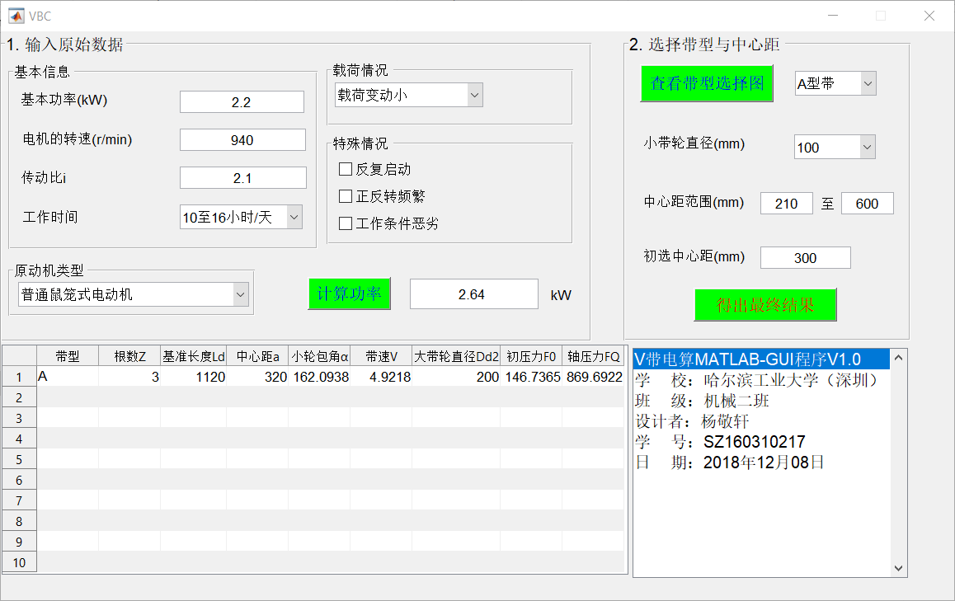
图6 程序运行第四步

- 第五步， 如果对初选结果不满意，可以随时更改任何参数，程序会自动重新进行运算，点击“得出最后结果”，就可以将结果输出在左下方的表格里，一次最多可以输出十组数据以供选择。运行示例如图7所示。
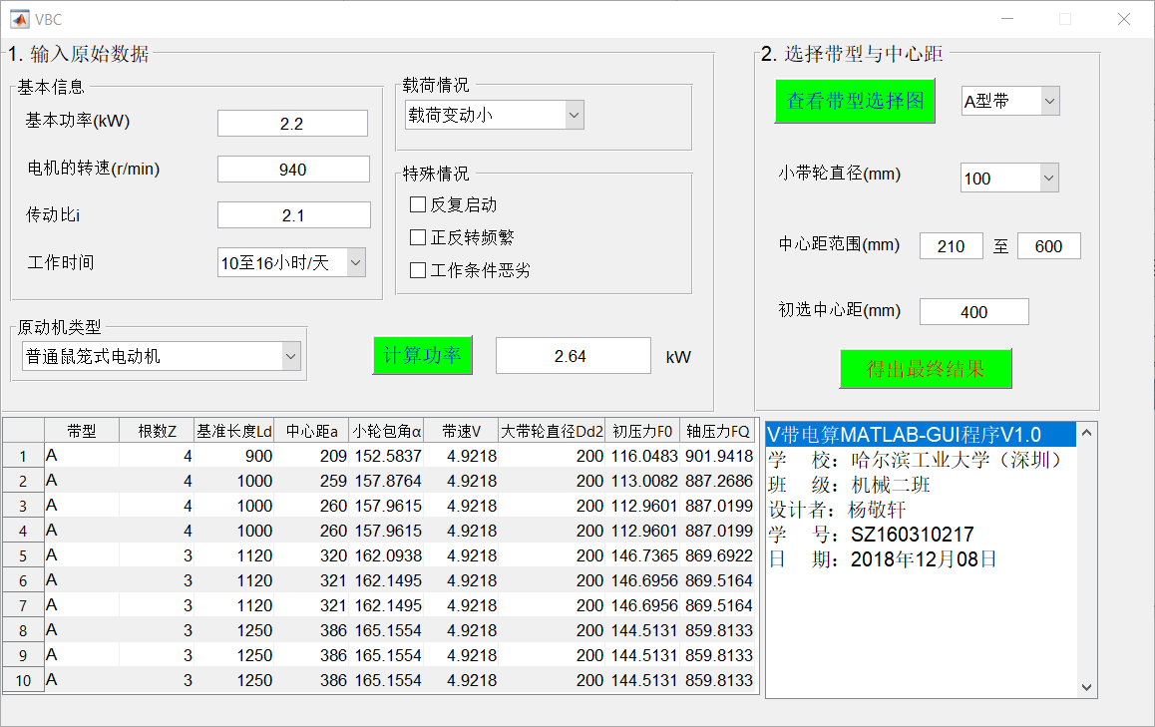
图7 程序运行第五步
- 总结
本次V带电算是一个综合性很强的任务，既需要对V带的设计过程了如指掌，也需要有比较强的编程能力。我从这次完整的电算训练中收获很大，不仅强化了对V带的设计过程中各个细节的理解，而且提升了编程实践能力，初步了解了MATLAB的GUI编程的概念与实现过程，这对将来解决工作中、科研中遇到的实际问题大有裨益。
- 参考文献
[1] 宋宝玉. 机械设计课程设计指导书[M]. 北京:高等教育出版社, 2016.
[2] 王黎钦, 陈铁鸣. 机械设计[M]. 哈尔滨:哈尔滨工业大学出版社, 2015.
[3] 王伯平. 互换性与测量技术基础[M].北京:机械工业出版社, 2017.
[4] 张锋, 宋宝玉. 机械设计大作业指导书[M]. 北京:高等教育出版社, 2009.
[5] 王熙宁, 袭建军. 画法几何及机械制图[M]. 北京:高等教育出版社, 2015.

