**Assignment 2 for BINF 8500**

**Summary table for Bacteria and Archaea K-means result:**

Table 1. Summary for K-means results

|  |  |  |  |  |
| --- | --- | --- | --- | --- |
| **k** | **MeanDisance** | **WCSS** | **AIC** | **BIC** |
| 1 | 4.4379 | 2580.0000 | 2620.0000 | 2677.3507 |
| 2 | 3.4886 | 1594.2814 | 1674.2814 | 1788.9828 |
| 3 | 3.1870 | 1330.5949 | 1450.5949 | 1622.6469 |
| 4 | 2.9403 | 1132.5120 | 1292.5120 | 1521.9147 |
| 5 | 2.7000 | 954.9834 | 1154.9834 | 1441.7369 |
| 6 | 2.5836 | 874.4281 | 1114.4281 | 1458.5322 |
| 7 | 2.4647 | 795.8002 | 1075.8002 | 1477.2550 |
| 8 | 2.3503 | 723.6439 | 1043.6439 | 1502.4495 |
| 9 | 2.2577 | 667.7373 | 1027.7373 | 1543.8935 |
| 10 | 2.1716 | 617.7568 | 1017.7568 | 1591.2637 |
| 11 | 2.0852 | 569.5979 | 1009.5979 | 1640.4555 |
| 12 | 2.0150 | 531.9053 | 1011.9053 | 1700.1136 |
| 13 | 1.9687 | 507.7385 | 1027.7385 | 1773.2974 |
| 14 | 1.9182 | 481.9885 | 1041.9885 | 1844.8982 |
| 15 | 1.8711 | 458.6482 | 1058.6482 | 1918.9085 |

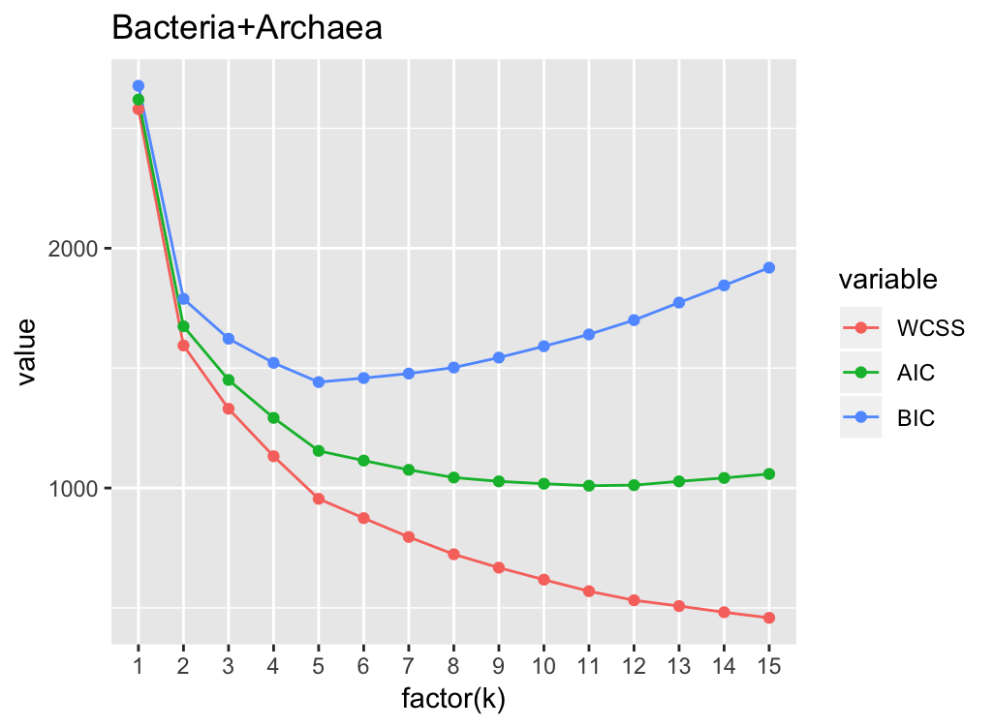

Figure 1. Visualized summary for K-means results. The lowest BIC locates at k=5.

Figure 2 shows the GC content and optimal growth temperature for each species, annotated with the cluster results from amino acid’ coordinates. Species in the 1st cluster have high GC content (around 60%-70%). Their optimal growth temperatures are variant, but most of them are relatively low. Species in the 2nd cluster have low to medium optimal growth temperature, and the GC contents are not far away from 50%, all of them under 60%. For the 3rd cluster, species have low optimal growth temperature (less than 45) and high GC contents around 60%. Species in the 4th cluster have low GC contents, mostly less than 40%, with large range of optimal growth temperatures. In the 5th cluster, species are mostly heat-resistant, with relatively high optimal growth temperatures. Their GC contents are medium, around 40% to 55%.

The clustering result reveals that both GC contents and optimal growth temperature could influence the amino acid preference. In addition, when the GC content is near 50%, optimal growth temperature tends to become the dominant factor for amino acid preference (Cluster 2 and Cluster 5). Otherwise, when the GC content is relatively far away from 50%, it becomes the most significant factor for amino acid preference (Cluster 4 and Cluster 1/3).

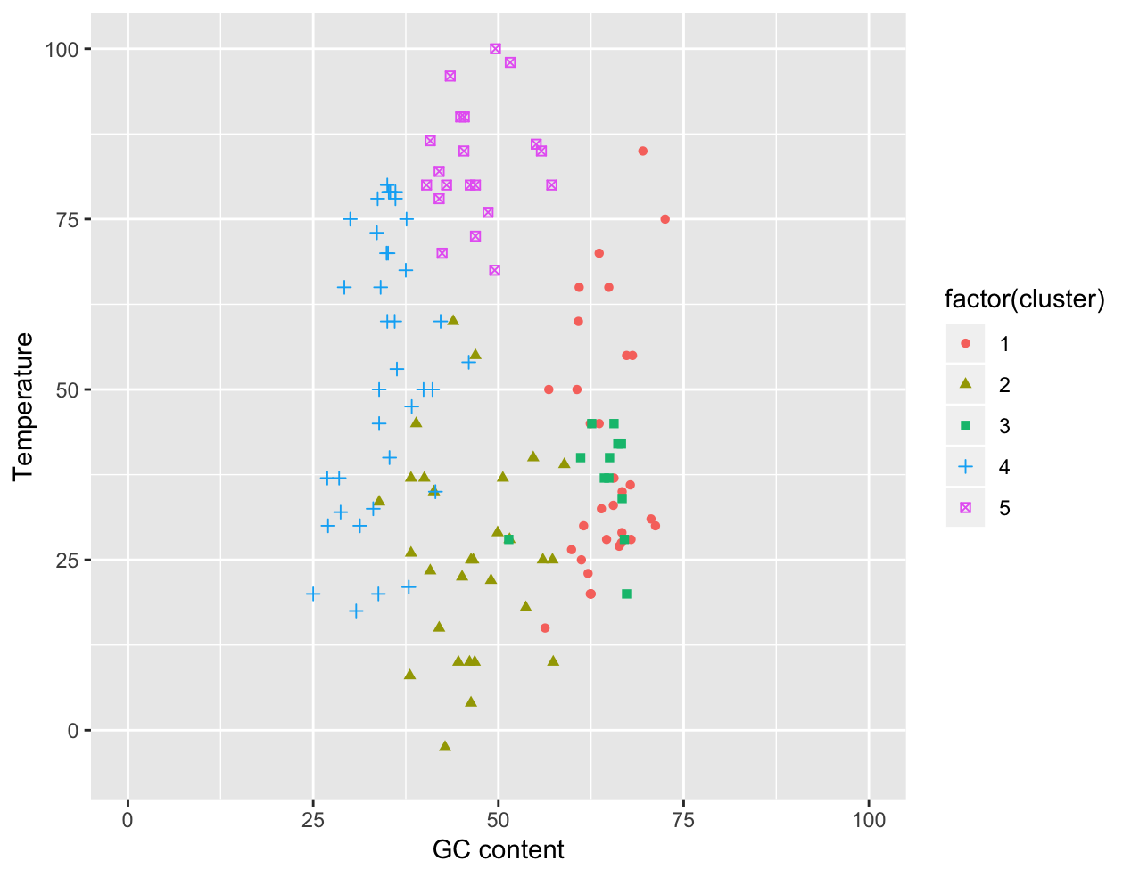

Figure 2. The dot plot showing clusters from amino acid preference are related to GC content and growth temperature