Process Book

Jinkyu Na  
Mengqiao Wang  
Jingyang Zhao

**Overview**

We collect the data from Kaggle. This dataset contains the basic game information, how many games released in each year, their sales amount in each region, the score of games, and publishers and developers of games.

**Research Question**

There were three questions we wished to answer by using our data visualization. The first question was the relationship between the video game platform and the amount of games produced. By our assumption, the number of video games released will be strongly connected with the popularity of video game platform. It is because the video game industries won’t consider investing large amount of money for the platforms that are not currently popular.

Our second question is the relationship between the genres of video games and the regions. Popular game genre may be different by regions. For example, Halo, a shooting game, is one of the leading game series in America, but it may not be a popular game in Japan.

The third question is the total sales of game industry by years. This question will also include the factors we used for the first and second question. This means we are also interested in not only finding the amount of total sales, but also finding the amount of platforms, amount of games, or by genre. In this way, we can compare which platform of games were produced or sold the most, so that we can approach closer to figure out what type of factors eventually affected in the change of sales.

**Acquire the Data**

We first realized that there are many missing values in the database, and not all the variables are we needed. Thus, we deleted the missing values and useless variables. We also found that there are many type of platforms in the database, but some of the platforms are same type with different versions. Thus, we grouped the platforms by types.

**Sketch of our dashboard**

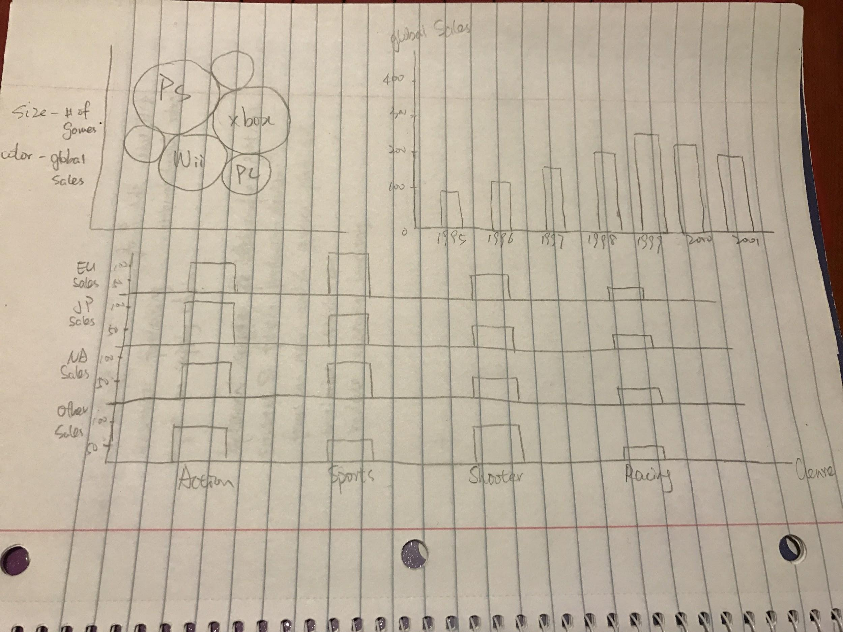

**Evaluation**

From the visualization we created, we were able to figure out several interesting points.

* Playstation platform was a bigger and more popular platform than X-Box platform. Playstation also had more number of video games released than X-Box.
* Action genre recorded the first in global video game sales. Shooter and sports were the followings. However, this was exceptional in Japan. Japan’s top preference for video game genre was role-playing, and action came after. Shooter game was found not to be popular in Japan.
* From the sales bar chart, we can notice a difference in sales pattern by looking at the comparison between the sales record of Xbox and Playstation. Playstation was at its peak from 2000 to 2005, and X-Box started to rise from 2007. In such relationship, we can assume that there may be some factors that affected video game players to move from Playstation to X-Box. It may be that a newly introduced X-Box platform was on a big hit, or a newly introduced X-Box based game had a big hit.
* Comparing the genre by platforms, we can also notice that X-box sold more shooter games, whereas Playstation sold more action games.