**Process Book: Video Games Analysis**

Jingyang Zhao

Mengqiao Wang

Jinkyu Na

**Overview**

Our group’s data is about the video game industry, and the different video games’ genre, rating, and the sales based on five different region. With using and analyzing the data, we are expecting to analyze the business patterns of video games. Some examples of patterns will be to determine any dominant series of games, genre, or platform in different countries, or any other trend inside the video game industry. Moreover, our group expect to answer our research questions, and possibly, to suggest any data recommendations to those who are considering of purchasing video games, or even to those who are belonged to the business of video game industry.

**Research Questions**

There are three questions we are looking for. The first question is regarding to the genre and the platform of video games, and the relationships between the factors with sales in each region. We assume that some genres are famous in certain region. For example, games that are produced or famous in the United States are mostly actions, or shooter games. But the case is different in Japan, where role-playing games tend to be more popular. Moreover, the type of platform will also matter. Having Xbox and Playstation as examples, Xbox is an American-based platform and Playstation is Japanese-based. If the sales of video game by genre has difference, the sales of each platform may be affected.

Our second question is the relationship of the result of first question with publishers and developers. Some publishers and developers will be experts in the specific industry, so it is possible that several publishers and developers will be dominant in certain genres or platforms. This will be a helpful source to the video game business, as the game published or developed by the dominant publishers and developer would have higher chances of producing benefits.

The third question is the combination of the previous two questions. It specifically focuses on the current trend of genres and platforms, and the scores of individual games from the users and the Metacritic source. With having a visualization showing which games are in trend, we can determine which games take the role as a ‘joker’. We are assuming that some game brand is dominant in the market, and will gigantically increase the sales when it releases. Comparing the data with the user and metacritic scores, we would be able to figure out the trend and dominant game brands.

**Acquiring the Data**

We first realized that there are many missing values in the database, and not all the variables are we needed. Thus, we deleted the missing values and useless variables. We also found that there are many type of platforms in the database, but some of the platforms are same type with different versions. Thus, we grouped the platforms by types.

**Sketch of our dashboard**

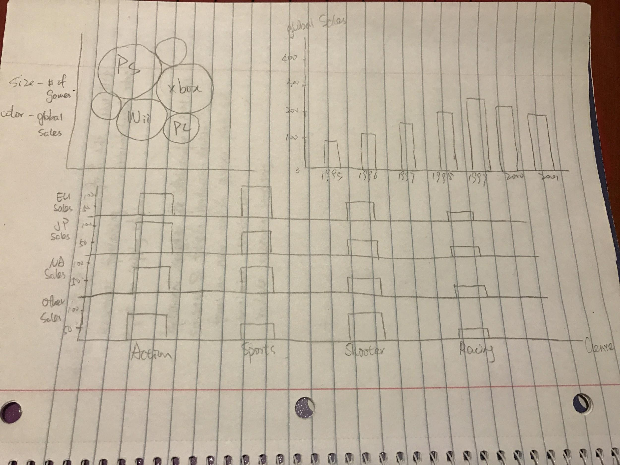

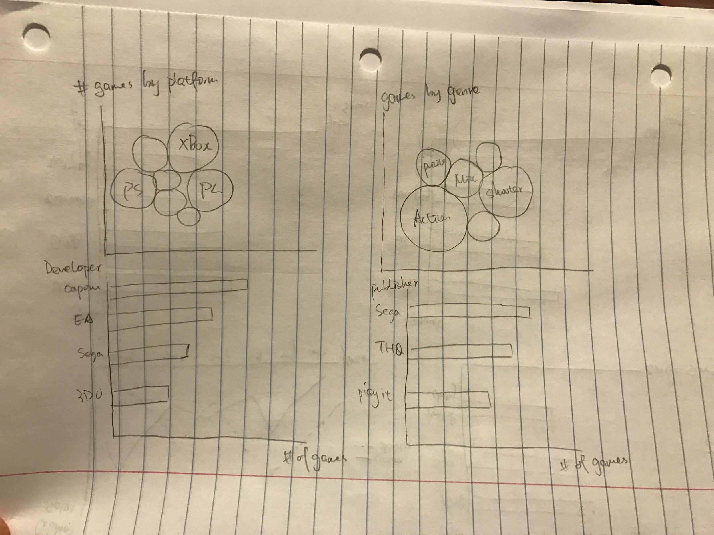

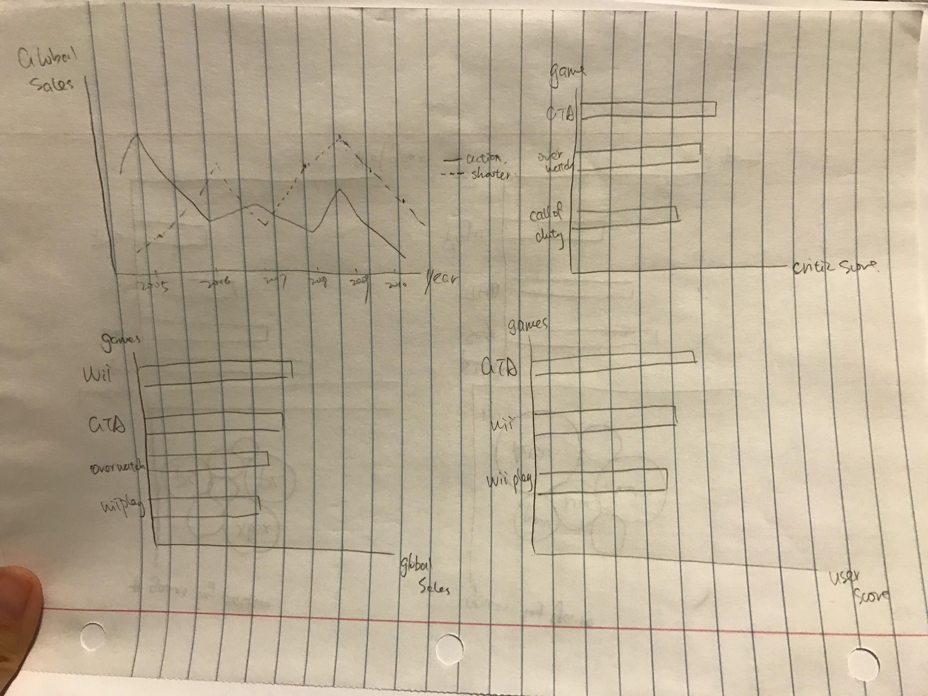

**Result**

**The first Question- How genre and platform of video games distribute the sales?  
(Appendix #1)**

To answer the question, we firstly created a visualization that shows genre and platform distributions in different regions. The regions in our data includes North America (NA), Europe (EU), Japan (JP), Other regions, and the Total sales. The result told us that Playstation platform was a bigger and more popular platform than XBox platform. Playstation also had more number of video games released than XBox.

Action genre recorded the first in global video game sales. Shooter and sports were the followings. However, the result was exceptional in Japan. Japan’s top preference for video game genre was role-playing, and action came after. Shooter game was found to be unpopular in Japan.

From the sales bar chart, we can notice a difference in sales pattern by looking at the comparison between the sales record of Xbox and Playstation. Playstation was at its peak from 2000 to 2005, and XBox started to rise from 2007. In such relationship, we could assume that there may be some factors that affected video game players to move from Playstation to XBox. It may be that a newly introduced XBox platform was on a big hit, or a newly introduced X-Box based game had a big hit.

**2. Second Question- Which developers and publishers are experts in different genre and platform? (Appendix #2)**

After figuring out the relationship about sales with genre and platform, we want to know which developers and publishers are experts in different genre and platform. Developer meas those companies who develop these games and the publisher mean those companies who publisher games. Obviously, publisher will publish the game either developed from their own or from other companies. Therefore, there are some companies are both publisher and developer.

At an unfiltered result (meaning the total result) Capcom was the developer who published the most games. Electronic Arts (EA) was the publisher who developed the most games.However, the result changes as we apply genre and platform filters. In action Genre, Omega Force and Ubisoft was the publisher and developer, respectively, who produced the most games. Omega Force is a Japanese brand producing action games, including the ‘Dynasty Warrior’ series. Ubisoft is a French game developing company. Its famous action game includes Assassin’s creed series, and Far Cry series. Furthermore, we could also find that Omega co-worked most of their action game with Tecmo Loel. But Ubisoft mostly worked with its subsidiary companies.

The platform filter showed interesting fac. Having Xbox platform as an example, we could find that EA was the dominant game publisher and developer in Xbox platform. The result was surprisingly almost identical in Playstation filter. We first assumed that American platform will rely more on the American and Western publishers and developers, but Japanese platform will rely more on Japanese companies. But as the result displays, EA can be determined as a dominant game publisher and developer in the video game industry.

**3. Third Question- What games are dominant in the market, and the trend of each genre. (Appendix #3)**

Finally, we checked marketing status about each games,or what games are dominant in the market. To find out answers, we firstly went over the trend of each genre and score of each games. From the trend, we could see which genre recorded the highest sales each year, and which game eventually boosted the high sales. The score of games will show which games were well-designed and receive higher scores. By combining trends and scores, we can recognize famous games publish a new version will lead to a relatively high global sales of the year. However, we could also find that the top-selling games do not necessarily have the highest score. For example, in 2006, sports recorded the highest global sales. It was the year that Nintendo Wii Sports released. This was a newly introduced game equipment, as the players used the remote control to actually make motions, such as swinging the remote. Therefore, we assumed that this different approach attracted players to try the new game. But the score of this game was eventually lower than the games published in the same year.

There are several specific years where the sales of genres noticeably increased. Sport genre is 2006 was one of the cases. For action genre, the year of 2002, 2008, and 2013 were specifically recorded with high number of sales. By tracking each year, we could find that the specific year was when the Grand Theft Auto (GTA) series were released. By this result we could conclude that GTA series are the dominant action game series, and it even breaks the trend of genre (Year 2008). Shooter genre recorded high sales in 2007 and 2011. In these years, the Call of Duty series were released. This tells that Call of Duty series is the most popular shooter game in the industry.

**Conclusion**

From our answers of three questions above, we ended up with several significant stories.

* Playstation was a most popular platform in the world, and follows Xbox
* It was difficult to determine which genre is the most popular. It was mostly determined by which dominating game genre are released in the year.
* The United States and Europe generally had identical video game preferences (genre and platform). Japan showed a completely different pattern from the Western market.
* Electronic Arts was the dominant game publisher and developer. But the result varied slightly based on the genres. Japanese publishers and developers stood out dominantly in role-playing genre, which was a more popular genre in Japan.
* Game scores from the users and metacritic did not link significantly to the sales of game (Nintendo Wii). But it could be said that video games with high sales typically recorded high user and metacritic score.
* Grand Theft Auto (GTA) series was the dominant video game in action genre, and Call of Duty series was dominant in shooter genre.

Even though role-playing genre was generally more popular in Japan, the leading role-playing games were the ones published and developed from Western world.

Appendix #1: The Sales of video games with different genre and region

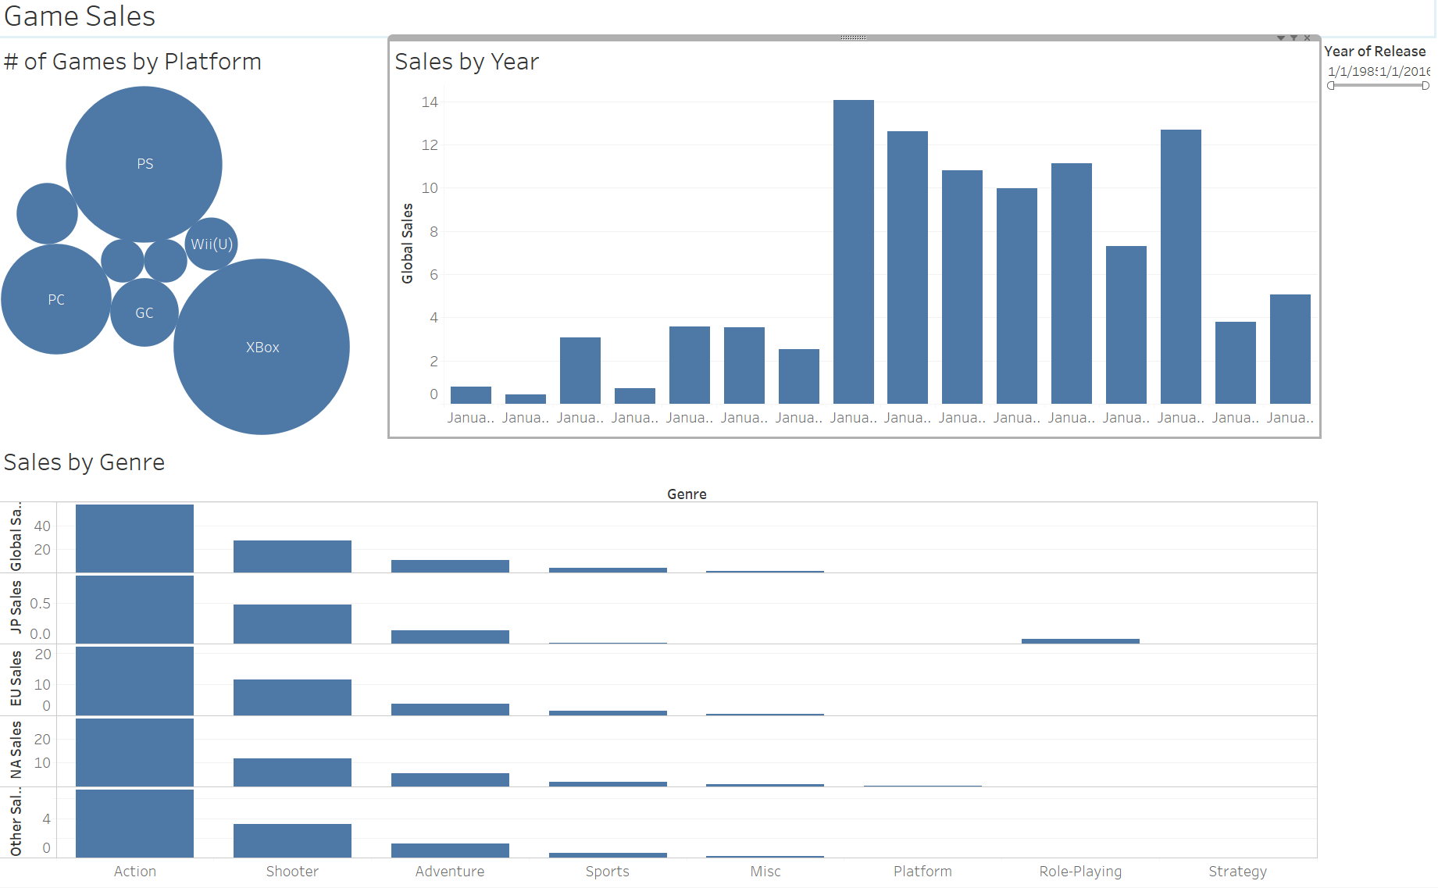

Appendix #2: The developers and publishers of different video games with different genre and platform

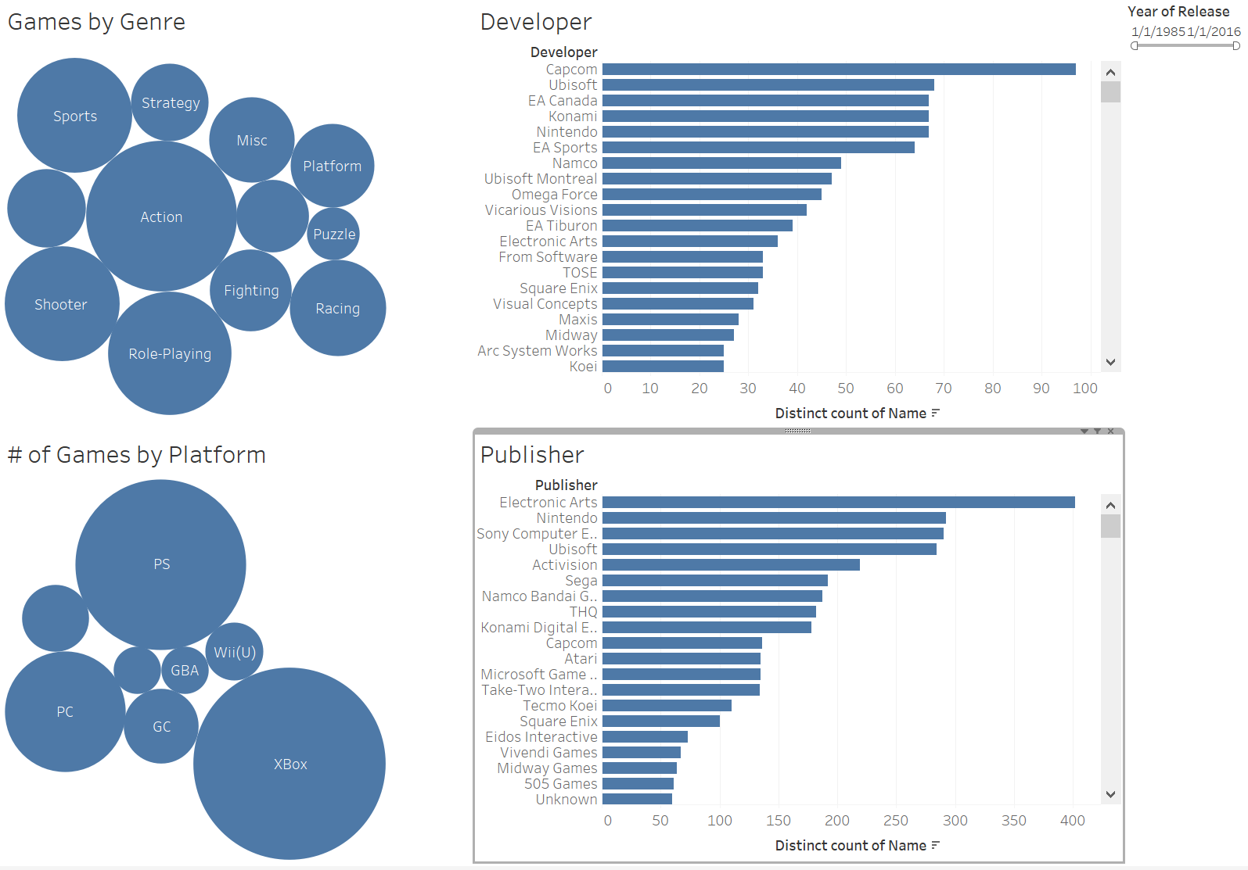

Appendix #3: The sales of different genres by year, and the following game’s user and metacritic score

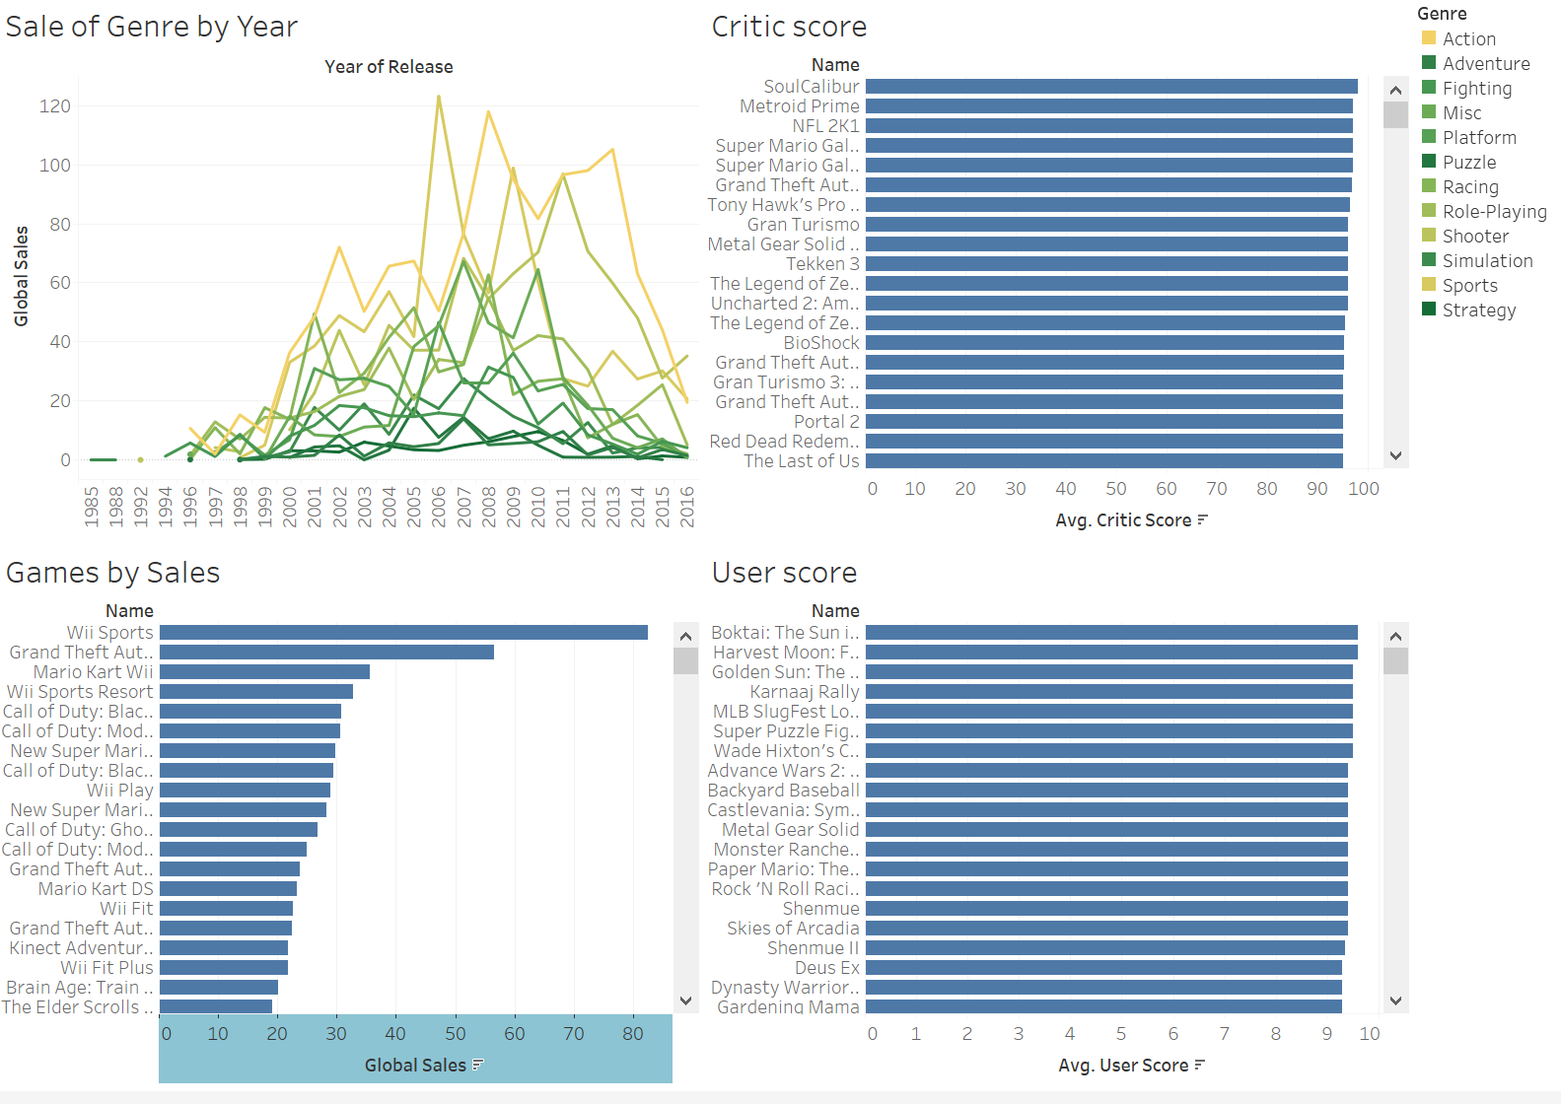

<https://public.tableau.com/profile/publish/Games_Final/Games#!/publish-confirm>