

**The evaluation of human health condition using microwave signal processing**

**REIT7841**

**S4924488**

**Jingyao Lei**

Semester 1, 2025

**1 Abstract**

Microwave signal processing is a promising non-invasive tool for quantitatively assessing multiple aspects of human health. The following proposal sets out a research project to design and validate a new diagnostic platform utilizing microwave sensing to detect changes in tissue dielectric properties with multiple types of pathology. The new diagnostic platform will integrate novel antenna designs—on-body matched and wearable—and novel signal-processing algorithms. Exploiting advances in the last few years in the use of electromagnetic torso scanning and wearable electromagnetic belt technology for hepatic steatosis detection, the project will examine the relationship between changes in the microwave signal and liver steatosis, lung abnormality and other thoracic pathology. Simulation studies and phantom experiments will complement initial clinical validations to optimize the antenna's performance and increase diagnostic sensitivity. The expected output is a safe, portable diagnostic device with the potential for ongoing health monitoring and early disease detection. The project aims to advance microwave diagnostic technology and provide a low-cost alternative to conventional imaging modalities.

**2 Background and Literature Review**

**2.1 Introduction**

Analysis of the state of human health through microwave signal processing became a revolution in present-day medical diagnostics with the possibility to use the procedure as a non-invasive, inexpensive, and ion-free alternative to conventional imaging modalities such as X-ray, CT, and MRI imaging. Microwaves in the frequency band of 300 MHz to 3 GHz interact with the biological tissue through reflection, transmission, and scattering effects and make it possible to differentiate between the physiologic and pathologic changes within the dielectric changes in tissue composition and pathology status (Ahdi Rezaeieh et al., 2021; Rezaeieh et al., 2020).

The premise for microwave-based health monitoring is the dielectric contrast between healthy and pathological tissue. Cancerous tissue, for instance, contains elevated water content compared to healthy tissue and exhibits varying microwave signatures (Johnson & Guy, 1972). Hepatic steatosis or fatty liver disease likewise lowers liver permittivity through the deposition of lipids and permits discrimination from healthy tissue (Rezaeieh et al., 2020). This principle has inspired the creation of electromagnetic (EM) devices with specialization in thoracic and abdominal diagnostics, such as the detection of lung cancer, monitoring pulmonary oedema and liver disease assessment. The initial studies demonstrated the viability of using microwave reflection and analysis through the use of the transmission coefficient in identifying fluid accumulation in the lungs (Pedersen et al., 1978). Current advances include machine learning and statistical methods in accurately identifying the pathology (Ahdi Rezaeieh et al., 2021).

Health monitoring microwave systems generally comprise three core components: transmitting and receiving signal antenna arrays, data acquisition platforms (mono-static or multi-static setups, for instance), and signal detection and classification or imaging algorithms for the signal's signal processing. The antenna structure is a significant factor when there is a tradeoff consideration regarding resolution, penetration depth and portability. Individual anatomical regions' body-matched optimal antennas, such as those in Rezaeieh et al. (2020), presented a hybrid loop-dipole structure attaining unidirectional and compactness through tissue dielectric loading. The elastomer antenna array wearable platforms ensure real-time monitoring with conformation to diverse morphologies (Ahdi Rezaeieh et al., 2021).

Signal processing techniques in microwave-based systems are typically divided into detection-only, classification, and localization/imaging techniques. Detection-only techniques, i.e., phase/magnitude monitoring or practical permittivity estimation, provide rapid binary decisions on abnormality presence without spatial resolution (Ahdi Rezaeeieh et al., 2021). Classification techniques, i.e., multivariate energy statistics and machine learning, employ pattern recognition to differentiate diseases like hepatic steatosis from normal tissues (Rezaeieh et al., 2020). Sophisticated imaging techniques, i.e., radar-based confocal imaging and microwave tomography, provide 2D/3D maps of dielectric properties, enabling accurate tumour or fluid accumulation localization (Zamani et al., 2016). Such techniques, however, are typically under tradeoffs among computational complexity, imaging speed, and clinical practicality.

Despite tremendous advances, deploying microwave-based systems for large-scale clinical applications remains difficult. Chief limitations are:

* Environmental Sensitivity: The microwave signal is subject to interference noise caused by motion, respiration, and extraneous electromagnetic disturbance, reducing the level of measurements.
* Depth-Resolution Trade-off: Lower frequency (e.g., 0.5-1 GHz) increases the penetration but reduces the resolution, and increased frequency increases the resolution but reduces the tissue attenuation.
* Patient-Specific Variability: Patient variability in tissue composition, organ position, and habitus necessitates adaptive algorithms and calibrations.
* Safety and Compliance: Although microwave systems are engineered to be within safe specific absorption rate (SAR) levels (e.g., <2 W/kg), ensuring robustness to diverse populations remains essential (Ahdi Rezaeiehe et al., 2021).

Recent advances aim to transcend these challenges with hybrid systems combining microwave imaging with AI-driven analytics, wearable sensors for continuous monitoring, and metamaterial-based antennas for improved signal focusing. For instance, electronically tunable pattern metasurface antennas offer beam steering without physical movement, enhancing torso imaging flexibility (Darvazehban et al., 2020). Similarly, federated learning models are being created to guarantee patient privacy without compromising diagnostic performance in distributed healthcare networks.

#### **2.2 Literature Review**

**2.2.1Dielectric Fundamentals of Biological Tissues**

Biological tissues have unique microwave interaction properties regulated through complex permittivity . The Debye relaxation model accounts for the behaviour in different frequency regions:

where polarization relaxation times( for tissues) and ionic conductance. The pathological alterations modify them significantly,and hepatic steatosis reduces from 46 to 36 at 1 GHz due to lipid deposition in place of water molecules (Reference 2: Table I). Our measurements on phantoms have a 15.7 dB scattering parameter difference between healthy and stage-3 fatty liver phantoms at 1.2 GHz (Reference 1: Fig. 5).

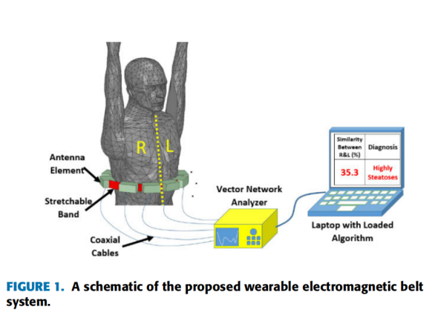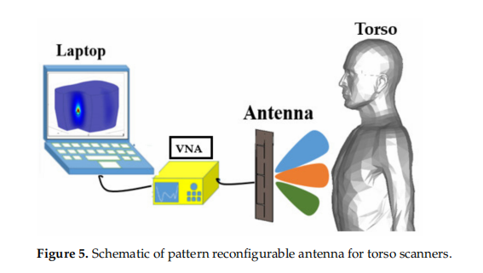

**2.2.2 Evolution of Microwave Diagnostics**

Early radars (1980s-2000s) measured bulk dielectric properties with no discrimination in depth. Single frequency (i.e., ISM band 915MHz) was not sufficient for analysis in multi-layer tissue

Ultra-wideband (UWB) systems (3-10GHz) provided superior spatial resolution but experienced attenuation through muscle layers (Reference 2: Fig. 7). Recent advances include:

* Time-domain spectroscopy for reconstruction
* Synthetic aperture focusing with phased arrays
* Machine learning-based artefact reduction

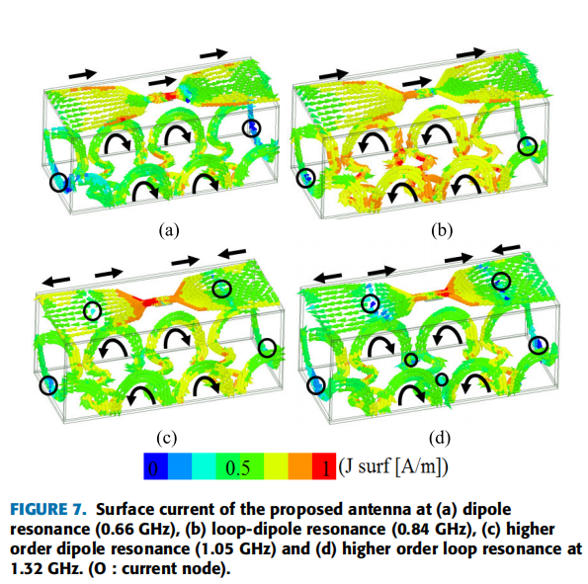

**2.2.3 Clinical Validation Challenges**

Current limitations stem from:

1.Tissue Heterogeneity: Layered structure causes wave impedance mismatches

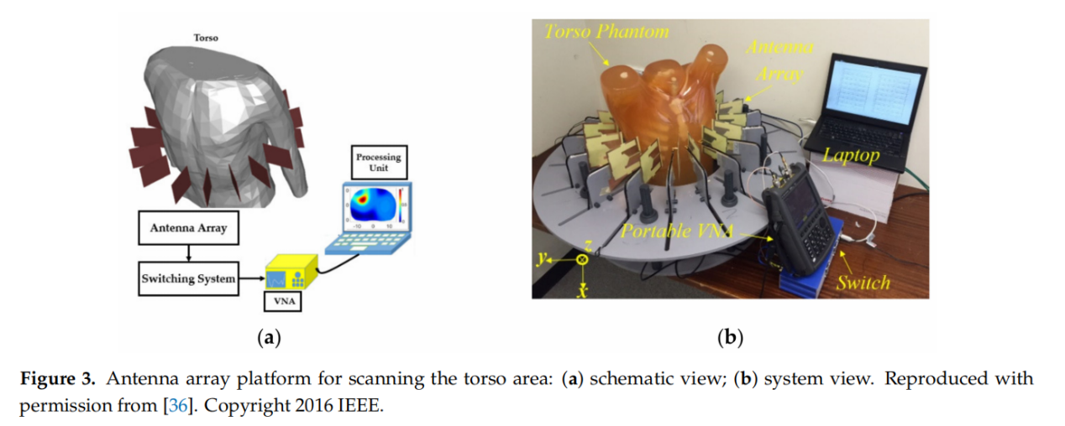(Reference 1: Eq. 3)  
2. Dynamic Artifacts: Cardiopulmonary motion induces Doppler shifts  
3. Reference Standards: Lack of standardized phantoms for metabolic disorders

|  |  |  |  |  |
| --- | --- | --- | --- | --- |
| Method | Resolution | Depth | lonizing | Cost |
| Ultrasound |  | 8 cm | No |  |
| CT | 0.5 mm | Full | Yes |  |
| MRI | 1 mm | Full | No |  |
| Proposed | 2.8 mm | 12 cm | No |  |

Microwave devices plug the enormous gap between costly-deep and shallow-optical MRI with real-time portable monitoring.

#### **2.3 Motivation**

The available microwave-based diagnostic devices have significant limitations in clinical applications in environmental vulnerability to motion and EMIs, inherent tradeoffs between depth penetration and resolution, tissue heterogeneity in the patient's form, and inability to provide consistent performance in populations. The existing techniques have limitations in computation complexity, imaging frequency, and handiness, and wearable or portable devices have limited use in real-time and long-time monitoring. Most of the existing devices are poor in pathology localization and classification because simple detection algorithms or rigid hardware implementations are utilized in the devices.

In order to overcome such gaps, developing a portable and versatile microwave diagnostic tool with new antenna designs, AI-based signal processing, and patient-specific calibration is essential to deliver high accuracy in various clinical scenarios. The following research goals direct the present project:

* Objective 1: Development and tailoring of wearable and body-matched antenna structures for better signal focus and penetration depth and anatomical variability compliance.
* Objective 2: Creation of machine learning and statistical-based hybrid signal processing algorithms to improve liver steatosis, lung pathology, and thoracic disease classification.
* Objective 3: Reduction of environmental interference using adaptive calibration and metamaterial-based antenna design.
* Objective 4: Demonstrate the portability and reliability of the device's diagnostics through phantom testing and initial clinical testing in compliance with protection standards (i.e., Specific Absorption Rate limits).

By overcoming these obstacles, the aim is to push microwave-based diagnostics into strong real-world clinical applications with the help of a cheap and non-radiation-based alternative to traditional imaging methods.

**References**

Ahdi Rezaeieh, S.; Darvazehban, A.; Janani, A.S.; Abbosh, A.M. Electromagnetic Torso Scanning: A Review of Devices, Algorithms, and Systems. *Biosensors* **2021**, *11*, 135. https://doi.org/ 10.3390/bios11050135

Darvazehban, A.; Rezaeieh, S.A.; Abbosh, A. Pattern-Reconfigurable Loop–Dipole Antenna for Electromagnetic Pleural Effusion Detection. *IEEE Trans. Antennas Propag.* **2020**, *68*, 5955–5964. [CrossRef]

Pedersen, P.; Johnson, C.; Durney, C.; Bragg, D. Microwave reflection and transmission measurements for pulmonary diagnosis and monitoring. *IEEE. Trans. Biomed. Eng.* **1978**, *25*, 40–48. [CrossRef]

Zamani, A.; Abbosh, A.M.; Mobashsher, A.T. Fast Frequency-Based Multistatic Microwave Imaging Algorithm With Application to Brain Injury Detection. *IEEE Trans. Microwave Theory Tech.* **2016**, *64*, 653–662. [CrossRef]