Assignment

Part1:

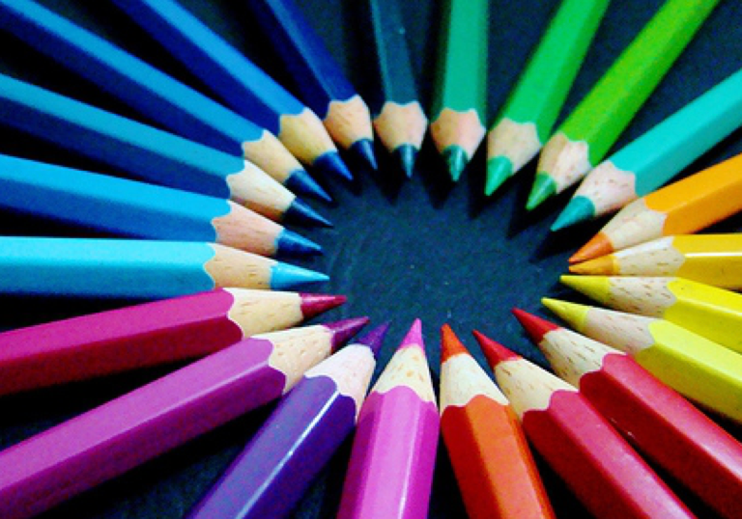

reconstructed pic original pic

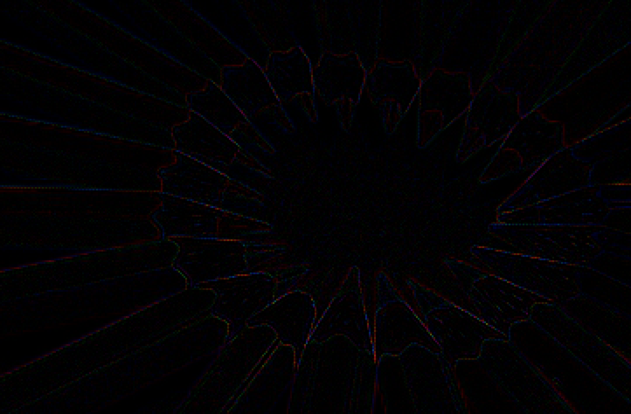

we can see from the third picture. Around edge of objects, there are some line around them. In my view, the reason of it is that when I process the image, some numbers are lost and I did not deal with edge problem.

Part 2:

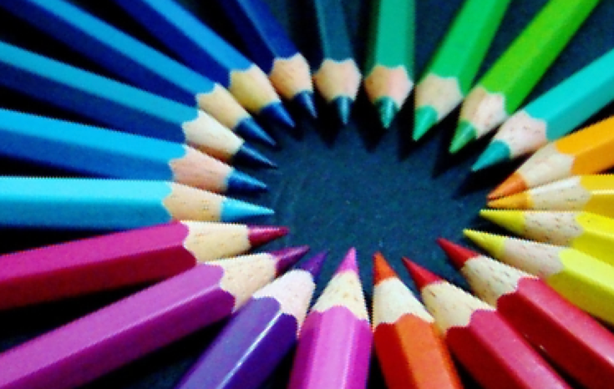

Compared with reconstructed picture in part one, we can see the improvement of this method. The picture is more clear and we can see more detail of objects.

In order to simplify the appearance of the coding, I made a class called “BayerToBGR”. Here are the main functions that I implemented:

**void** changeGreen(Mat &image); *// transform a picture into a matrix that only has green pixels***void** changeRed(Mat &image); *// transform a picture into a matrix that only has red pixels***void** changeBlue(Mat &image); *// transform a picture into a matrix that only has blue pixels***void** description(Mat &image); *// help you to see the matrix of your image;***void** filter(**float** kernel_data[], Mat &image); *// filter2D***void** showNewPictures(String name, Mat &image); *// show an image in a small window***void** testFirstPart(Mat &image, Mat &image1, Mat &image2); *// to show an image that is a subtraction of original image and reconstructed image***void** modifiedColor(Mat &image1, Mat &image2, Mat &image3); *// a modified image*