Libraries:
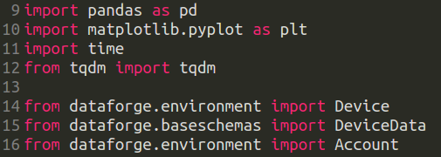

Function getDevices():

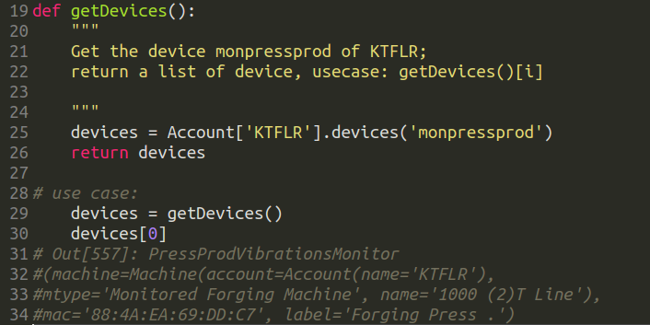

Function printStrokes():
Explication:
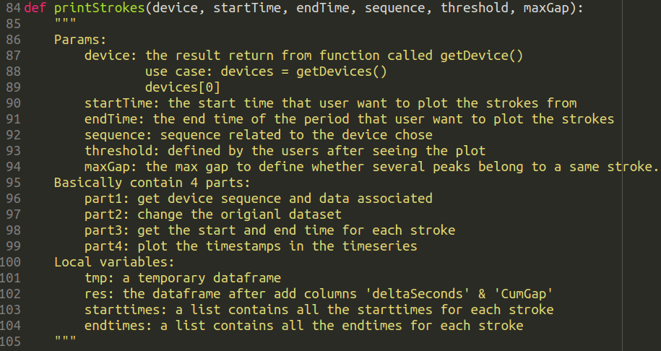

Part1:
Get device sequence and data
data:
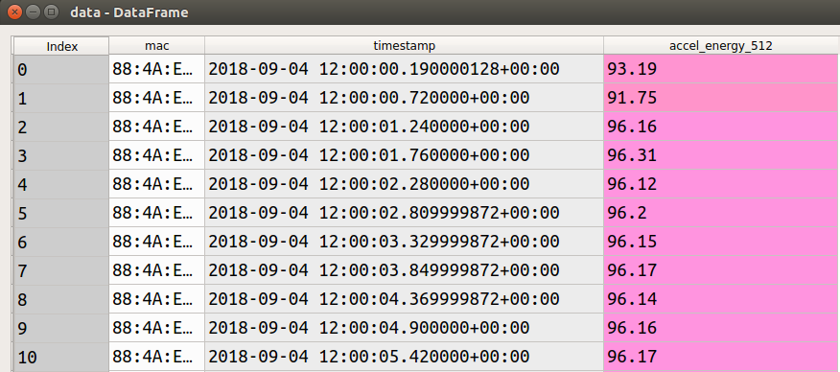
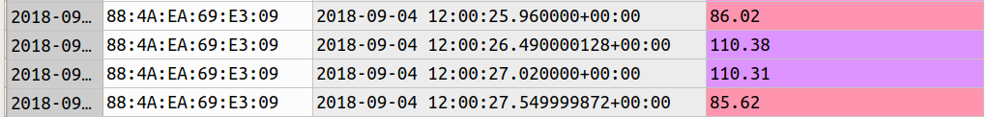

res:
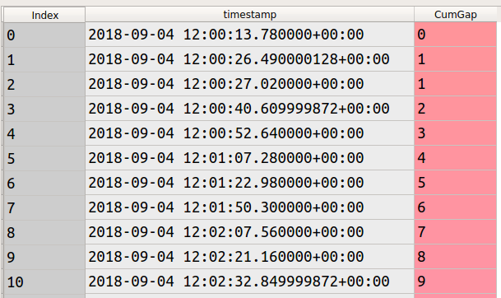
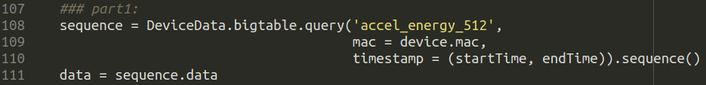

res[‘timestamp’].groupby(‘CumGap’)

grouped = res.groupby(‘CumGap’)

boundaries = [(df.index[0], df.index[-1]) for df in grouped.values()]

Part2:
Change on the original data
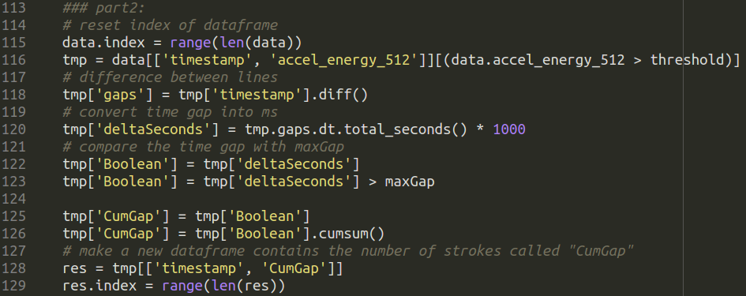

Part3:
Get start and end time for each stroke
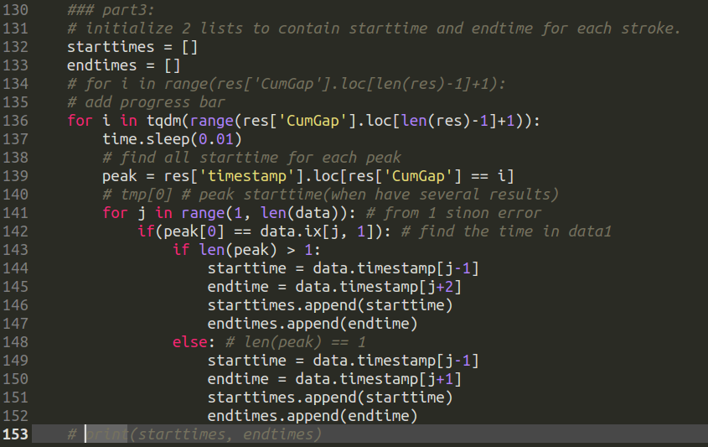
Part4:
Plot the sub-zone: each stroke
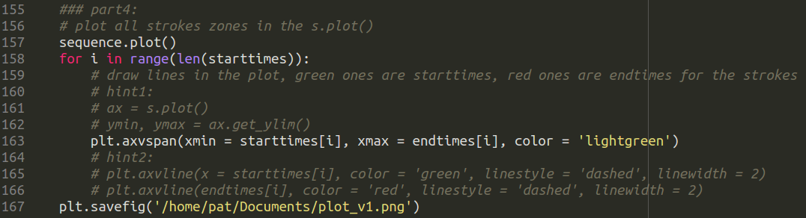

Input variables:
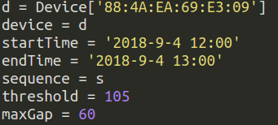

Call function:

Result:

running:
finish:

plot:
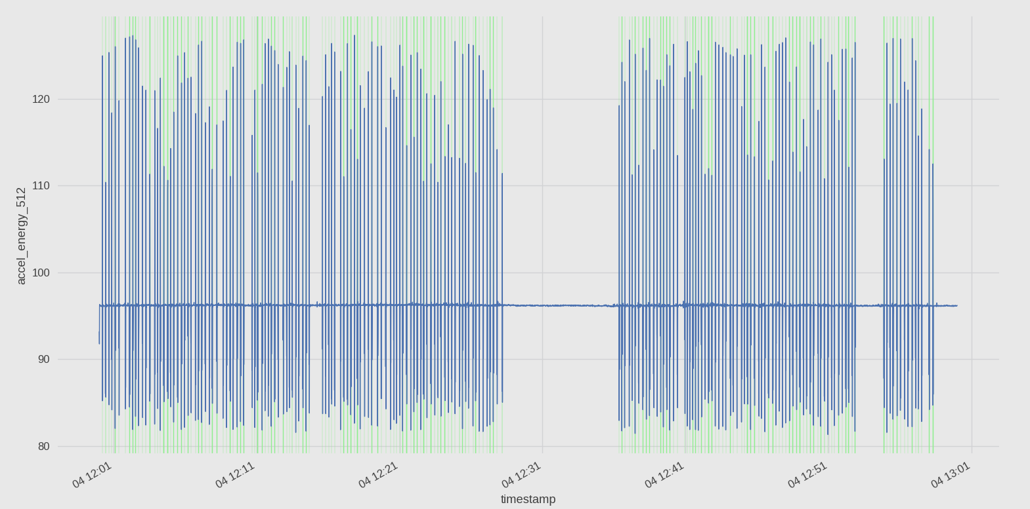
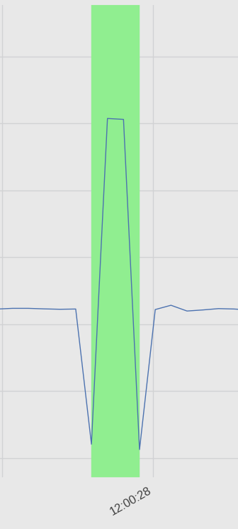

# find threshold:
with sns
