**Tax Reform in a Heterogeneous Agent Model**

1. **Introduction**

This paper studies the effects of a tax reform that increases the progressivity of the labor income tax in an economy with heterogeneous agents. In our model, households maximize expected CRRA utility subject to a borrowing constraint, while facing idiosyncratic productivity shocks. Firms produce output according to a Cobb-Douglas production function, and the government finances its purchases using tax revenues collected from labor income. We compare two tax regimes: a flat tax (λ = 0) and a progressive tax (λ = 0.15) under the calibration targets of an equilibrium interest rate of 0.04,a wage normalized to 1, and a government purchases-to-output ratio of 0.2.

1. **Model Description**
   1. Household Problem

Households maximize expected utility：

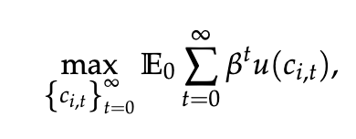

With CRRA utility function:

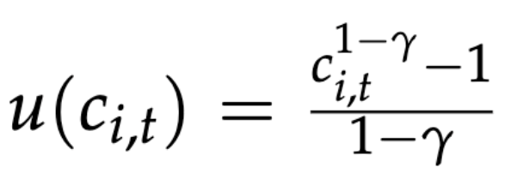 γ=2

Households face the budget constraint:

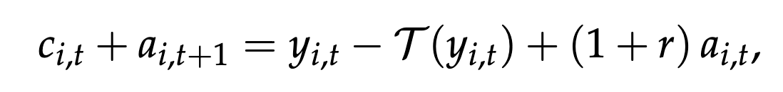

where labor income is ( y_t = z_t ) (with wage normalized to 1) and T( y_t ) is the tax function. In our formulation the tax function is given by:

T(y)=y−(1−τ)y ^(1−λ)

so that the post-tax income is:

$\overline{y}$ =(1−τ)y ^(1-λ)

For λ = 0 the model reduces to a flat tax with:

$\overline{y}$ =(1−τ)y

2.2 Productivity Process

The idiosyncratic productivity shock z_t follows an AR(1) process in logs:

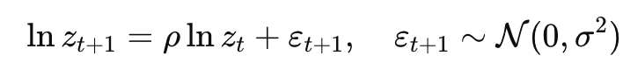

with ρ = 0.9 and σ = 0.4 . Using Tauchen’s method with 5 nodes, we discretize the process and normalize the states so that the mean of z is one.

2.3 Firm Problem

The representative firm produces output according to:

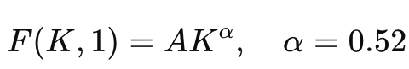 α= 0.467

with total factor productivity A=1 and depreciation rate δ=0.1 The first order condition for capital gives:

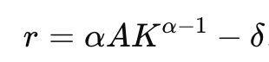

Given the target interest rate r = 0.04, we solve for Kand determine the corresponding wage w (which is normalized to 1 in calibration).

2.4 Government and Market Clearing

The government collects tax revenue from labor income. Under the flat tax regime, the average tax revenue is simply G =τ and we choose τ such that G/Y=0.2. In the progressive tax case (λ = 0.15), τis adjusted to keep government revenue unchanged:

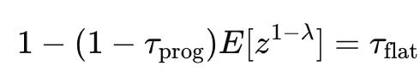

Market clearing in the asset market requires that the aggregate asset demand of households equals the capital supplied by firms.

**3. Calibration and Numerical Methods**

3.1 Calibration

We use the following calibrated parameters:

- Discount factor: β= 0.96

- Relative risk aversion: γ= 2

- Persistence: ρ= 0.9

- Shock volatility: σ= 0.4

- Capital share: α= 0.52

- Depreciation rate: δ= 0.1

- Productivity level: A= 1

- Labor supply: L=1

For the flat tax case (λ = 0), the target interest rate is r = 0.04 and the government revenue-to-output ratio is 0.2, implying a flat tax rate τ_flat = 0.2 Y where Y = A K^α

3.2 Numerical Methods

We solve the household problem using value function iteration over a non-uniform asset grid (150 points, with a grid concentrated at low asset levels). The Bellman operator is iterated until convergence, and the optimal policy function is extracted. The transition matrix is constructed based on the policy function and the productivity Markov transition matrix; its dominant eigenvector yields the stationary distribution. Using the steady state, we compute aggregate asset demand and compare it with the firm's capital supply. The Gini coefficients for both asset holdings and after-tax labor income are calculated by evaluating pairwise differences weighted by the stationary distribution.

4. **Results**

4.1 **Equilibrium**

For the flat tax regime (λ = 0), our calibration yields:

- Equilibrium interest rate r=0.04 (by construction)

- Firm capital K_target and wage w with w normalized to 1

- A flat tax rateτ_flat determined by G/Y=0.2.

For the progressive tax regime (λ = 0.15) , the tax rate τ_prog is chosen to equate government revenue with the flat tax case. The equilibrium is solved analogously. Key equilibrium statistics include the aggregate asset holdings (which clear the asset market), the capital-to-output ratio, and residuals in the asset market.

4.2 Distribution and Inequality

Using the computed stationary distributions, we obtain:

- The marginal distribution of assets.

- Lorenz curves for assets, which graphically illustrate the inequality in asset holdings.

- Gini coefficients computed from the stationary distributions:

- For assets:

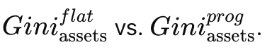

- For after-tax labor income using post-tax income (1-τ)y^(1-λ):

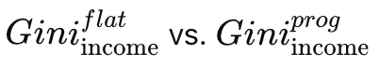

4.3 Graphical Results

The following plots are generated:

Value Function : For each productivity state, the value function is plotted, showing the effect of tax regime on household optimization.

Policy Functions: Optimal asset choices (next-period assets as a function of current assets) are plotted, with a 45° reference line for comparison.

Asset Distribution: The marginal density of assets is plotted, illustrating how households accumulate assets under each tax regime.

Lorenz Curves : The cumulative distribution of assets is plotted against the cumulative share of assets, together with a 45° line indicating perfect equality.

Gini Coefficients: Bar charts display the computed Gini coefficients for assets and after-tax income for the two regimes.

The results indicate that the progressive tax system alters households savings behavior and typically leads to different inequality outcomes compared to the flat tax regime.

**5. Conclusion**

This paper analyzes the effects of increasing labor tax progressivity in a heterogeneous agent model. By calibrating the model to match key equilibrium conditions (r = 0.04, w = 1, and G/Y = 0.2) under a flat tax regime and then adjusting the tax rate under a progressive tax regime (λ = 0.15) to maintain government revenue, we find that tax progressivity affects both the equilibrium interest rate and the distribution of assets and after-tax incomes. Our numerical results – including value functions, policy functions, asset distributions, Lorenz curves, and Gini coefficients – illustrate that progressive taxation can modify incentives for savings and, consequently, affect overall inequality.

Future research may extend the analysis by incorporating additional frictions or by exploring alternative calibration targets. The numerical methods used here provide a robust framework for studying policy reforms in heterogeneous agent settings.

Data source:

1. penn world table