

Java Auto Tester

MITTUNIVERSITETET
DSV Östersund

Examinator | Raja-Khurram Shahzad | Raja-Khurram.Shahzad@miun.se
Supervisor | Raja-Khurram Shahzad | Raja-Khurram.Shahzad@miun.se
Author 1 | Tommy Yasi | toya1800@student.miun.se
Author 2 | Jingzhong Qin | jiqi1901@student.miun.se
Programme | Programvaruteknik, 180hp
Course | DT002G, Applied Computer Engineering
Field of study | Computer Engineering
semester, year | VT, 2022

Table of Contents
1 Introduction 4
1.1 Problem Statement & Purpose 4
1.2 Scope 4
1.3 Completeness Criteria 4
2 Overall Description 5
2.1 Product Features 5
2.2 Design and Implementation Constraints 5
2.3 Assumptions and Dependencies 5
2.4 User Classes and Characteristics 5
3 Use Cases 6
4 Functional Requirements 7
5 Non-Functional Requirements 8
6 Documentation 9
7 Conditions for Delivery 10
References 11

Introduction
GitHub is commonly used to host open-source projects. According to Wikipedia, as of November 2021, GitHub reports having over 73 million developers and more than 200 million repositories including 28 million public repositories. GitHub offers the distributed version control and source code management functionality of Git with it’s own features. It provides also access control and other collaboration features such as bug tracking, task management, continuous integration etc for every project. It’s the largest source code host since 2008.

Problem Statement & Purpose
Developers often need to use a lot of time to test software that other developers have developed for errors or undesired behavior. It can be a long process and very difficult to test everything within others' code without missing some important details. Developers need tools to test program faster. Therefore we want to design a program which can automatically execute tests for a given Java GitHub repository using Maven/Gradle, so all the developers can test other programs faster. So the goal is to have a CLI(Command Line Interface) command take a GitHub repository as an input and then automatically downloads and runs the tests the project has. The intention is to run the program on open-source software from GitHub as many and as big size as possible/available.

Scope
Our program is going to run Java project(Maven/Gradle project) that has tests(in src/test folder). The result of the tests will be displayed on the screen: all tests passed or failure.

Completeness Criteria
Our program should download the repository and run all tests the repository has after user entered the remote URL(the place where the code is stored). The result should be displayed for the user. The result should be exactly the same as we manually run the tests in any Java IDE.

Overall Description
Our program is called Java auto tester. In this section, we will show its structure och explain how the components of the program interacts with each other.

Product Features
This program has the following components:
1. A component that download GitHub repository by using a URL input and the repository will be stored in a special folder in the program.
2. A component that collects all tests that specific project (tests are stored in src/test folder) has and runs the tests. Result will be displayed for user and the repository will be removed from the special folder in order to save storage space.

Java Auto Tester will have the following features:
1. Allow a user to enter a remote URL to a specific repository
2. Java Auto Tester will download the repository and the repository will be stored in a special folder within it.
3. Java Auto Tester collects the tests the repository has by first finding the filenames that contain “test” or “Test” within the src/test folder then trying to find “@Test” tags within the files.
4. Java Auto Tester runs all tests and outputs the result, the repository will be deleted from the special folder to free up space.
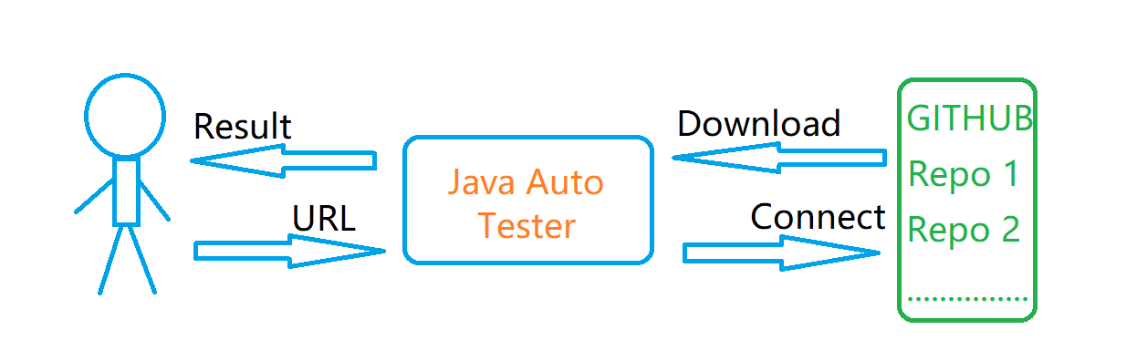
Fig.1 The overall model of Java Auto Tester

Design and Implementation Constraints
The major constraint of Java Auto Tester is that during the tests collection, it’s possible that some filename doesn’t contain the keyword “test” or “Test”, or the tests may be stored in different folder than src/test, so Java Auto Tester may miss the files. Moreover, some file may doesn’t missed the “@Test” tag, so the program will miss the files/test units too.

Assumptions and Dependencies
Program language(Java) and platform dependency.

User Classes and Characteristics
There are two user classes for Java Auto Tester.
Primary Users: Administrator who updates the program and notify the user for update.
Secondary Users: End users who will use Java Auto Tester to run the tests.

Use Cases
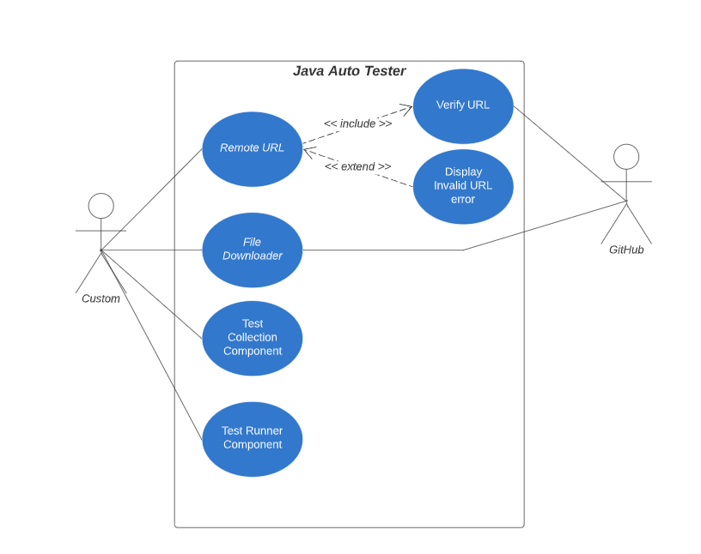
Fig 2. Use case diagram for primary user and secondary user

Identifier | Remote URL
Purpose | User can enter the remote URL for a GitHub repository
Priority | High
Pre-conditions | User should have the Java Auto Tester application
Post-conditions | System connects to the repository using URL
Typical Course of Action
S# | Actor Action | System Response
1 | User | System connects to the repository

Alternate Course of Action
S# | Actor Action | System Response
1 | User | System will output an error message

Table 1 UC-1-Remote URL

Identifier | File Downloader
Purpose | User downloads the repository using the remote RUL as input
Priority | High
Pre-condition | GitHub has verified the URL and the internet connection is stable
Post-condition | System will download the whole repository and the repository will be stored in a specific folder
Typical Course of Action
S# | Actor Action | System Response
1 | User | Download the repository
Alternate Course of Action
S# | Actor Action | System Response
1 | User | Fail to download the repository
Table 2 UC-2 – File Downloader

Identifier | Test Collection Component
Purpose | System collects the test classes
Priority | High
Pre-condition | The Repository has been downloaded
Post-condition | System adds the test classes to a specific file
Typical Course of Action
S# | Actor Action | System Response
1 | User | Adds the test classes to a specific file
Alternate Course of Action
S# | Actor Action | System Response
1 | User | System cannot find any test classes or some error occurs
Table 3 UC-3 – Test Collection Component

Identifier | Test Runner Component
Purpose | System runs the tests and output the result for user
Priority | High
Pre-conditions | System has collect some tests
Post-conditions | System will output the result for user
Typical Course of Action
S# | Actor Action | System Response
1 | User | Output the result
Alternates Course of Action
S# | Actor Action | System Response
1 | User | Fail to run the tests

Functional Requirements
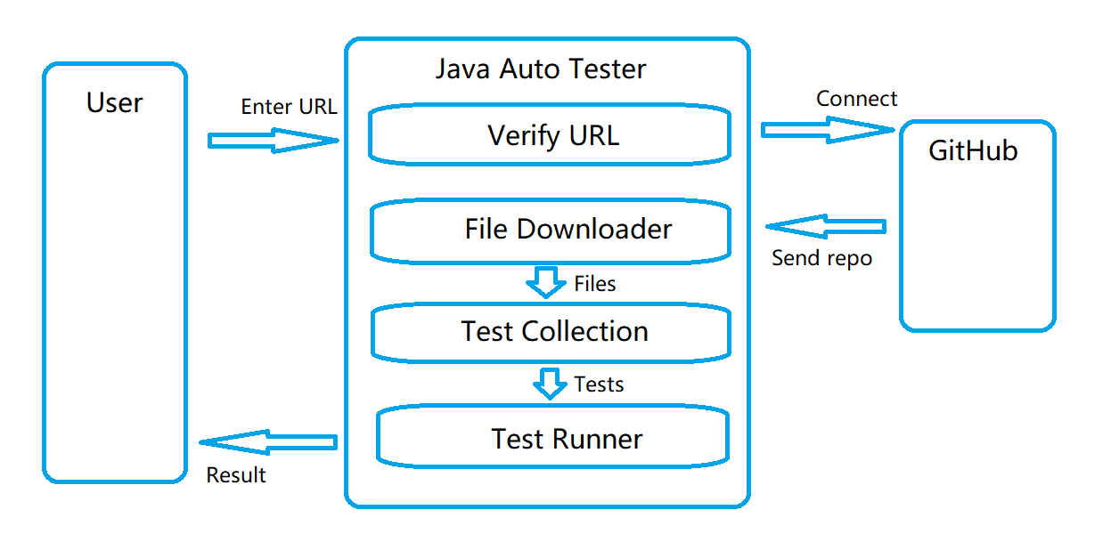
Fig 3. Functional description of Java Auto Tester

ID: FR1
TITLE: Verify URL input
DESC: The application should connect to a specific repository on GitHub if the provided URL is valid
RAT: The user must know if the URL works
DEP: None

ID: FR2
TITLE: Downllad Repository
DESC: The application should be able to download the specific repository using provided URL if the URL is valid
RAT: The application should download whole repository if the URL is valid
DEP: FR1

ID: FR3
TITLE: Run tests and remove repository after the execution
DESC: The application should be able to run the tests the specific repository has and delete the repository afterwards(free up space)
RAT: The application should run the tests and delete them afterwards
DEP: FR2

ID: FR4
TITLE: Provide result about the test
DESC: The application should be able to display the result for user
RAT: The user must know the result of the tests
DEP: FR3

Non-Functional Requirements

5.1 Performance Requirements
ID: QR1
TITLE: Internet connection
DESC: The application should make the user aware if there was a connection error in the middle of the process
RAT: The user must know if there is a connection issue
DEP: None

ID: QR2
TITLE: Response Time
DESC: The response time of running the tests can be divided into 3 categories: small projects, medium projects and large projects. The response time of running tests from a small project should not be more than 1 minute, the response time of running tests from a medium project should not be more than 3 minutes and the response time of running tests from a large project should not be more than 5 minutes.
RAT: The user should not wait too long for getting results.
DEP: QR 1

5.2 Maintainability
ID: RQ3
TITLE: Application update
DESC: The application should be easy to update if changes are needed. The program should be written with widely known software engineering concepts to make sure that the code is easy to understand and change.
RAT: Fulfill future changes.
DEP: None

5.3 Reliability
ID: QR4
TITLE: System Availability
DESC: The availability of the system should be more than 99% of the time.
RAT: The system should be available to user at time of need.
DEP: None

5.4 Availability
ID: QR5
TITLE: Open Source
DESC: The source code of the system should be able to access for anyone who want to access it.
RAT: The source code of the program should be available to all users, also for the developer who want to make a change(through pull request)
DEP: None

Documentation
The application will be documented in the Readme.md which comes with the program. This will be used as the user manual.

Conditions for Delivery
We will publish our system on Bitbucket and GitHub.

References

[1] | W. S. Humphrey, "The software engineering process: definition and scope", Proceedings of the 4th international software process workshop on Representing and enacting the software process Pp. 82-83, 1988.
[2] | Yao, J., Wan, X. & Xiao, ”Recent advances in document summarization”, Journal of Knowledge and Information Systems, 53:2, pp. 297-336, 2017.

Please look at the exemples of references. Please remember, that each referens shall be indicated with a specific number in IEEE format. You may like to look at ”Zotero” for referens management. Please remember, web addresses, i.e., URL shall be given as footnotes.

