

Självständigt arbete på grundnivå
Applied Computer Engineering

Datateknik
Computer engineering

Title
Java Auto Tester

Name of author(s)
Tommy Yasi
Jingzhong Qin

MITTUNIVERSITETET
DSV Östersund

Examiner | Khurram Shahzad | Raja-Khurram.Shahzad@miun.se
Supervisor | Khurram Shahzad | Raja-Khurram.Shahzad@miun.se
Author | Jinghzong Qin | jiqi1901@studnt.miun.se
Author | Tommy Yasi | toya1800@student.miun.se
Programme | Programvaruteknik, 180hp
Course | DT002G, Applied Computer Engineering
Field of study | Computer Engineering
Semester, year | VT, 2022

Abstract
GitHub is commonly used to host open-source projects. It also provides access control and other collaboration features such as bug tracking, task management, continuous integration, etc for every project. Software testing is a process of evaluating and verifying the performance and quality of an application. The benefits of testing include preventing bugs, saving development costs, enhancing reliability, etc. Developers often need to use a lot of time to test software that other developers have created for errors or undesired behavior. It can be a long process and very difficult to test everything within others’ code without missing some important details. We have created a program that downloads a Maven or Gradle project from GitHub via a link provided by the user and run all tests the project has to show the results on the screen. All this will be done via the Command Line Interface. In this paper we described how we implemented our program, what requirements should be met, and the limitations of the program. Future work is needed in order to run test cases within other Java projects, not only in Maven or Gradle projects.

Table of Contents
Table of Tables 5
Table of Figures 5
Terminology 6
1 Introduction 7
1.1 Problem Statement 7
1.2 Background and Motivation 7
1.3 Aim 7
1.4 Scope 8
1.5 Completeness Criteria 8
1.6 Time Plan 8
1.7 Outline 8
2 Methodology 9
2.1 Requirements 9
2.2 Development Method and Workflow 9
2.3 Tools and Architecture 10
3 Implementation 11
3.1 Design 11
3.2 Testing 13
4 Results 14
5 Analysis and Discussion 15
References 16
Appendix 17

Table of Tables
Table 1 | Functional requirements
Table 2 | Non-functional requirements

Table of Figures
Figure 1 | The overall model of Java Auto Tester
Figure 2 | Components of Java Auto Tester
Figure 3 | runMavenTests.bat
Figure 4 | RunGradleTests.bat
Figure 5 | JavaAutoTester.bat
Figure 6 | result after execution

Terminology

Maven | A build automation tool used primarily for Java projects
Gradle | A build automation tool for multi-language software development
JDK | Java Development Kit
CLI | Command-line Interface

Introduction
GitHub is commonly used to host open-source projects[1]. It also provides access control and other collaboration features such as bug tracking, task management, continuous integration, etc for every project. Software testing is a process of evaluating and verifying the performance and quality of an application. The benefits of testing include preventing bugs, saving development costs, etc. Therefore a project needs to be tested before users download and use it. Running tests on a project may take a long time, to simplify this process, we can use a tool to run all the tests instead of running them manually.

Problem Statement
Developers need to connect to a specific GitHub repository, clone the project before running the tests project has if they want to test a project from GitHub. If the tests fail or it’s unable to build the project, this means that the project won't match the desired performance or it needs some update to build the program successfully. So the developer needs to find another project, he has to delete the repository to free up space and clone another repository from GitHub again. This process can take a lot of time.

Background and Motivation
Java is one of the most popular programming languages on GitHub for developers. Many Java projects use Maven[2] or Gradle[3] to simplify the build process. As mentioned before, the testing process can take a lot of time. The developers will save much time if they can use a tool that can do these things with one command(Command Line Interface)[4]: user enters the URL as an input, then the tool automatically downloads the specific repository and runs the tests. The repository which has been downloaded will be deleted after the execution in order to free up storage space on the device. If it fails to build the program or the project for some reason cannot be tested, the repository which has been downloaded before will automatically be removed.

Aim
This project aims to create a program that runs all test cases for a given Maven or Gradle project automatically using a URL input and output the results of testing(Figure 1).
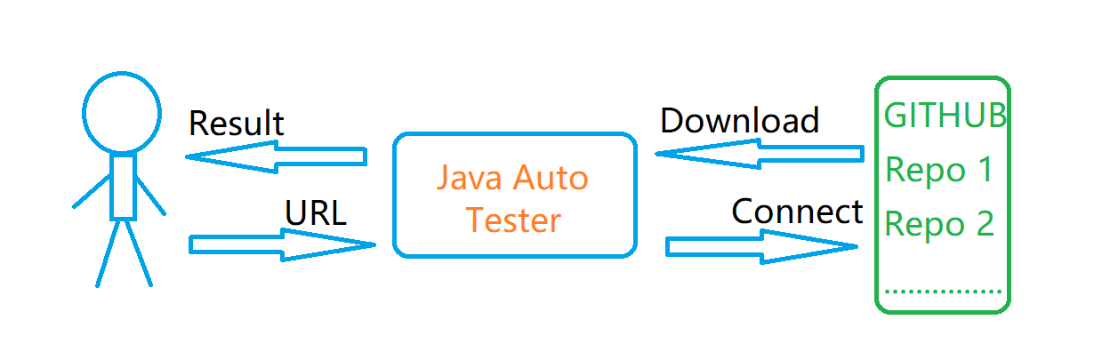
Figure 1: The overall model of Java Auto Tester

Scope
Our program is a command line tool that runs a Java project(Maven/Gradle project which has pom.xml file or gradle.build file) that has test cases in src/test folder. The test file should contain some “@Test” annotation to get executed.

Completeness Criteria
A program that downloads the given link to a GitHub repository and runs all tests. The result should be displayed for the user and should be exactly the same as we manually run the tests in any Java IDE.

Time Plan
v5 Requirement specifications
v6 Preparing design specifications and starting implementation
v7 Implementation
v8 Refining design specifications + implementation
v9 Implementation
v10 Preparing Test specification + implementation
v11 Testing + Final Changes + Submission

Outline
In the Introduction section, we have introduced our project and described the problem our program aims to solve. The rest of this paper is organized as follows. Section II describes the requirements, tools that are needed to create the program, and the structure of the program. Section III describes how we implemented the program. Section IV gives our result. Section V gives our analysis and discussion about the project.

Methodology
This section presents the methods used to complete the project. We started by planning the different steps from getting the Github repository to set up everything to be ready for testing. To ensure that the program would work and have all the needed components, we first wrote down the architecture design of the project and the requirements. After that, the design was implemented. Once all components were finished we could test the program to see that it met all requirements. The workflow consisted of four phases which are presented below.

Requirements
Our program has requirements as follows:
Functional requirements:
Identifier | Title | Status
FR1 | Provide a URL | Fulfilled
FR2 | Verify URL input | Fulfilled
FR3 | Download Repository | Fulfilled
FR4 | Identify the project type | Fulfilled
FR5 | Find test cases | Fulfilled
FR6 | Run the tests | Fulfilled
FR7 | Remove the repository | Fulfilled
Table 1. Functional requirements
Non-functional requirements:
Identifier | Title
QR1 | Internet connection
QR2 | Response Time
QR3 | Application Update
QR4 | System Availability
QR5 | Open Source
Table 2. Non-functional requirements
A more detailed description of the functional or non-functional requirements is available in appendix A and appendix B.

Development Method and Workflow
The development workflow consists of four phases: figuring out requirement specifications of the program, design, implementation, and testing. We used a Trello board [5] to record feedback from the weekly meetings and mark tasks as “To Do”, “In Progress”, “In Backlog”, and “Done”. To synchronize our work we created a Bitbucket repository to store our project. We wrote components of the project and pushed the changes to the Bitbucket repository as often as we could. A new branch would be created when we started writing a new component. Every component was tested before we continued with the next one. Once one branch was finished and tested, it was merged with the master branch to keep it updated and build on from every component until it was finished. The design of the program can be changed if we find it’s impossible for us to implement the feature or it doesn’t meet the requirements well.

Architecture and Tools
The source code is stored on Bitbucket and Git is used to manage changes to the source code. Trello is used to handle the communication within our team.
Our program is written in Java, it uses Java Development Kit 17. It’s a Maven project. The program uses Maven and Gradle to run test cases within the repository. It uses the following dependencies: jgit, jupiter, junit.platform.

Implementation

Design
Our program has the following components((Figure 2):
1. Component RepositoryDownloader uses dependency JGit to clone a repository using the URL provided by the user. The repository will be stored in a particular folder.
2. Component ProjectIdentifier is used to check if the project that has been downloaded is a Maven or Gradle project, in other words, ProjectIdentifier tries to find pom.xml or build.gradle in the root directory.
3. Component TestCaseFinder searches a file that contains “@Test” annotation from the repository and all its subdirectories.
4. TestCaseFinder will return immediately if a such file is found.
5. Component TestRunner uses two batch files to run the project, one for the Maven project and the other one for the Gradle project. TestRunner displays the result of testing for the user.
6. Component DirectoryCleaner is used to delete the repository and all its subdirectories.
7. Component JavaAutoTester assembles components above to make a program: it takes a user input, downloads the repository from GitHub, saves the repository to a particular directory. If it fails to clone the repository, an error message will be displayed for the user, and the program terminates. If the repository has been downloaded successfully, the program will use the component ProjectIdentifier to check if the project is a Maven or Gradle project. The program will terminate if the project is neither a Maven nor a Gradle project. The program will use the component TestCaseFinder to check if the project contains some test cases. The program will terminate if no test cases are found. JavaAutoTester will invoke component TestRunner only if the project is a Maven or Gradle project and the project contains some test case. The program will display the result for the user. At last, JavaAutoTester uses the component DirectoryCleaner to free up space. It’s worth mentioning that JavaAutoTester will display an error message to the user to explain why it can’t run the test cases before it terminates, for example, the project doesn’t contain any test cases.
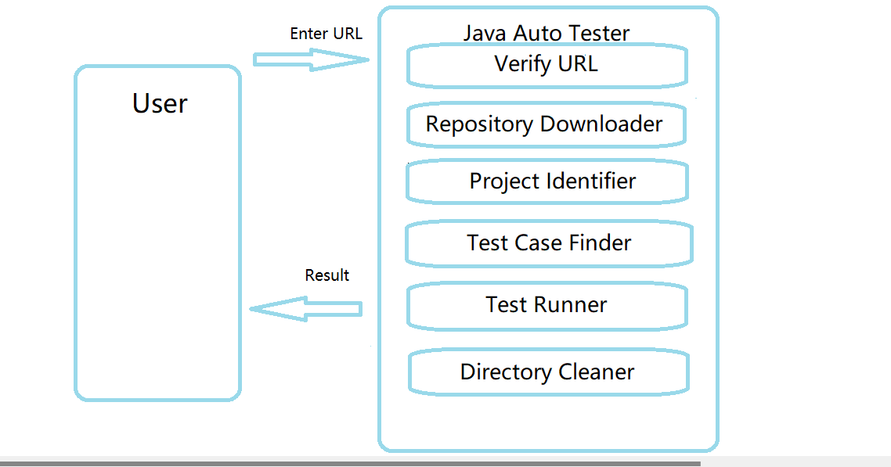
Fig 2. Components of Java Auto Tester
In order to run JavaAutoTester with a command, we exported the JavaAutoTester to a JAR file. A batch file named JavaAutoTester is used to run the JAR with user input(URL). We added the batch file to PATH Environment Variable so it can be accessed from any location in the command prompt(cmd.exe).
To run test cases within a Maven project, vi uses the following code in runMavenTests.bat(Figure 3):
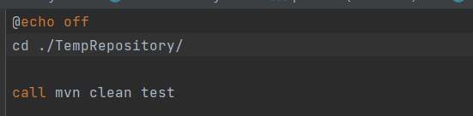
Figure 3: runMavenTests.bat
The program accesses TempRepository folder, then executes code “mvn clean test” to run the test cases within the Maven project.
To run test cases within a Gradle project, vi uses the following code in runGradleTests.bat(Figure 4):
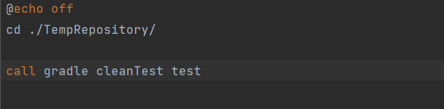
Figure 4: runGradleTests.bat
Again, the program accesses TempRepository folder, then executes code “gradle cleanTest test” to run the test cases within the Gradle project.
To run “JavaAutoTester URL_To_GitHub_Repository” as a command, vi uses the following code in JavaAutoTester.bat(Figure 5):
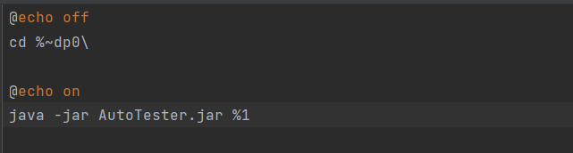
Figure 5: JavaAutoTester.bat
The program goes to the current working directory and runs AutoTester.jar using an argument provided by the user.

Testing
Every component was tested manually in an isolated environment, in their own branch, before being merged with the master branch and tested in the main program as a whole. We used different URLs to test our program, such as invalid URLs, URLs that link to a repository that is neither a Maven nor a Gradle project, URLs that link to Maven projects, URLs that link to Gradle projects. The program outputs excepted results.

Results
The following results were displayed by running the tool using a URL that links to a Maven project on GitHub, the project is called “MojoHaus Versions Maven Plugin”, it’s a versions-maven-plugin. The versions plugin is used when we want to manage the versions of artifacts in a project’s POM.
The program is run using the following command:
JavaAutoTester https://github.com/mojohaus/versions-maven-plugin.git
The program prints out execution status to the terminal, including how long time it took to build the program and run the tests, etc(Figure 6):
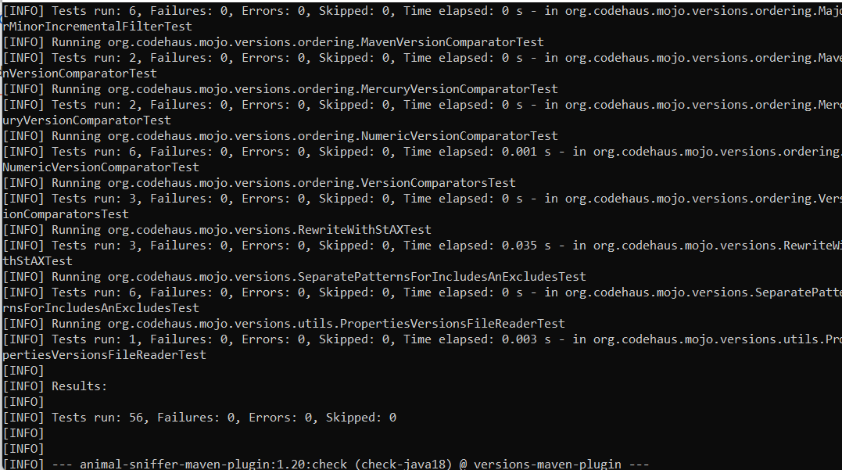
Figure 6: result after execution
JavaAutoTester removes the repository that has been downloaded before it terminates.

Analysis and Discussion
The result indicates that the tool met all requirements. It's a fairly simple program and is easy to use. The program will serve its purpose and save the user some time by both running the tests and automatically deleting them. Just like any other program, the tool has also limitations:
1. We need to build the program before we run the test cases within the repository. If it fails to build the program, the program will terminate without running any test cases.
2. It may take a long time to build the program, especially the Gradle projects.
3 The issues with the testing are not easily solved from our end since both the Maven and Gradle clean tests cannot cover all dependencies.
4. When the tool downloads the repository from GitHub, it creates a new directory, named TempRepostiory. The tool will save the repository to the folder. The folder will be removed after the program runs all test cases. If for some reason, the directory cannot be removed, it will be impossible for the tool to download another repository from GitHub next time, the program will fail forever.
5. The tool can only run test cases within Maven projects or Gradle projects.
The tool could be improved in many ways, for example, it could run all test cases within a Java project, not only test cases in Gradle or Maven projects, speed up the build process to shorten execution time, etc.

References
[1] https://github.com/github [Accessed: 07-Mar-2022]
[2] https://maven.apache.org/what-is-maven.html Accessed: 07-Mar-2022]
[3] https://docs.gradle.org/current/userguide/what_is_gradle.html Accessed: 08-Mar-2022]
[4] https://www.techtarget.com/searchwindowsserver/definition/command-line-interface-CLI Accessed: 09-Mar-2022]
[5] https://help.trello.com/article/708-what-is-trello Accessed: 10-Mar-2022]

Appendix
A Functional requirements
ID | FR1
TITLE | Provide a URL
DESC | The application should accept the user input
RAT | The user should input something to start running the application
DEP | None

ID | FR2
TITLE | Verify URL input
DESC | The application should connect to a specific repository on GitHub if the provided URL is valid
RAT | The user must know if the URL works
DEP | FR1

ID | FR3
TITLE | Download Repository
DESC | The application should be able to download the specific repository using provided URL if the URL is valid
RAT | Start downloading repository by given URL
DEP | FR2

ID | FR4
TITLE | Identify the project type
DESC | The application should be able to check if the project is a Maven or Gradle project
RAT | Know if it is a Maven or Gradle project
DEP | FR3

ID | FR5
TITLE | Find test cases
DESC | The application should be able to know if the repository contains some test cases
RAT | Find test cases in the project
DEP | FR4

ID | FR6
TITLE | Run the tests
DESC | The application should be able to run the tests within the project and display the result for the user
RAT | Run test cases and display results
DEP | FR5

ID | FR7
TITLE | Remove the repository
DESC | The application should remove the repository that has been downloaded in order to free up space
RAT | Delete temporary repository
DEP | FR6

B Non-Functional Requirements

ID | QR1
TITLE | Internet connection
DESC | The application should make the user aware if there was a connection error in the middle of the process
RAT | The user must know if there is a connection issue
DEP | None

ID | QR2
TITLE | Response Time
DESC | The response time of running the tests can be divided into 3 categories: small projects, medium projects, and large projects. The response time of running tests from a small project should not be more than 1 minute, the response time of running tests from a medium project should not be more than 3 minutes and the response time of running tests from a large project should not be more than 5 minutes.
RAT | The user should not wait too long for getting results.
DEP | QR 1

ID | QR3
TITLE | Application update
DESC | The application should be easy to update if changes are needed. The program should be written with widely known software engineering concepts to make sure that the code is easy to understand and change.
RAT | Fulfil future changes.
DEP | None

ID | QR4
TITLE | System Availability
DESC | The availability of system should be available all the time.
RAT | The system should be available to users at the time of need.
DEP | None

ID | QR5
TITLE | Open Source
DESC | The source code of the system should be able to access for anyone who wants to access it.
RAT | The source code of the program should be available to all users, also for the developer who wants to make a change(through pull request)
DEP | None

