COMP8430 Data wrangling project

u5976992

Word count: 1339 words

# 1. Data and problem description and overall strategy

## 1.1 Problem description

Nowadays, Android and iOS are the most popular mobile systems. I’m very interested in the difference of user preference for apps between the two different systems. I choose Google play store data set and Apple app store data set. The hypothetical end-use of them is to find the linkage of rating in Google play store and rating in Apple app store for the same app.

## 1.2 Overall strategy

Firstly, we need to analysis each data set. In this step, I will decide features that are used in the future work and find some useful information such as missing values, incorrect values, features type. Using the information to get data quality. Secondly, we need to do data preparation and cleaning. In this step, I will remove duplicate records and deal with records that contain missing value or incorrect value. I will change features type to correct one. Thirdly, we need to do record linkage. I will simplify those app name to find more record linage. Merge them as a new table.

# 2. Data description and data exploration

## 2.1 Google play store data set description

Google play store data set comes from <https://www.kaggle.com/lava18/google-play-store-apps>. It’s collected in 2018 by Lavanya Gupta, a software developer at HSBC Software Development. The data set contains 10841 records. There are 13 features as follow,

|  |  |  |  |
| --- | --- | --- | --- |
| No | Feature Name | Type | Description |
| 1 | App | string | application name |
| 2 | Category | string | category the app belongs to |
| 3 | Rating | float | overall user rating of the app |
| 4 | Reviews | string | the number of user reviews for the app |
| 5 | Size | string | size of the app |
| 6 | Installs | string | the number of user downloads/installs for the app |
| 7 | Type | string | paid/free |
| 8 | Price | string | price of the app |
| 9 | Content Rating | string | age group the app is targeted at  children/mature21+/adult |
| 10 | Genres | string | genres the app belongs to |
| 11 | Last Updated | string | date when the app was last updated on Play Store |
| 12 | Current Ver | string | current version |
| 13 | Android Ver | string | minimax required Android version |

Since we need to find the linkage of rating between Google play store and Apple app store for the same app, I want to focus on such features as follow,

1. App: as the key to merge tables
2. Rating: use it the compute the correlation
3. Reviews: we need to use this to remove those apps that too few people rate since those ratings may be very bias.

According to my experiment, there is only one record rating greater than 5, which is an unexpected value. After removing that, we can find the density of rating as below, which imply that most apps rating is the range of 3 to 5.

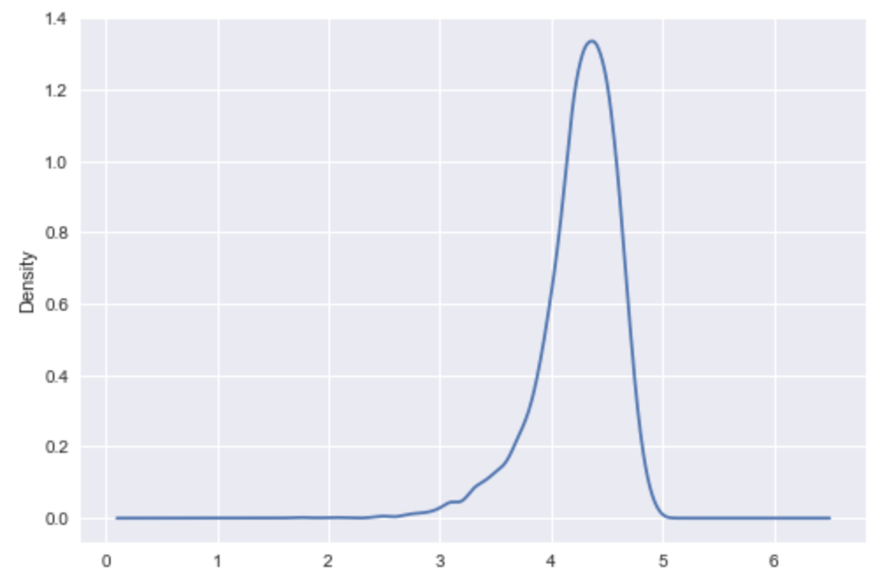

the density of rating of Google play store data set

## 2.2 Apple app store data set description

Apple app store data set comes from <https://www.kaggle.com/ramamet4/app-store-apple-data-set-10k-apps>. The data was extracted from the iTunes Search API in July 2017 by Ramanathan, a research engineer at KIT. The data set contains 7198 records. There are 17 features as follow,

|  |  |  |  |
| --- | --- | --- | --- |
| No | Feature Name | Type | Description |
| 1 | Unnamed: 0 | int | unknown |
| 2 | id | int | App ID |
| 3 | track_name | string | application name |
| 4 | size_bytes | int | size of the app |
| 5 | currency | string | currency type |
| 6 | price | float | price of the app |
| 7 | rating_count_tot | int | user rating counts for all version |
| 8 | rating_count_ver | int | user rating counts for current version |
| 9 | user_rating | float | user rating for all version |
| 10 | user_rating_ver | float | user rating for current version |
| 11 | ver | string | latest version |
| 12 | cont_rating | string | content rating |
| 13 | prime_genre | string | genres the app belongs to |
| 14 | sup_devices.num | int | the number of supporting devices |
| 15 | ipadSc_urls.num | int | the number of screenshots showed for display |
| 16 | lang.num | int | the number of supported languages |
| 17 | vpp_lic | int | vpp device based licensing enabled |

For this data set, we need features as follow,

1. track_name: as the key to merge tables
2. user_rating: use it to compute correlation
3. rating_count_tot: we need to use this to remove those apps that too few people rate since those ratings may be very bias.

Notice that the rating in the Google play store data set is discrete. However, in the Apple app store data set, the rating is divided exactly by 0.5. Therefore, we can find the histogram of rating as below. There are too many 0 and 5 value records, maybe since too few people rate those apps.

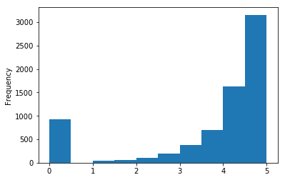

the histogram of rating of Apple app store data set

# 3. Data quality assessment

## 3.1 Google play store data set

* App name: the value should be a string. There are 9660 unique values. We need to deal with those duplicate records later.
* Rating: the value should be a number and in the range of 0 to 5. There are 1474 records missing this value. There is one record which Rating value is 19.0.
* Reviews: the value should be a number and greater than or equal to 0. There is one record which Review value is ‘3.0M’. We need to convert it to 3000000.
* Installs: the value should be one of ‘0+’, ‘1+’, ‘5+’, ‘10+’, ‘50+’, ‘100+’, ‘500+’, ..., ‘1,000,000,000+’. There is one record which Installs is ‘Free’ and one record which Install is ‘0’.
* Price: the value should be greater than or equal to 0. There is one record which Price value is ‘Everyone’.

|  |  |  |  |
| --- | --- | --- | --- |
|  | App name | Rating | Reviews |
| Completeness | 100% | 86.4% | 100% |
| Uniqueness | 89.1% | No need | No need |
| Validity | 100% | 99.9% | 99.9% |

## 3.2 Apple app store data set

track_name: the value should be a string. There are 7195 unique values.

user_rating: the value should be divided exactly by 0.5. All records values are valid.

rating_count_tot: the value should be a number and greater than or equal to 0. All records values are valid.

|  |  |  |  |
| --- | --- | --- | --- |
|  | track_name | user_rating | rating_count_tot |
| Completeness | 100% | 100% | 100% |
| Uniqueness | 99.9% | No need | No need |
| Validity | 100% | 100% | 100% |

# 4. Data preparation and cleaning

## 4.1 Google play store data set

Firstly, we need to remove duplicate record for the same app. I find the records that contains the same app name and keep the latest version one.

Secondly, we remove the records that rating is greater than 5 or smaller than 0.

Thirdly, I convert one record that Review is ‘3.0M’ to 3000000. Then change Review type from Sting to int.

Finally, I remove those records that Reviews is smaller than 1000. I think those records’ rating maybe be too bias.

In the end, we have 4802 records in this data set.

## 4.2 Apple app store data set

basically we do the same thing. Except, we don’t need to deal with the rating_count_tot since it’s already good enough and I choose 100 as threshold for Apple app store since there the number of users in Apple app store is largely smaller than the number of users in Google play store.

In the end, we have 4489 records in this data set.

# 5. Data integration or record linkage

The most difficult part is to find the same app in those two different data sets since the app name is much different in those two data sets and we don’t have other features to deal with it.

According to my experiment, many apps name follows the format like

* real name: some description
* real name - some description
* real name – some description

Therefore, I extract the real name from the original app name and make it as a new feature.

Then, I change the feature name to make the result much more readable.

After merge two tables. We have 579 records. The result table looks like as below,

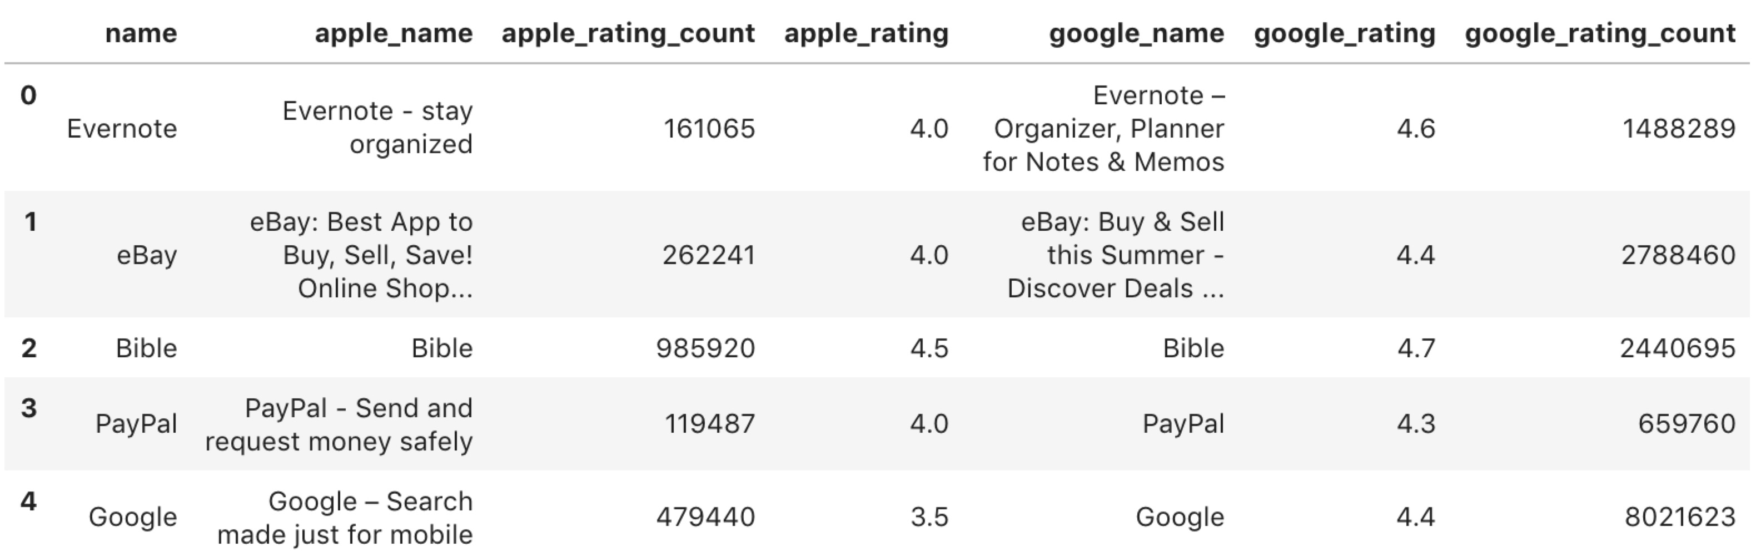

sample of the final result

We will know the simplified name of the app and their names in different app stores. Also, we have the rating of the app and the number of rating count in different app stores. We can use those data to compute the correlation. The correlation between the rating in Google play store and the rating in Apple app store is 0.63.