**Homework1**

Dept. Computer Science

2017147594

Jinho Ha

7. (a)

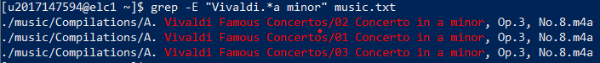

Option “-E” is used for Regular Expression. There are 3 concerts in a minor by Vivaldi.

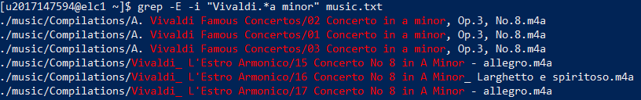

When case is ignored, there are 3 more concerts; written in capital letter “A”.

(b)

Regular Expression : (c|d|e|f|g|a|h) minor

Escape letter is needed for command.

Command line is below:



(c)

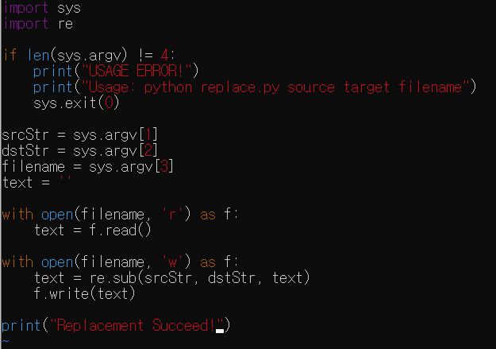My code is here :

It works on elc1 server

