The Bookstore Database

Project Report

Jinhoo Bong & James Samson

1. Introduction
   1. The purpose of an online bookstore is to serve as a single location where customers can search through a collection of books and purchase them. The bookstore should have the functionality to allow customers to create accounts, see information for the available books, and to order books. Ideally, an online bookstore is easy to navigate and has a great selection of books. The bookstore should be able to reliably maintain customer, book, and order information and the relationships between the different data types. An example of an effective and massively popular online bookstore is Amazon.com. Although the site now sells thousands of different types of products, it was originally a simple online bookstore. Another example is the University of Richmond campus bookstore. This bookstore has both a physical store and an online store.
2. Bookstore Components
   1. Login Page
      1. The login page for our bookstore is very simple. This is the first page that a customer sees when they go to our website. It allows the customer to sign in with the username and password that they have stored. If a customer does not have an account, it has a button to register. Clicking the button will take the customer to a registration page.

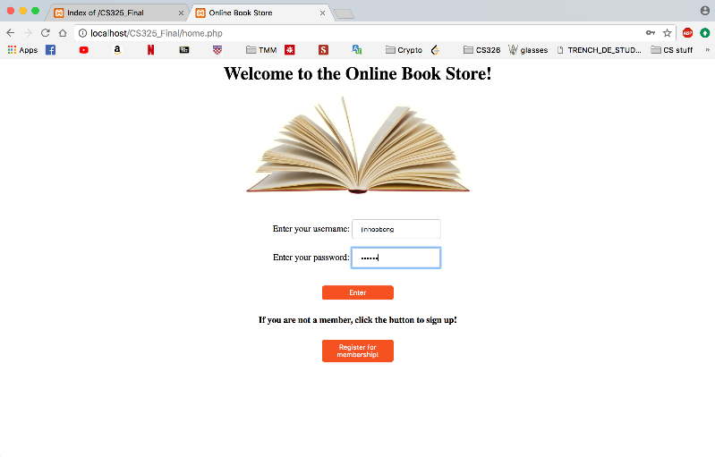

* 1. Registration Page
     1. The registration page has more boxes to enter information than the login page. This page allows customers to create an account for our bookstore by entering the necessary information. Some of the required information includes first and last name, home address, and email address. The customer will also create a username and password to sign in to the bookstore quickly next time they want to buy a book.

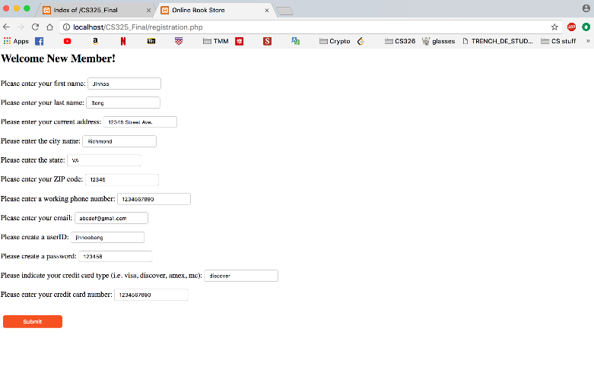

* 1. Book Selection Page
     1. The book selection page is where our customers will choose the book that they are interested in purchasing. The page contains a dropdown menu with a list of books and a button to get information for the selected book. The button will take the customer to an information page for the book that they select. The menu on our bookstore currently contains a short list of books. We can quickly add books to this menu as the bookstore grows and gains more customers.

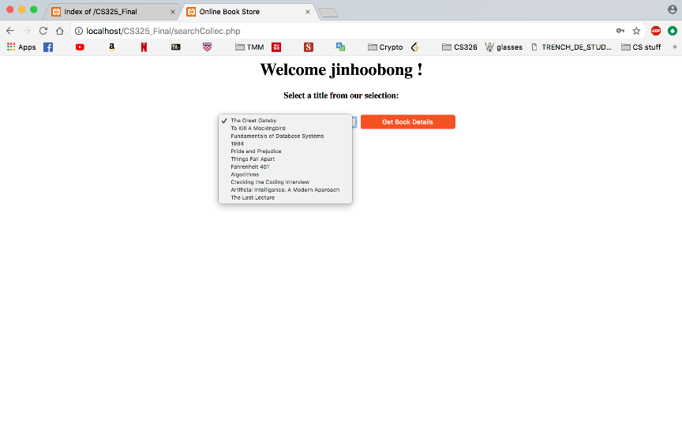

* 1. Book Information Page
     1. The book information page will be different depending on which book a customer selects from the book selection page. This page contains all the information relevant to the selected book. Some of this information includes title, author, ISBN, and price. The page also allows the customer to choose how many of this book they would like to purchase. When they are ready they can click a button to add the books to their cart. If they are not interested in buying, they can click a button to go back to the book selection page.

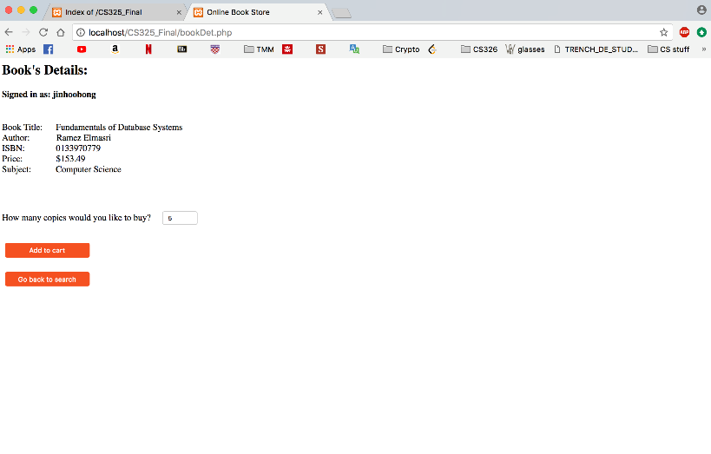

* 1. Carts and Orders
     1. Customers can add books to their cart before they decide to finally make an order. Once the customer has added the books to the cart that they want, they can place an order. The customer can view their cart and order invoice as they proceed through the process of purchasing books.

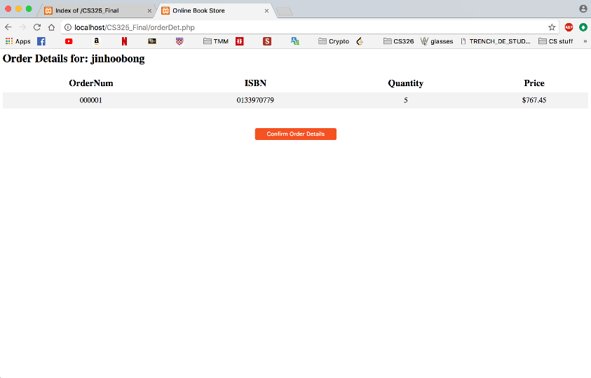

* 1. Thank You Page
     1. Once an order has been placed, the customer will be taken to a thank you page. This page thanks the customer for their order and contains a button. When clicked, this button takes the customer back to the bookstore home page.

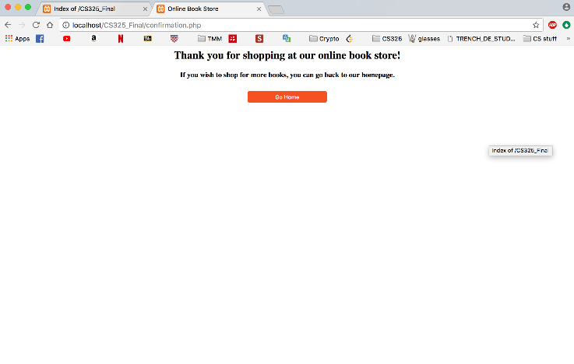

1. Bookstore Back-end
   1. The bookstore runs using a mySQL database. This database contains information on Members, Books, Orders, and everything else necessary to run effectively. We did not use any external code to develop our bookstore. We wrote all of the code to build the database and front-end for this project. When a customer creates an account, the information that they entered on the registration page will be stored in the Members table.

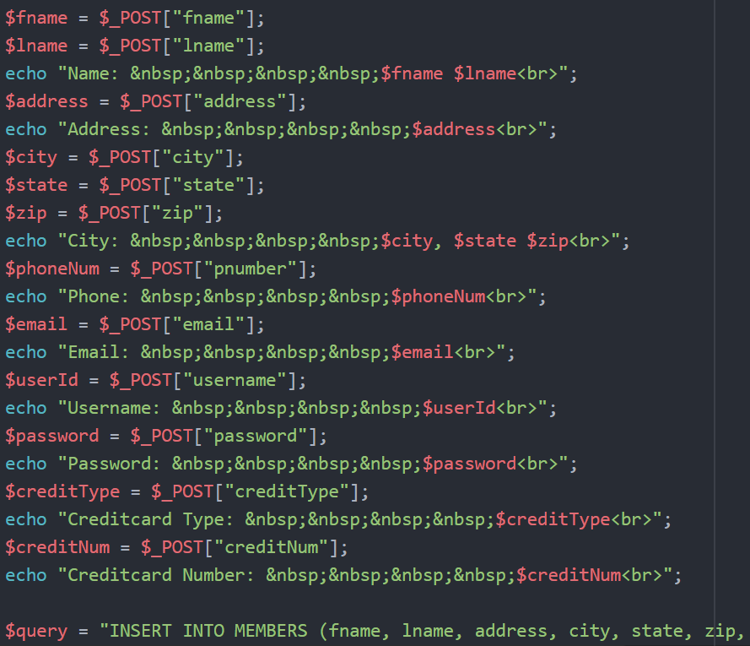

* 1. When a customer makes a book selection, a query is run to get the information from the Books table for the selected book.

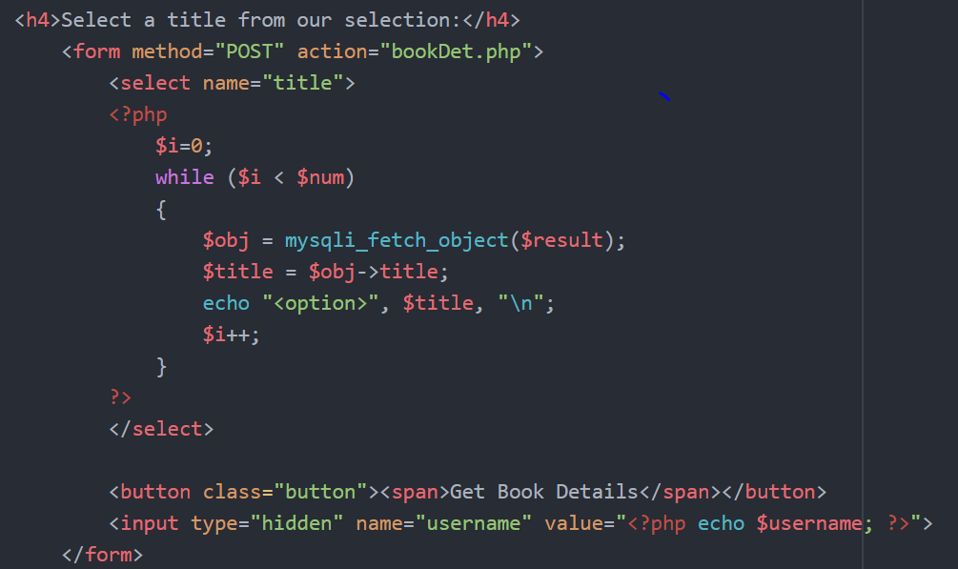

* 1. When an order is placed, the relevant information is stored in the Orders table. Before this happens, an order confirmation page appears in front of the customer with information on their order. This information includes the order number, customer ID, and shipping date and address.

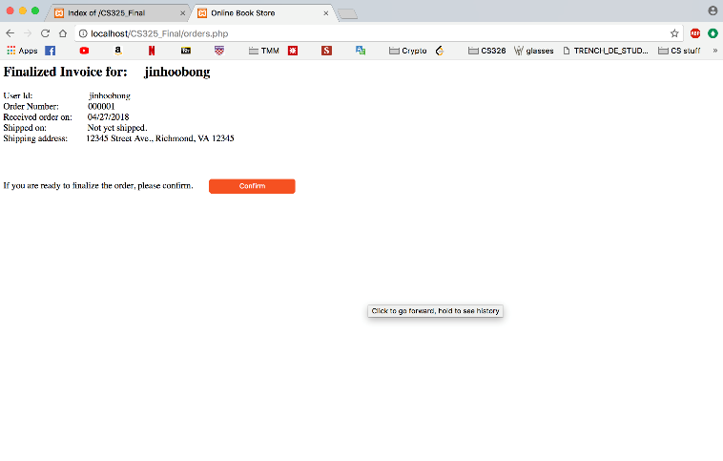

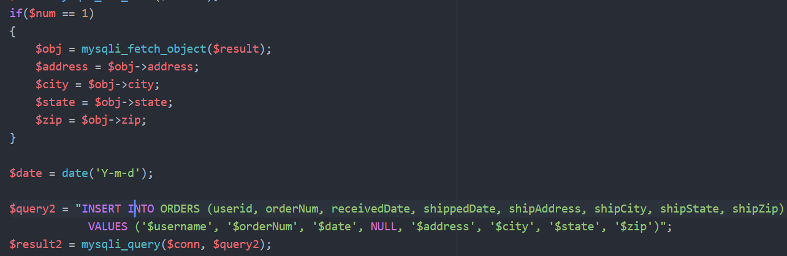

1. Conclusion
   1. An online bookstore can be built to be very complicated. Like most systems, there is an almost unlimited amount of detail and complexity that can be added to an online bookstore. Our bookstore contains all the necessary functionality for a customer to create an account and choose a book to purchase. This requires multiple tables for storing data and multiple pages for the user to click through. Our bookstore is complex enough to do what is required of it, but still simple enough for any user. It is also a solid base that we can add greater functionality to in the future. Developing this bookstore taught us about linking databases with the web and gave us an opportunity to practice what we have been learning throughout the semester.