**MEG multivariate pattern analysis.**

To reveal the time course of face/house image processing, we performed multivariate pattern analysis on the MEG signals in a time-resolved manner. We first extracted a set of dot response features for each subject, based on ECOG responses across sensors (50 channels), trials, timepoints (-200 to 600 ms with respect to image onset; down-sample to 10 ms resolution) and conditions (2 stimulus types x 4 adaptation level). Then, we trained and tested support vector machines (SVM) on every pair of image stimulus for each time point using the raw ECOG signal. Dissimilarity for each pair of stimuli was computed as two-fold cross-validated decoding accuracy, resulting in one 8 × 8 MEG representational dissimilarity matrix (RDM) per subject and time point.

To analyze the representation of dot image dimensions in the MEG data, we used representational similarity analysis (RSA). We created model RDMs for each image dimension which were 32 (8 × 8 / 2) matrices where 1~3 corresponded to a between category stimulus comparison (e.g., face vs house for the stimuli model, novel Euclidean distance for adaptation model) and 0 to a within category stimulus comparison (e.g., face vs. face). This procedure resulted in two image models corresponding to the stimulus types and adaptation level of our stimuli. To compute correlations between each model and the MEG data, we extracted the lower off-diagonal of each of these matrixes as vectors. For each model and subject, we computed the partial rank coefficients (Spearman correlation) between the stimuli model and the ECOG RDM at each time point partialling out another models. This step was crucial because some of the models are correlated and partialling out the other models thus allowed us to disentangle contributions of the models from each other.

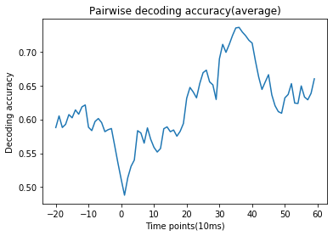

Figure1. averaged decoding accuracy.

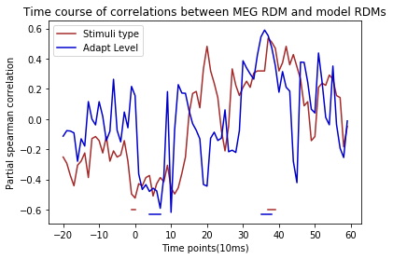

Figure 2. Time course of partial spearman correlation between ECOG RDM and model RDMs.

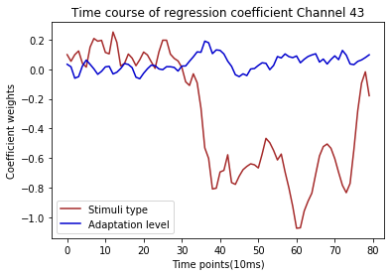

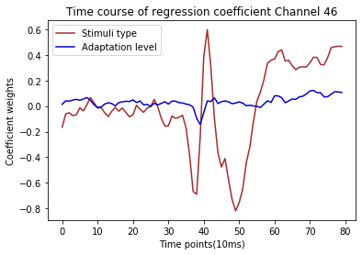

Figure 3,4 Linear regression results at electrodes 43 and 47.