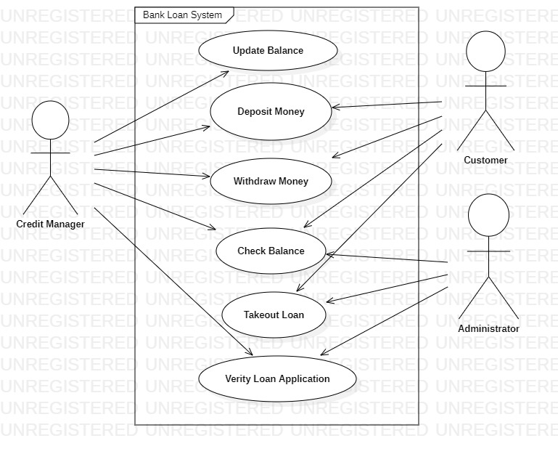

|  |  |
| --- | --- |
| ***USE-CASE:*** | Update Balance |
| ***PRIMARY ACTOR:*** | Credit Manager |
| ***GOAL IN CONTEXT:*** | To Update balance in the customer’s account |
| ***PRECONDITIONS:*** | 1) Customer has an active account in the bank |
| ***TRIGGER:*** | The Customer has to deposit money in the bank |
| ***SCENARIO:*** | 1. The Credit Manager login to the bank system. 2. The Credit Manager checks if any money transaction happens or not. 3. The Credit Manager update the balance of the Customer’s account. |
| ***EXCEPTIONS:*** | 1. The Credit Manager Mistakenly updates the wrong amount in balance sheet. 2. The Customer would be confused about his account balance. 3. Tries to do any other works. |
| ***PRIORITY:*** | Essential, must be implemented. |
| ***WHEN AVAILABLE:*** | First increment. |
| ***FREQUENCY OF USE:*** | Regularly. |
| ***CHANNEL TO ACTOR:*** | Via web application interface. |
| ***SECONDARY ACTOR:*** | None. |
| ***CHANNELS TO SECONDARY ACTORS:*** | None. |
| ***OPEN ISSUES:*** | 1. The credit manager must update all the transactions properly. 2. The calculation of money must be done perfectly. |

|  |  |
| --- | --- |
| ***USE-CASE:*** | Deposit Money |
| ***PRIMARY ACTOR:*** | Customer, Credit Manager |
| ***GOAL IN CONTEXT:*** | To Deposit cash into the customer’s account |
| ***PRECONDITIONS:*** | 1) Customer has an active account in the bank |
| ***TRIGGER:*** | The customer decides to login to his account. |
| ***SCENARIO:*** | 1. The Customer login to the bank system. 2. The Customer deposits money into his account. 3. The Credit Manager validates if the money is properly stored in the customer’s account. |
| ***EXCEPTIONS:*** | 1. The Customer Mistakenly deposits the wrong amount. 2. The credit manager enters the wrong data. 3. Tries to do any other works |
| ***PRIORITY:*** | Essential, must be implemented. |
| ***WHEN AVAILABLE:*** | First increment. |
| ***FREQUENCY OF USE:*** | Regularly. |
| ***CHANNEL TO ACTOR:*** | Via web application interface, physically going into the bank. |
| ***SECONDARY ACTOR:*** | None. |
| ***CHANNELS TO SECONDARY ACTORS:*** | None. |
| ***OPEN ISSUES:*** | 1. The calculation of money must be done perfectly. 2. The money should be stored properly. 3. The credit manager must ensure all the transactions properly. |

|  |  |
| --- | --- |
| ***USE-CASE:*** | Withdraw Money |
| ***PRIMARY ACTOR:*** | Customer, Credit Manager |
| ***GOAL IN CONTEXT:*** | To Withdraw cash from bank. |
| ***PRECONDITIONS:*** | 1. Customer has an active account in the bank 2. Customer has enough balance for the withdrawal amount. |
| ***TRIGGER:*** | The customer requests to withdraw money. |
| ***SCENARIO:*** | 1. The Customer login to the bank system. 2. The Customer requests to withdraw money. 3. The Credit Manager validates if the customer has enough money in his account. |
| ***EXCEPTIONS:*** | 1. The Customer requests for more money than the existing balance. 2. The credit manager enters the wrong withdrawal amount. 3. Tries to do any other works |
| ***PRIORITY:*** | Essential, must be implemented. |
| ***WHEN AVAILABLE:*** | First increment. |
| ***FREQUENCY OF USE:*** | Regularly. |
| ***CHANNEL TO ACTOR:*** | Via web application interface, physically going into the bank, Via ATM. |
| ***SECONDARY ACTOR:*** | None. |
| ***CHANNELS TO SECONDARY ACTORS:*** | None. |
| ***OPEN ISSUES:*** | 1. The calculation of balance and withdrawal money must be done perfectly. 2. The balance should be updated after withdrawal. 3. The credit manager must ensure all the transactions properly. |

|  |  |
| --- | --- |
| ***USE-CASE:*** | Check Balance |
| ***PRIMARY ACTOR:*** | Customer |
| ***GOAL IN CONTEXT:*** | To Check the amount of cash in customer’s account |
| ***PRECONDITIONS:*** | Customer must have an account in the bank |
| ***TRIGGER:*** | The customer decides to login to his account. |
| ***SCENARIO:*** | 1. The Customer login to the bank system and check their respective balance. 2. The Credit Manager can also check if he wants to check anyone’s balance |
| ***EXCEPTIONS:*** | 1. The Customer Mistakenly inputs the wrong account number. 2. The credit manager enters the wrong data. 3. Tries to do any other works |
| ***PRIORITY:*** | Essential, must be implemented. |
| ***WHEN AVAILABLE:*** | Always. |
| ***FREQUENCY OF USE:*** | Regularly. |
| ***CHANNEL TO ACTOR:*** | Via web application interface, physically going into the bank. |
| ***SECONDARY ACTOR:*** | None. |
| ***CHANNELS TO SECONDARY ACTORS:*** | None. |
| ***OPEN ISSUES:*** | The calculation of money must be done perfectly. |

|  |  |
| --- | --- |
| ***USE-CASE:*** | Takeout Loan |
| ***PRIMARY ACTOR:*** | Customer, Administrator |
| ***GOAL IN CONTEXT:*** | To Sanction the desired amount of loan for the customer |
| ***PRECONDITIONS:*** | 1. Customer has an active account in the bank. 2. Customer has kept an asset in the bank equivalent to the loan amount |
| ***TRIGGER:*** | The customer decides to take a loan |
| ***SCENARIO:*** | 1. The customers applies for a loan in the bank 2. The customer keeps a mortgage in the bank. 3. The Administrator checks if the Mortgage is ideal for the loan amount. 4. The desired loan amount is sanctioned for the customer with a fixed interest. |
| ***EXCEPTIONS:*** | 1) The customer does not keep a mortgage.  2) The bank does not give loan to the customer.  3) The customer does not have an account in the bank. |
| ***PRIORITY:*** | Essential, must be implemented. |
| ***WHEN AVAILABLE:*** | First increment. |
| ***FREQUENCY OF USE:*** | Regularly. |
| ***CHANNEL TO ACTOR:*** | Via web application interface, physically going into the bank. |
| ***SECONDARY ACTOR:*** | None. |
| ***CHANNELS TO SECONDARY ACTORS:*** | None. |
| ***OPEN ISSUES:*** | 1) The calculation of money must be done perfectly.  2) The calculation of interest must be done properly.  3) The Administrator must properly check the mortgage unbiasedly before sanctioning the loan.  4) The customer must pay the interest in time  5) All the records should be kept properly. |

|  |  |
| --- | --- |
| ***USE-CASE:*** | Verify loan application |
| ***PRIMARY ACTOR:*** | Administrator, Credit Manager |
| ***GOAL IN CONTEXT:*** | To Verify the Identity of the customer to sanction loan |
| ***PRECONDITIONS:*** | Customer may/may not have an account in the bank |
| ***TRIGGER:*** | The Administrator/Credit Manager decides to active the account of the customer. |
| ***SCENARIO:*** | 1. The Customer login to the bank system and check their respective loan details. 2. The Credit Manager can also check the track of loan of anyone’s accounts. |
| ***EXCEPTIONS:*** | 1. The Customer Mistakenly inputs the wrong account number. 2. The credit manager enters the wrong data. 3. Tries to do any other works |
| ***PRIORITY:*** | Essential, must be implemented. |
| ***WHEN AVAILABLE:*** | For a certain time. |
| ***FREQUENCY OF USE:*** | Periodically. |
| ***CHANNEL TO ACTOR:*** | Via web application interface, physically going into the bank. |
| ***SECONDARY ACTOR:*** | None. |
| ***CHANNELS TO SECONDARY ACTORS:*** | None. |
| ***OPEN ISSUES:*** | 1. The calculation of money must be done perfectly.  2.The credit manager must ensure all the transactions properly |