1. DATA PERUSAHAAN / COMPANY PROFILE
A | COMPANY NAME (harus sama persis dengan NIB) |  | PT Home Center Indonesia |  |  | NPWP |  |  | NIB
B | ADDRESS (harus sama persis dengan NIB) |  | Gedung Kawan Lama, Jl. Puri Kencana No. 01, Kel. Kembangan Selatan Kec. Kembangan, Kota Administrasi Jakarta Barat 11610
C | CONTACT PERSON (Sesuai NIB) |  | Irene Vandalita
D | OFFICE & MOBILE PHONE# |  | 215828282
E | EMAIL |  | perizinan.hci@kawanlamaretail.com
No. | Product Name | HS Code | Article Number / Article Name | Color | Lapisan Atas (Outter) | Lapisan Bawah (Inner) | Material | Brand | Country of Origin | Factory Name | Factory Address | Photo of Product | Additional info / Remarks
1 | Sarung bantal & guling | 6304.93.00 | CUSHION COVER VBRNT POSITIVITY A 30X50CM/10620480 | Kuning |  |  | Polyester | INFORMA | CHINA | HANGZHOU SASUN IMP AND EXP CO.,LTD. | 3F,Building 2,Binhe International Science and Technology Innovation Park，425 Miaohouwang Road,Binjiang District,HANGZHOU,CHINA. | 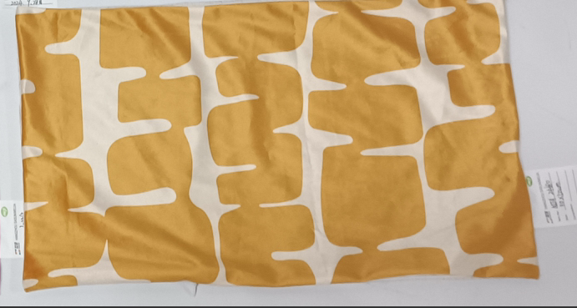
2 | Sarung bantal & guling | 6304.93.00 | CUSHION COVER VBRNT POSITIVITY B 30X50CM/10620483 | Merah |  |  | Polyester | INFORMA | CHINA | HANGZHOU SASUN IMP AND EXP CO.,LTD. | 3F,Building 2,Binhe International Science and Technology Innovation Park，425 Miaohouwang Road,Binjiang District,HANGZHOU,CHINA. | 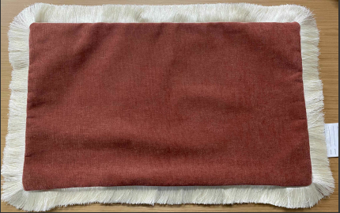
3 | Sarung bantal & guling | 6304.91.90 | CUSHION COVER VBRNT POSITIVITY C 45X45CM/10620484 | Hijau |  |  | Polyester | INFORMA | CHINA | HANGZHOU SASUN IMP AND EXP CO.,LTD. | 3F,Building 2,Binhe International Science and Technology Innovation Park，425 Miaohouwang Road,Binjiang District,HANGZHOU,CHINA. | 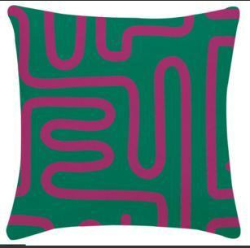
4 | Sarung bantal & guling | 6304.91.90 | CUSHION COVER VBRNT POSITIVITY D 45X45CM/10620485 | Merah |  |  | Polyester | INFORMA | CHINA | HANGZHOU SASUN IMP AND EXP CO.,LTD. | 3F,Building 2,Binhe International Science and Technology Innovation Park，425 Miaohouwang Road,Binjiang District,HANGZHOU,CHINA. | 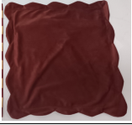
5 | Sarung bantal & guling | 6304.91.90 | CUSHION COVER VBRNT POSITIVITY E 45X45CM/10620486 | Hijau |  |  | Polyester | INFORMA | CHINA | HANGZHOU SASUN IMP AND EXP CO.,LTD. | 3F,Building 2,Binhe International Science and Technology Innovation Park，425 Miaohouwang Road,Binjiang District,HANGZHOU,CHINA. | 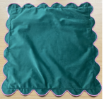  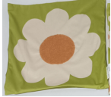
6 | Sarung bantal & guling | 6304.91.90 | CUSHION COVER RETROFIT CLUB A 45X45CM/10620481 | Hijau |  |  | Polyester | INFORMA | CHINA | HANGZHOU SASUN IMP AND EXP CO.,LTD. | 3F,Building 2,Binhe International Science and Technology Innovation Park，425 Miaohouwang Road,Binjiang District,HANGZHOU,CHINA.
7 | Sarung bantal & guling | 6304.93.00 | CUSHION COVER RETROFIT CLUB C 45X45CM/10622563 | Hijau & Orange |  |  | Polyester | INFORMA | CHINA | HANGZHOU SASUN IMP AND EXP CO.,LTD. | 3F,Building 2,Binhe International Science and Technology Innovation Park，425 Miaohouwang Road,Binjiang District,HANGZHOU,CHINA. | 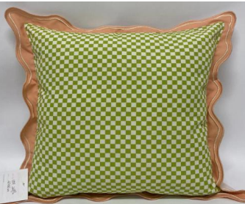  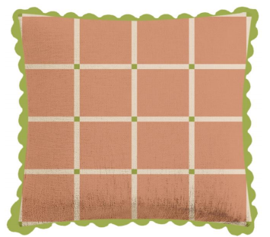
8 | Sarung bantal & guling | 6304.93.00 | CUSHION COVER RETROFIT CLUB D 45X45CM/10622564 | Hijau & Orange |  |  | Polyester | INFORMA | CHINA | HANGZHOU SASUN IMP AND EXP CO.,LTD. | 3F,Building 2,Binhe International Science and Technology Innovation Park，425 Miaohouwang Road,Binjiang District,HANGZHOU,CHINA.
9 | Sarung bantal & guling | 6304.93.00 | CUSHION COVER RETROFIT CLUB B 30X50CM/10620482 | Hijau & Biru |  |  | Polyester | INFORMA | CHINA | HANGZHOU SASUN IMP AND EXP CO.,LTD. | 3F,Building 2,Binhe International Science and Technology Innovation Park，425 Miaohouwang Road,Binjiang District,HANGZHOU,CHINA. | 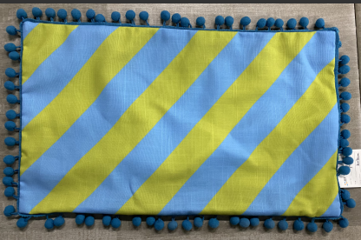
2 | Dengan ini saya nyatakan bahwa informasi yang telah kami isi di atas adalah benar.
 | _________________, Tanggal: DD / MM / YEAR)
 | ( NAMA & TANDA TANGAN) |  |  | (STEMPEL BASAH)
 | Catatan:
1 | Mohon hardcopy FDS (yang sudah ditandatangan + stempel) dan softcopy (JANGAN DI PDF) dikirim kembali melalui email ke: gunawan@qualis-indonesia dan mia.swastika@qualis-indonesia.com.

