LAPORAN HASIL UJI (LHU)
TEST REPORT

1. Alat uji / alat ukur yang digunakan.
Measuring equipment

No. | Nama Alat  Equipment name
1. | Kain, Air, Hexane / Petroleum spirit.
2. | Digital caliper.
3. | Torque driver.
4. | Impact test device, Impact hammer.
5. | Salt spray test machine.
6. | Vibration test equipment.
7. | Photobiological hazard test instrument.
8. | Power cord pull, Torsion tester.
9. | Earth continuity tester.
10. | Probe (A / B / C / D), Prevent electric shock circuit device.
11. | Dust chamber (IP5X/6X).
12. | Vertically falling water drops device (IPX1/2), Oscillating tube spraying water device (IPX3/4),  Flush test device (IPX5/6), Water immersion test equipment (IPX7), Prevent flooding device (IPX8).
13. | Programmed constant temperature & Humidity test chamber.
14. | Insulation resistance tester.
15. | AC DC withstand voltage tester.
16. | Leakage current tester.
17. | Creepage distance gauge.
18. | Lamps constant temperature endurance chamber.
19. | Draught proof, Temperature power test system.
20. | High-precision circulator exact oven, Ball pressure device, Optical magnifier (Lupe).
21. | Needle flame tester, Glow wire tester.
22. | Track index tester.

{Pictures}
Produk uji
Test product
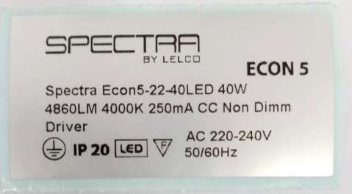
Gambar 1 – Label Penandaan Produk
Pictures 1 – Product marking
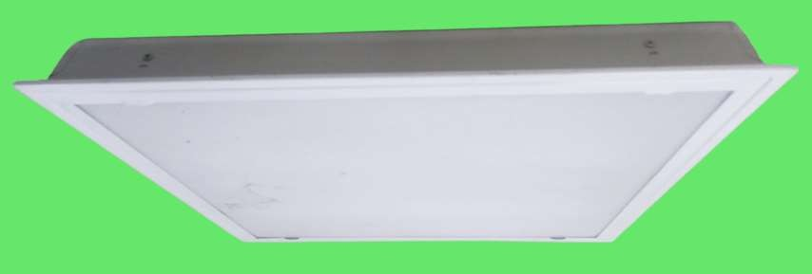
Gambar 2 – Tampak Depan
Pictures 2 – Front view

{AdditionalData}
{tableLED}

