

TEST REPORT
No.QI-25/07/0111T
Applicant Company Name | PT HOME CENTER INDONESIA
Attention | PT HOME CENTER INDONESIA
Address | GEDUNG KAWAN LAMA, JL. PURI KENCANA NO. 1, Desa/Kelurahan Kembangan Selatan Kec. Kembangan, Kota Adm. Jakarta Barat, Provinsi DKI Jakarta,,,Kota Adm. Jakarta Barat,11610,ID
Request No. | smp/25080300 |  | Test performance date | 12 August 2025
Received Date of Sample | 12 August 2025 |  | Issue date | 12 August 2025
 |  |  | Test Report valid until | 14 February 2026
Sample Description | Bedcover
Material/fiber type
Brand Product
Factory Name
Factory Address
Country of Origin
Approved and digitally signed on behalf of
PT. Qualis Indonesia


Jang Yadi
Chemical Laboratory Manager
This document is electronically generated and bears no signature. Please scan above QR code to verify document originality.

Type
Group of Product | Bedcover
Description of Product | Bed covers are made of cotton, and or man-made fiber materials, and or a mixture of both, which are impregnated, coated, covered or laminated by materials with specific functions.
Remark

Sample Picture:

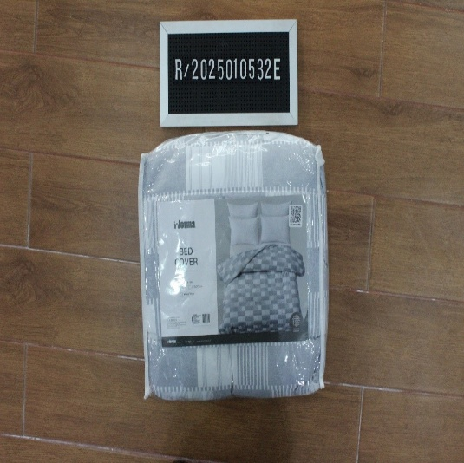  Sample A | 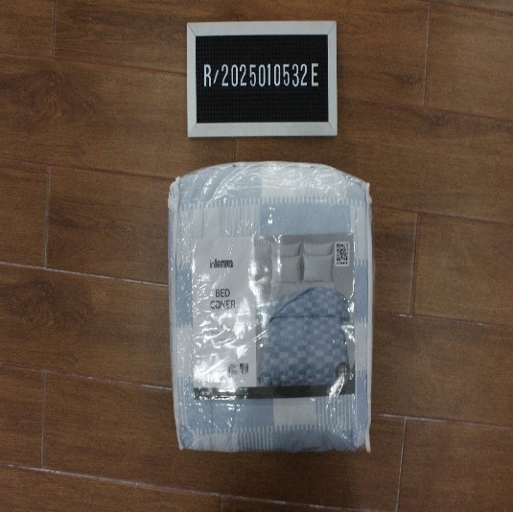  Sample B
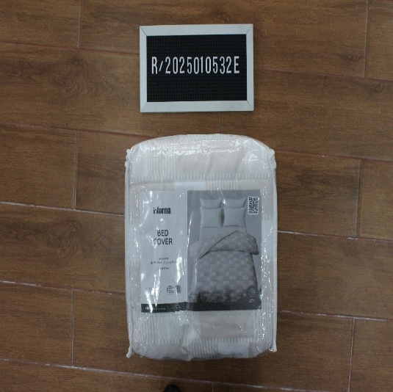  Sample C | 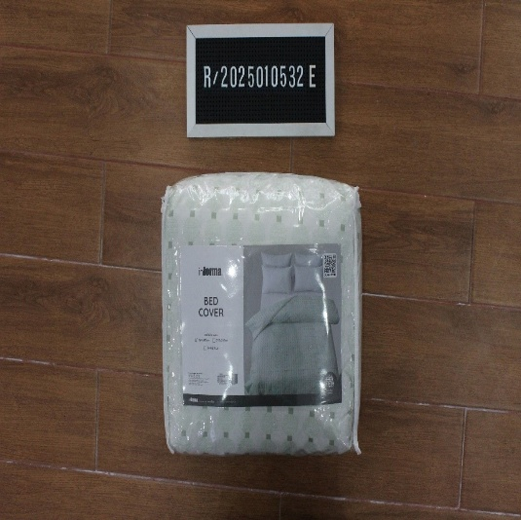  Sample D

Note: Test samples are selected by the laboratory and composited in accordance with the Decree of the Director General of Consumer Protection and Trade Order Number 36 of 2023 concerning Technical Instructions for Procedures for Implementing Verification of Registration and Testing of Goods Related to Security, Safety, Health and the Environment.

Overall Conclusion:

For compliance with the requirements Permendag No. 26 Tahun 2021:
No. | Test Parameters | Test Method | Results
1 | Azo dyes | SNI ISO 24362-1: 2015 | PASS
2 | Extractable Heavy Metal | SNI 7334: 2009 | PASS
3 | Flame Retardant | SNI ISO 17881-1 : 2017% | PASS
4 | Formaldehyde | SNI ISO 14184-1: 2015 | PASS
5 | PFOA & PFOS | SNI 8360 : 2017 | PASS

Sample Description:
Sr. No. | Sample Description | Sample ID
1 | Sample A - Kain utama (Hitam) | 001
2 | Sample B - Kain utama (Biru) | 002
3 | Sample C - Kain utama (Coklat) | 003
4 | Sample D - Kain utama (Hijau) | 004
5 | Sample A,Sample B,Sample C,Sample D - Kain utama (Putih) | 005

Note: main colors: red, yellow, green, blue, orange, brown, purple, black, white and multicolor

Test Result

- Extractable Heavy Metal

Test Method: SNI 7334: 2009 analyzed by ICP-OES
Element | CAS Number | Result(mg/kg)  (001+002+003) | Result(mg/kg)  (004+005) | Requirement
Nickel (Ni) | n/a | N.D | N.D | Maximum 1.0
Lead (Pb) | n/a | N.D | N.D | Maximum 0.20
Cadmium (Cd) | n/a | N.D | N.D | Maximum 0.1
Copper (Cu) | n/a | N.D | N.D | Maximum 25
Remark |  | PASS | PASS
Method Detection Limit= Nickel (Ni): 0.050, Lead (Pb): 0.050 , Cadmium (Cd): 0.015 , Copper (Cu): 0.020

2. Azo dyes
Test Method: SNI ISO 24362-1: 2015, analyzed by GC-MS
Element | CAS Number | Result(mg/kg)  (001+002+003) | Result(mg/kg)  (004+005) | Requirement
4-aminobiphenyl / biphenyl-4-ylamine / xenylamine | 92-67-1 | N.D | N.D | Maximum 20
Benzidine | 92-87-5 | N.D | N.D | Maximum 20
4-chloro-o-toluidine | 95-69-2 | N.D | N.D | Maximum 20
2-naphthylamine | 91-59-8 | N.D | N.D | Maximum 20
o-aminoazotoluene / 4-amino-2’,3-dimethylazobenzene / 4-o-tolylazo-o-toluidine | 97-56-3 | N.D | N.D | Maximum 20
5-nitro-o-toluidine / 2-amino-4-nitrotoluene | 99-55-8 | N.D | N.D | Maximum 20
4-chloroaniline | 106-47-8 | N.D | N.D | Maximum 20
2,4-diaminoanisole / 4-methoxy-m-phenylenediamine | 615-05-4 | N.D | N.D | Maximum 20
4,4’-diaminodiphenylmethane / 4,4’-methylenedianiline | 101-77-9 | N.D | N.D | Maximum 20
3,3’-dichlorobenzidine / 3,3’-dichlorobiphenyl-4,4’-ylenediamine | 91-94-1 | N.D | N.D | Maximum 20
3,3’ dimethoxybenzidine / o-dianisidine | 119-90-4 | N.D | N.D | Maximum 20
3,3’-dimethylbenzidine / 4,4’-bi-o-toluidine | 119-93-7 | N.D | N.D | Maximum 20
4,4’-methylenedi-o-toluidine | 838-88-0 | N.D | N.D | Maximum 20
p-cresidine / 6-methoxy-m-toluidine | 120-71-8 | N.D | N.D | Maximum 20
4,4’-methylene-bis-(2-chloroaniline) / 2,2;-dichloro-4-4’-methylene-dianiline | 101-14-4 | N.D | N.D | Maximum 20
4,4’-oxydianiline | 101-80-4 | N.D | N.D | Maximum 20
4,4’-thiodianiline | 139-65-1 | N.D | N.D | Maximum 20
o-toluidine / 2-aminotoluene | 95-53-4 | N.D | N.D | Maximum 20
2,4-toluendiamine / 4-methyl-m-phenylenediamine / 2,4-diaminotoluene | 95-80-7 | N.D | N.D | Maximum 20
2,4,5-trimethylaniline | 137-17-7 | N.D | N.D | Maximum 20
2-methoxyaniline / o-anisidine | 90-04-0 | N.D | N.D | Maximum 20
4-aminoazobenzene* | 60-09-3 | N.D | N.D | Maximum 20
Remark |  | PASS | PASS

3. Flame Retardant
Test Method: SNI ISO 17881-1 : 2017%, analyzed by GC-MS
Element | CAS Number | Result(mg/kg)  (001+002+003  +004+005) | Requirement
Pentabromodiphenyl Ether (pentaBDE) | 32534-81-9 | N.D | Maximum 5
Remark |  | PASS
Method Detection Limit= Pentabromodiphenyl Ether (pentaBDE): 2

4. PFOA & PFOS
Test Method: SNI 8360 : 2017, analyzed by LC-MS
Element | CAS Number | Result(mg/kg)  (001+002+003  +004+005) | Requirement
Perfluorooctanesulfonate (PFOS) | 1763-23-1 | N.D | Maximum 1.0
Perfluorooctanoic acid (PFOA) | 335-67-1 | N.D | Maximum 1.0
Remark |  | PASS
Method Detection Limit= Perfluorooctanesulfonate (PFOS): 0.5, Perfluorooctanoic acid (PFOA): 0.5

5. Formaldehyde
Test Method: SNI ISO 14184-1: 2015, analyzed by UV-Visible
Element | CAS Number | Result(mg/kg)  (001+002+003  +004+005) | Requirement
Formaldehyde | 50-00-0 | N.D | Maximum 16
Remark |  | PASS
Method Detection Limit= Formaldehyde: 16

*********************************** End of The Test Report**********************************

LAMPIRAN
ATTACHMENT

TABEL PENGELOMPOKAN BARANG
Table of Product Grouping

PT. HOME CENTER INDONESIA
GEDUNG KAWAN LAMA, JL. PURI KENCANA NO. 1, Desa/Kelurahan Kembangan Selatan,
Kec. Kembangan, Kota Adm. Jakarta Barat, Provinsi DKI Jakarta, Kode Pos: 11610

Kelompok Barang
Grouping of Product: Bedcover

No. | Product Name | Article No. | Color | Material | Brand | Photo of Product
1 | Seprai | 10572015/FITTED SHEET WHITE (A) - TENCEL(TM) | PUTIH | 100% TENCEL | INFORMA | 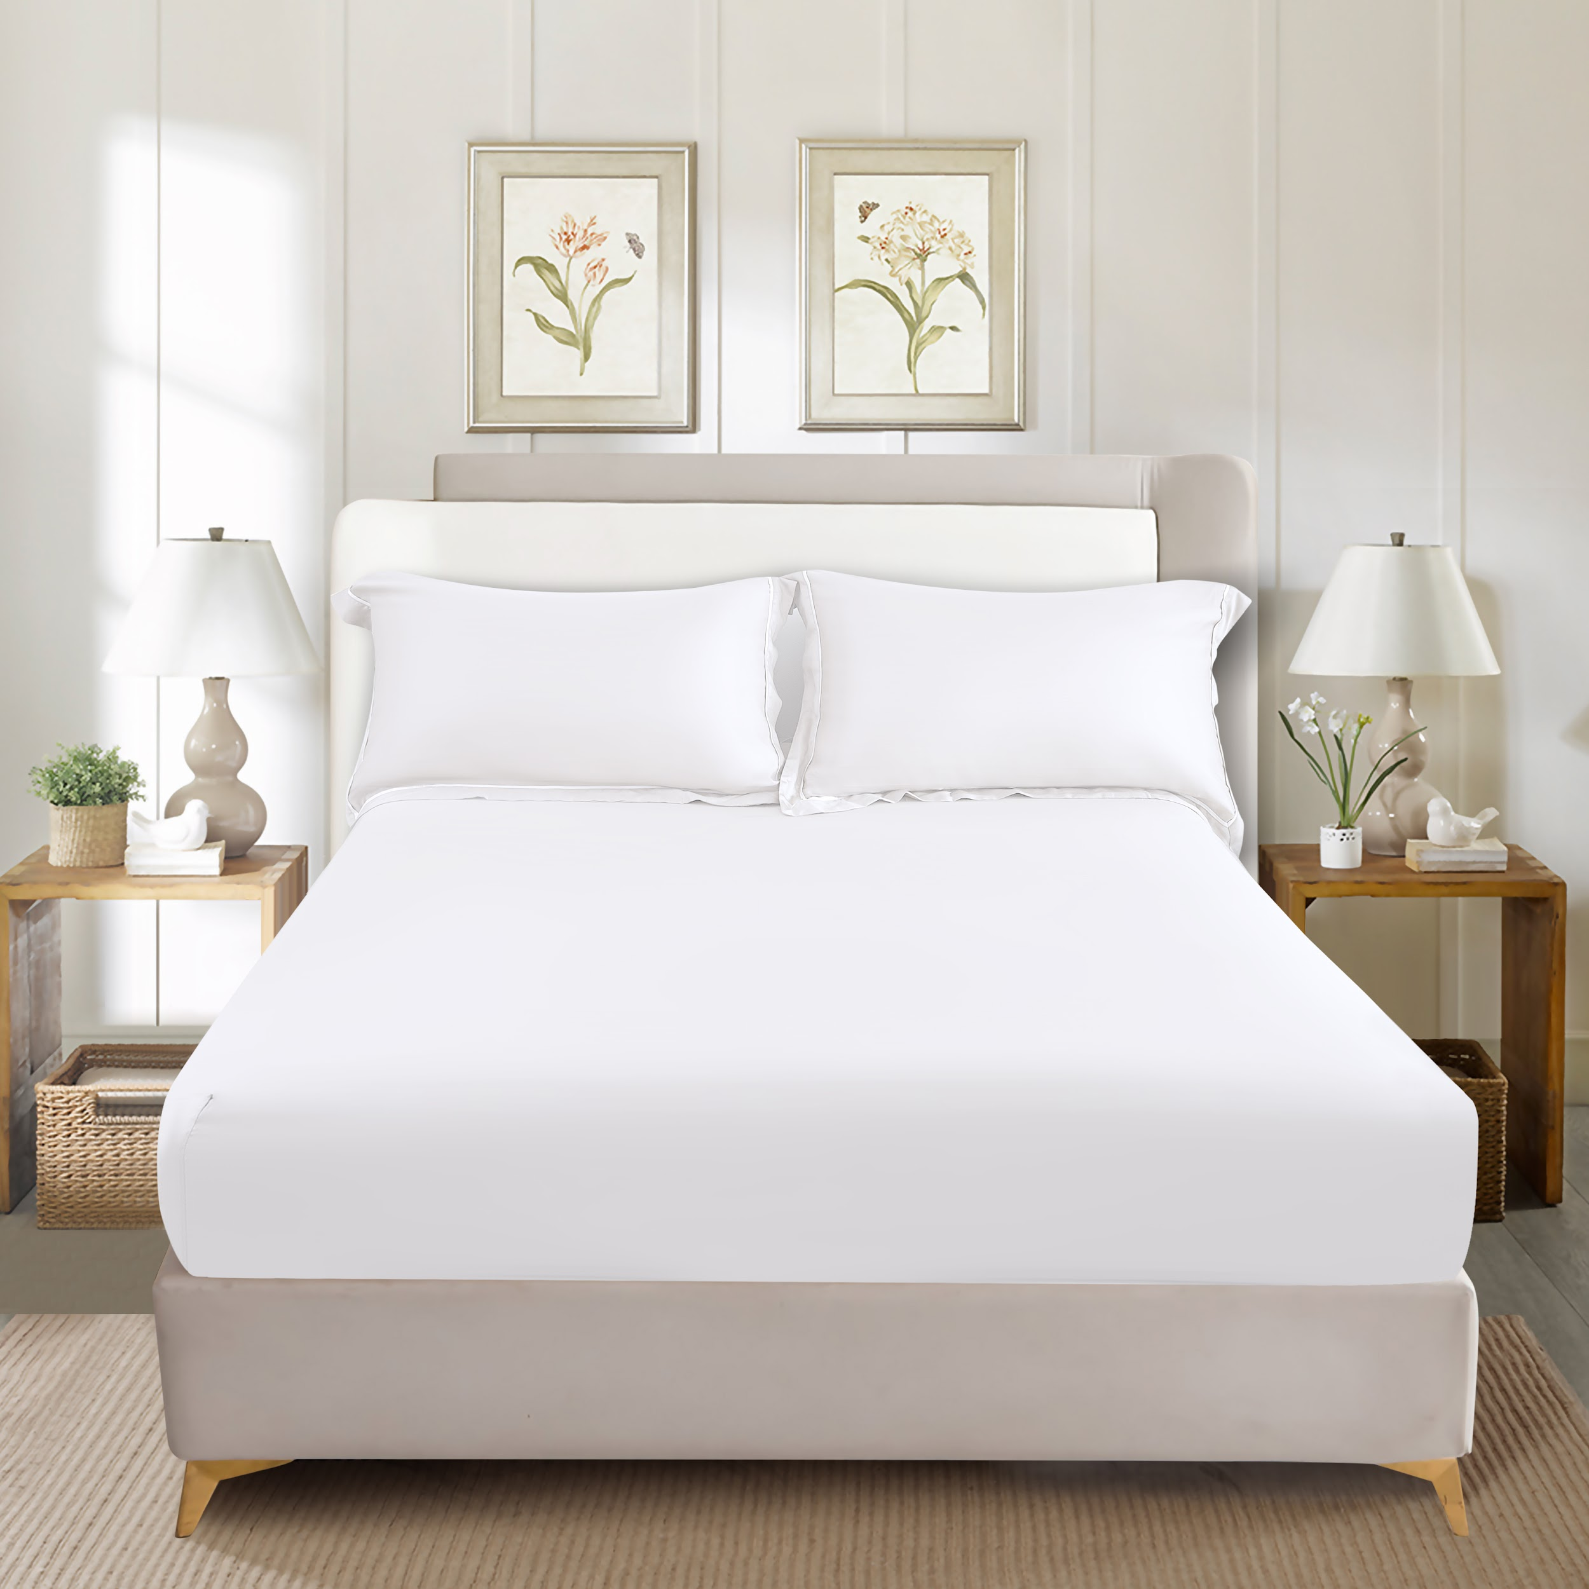
1 | Seprai | 10572016/FITTED SHEET WHITE (B) - TENCEL(TM)
1 | Seprai | 10572017/FITTED SHEET WHITE (C) - TENCEL(TM)
2 | Seprai | 10572018/FITTED SHEET GREY (A) - TENCEL(TM) | ABU-ABU | 100% TENCEL | INFORMA | 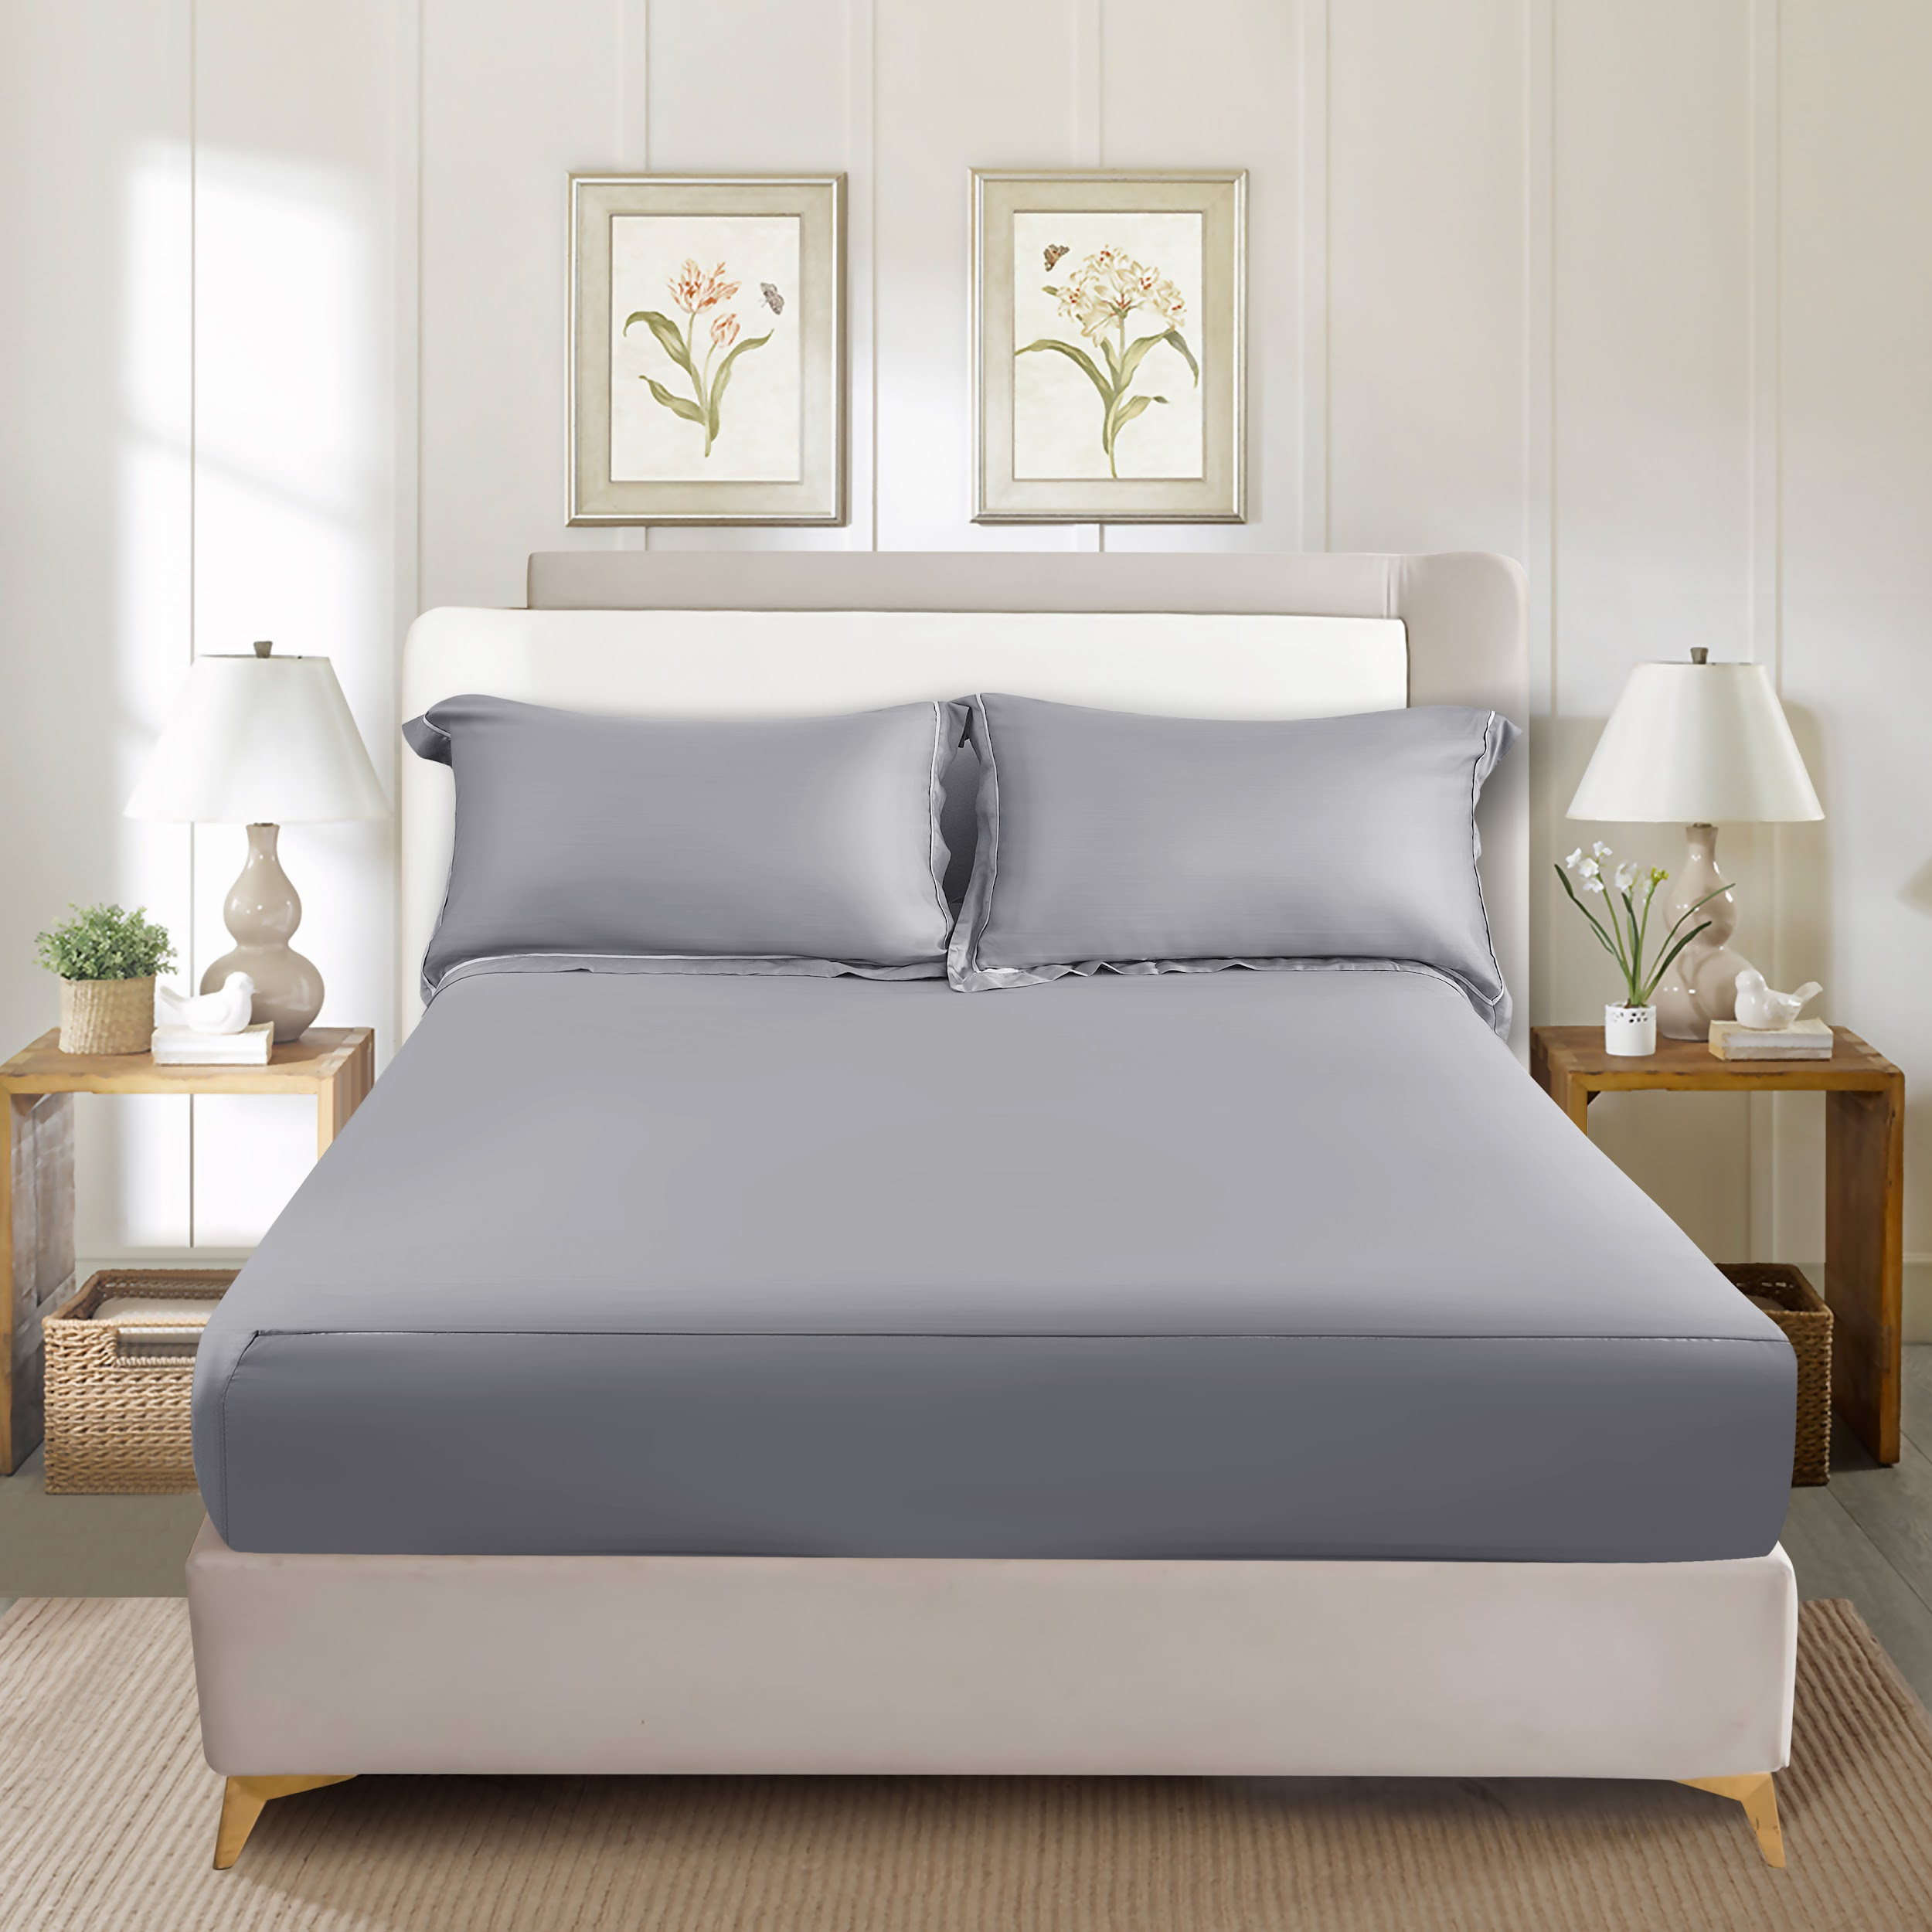
2 | Seprai | 10572019/FITTED SHEET GREY (B) - TENCEL(TM)
2 | Seprai | 10572020/FITTED SHEET GREY (C) - TENCEL(TM)
3 | Seprai | 10572021/FITTED SHEET PINK (A) - TENCEL(TM) | PINK | 100% TENCEL | INFORMA | 
3 | Seprai | 10572022/FITTED SHEET PINK (B) - TENCEL(TM)
3 | Seprai | 10572023/FITTED SHEET PINK (C) - TENCEL(TM)
4 | Seprai | 10572024/FITTED SHEET BLUEGREY (A) - TENCEL(TM) | BIRU MUDA | 100% TENCEL | INFORMA | 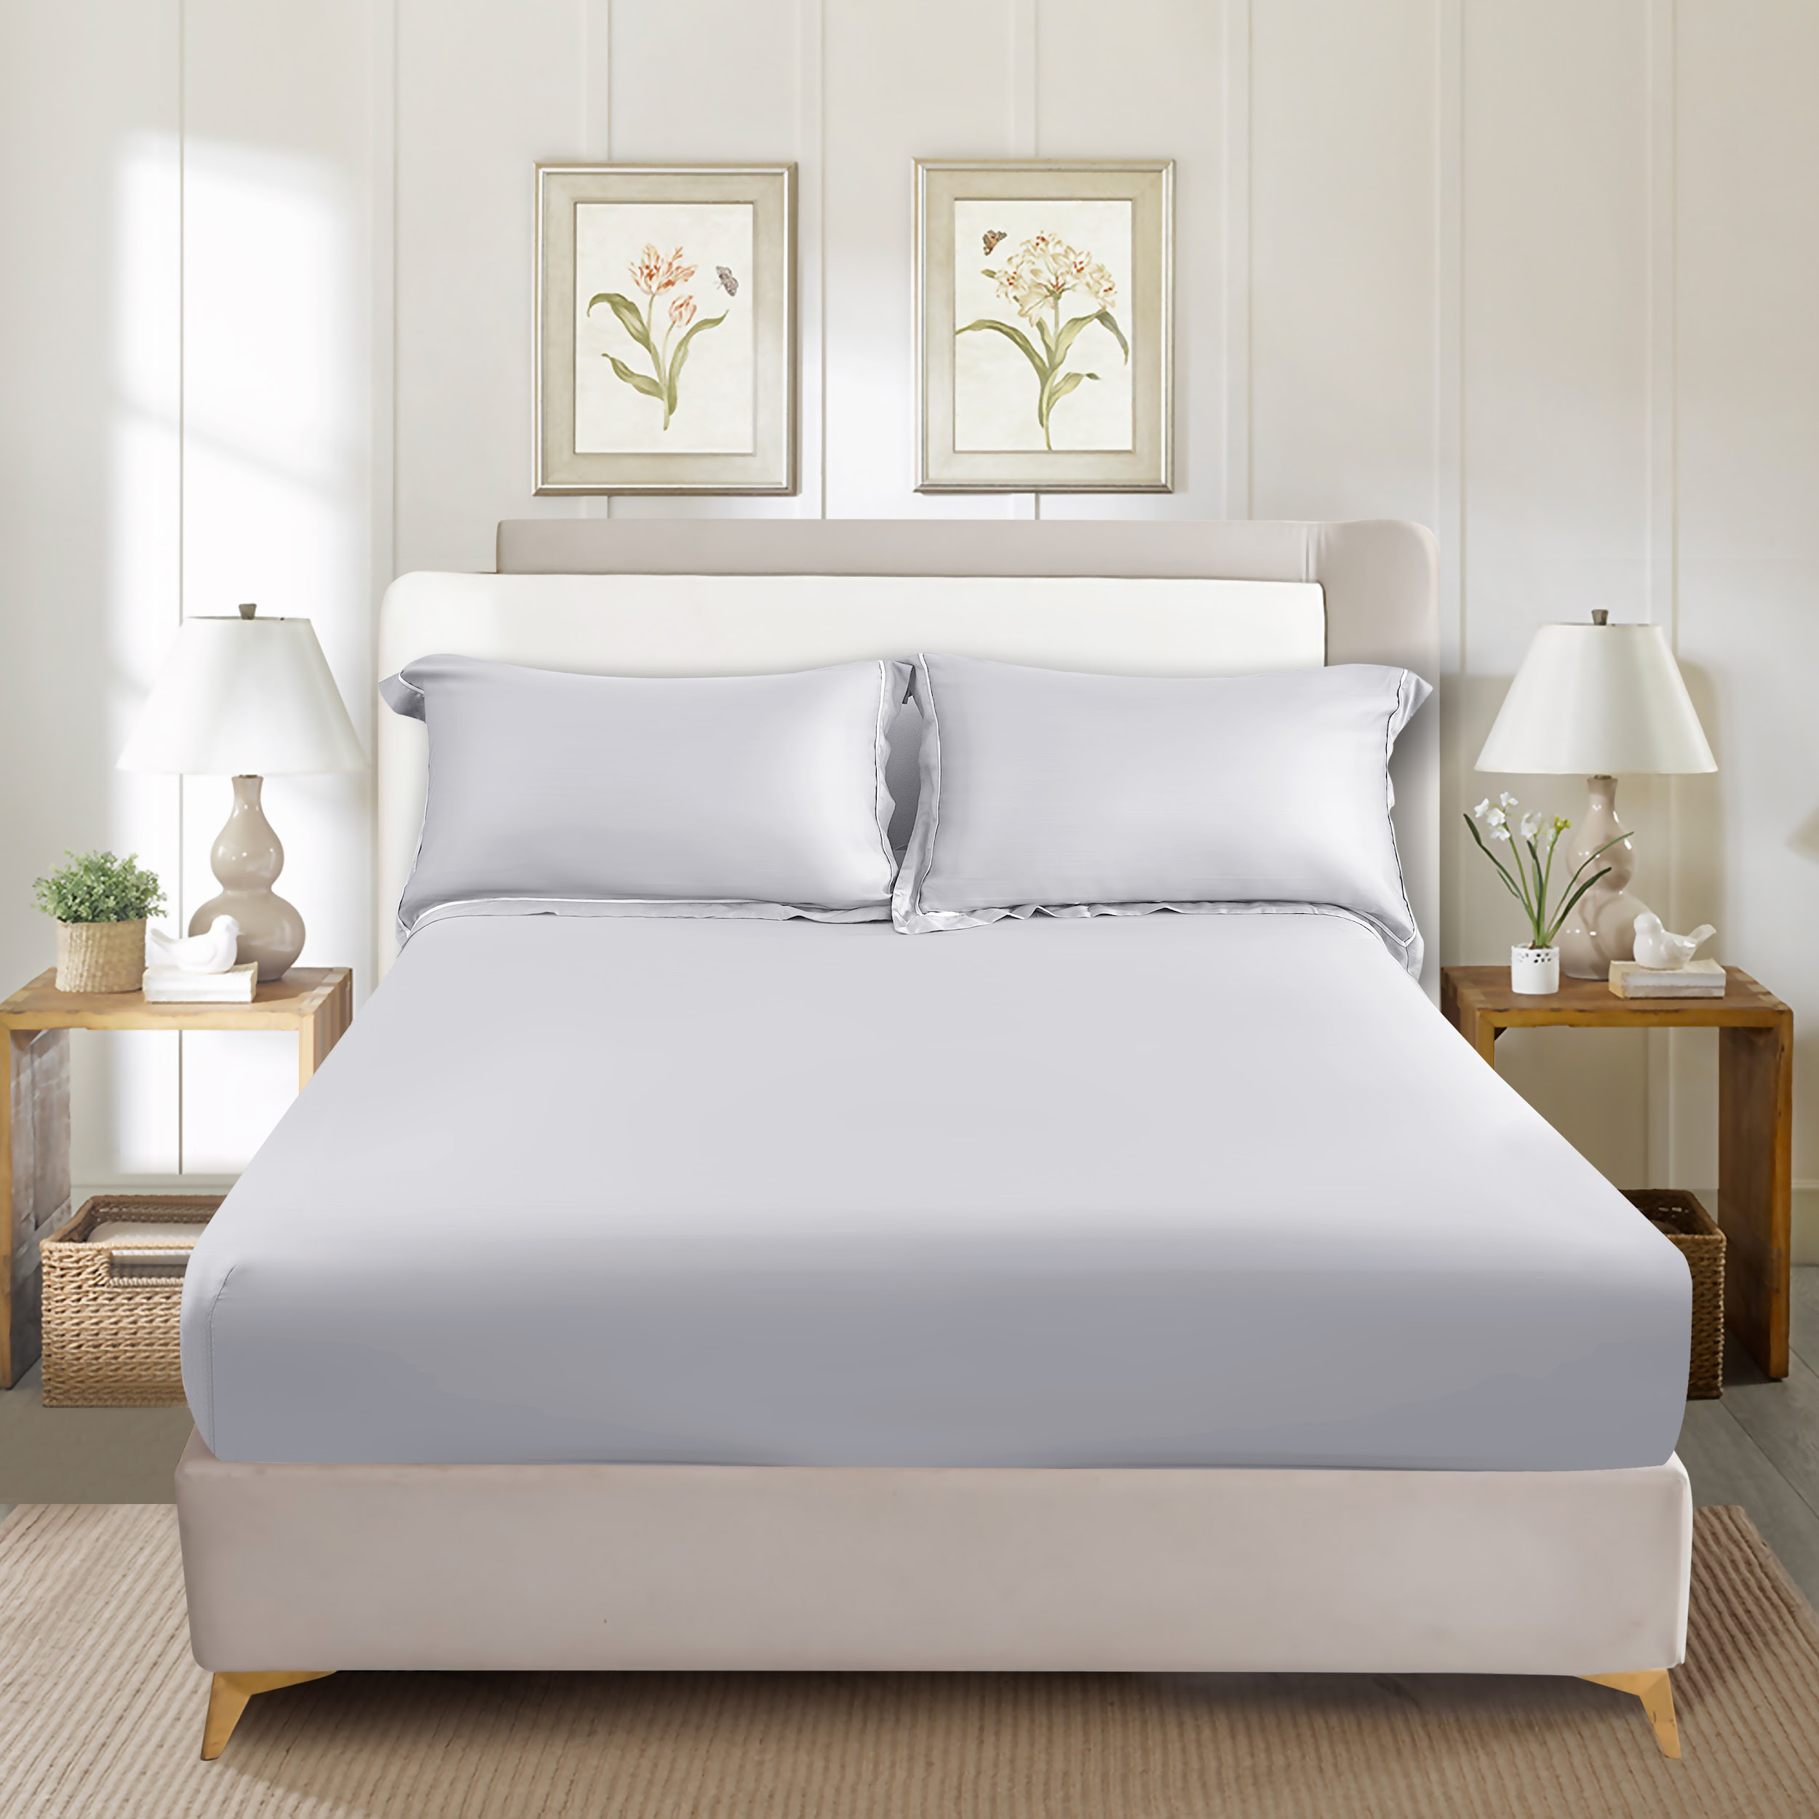
4 | Seprai | 10572025/FITTED SHEET BLUEGREY (B) - TENCEL(TM)
4 | Seprai | 10572026/FITTED SHEET BLUEGREY (C) - TENCEL(TM)
5 | Seprai | 10572027/FITTED SHEET SAGEGREEN (A) - TENCEL(TM) | HIJAU | 100% TENCEL | INFORMA | 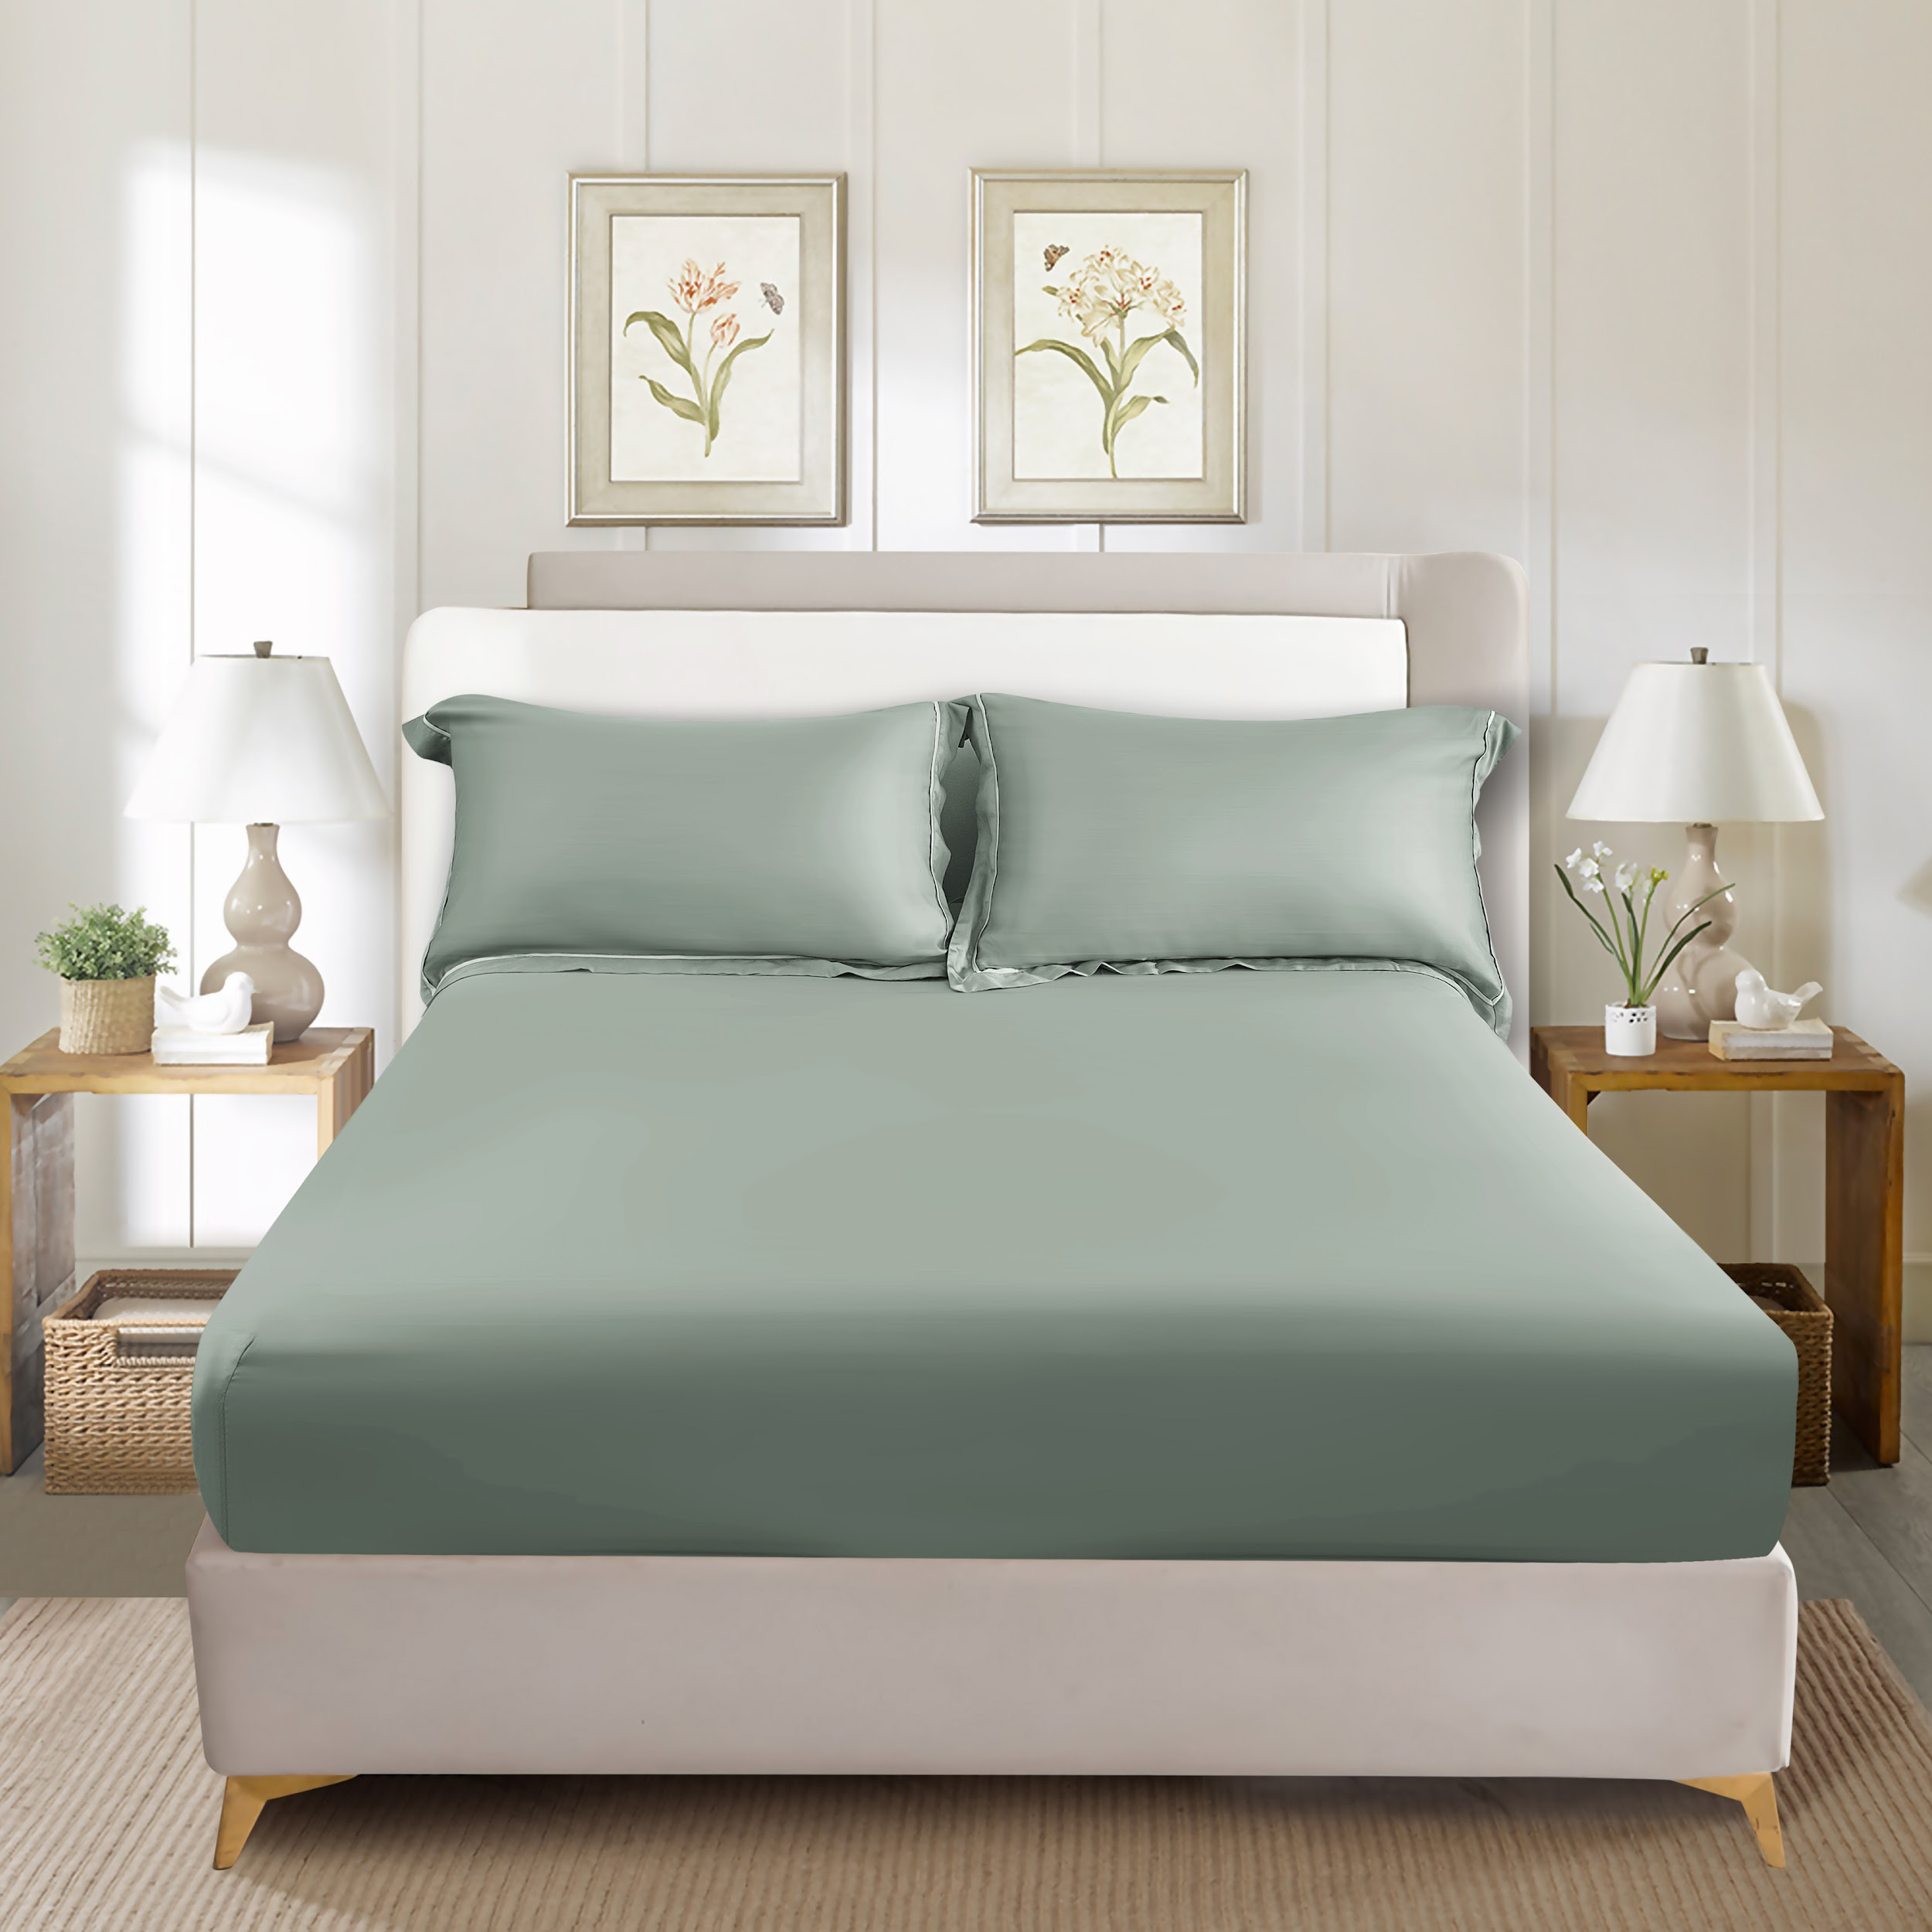
5 | Seprai | 10572028/FITTED SHEET SAGEGREEN (B) - TENCEL(TM)
5 | Seprai | 10572029/FITTED SHEET SAGEGREEN (C) - TENCEL(TM)
6 | Seprai | 10572030/FITTED SHEET BROWN (A) - TENCEL(TM) | COKLAT | 100% TENCEL | INFORMA | 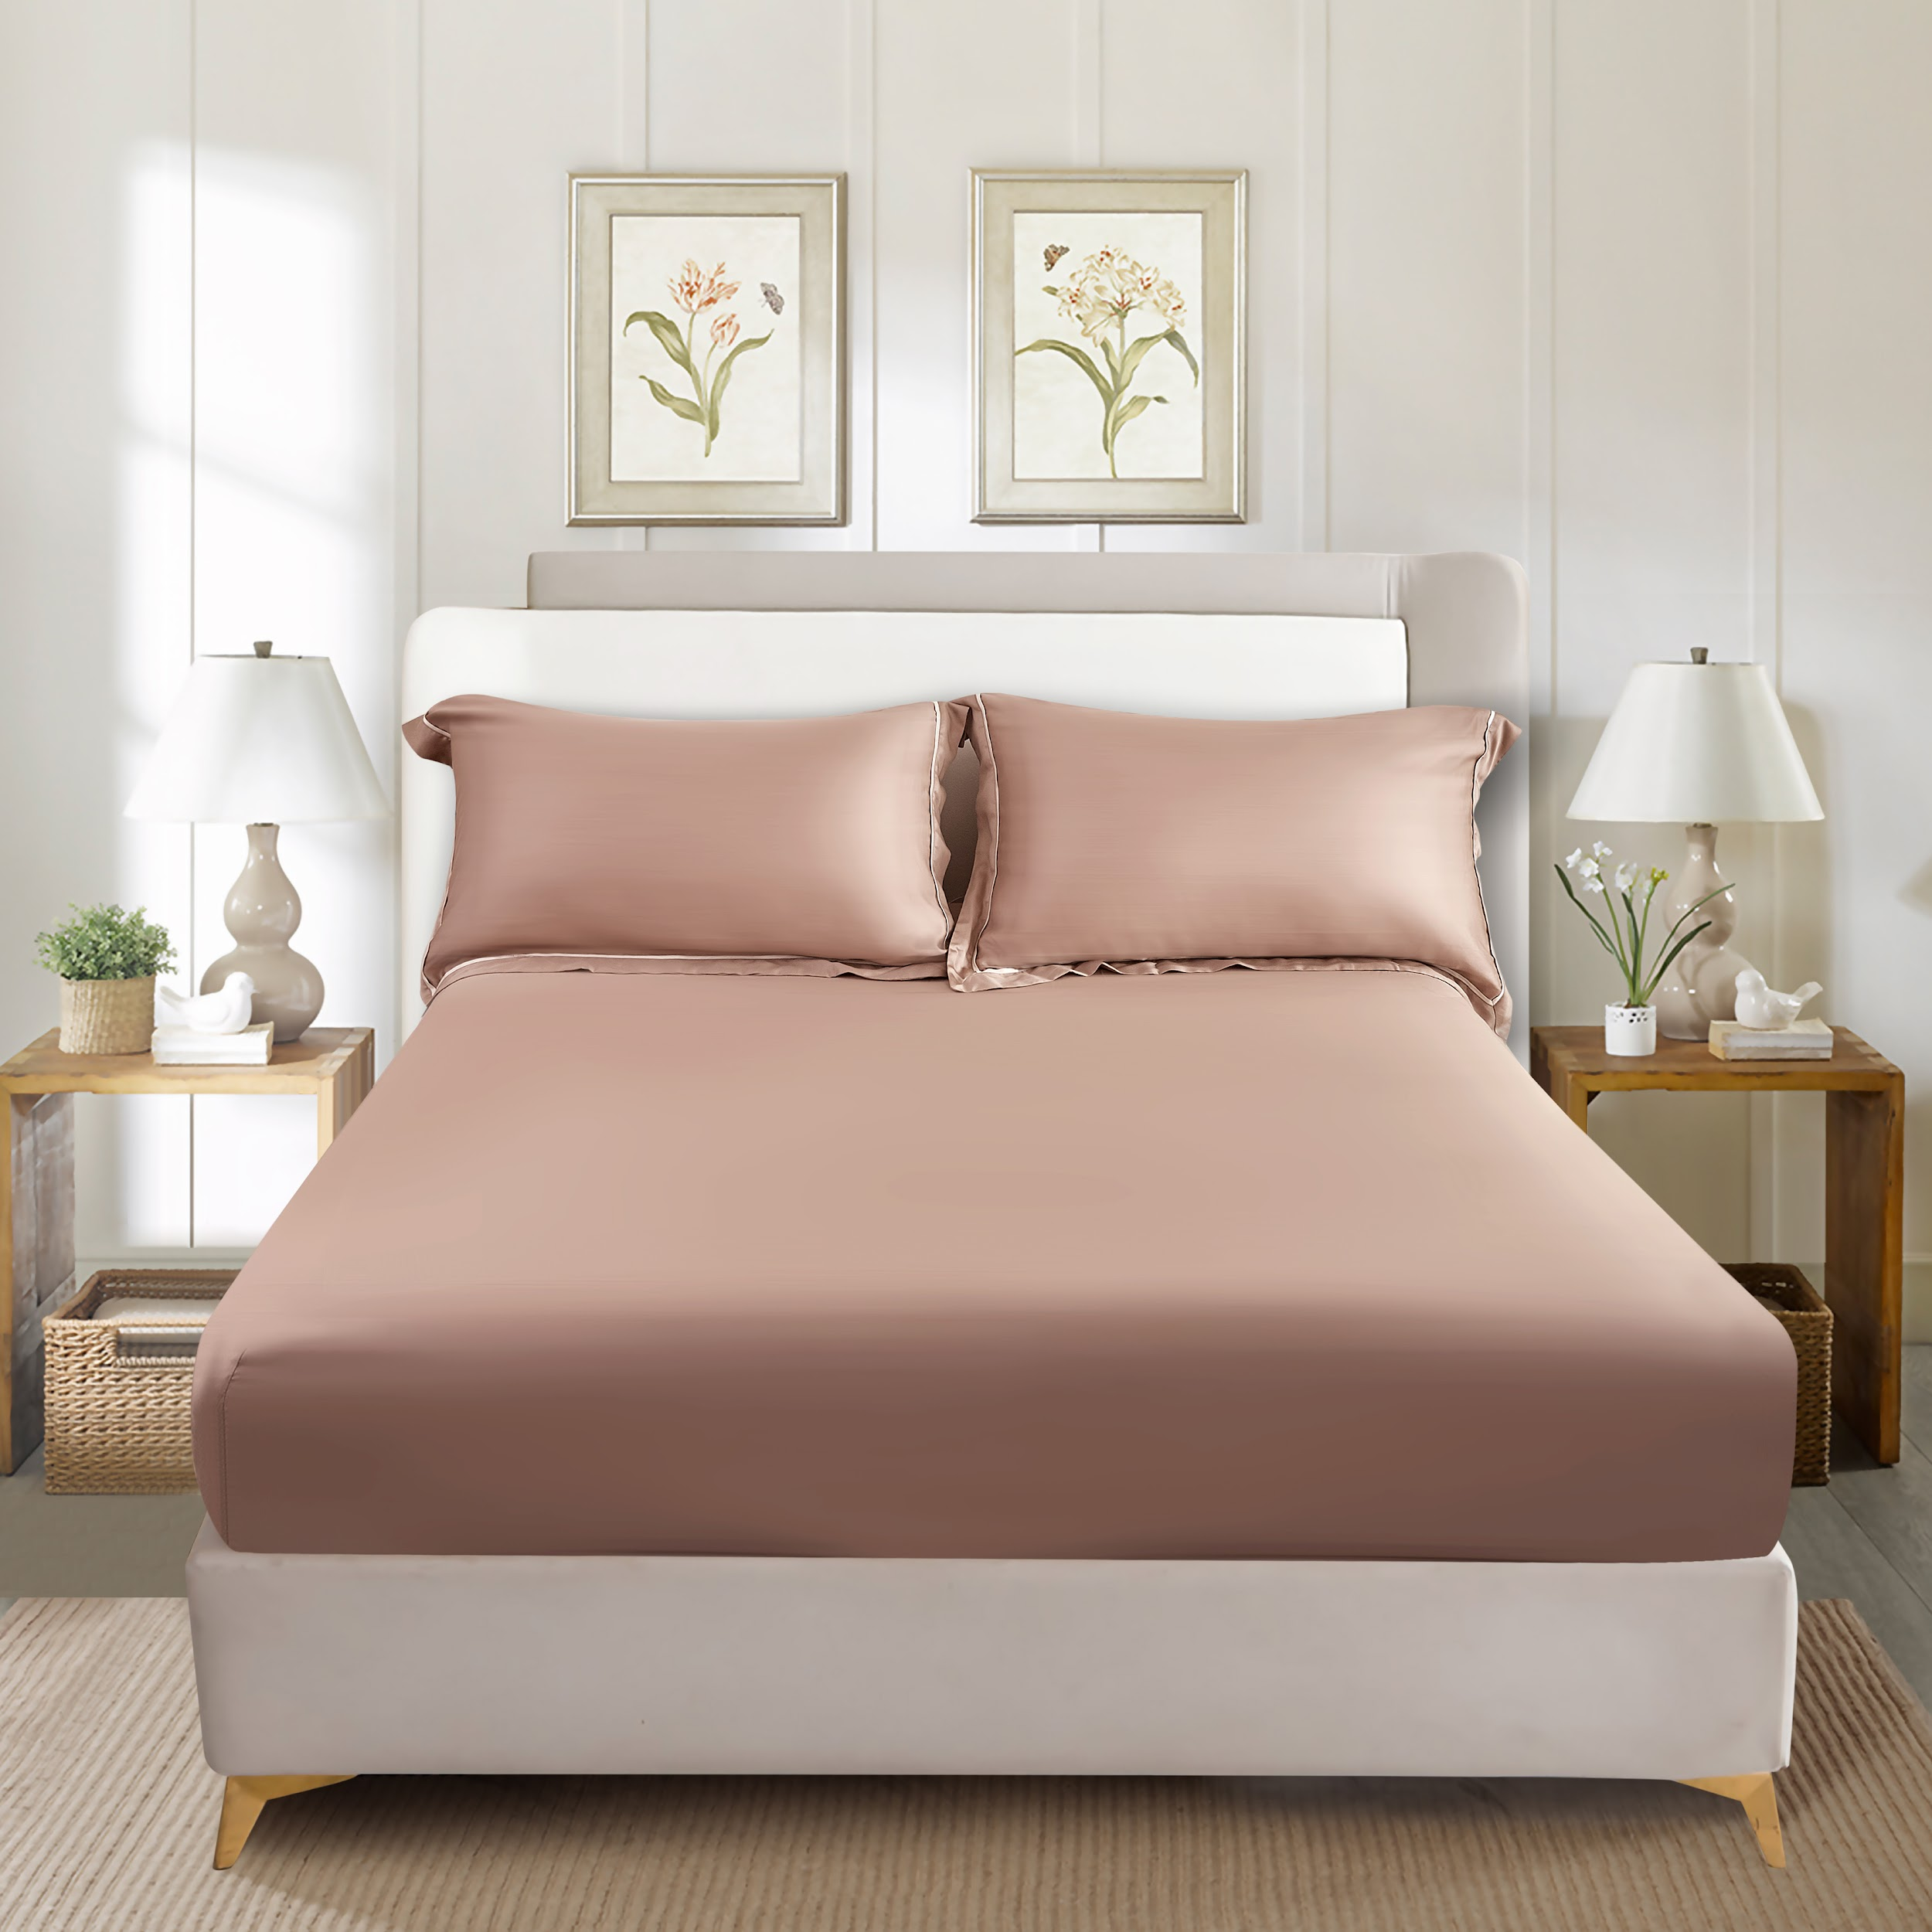
6 | Seprai | 10572031/FITTED SHEET BROWN (B) - TENCEL(TM)
6 | Seprai | 10572032/FITTED SHEET BROWN (C) - TENCEL(TM)
7 | Seprai | 10572033/FITTED SHEET IVORY (A) - TENCEL(TM) | IVORY | 100% TENCEL | INFORMA | 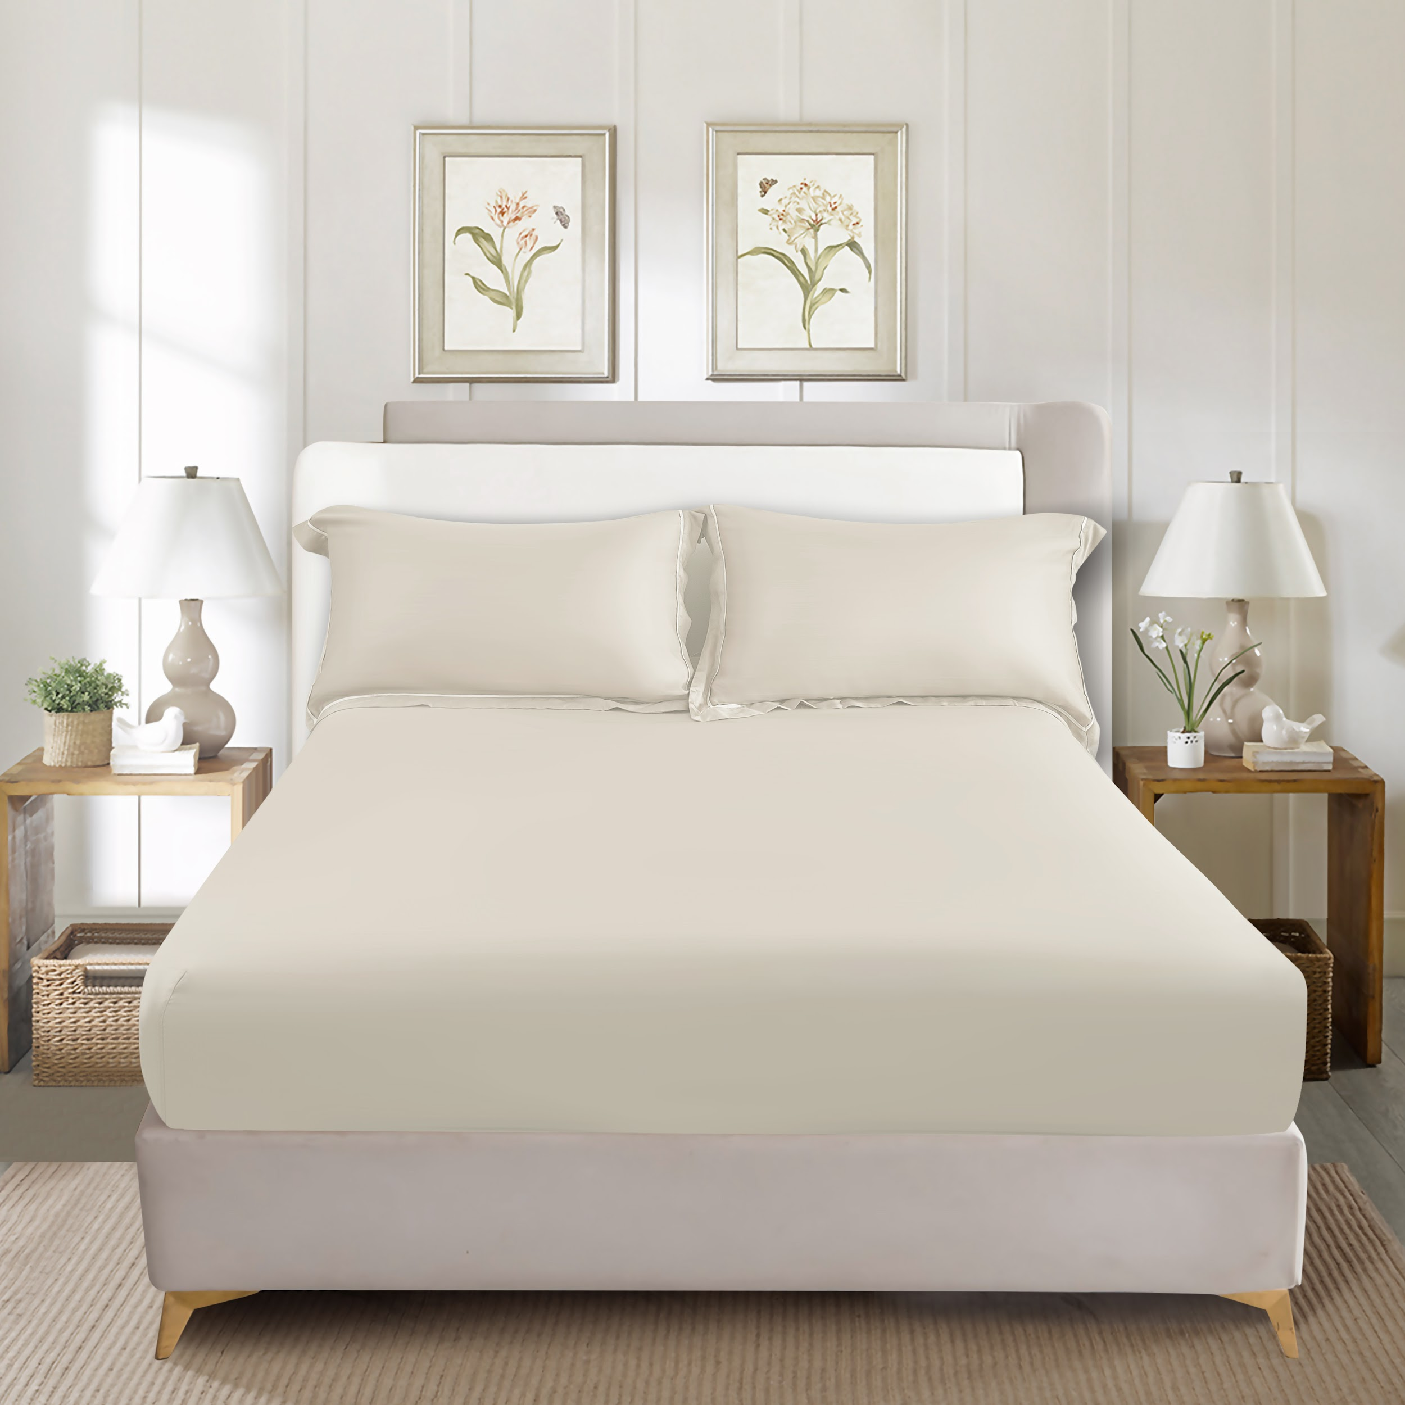
7 | Seprai | 10572034/FITTED SHEET IVORY (B) - TENCEL(TM)
7 | Seprai | 10572035/FITTED SHEET IVORY (C) - TENCEL(TM)
8 | Sarung Selimut | 10572036/DUVET COVER WHITE (A) - TENCEL(TM) | PUTIH | 100% TENCEL | INFORMA | 
8 | Sarung Selimut | 10572037/DUVET COVER WHITE (B) - TENCEL(TM)
8 | Sarung Selimut | 10572038/DUVET COVER WHITE (C) - TENCEL(TM)
9 | Sarung Selimut | 10572039/DUVET COVER GREY (A) - TENCEL(TM) | ABU-ABU | 100% TENCEL | INFORMA | 
9 | Sarung Selimut | 10572040/DUVET COVER GREY (B) - TENCEL(TM)
9 | Sarung Selimut | 10572041/DUVET COVER GREY (C) - TENCEL(TM)
10 | Sarung Selimut | 10572042/DUVET COVER PINK (A) - TENCEL(TM) | PINK | 100% TENCEL | INFORMA | 
10 | Sarung Selimut | 10572043/DUVET COVER PINK (B) - TENCEL(TM)
10 | Sarung Selimut | 10572044/DUVET COVER PINK (C) - TENCEL(TM)
11 | Sarung Selimut | 10572045/DUVET COVER BLUEGREY (A) - TENCEL(TM) | BIRU MUDA | 100% TENCEL | INFORMA | 
11 | Sarung Selimut | 10572046/DUVET COVER BLUEGREY (B) - TENCEL(TM)
11 | Sarung Selimut | 10572047/DUVET COVER BLUEGREY (C) - TENCEL(TM)
12 | Sarung Selimut | 10572048/DUVET COVER SAGEGREEN (A) - TENCEL(TM) | HIJAU | 100% TENCEL | INFORMA | 
12 | Sarung Selimut | 10572049/DUVET COVER SAGEGREEN (B) - TENCEL(TM)
12 | Sarung Selimut | 10572350/DUVET COVER SAGEGREEN (C) - TENCEL(TM)
13 | Sarung Selimut | 10572351/DUVET COVER BROWN (A) - TENCEL(TM) | COKLAT | 100% TENCEL | INFORMA | 
13 | Sarung Selimut | 10572352/DUVET COVER BROWN (B) - TENCEL(TM)
13 | Sarung Selimut | 10572353/DUVET COVER BROWN (C) - TENCEL(TM)
14 | Sarung Selimut | 10572354/DUVET COVER IVORY (A) - TENCEL(TM) | IVORY | 100% TENCEL | INFORMA | 
14 | Sarung Selimut | 10572355/DUVET COVER IVORY (B) - TENCEL(TM)
14 | Sarung Selimut | 10572356/DUVET COVER IVORY (C) - TENCEL(TM)
15 | SARUNG BANTAL & GULING | 10572377/10572384 - PILLOW BOLSTER CASE WHITE - TENCEL(TM) | PUTIH | 100% TENCEL | INFORMA | 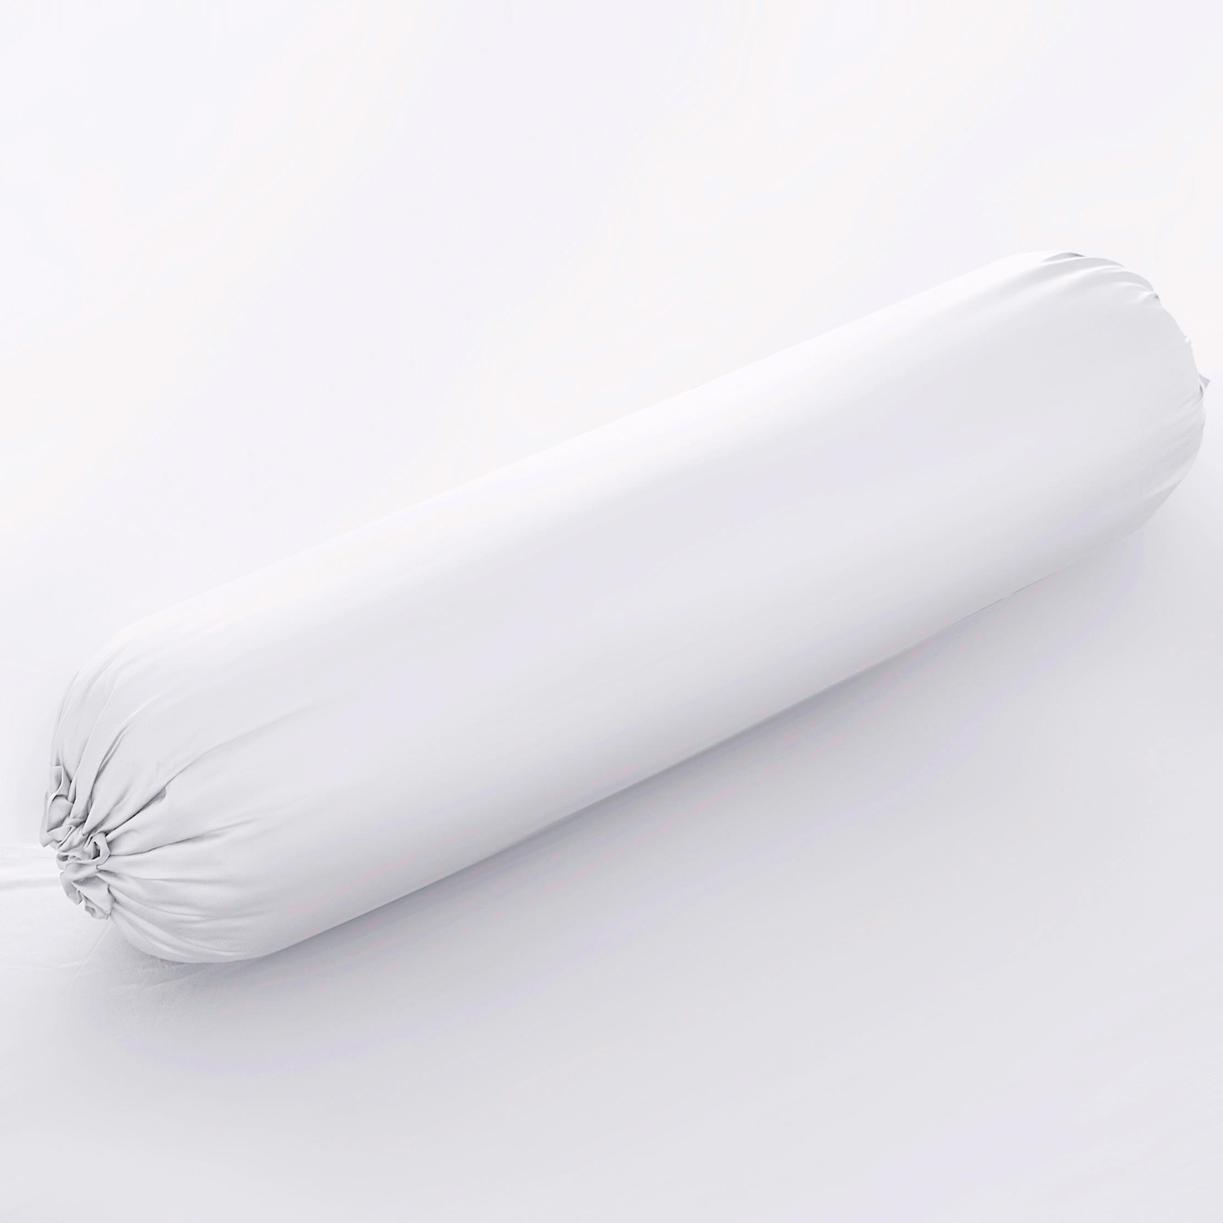  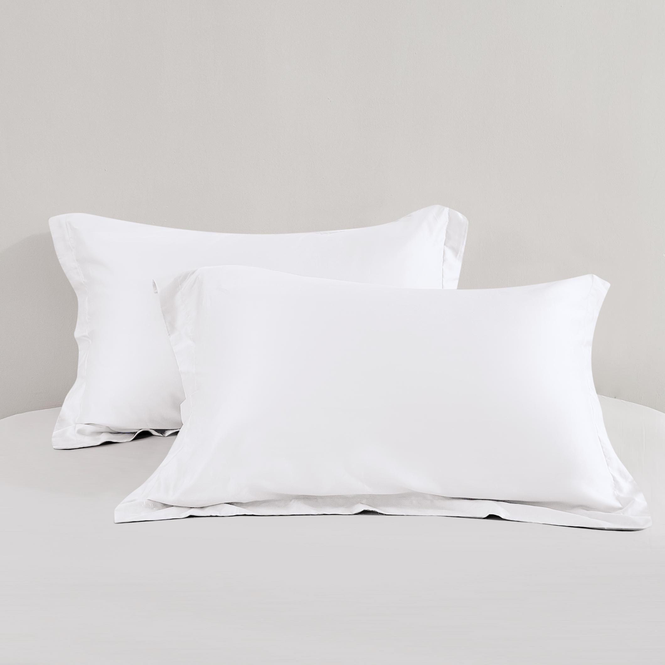
16 | SARUNG BANTAL & GULING | 10572378/10572385 - PILLOW BOLSTER CASE GREY - TENCEL(TM) | ABU-ABU | 100% TENCEL | INFORMA | 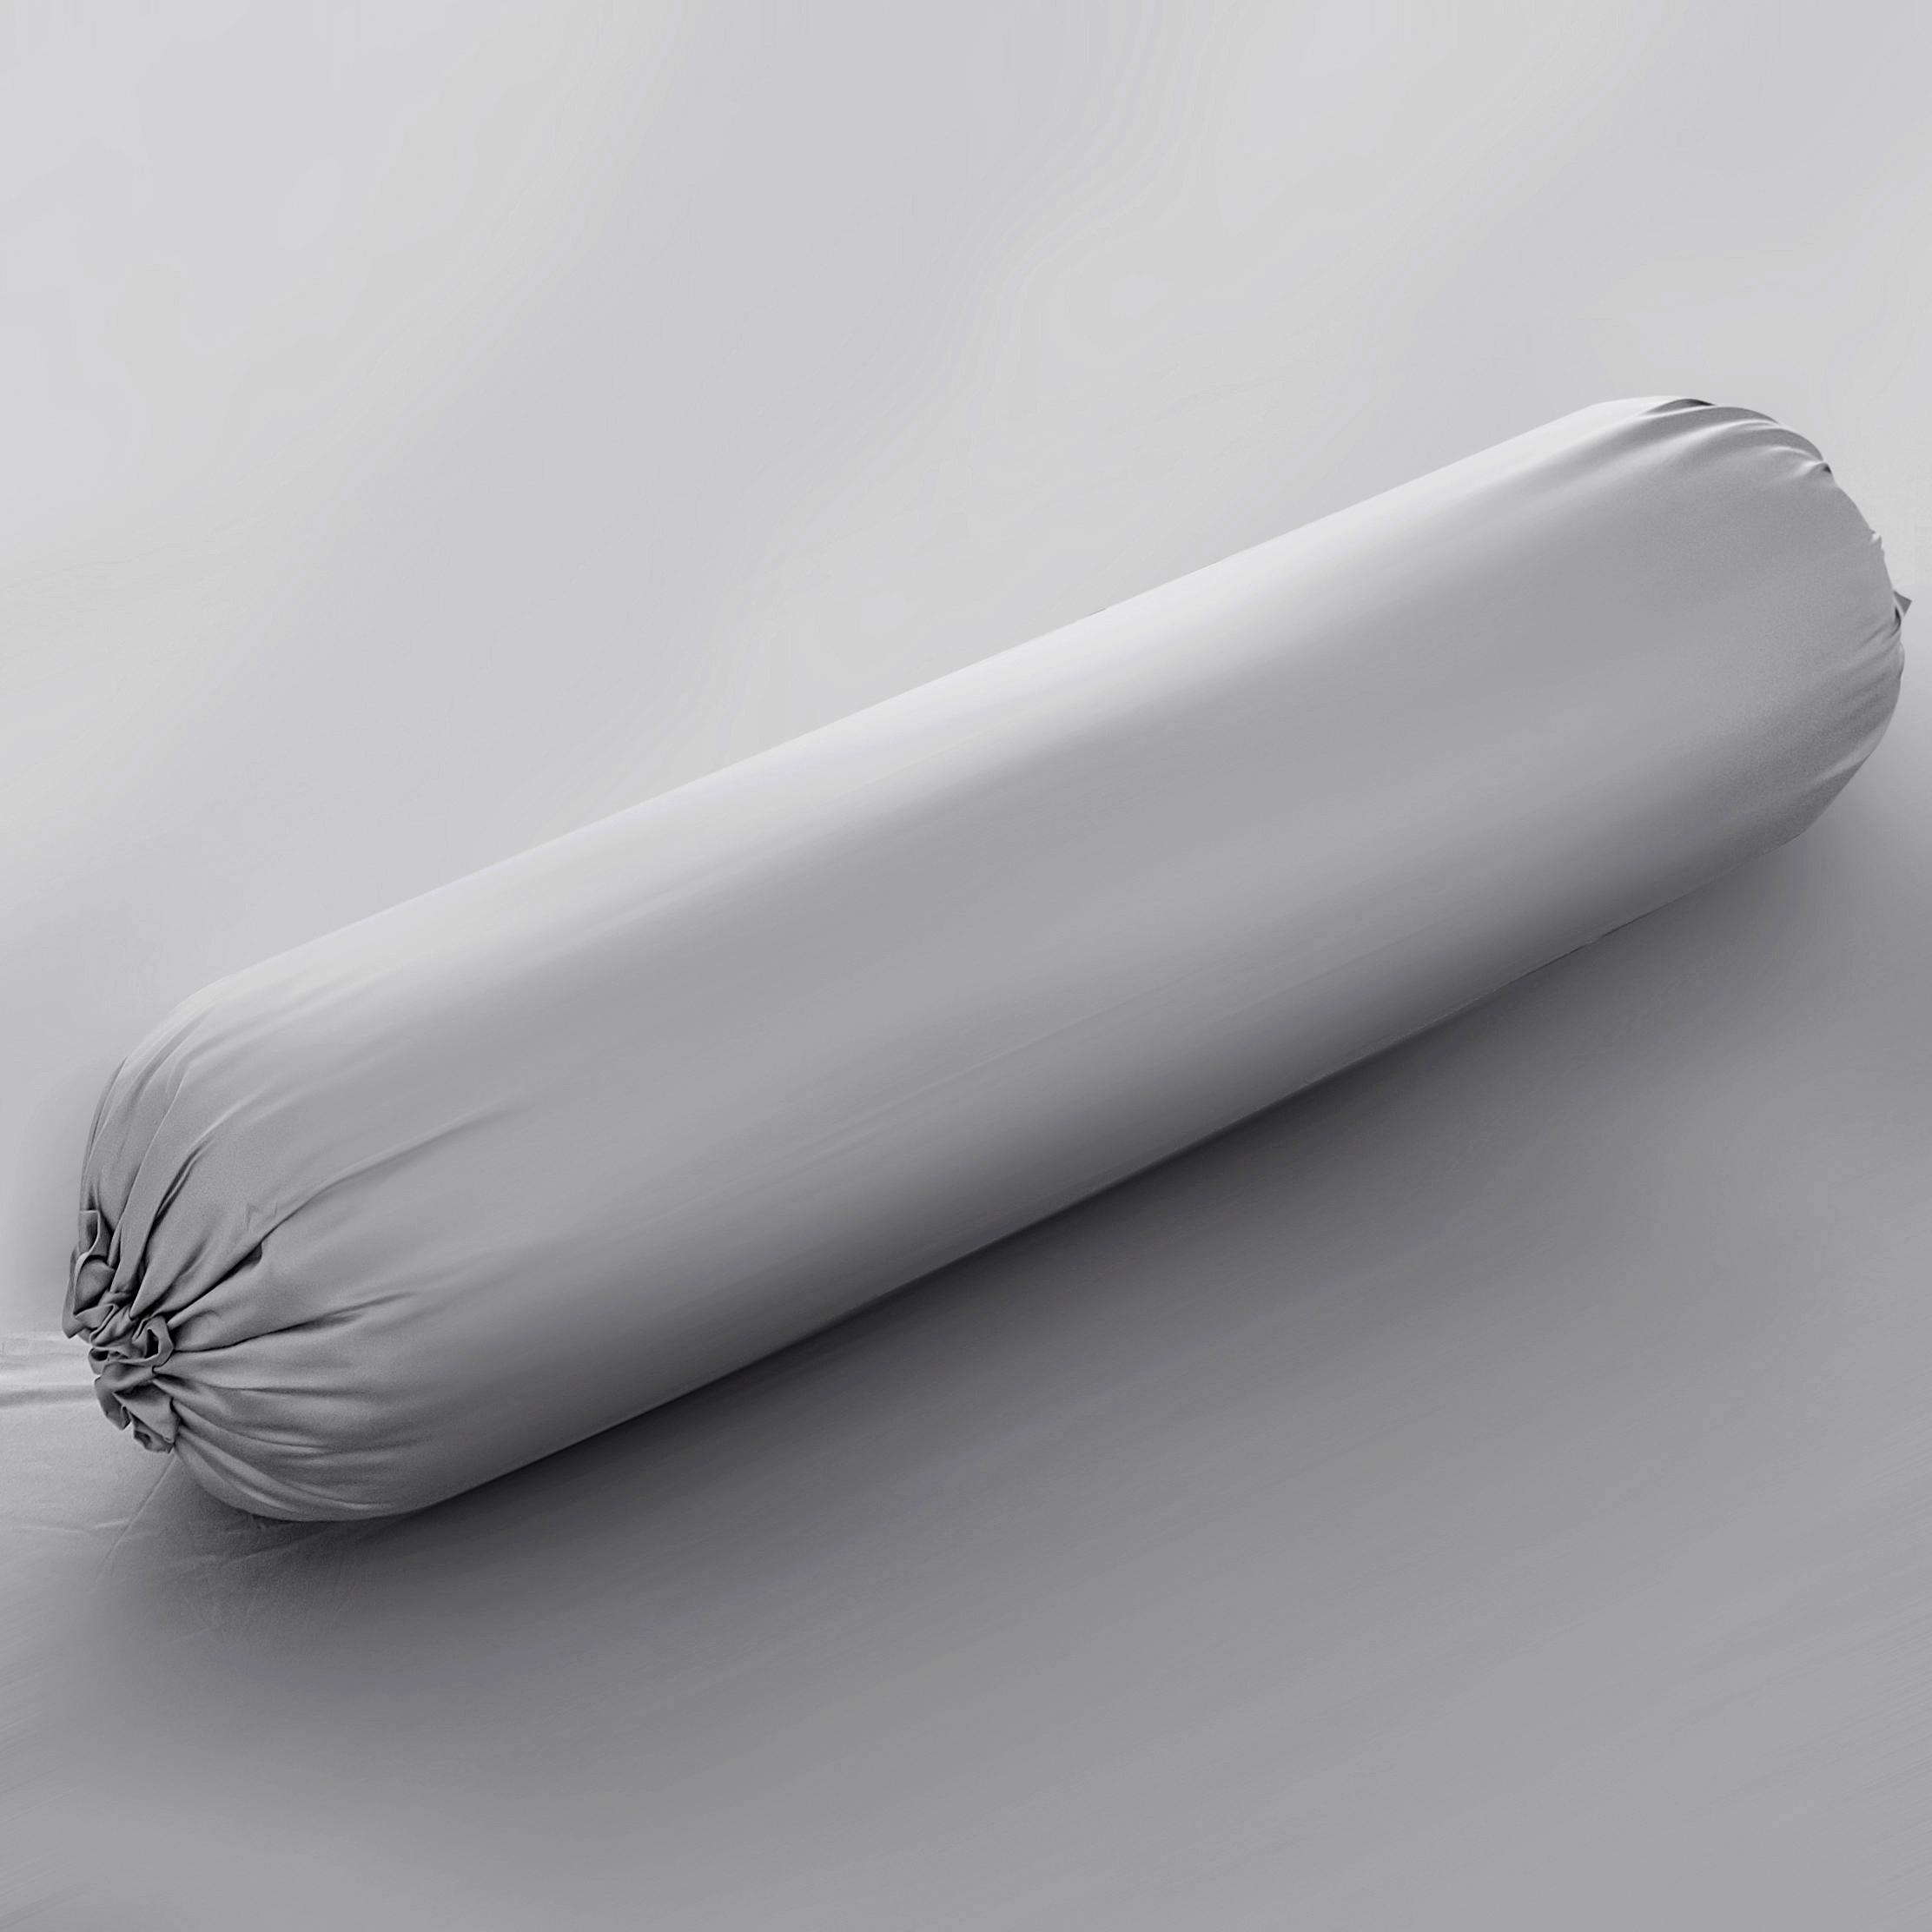  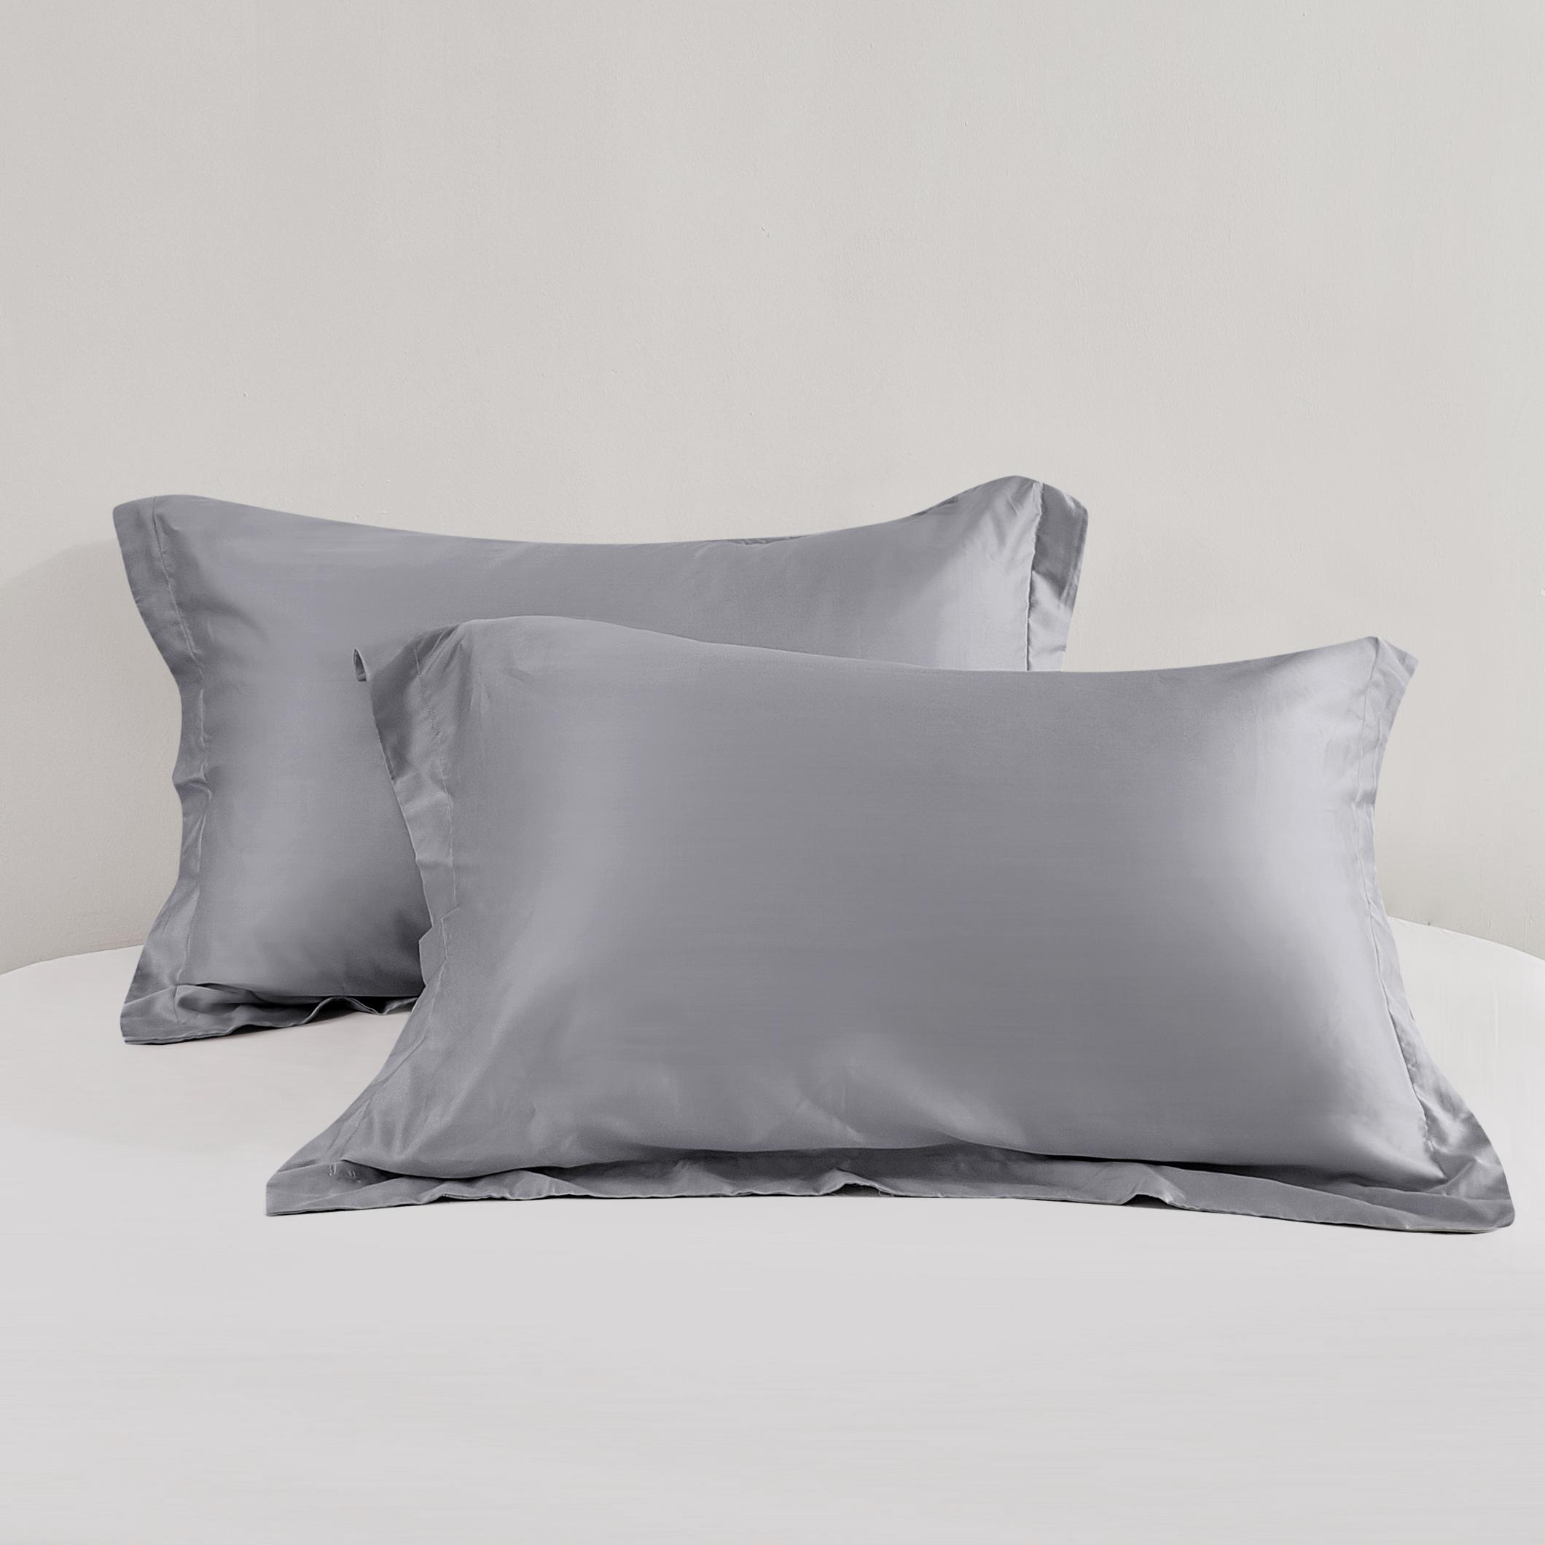
17 | SARUNG BANTAL & GULING | 10572379/10572386 - PILLOW BOLSTER CASE PINK - TENCEL(TM) | PINK | 100% TENCEL | INFORMA | 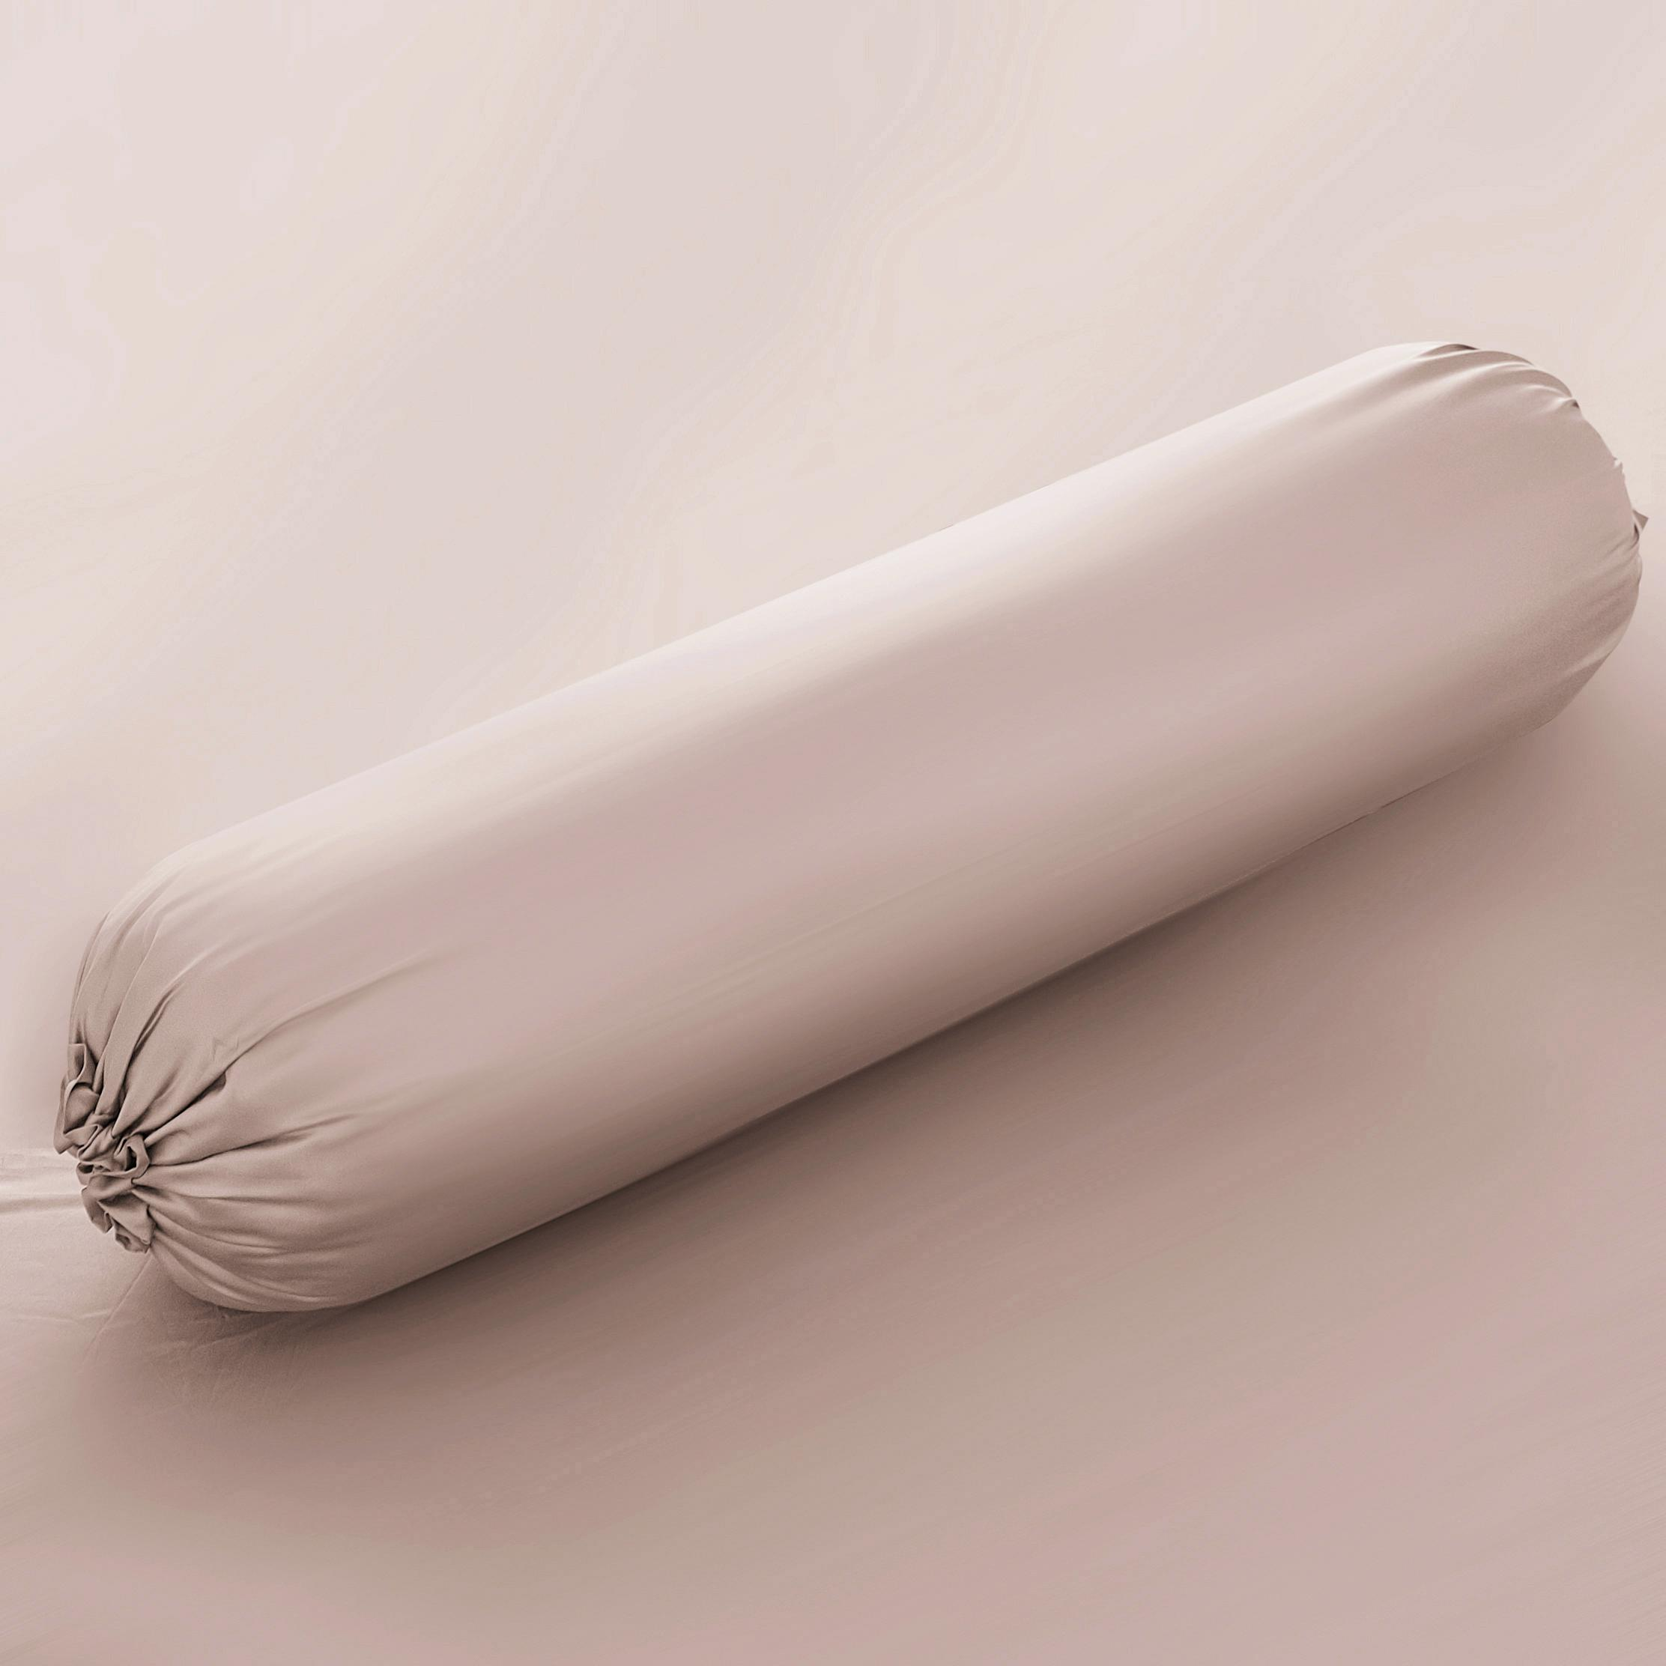  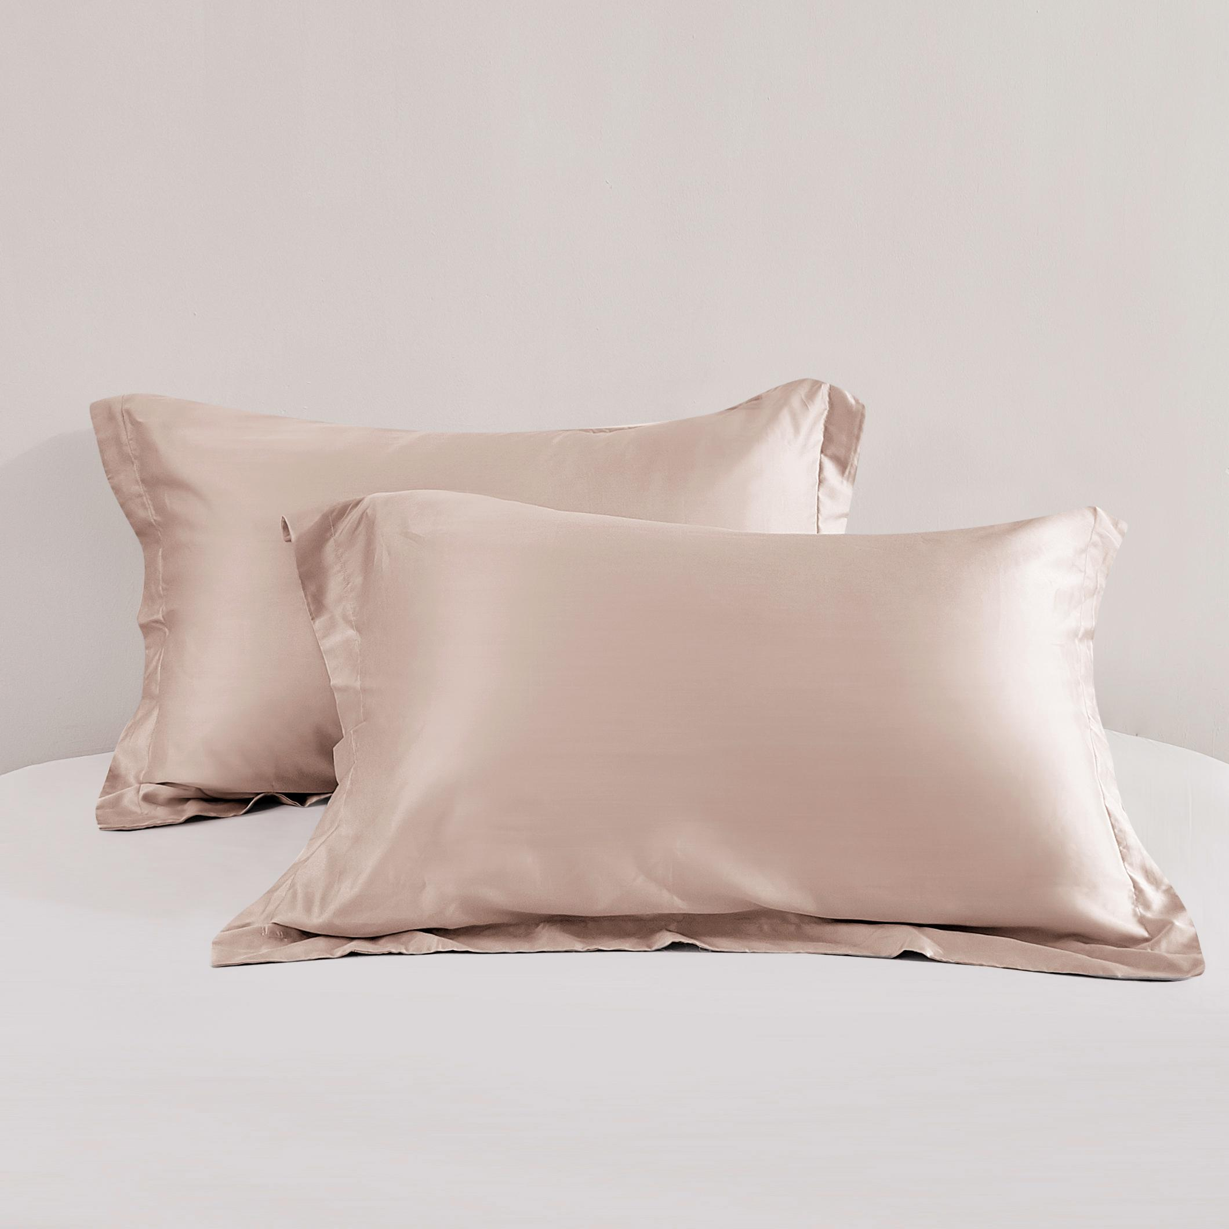
18 | SARUNG BANTAL & GULING | 10572380/10572387 - PILLOW BOLSTER CASE BLUEGREY - TENCEL(TM) | BIRU MUDA | 100% TENCEL | INFORMA | 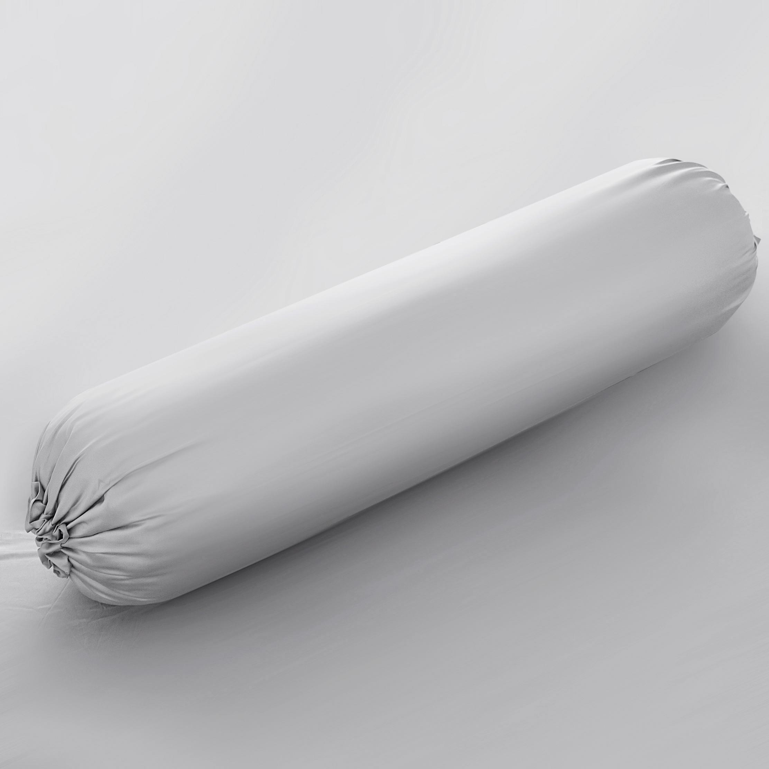  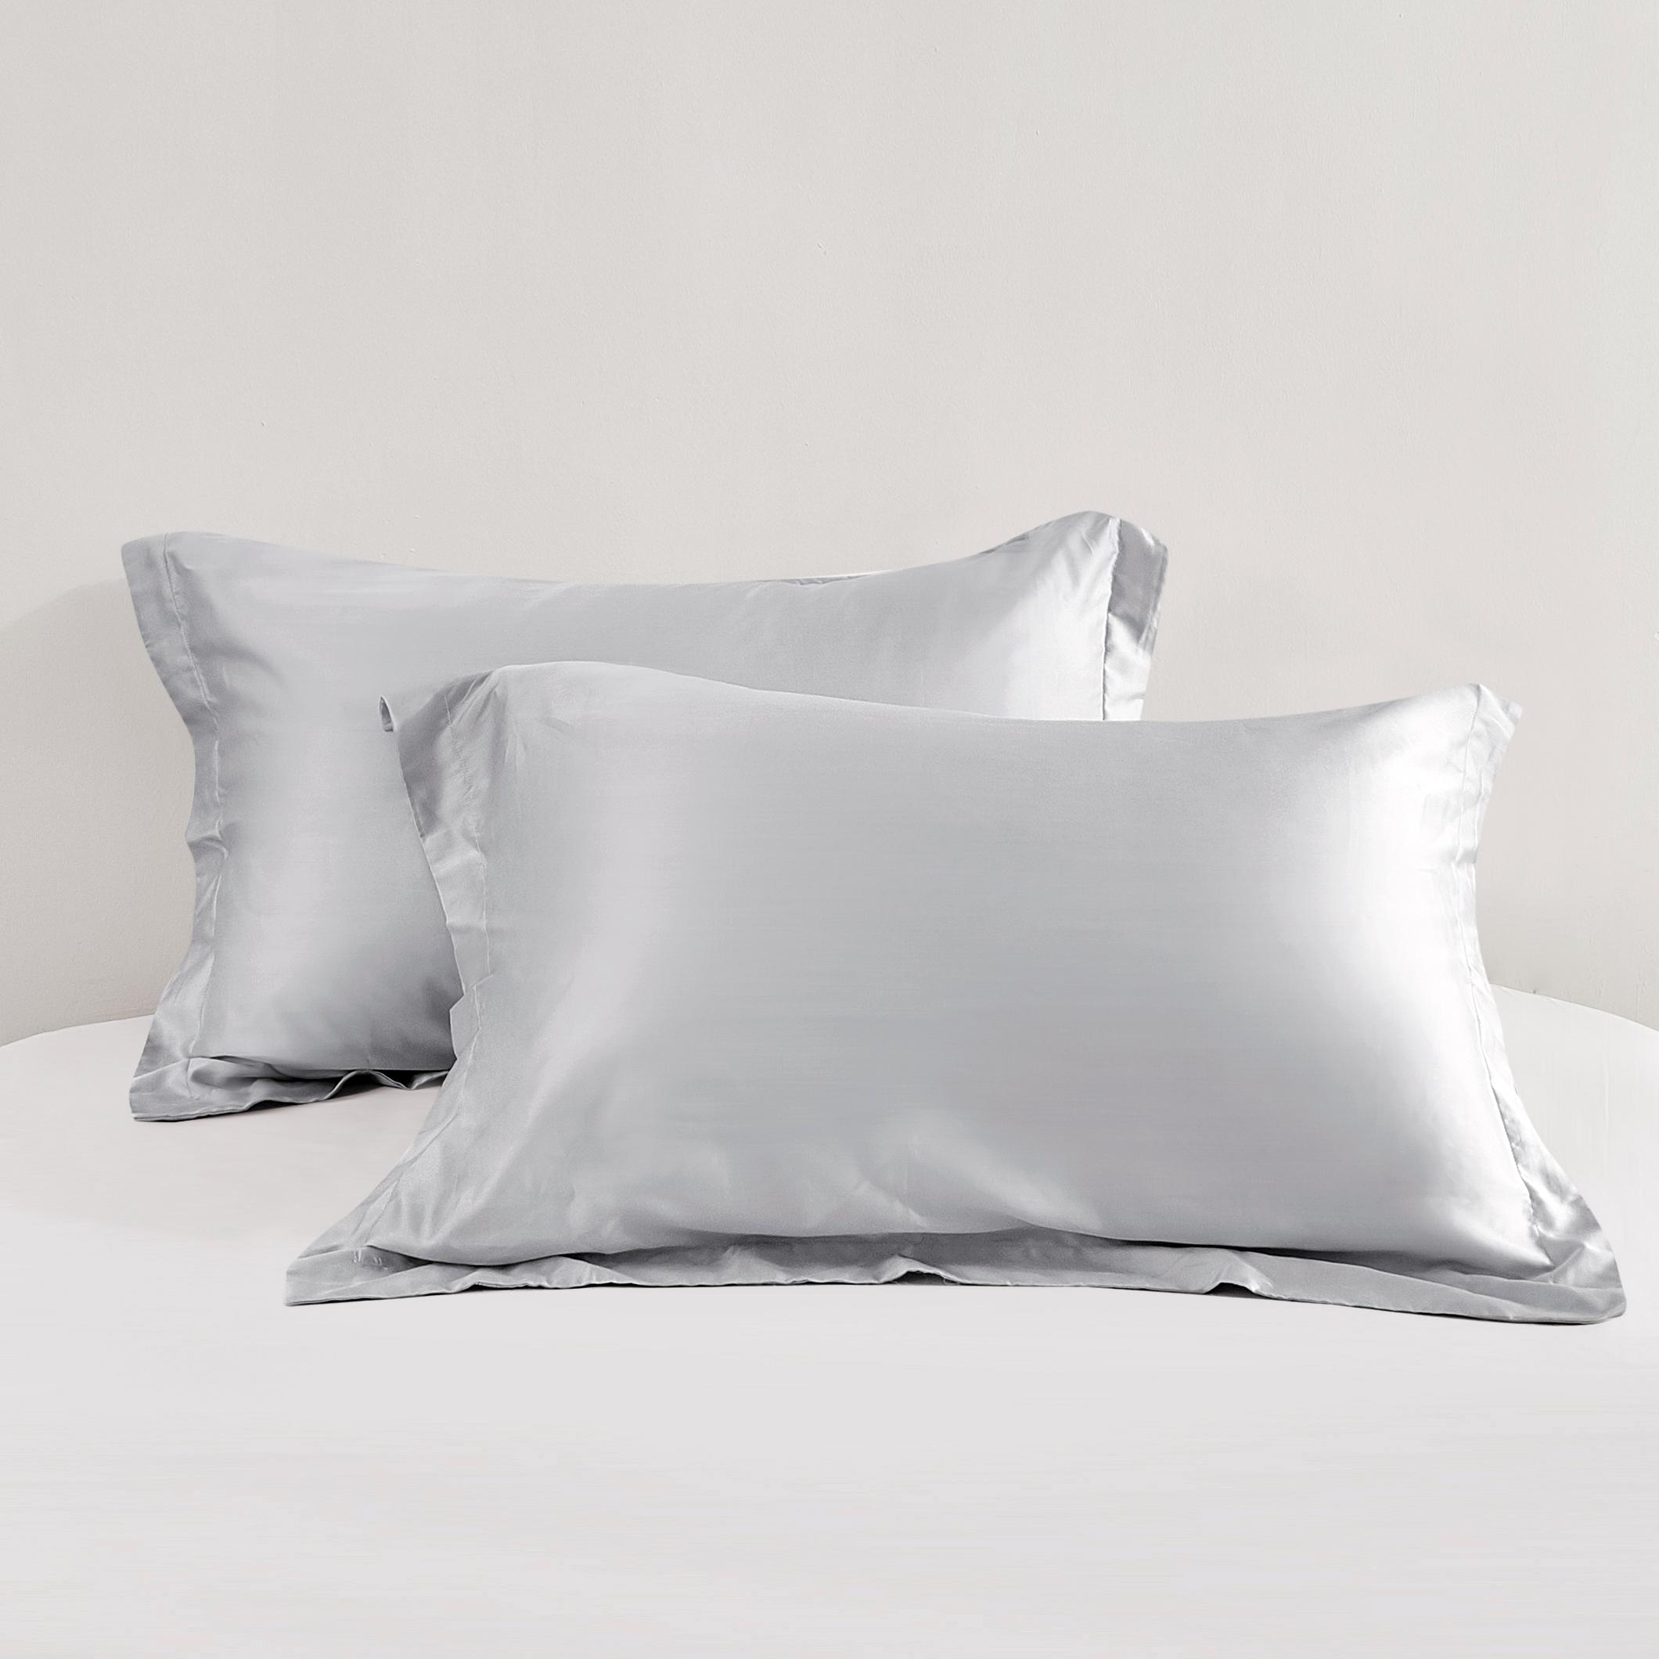
19 | SARUNG BANTAL & GULING | 10572381/10572388 - PILLOW BOLSTER CASE SAGEGREEN - TENCEL(TM) | HIJAU | 100% TENCEL | INFORMA | 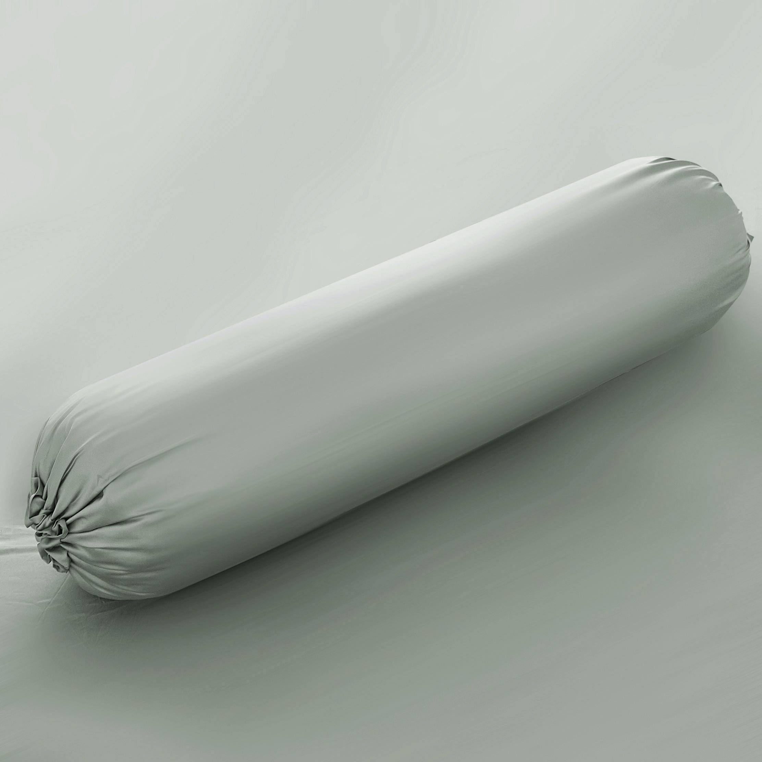  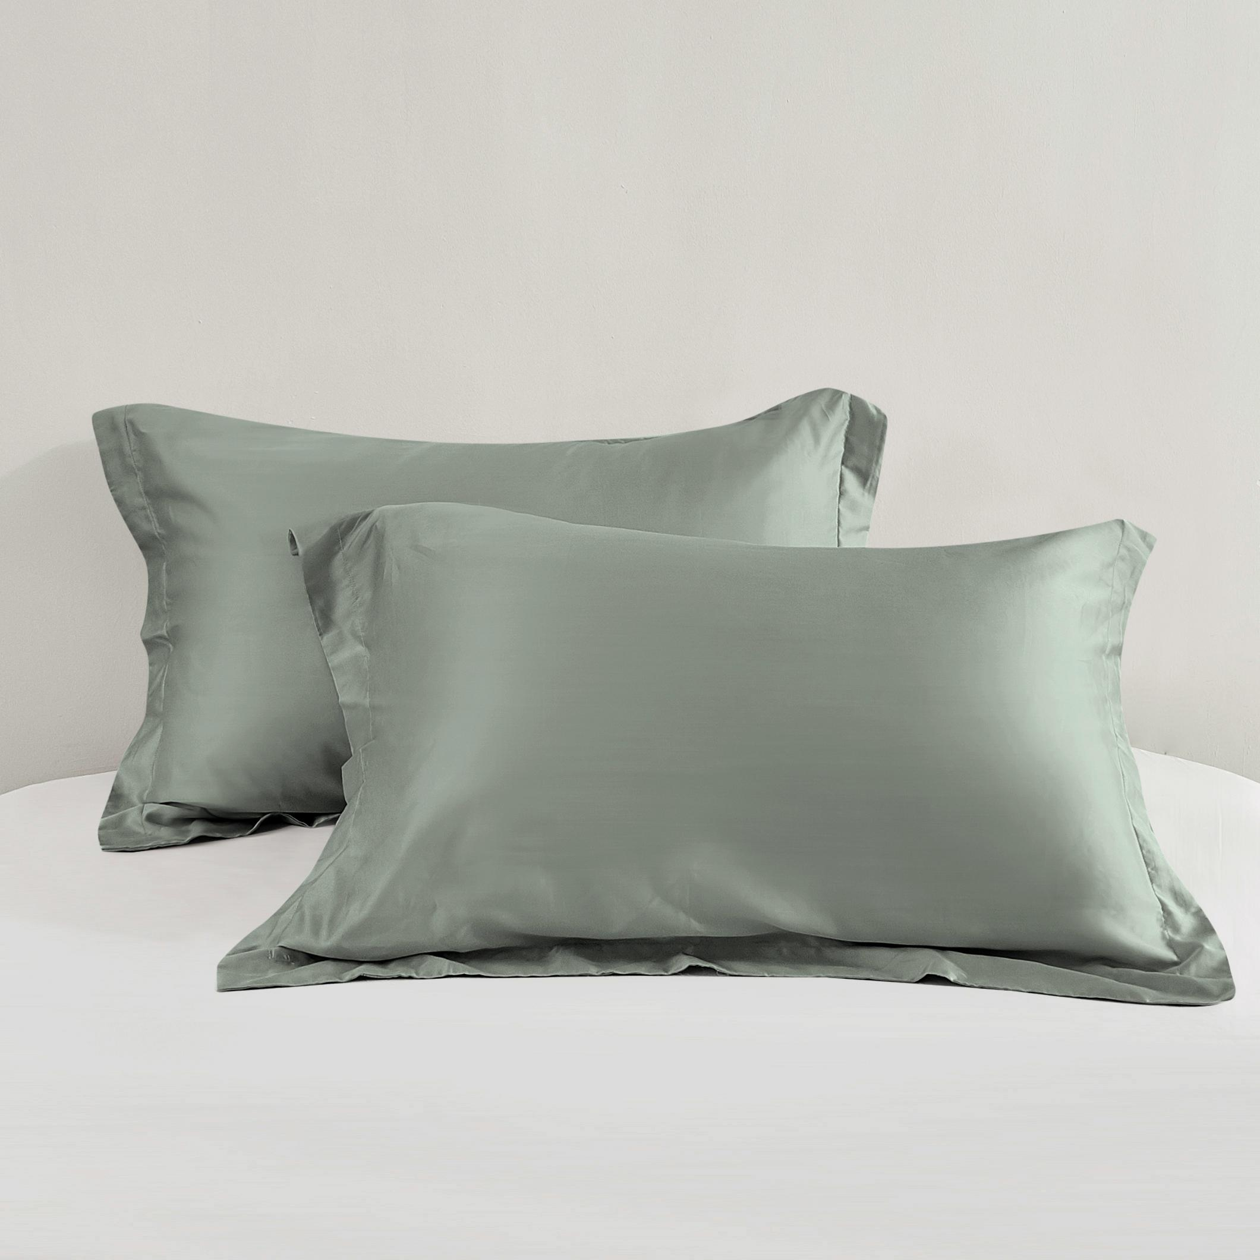
20 | SARUNG BANTAL & GULING | 10572382/10572389 - PILLOW BOLSTER CASE BROWN - TENCEL(TM) | COKLAT | 100% TENCEL | INFORMA | 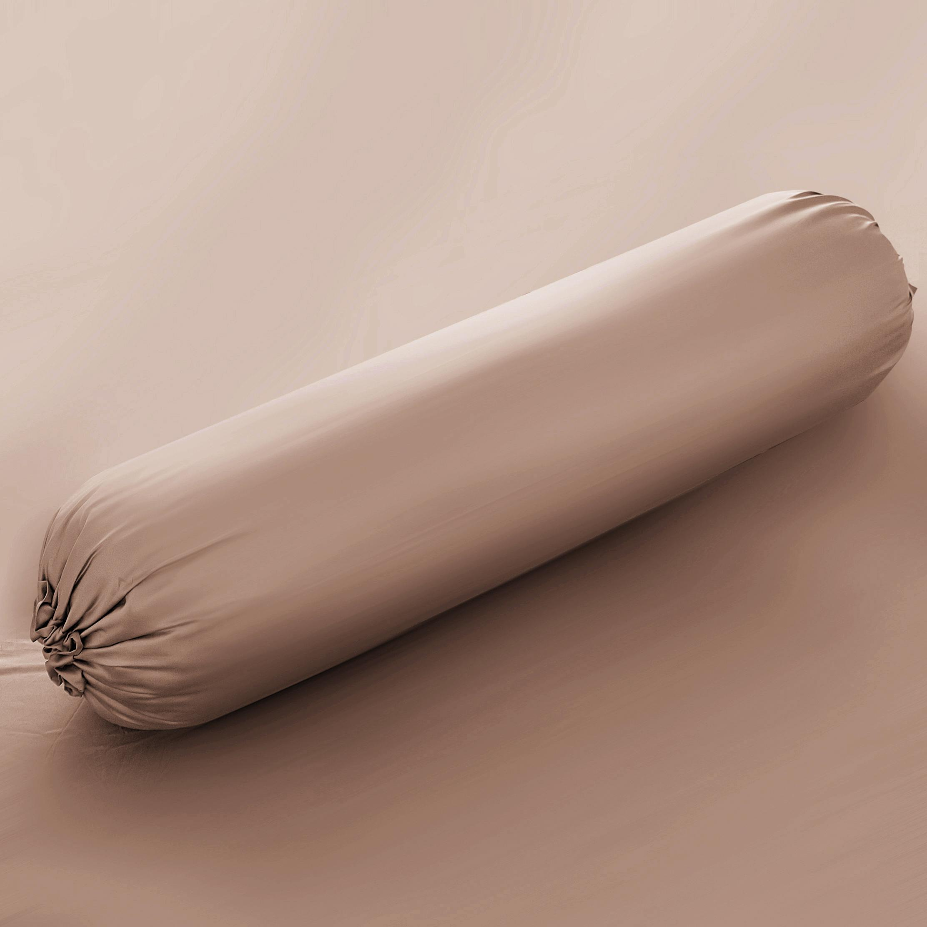  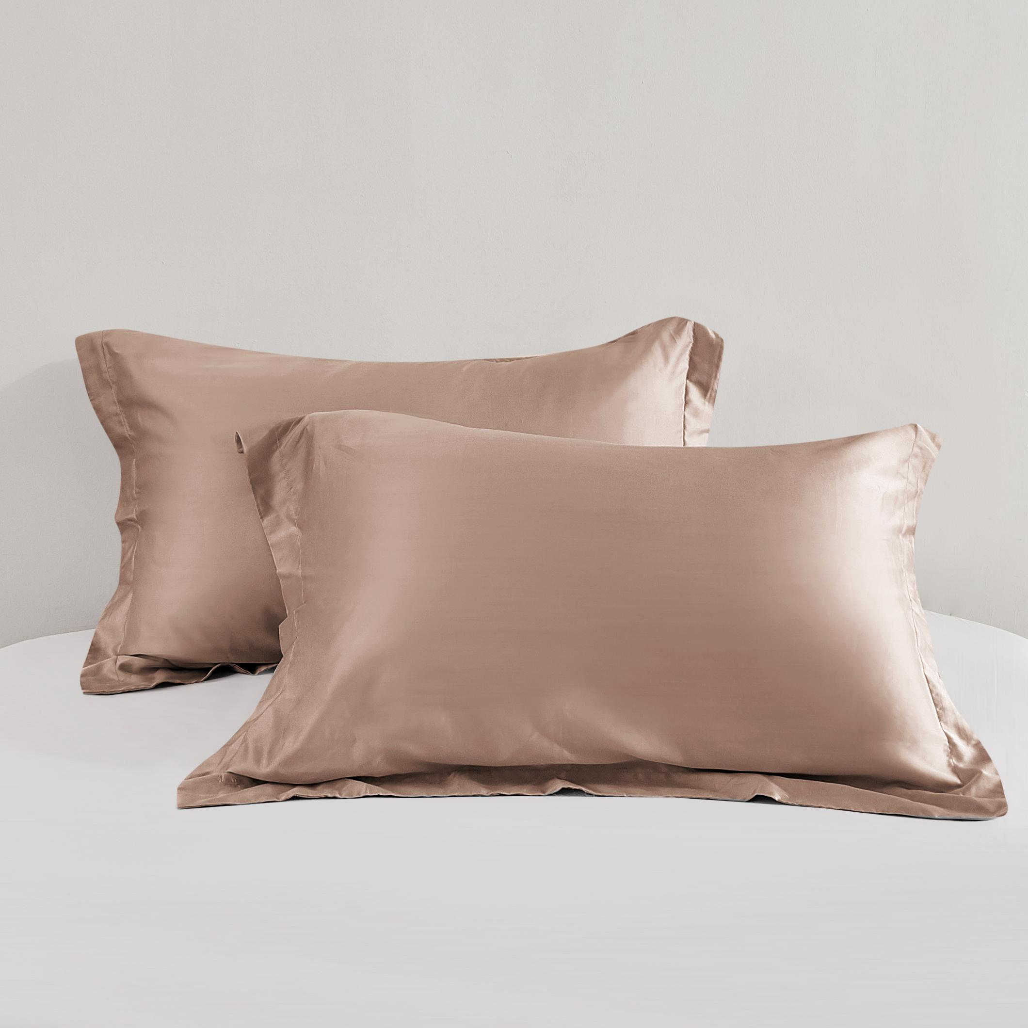
21 | SARUNG BANTAL & GULING | 10572383/10572390 - PILLOW BOLSTER CASE IVORY - TENCEL(TM) | IVORY | 100% TENCEL | INFORMA | 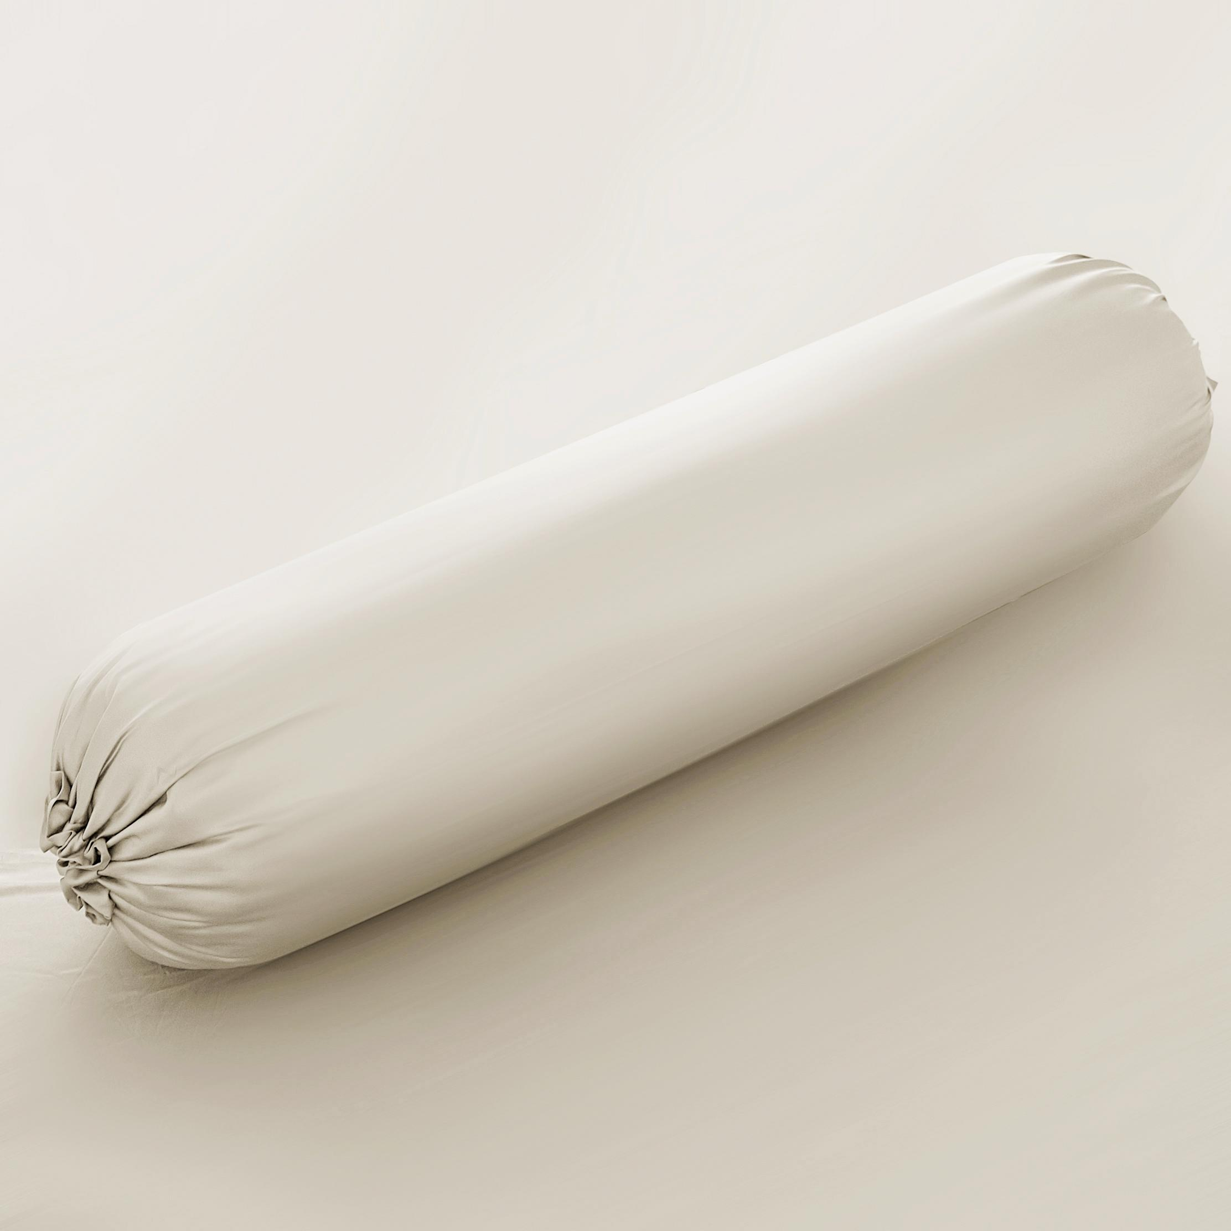  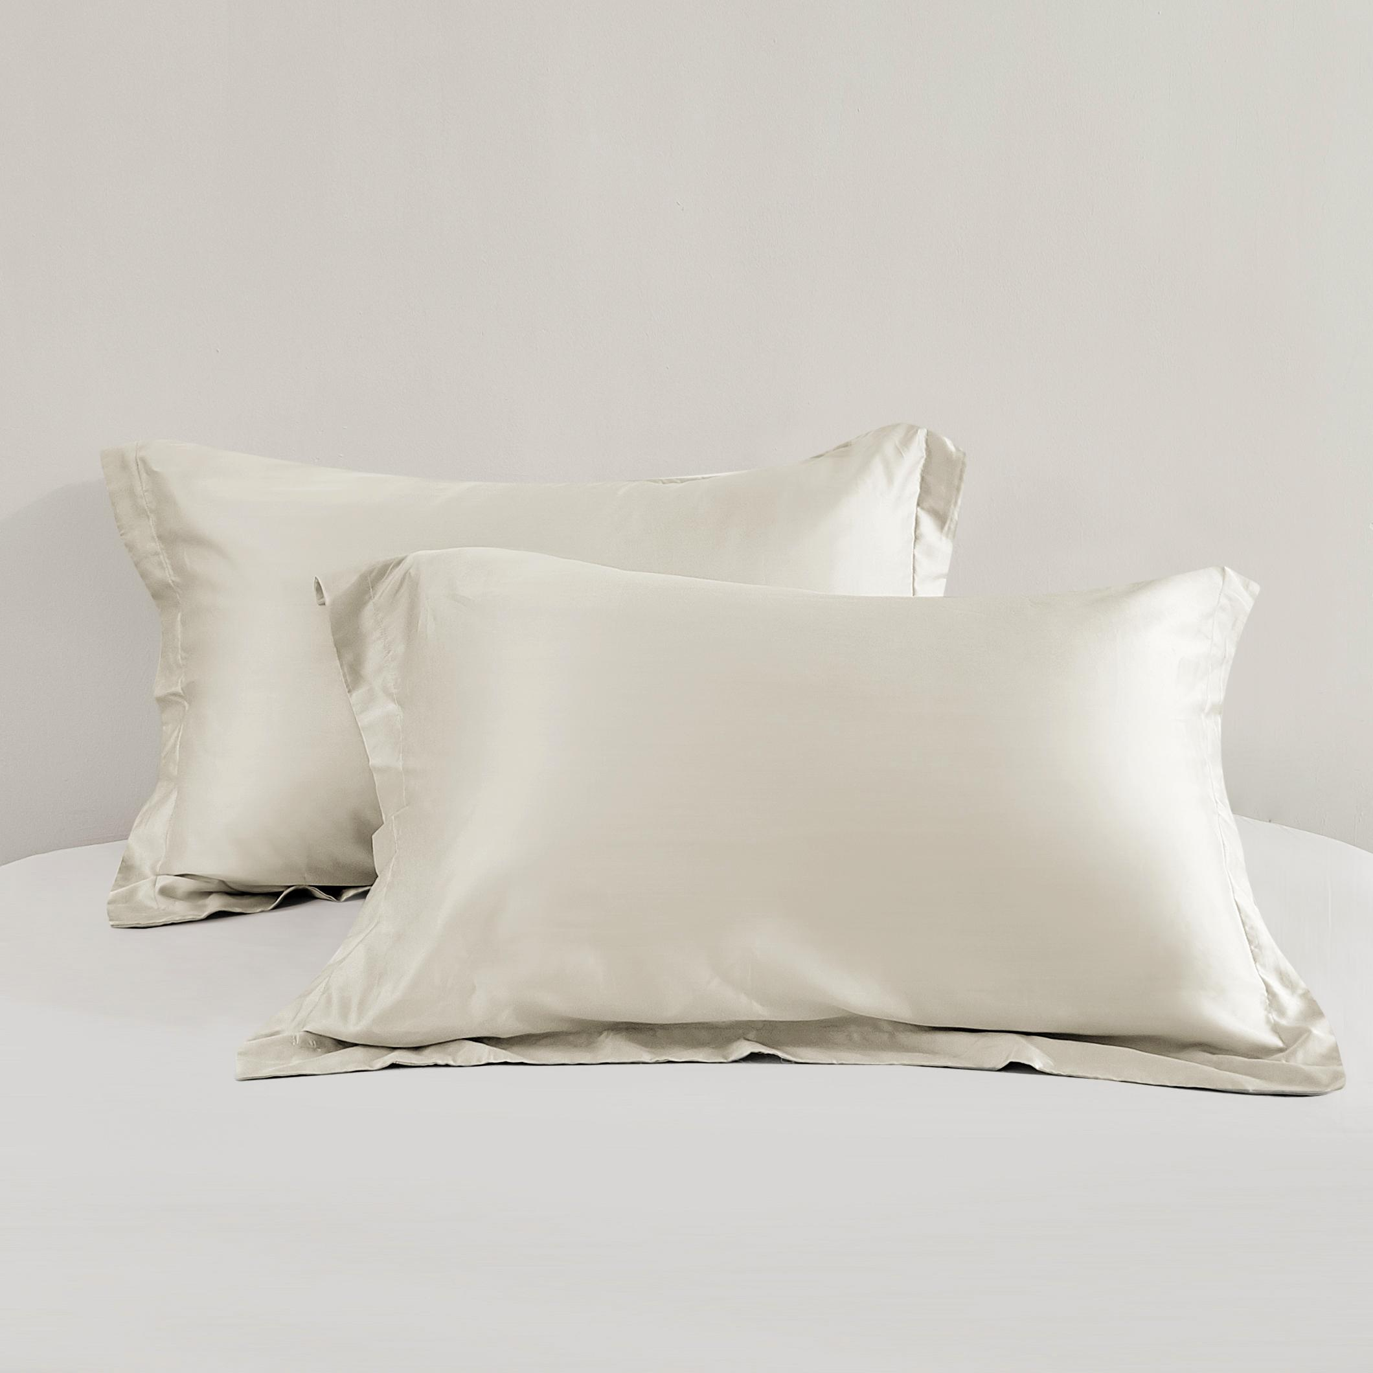
22 | SEPRAI SET | 10570155 SHEET SET MICROFIBER (B) YADA GREY | ABU-ABU, PUTIH | 100% POLIESTER | INFORMA | 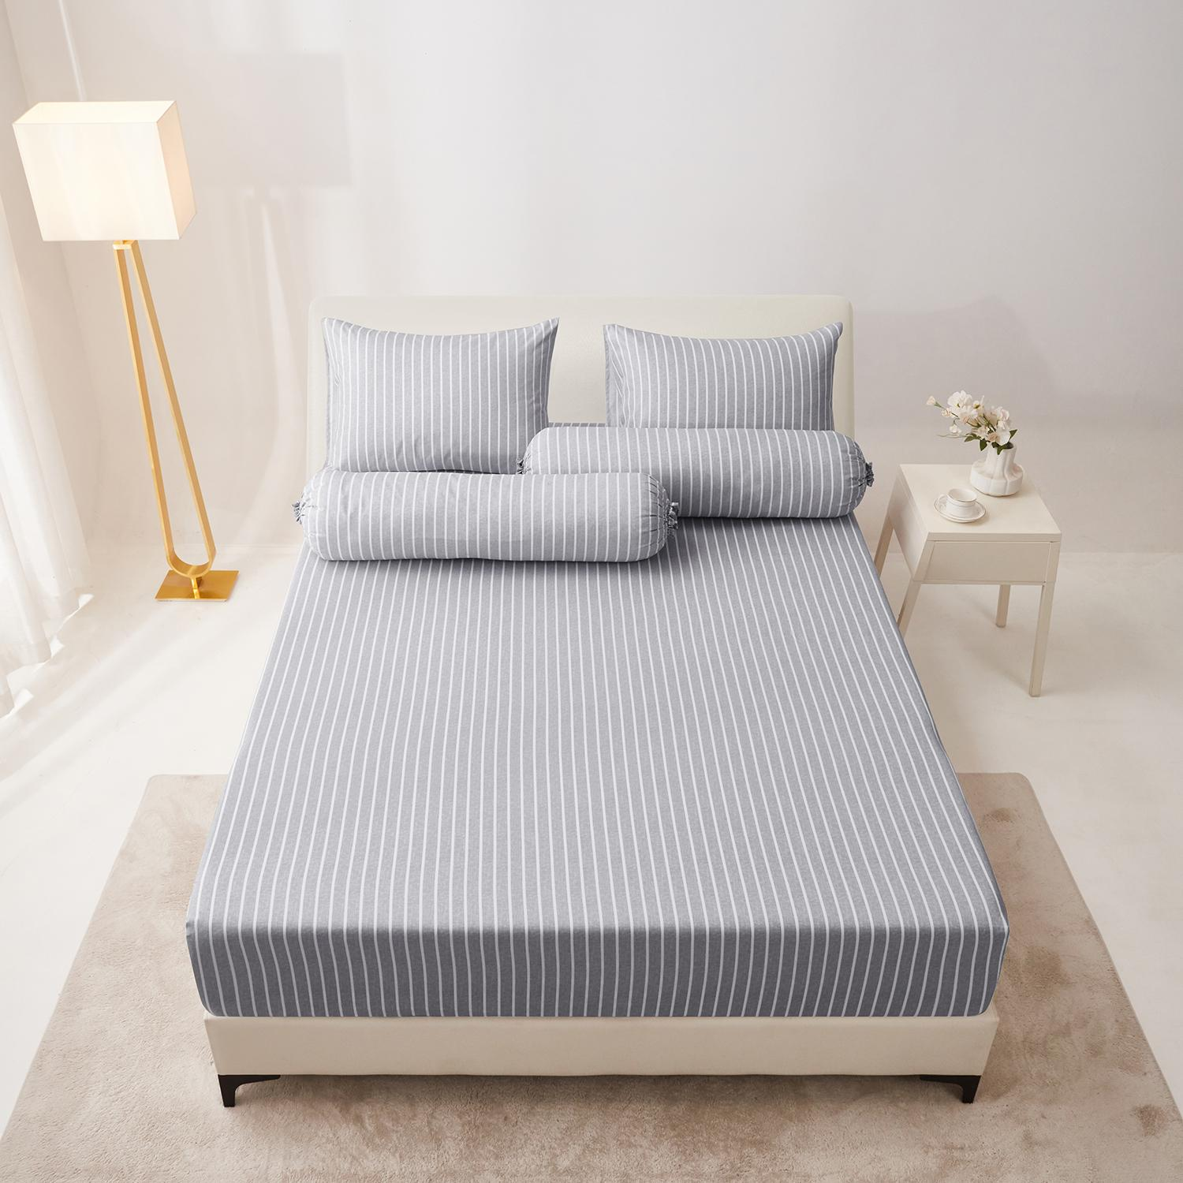
22 | SEPRAI SET | 10570156 SHEET SET MICROFIBER (C) YADA GREY
22 | SEPRAI SET | 10570157 SHEET SET MICROFIBER (D) YADA GREY
22 | SEPRAI SET | 10570158 SHEET SET MICROFIBER (E) YADA GREY
23 | SEPRAI SET | 10570159 SHEET SET MICROFIBER (B) YADA BLUE | BIRU, PUTIH | 100% POLIESTER | INFORMA | 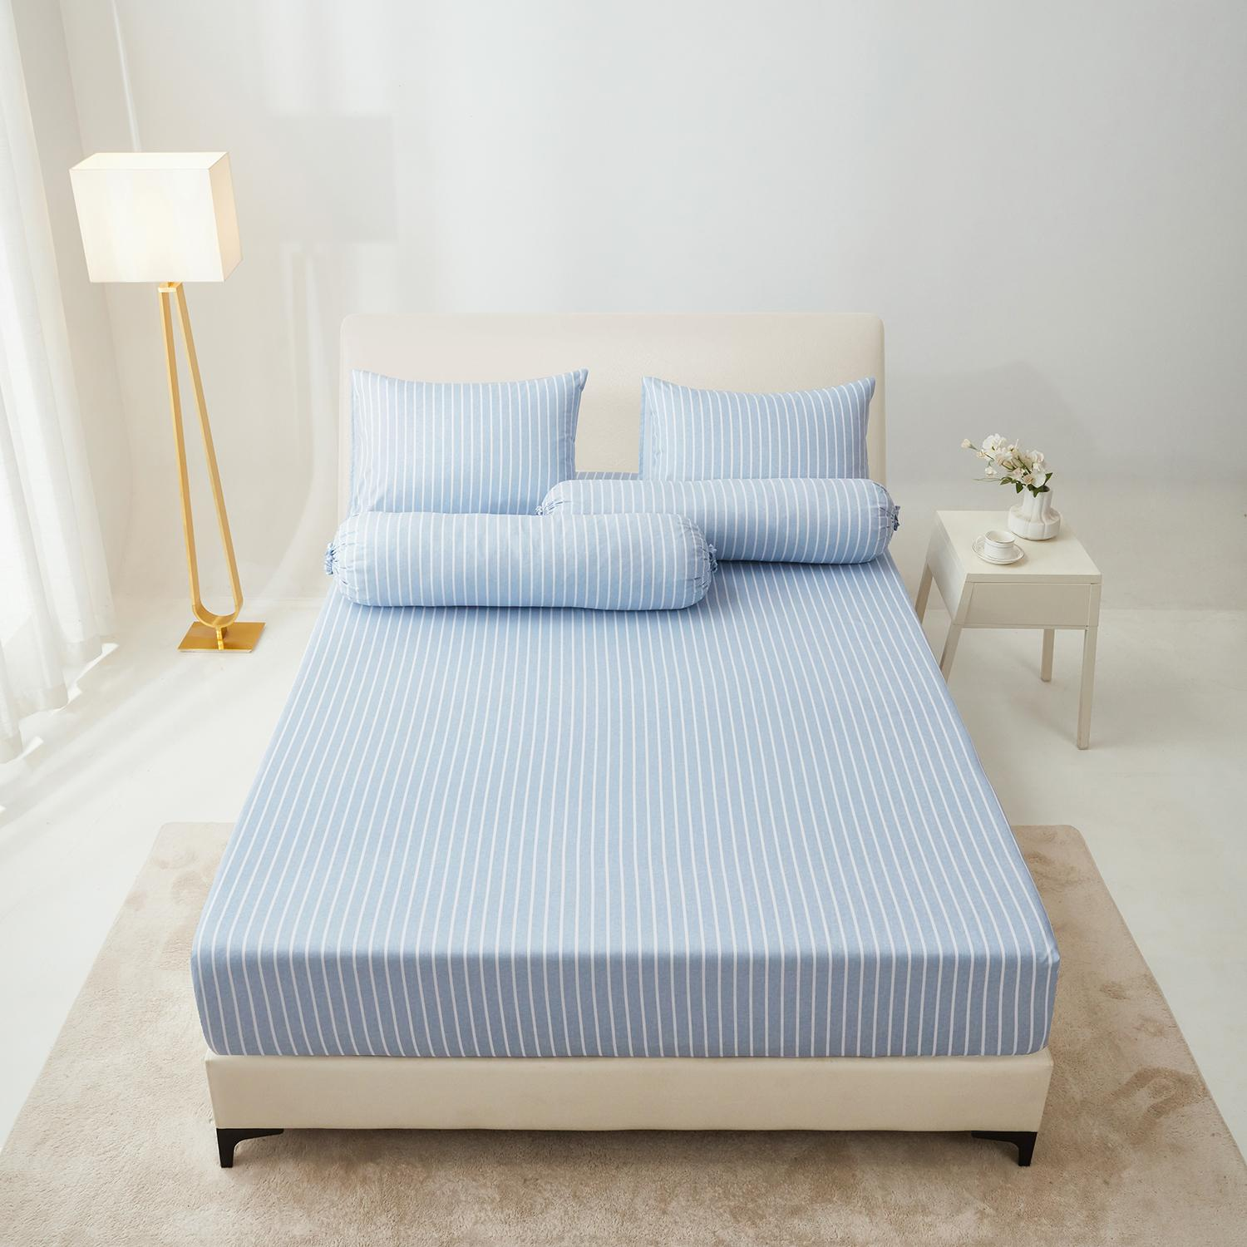
23 | SEPRAI SET | 10570160 SHEET SET MICROFIBER (C) YADA BLUE
23 | SEPRAI SET | 10570161 SHEET SET MICROFIBER (D) YADA BLUE
23 | SEPRAI SET | 10570162 SHEET SET MICROFIBER (E) YADA BLUE
24 | SEPRAI SET | 10570163 SHEET SET MICROFIBER (B) YADA BROWN | COKLAT, PUTIH | 100% POLIESTER | INFORMA | 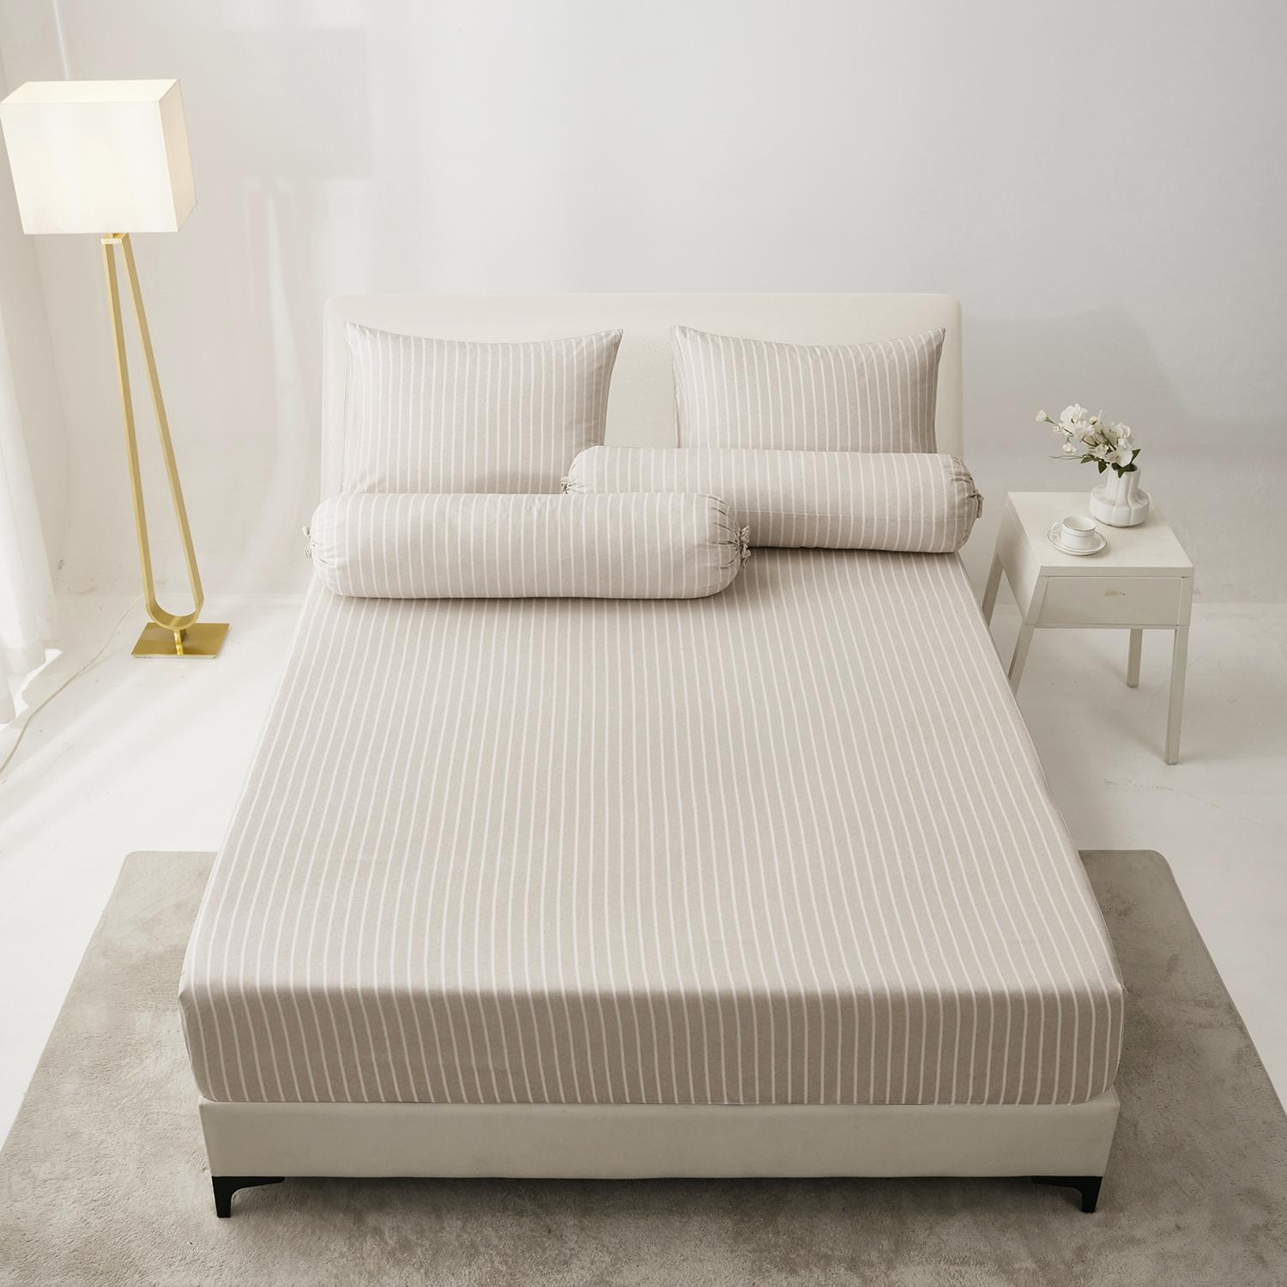
24 | SEPRAI SET | 10570164 SHEET SET MICROFIBER (C) YADA BROWN
24 | SEPRAI SET | 10570165 SHEET SET MICROFIBER (D) YADA BROWN
24 | SEPRAI SET | 10570166 SHEET SET MICROFIBER (E) YADA BROWN
25 | SEPRAI SET | 10570167 SHEET SET MICROFIBER (B) YODA NAVY | BIRU | 100% POLIESTER | INFORMA | 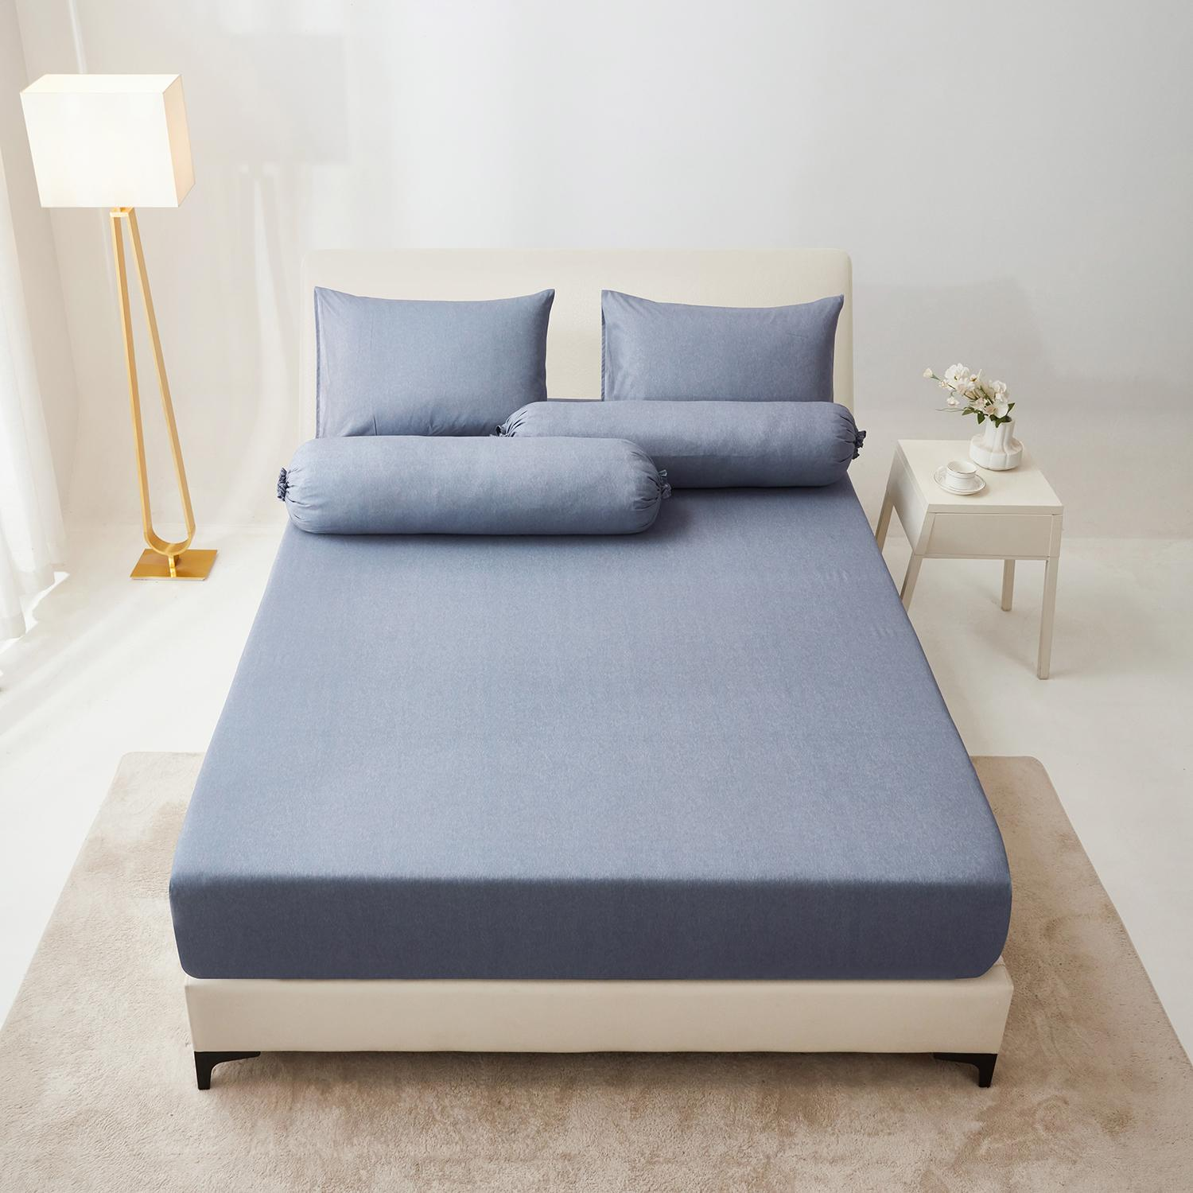
25 | SEPRAI SET | 10570168 SHEET SET MICROFIBER (C) YODA NAVY
25 | SEPRAI SET | 10570169 SHEET SET MICROFIBER (D) YODA NAVY
25 | SEPRAI SET | 10570170 SHEET SET MICROFIBER (E) YODA NAVY
26 | SEPRAI SET | 10570171 SHEET SET MICROFIBER (B) YODA GREEN | HIJAU | 100% POLIESTER | INFORMA | 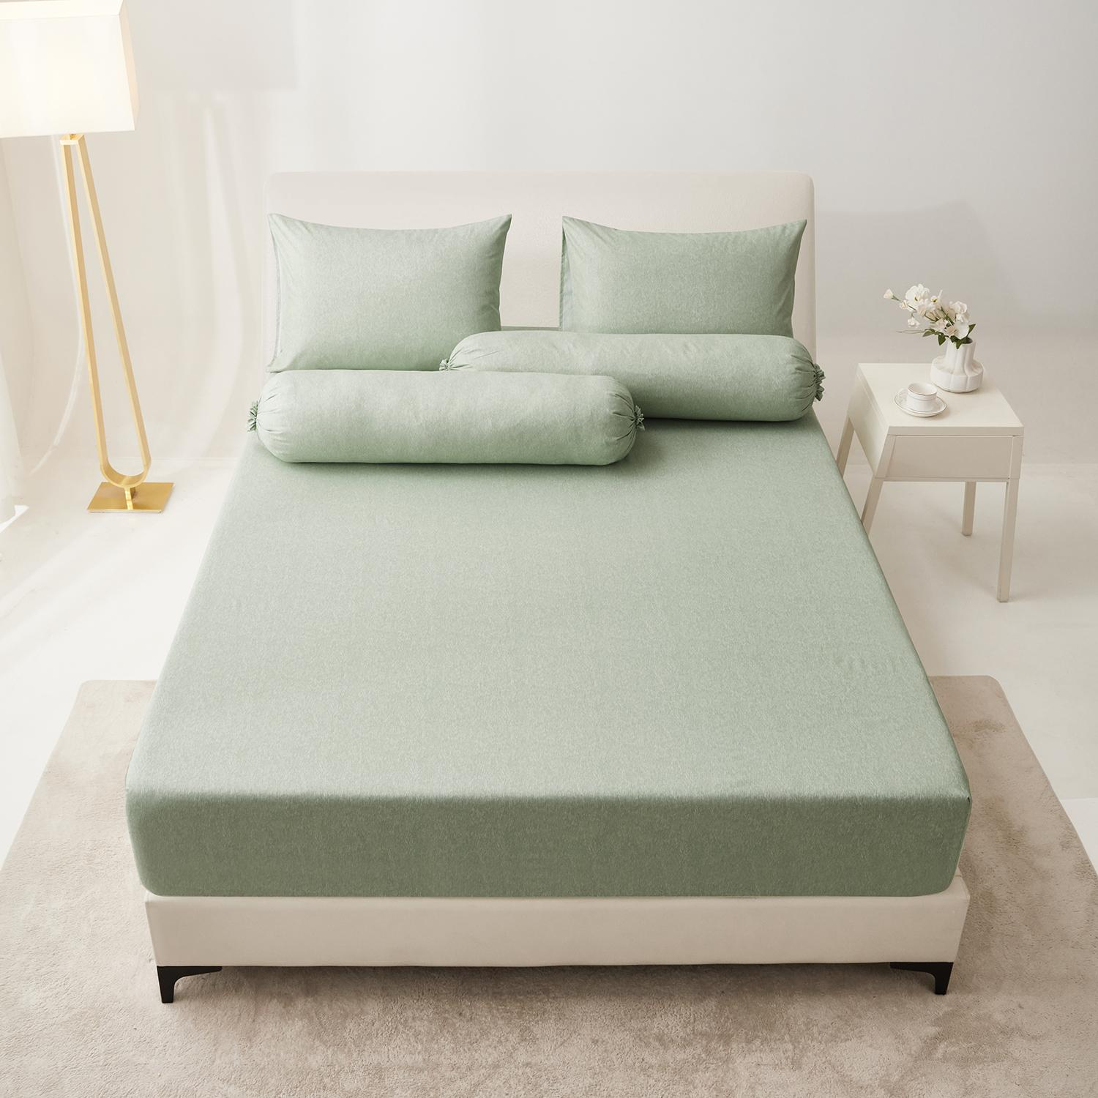
26 | SEPRAI SET | 10570172 SHEET SET MICROFIBER (C) YODA GREEN
26 | SEPRAI SET | 10570173 SHEET SET MICROFIBER (D) YODA GREEN
26 | SEPRAI SET | 10570174 SHEET SET MICROFIBER (E) YODA GREEN
27 | SEPRAI SET | 10570175 SHEET SET MICROFIBER (B) YODA BROWN | COKLAT | 100% POLIESTER | INFORMA | 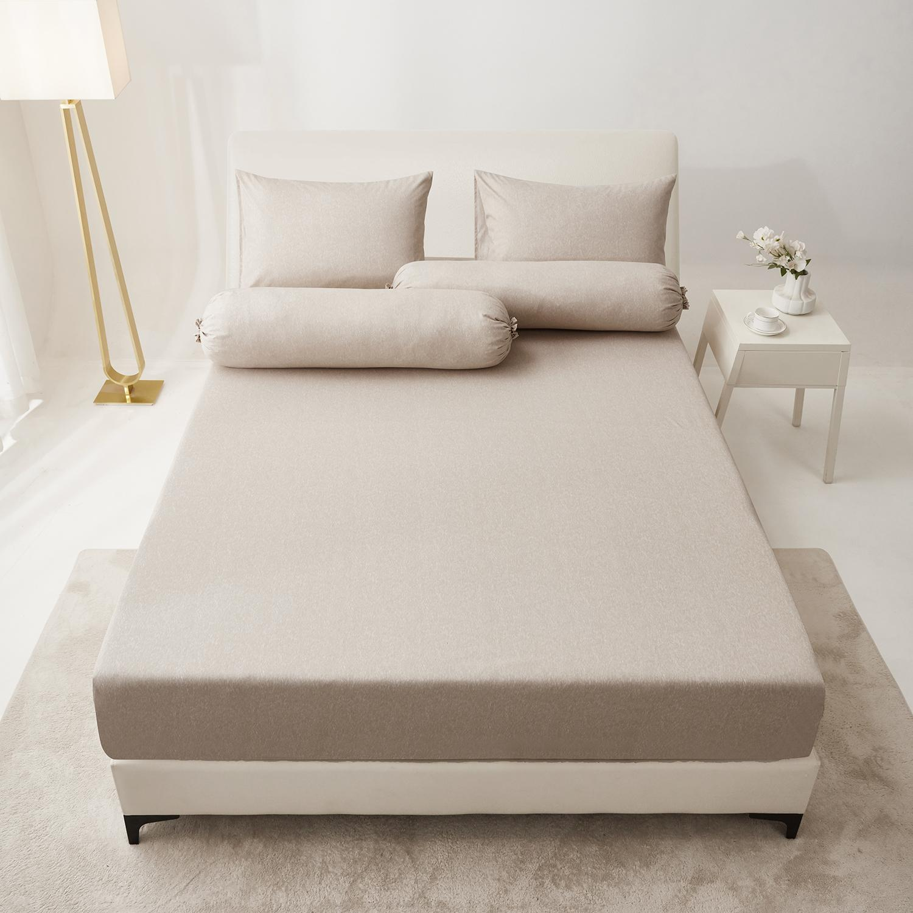
27 | SEPRAI SET | 10570176 SHEET SET MICROFIBER (C) YODA BROWN
27 | SEPRAI SET | 10570177 SHEET SET MICROFIBER (D) YODA BROWN
27 | SEPRAI SET | 10570178 SHEET SET MICROFIBER (E) YODA BROWN
28 | BEDCOVER | 10570603/BED COVER MICROFIBER (B) YAEL GREY | ABU-ABU, PUTIH | 100% POLIESTER | INFORMA | 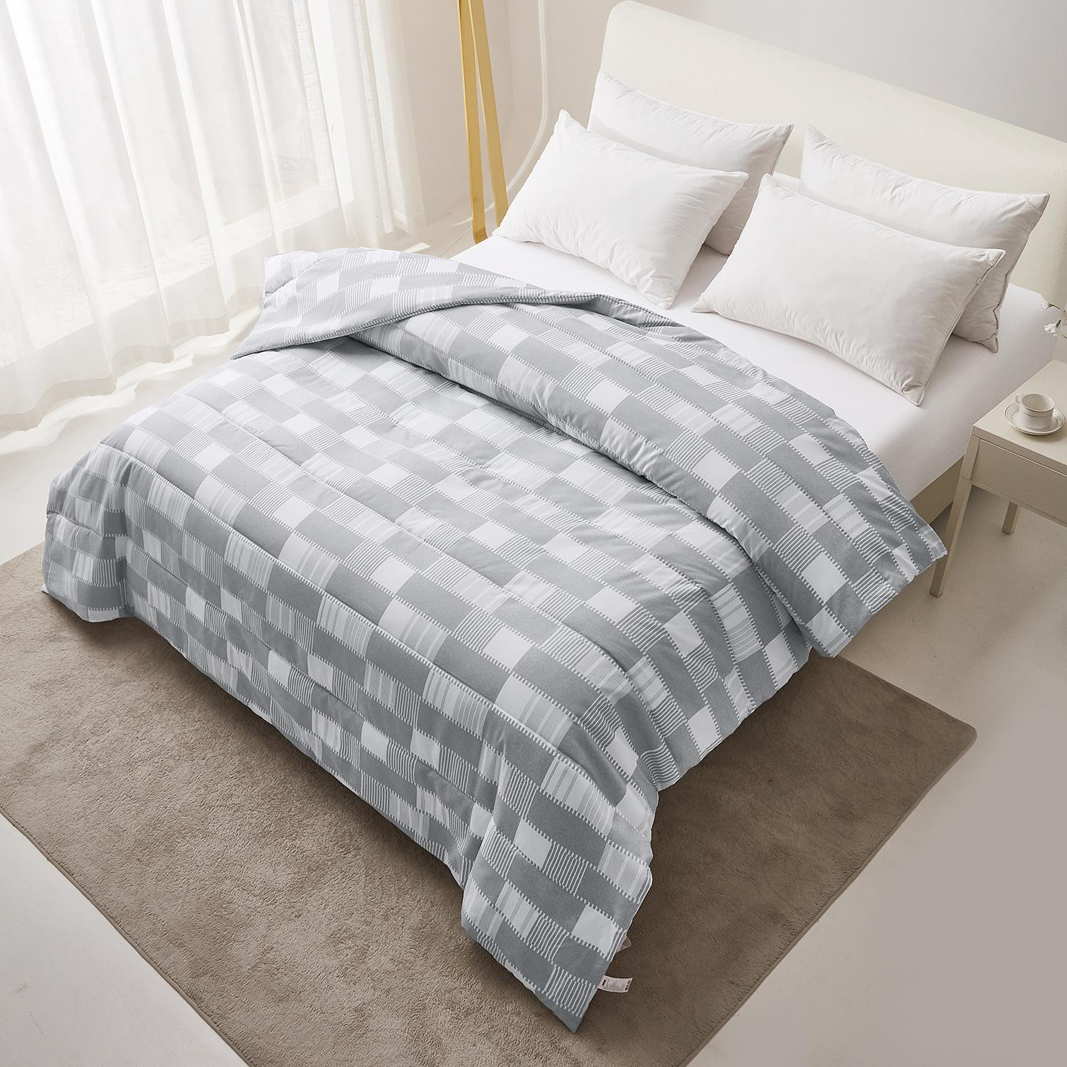
28 | BEDCOVER | 10570604/BED COVER MICROFIBER (C) YAEL GREY
28 | BEDCOVER | 10570605/BED COVER MICROFIBER (D) YAEL GREY
29 | BEDCOVER | 10570606/BED COVER MICROFIBER (B) YAEL BLUE | BIRU, PUTIH | 100% POLIESTER | INFORMA | 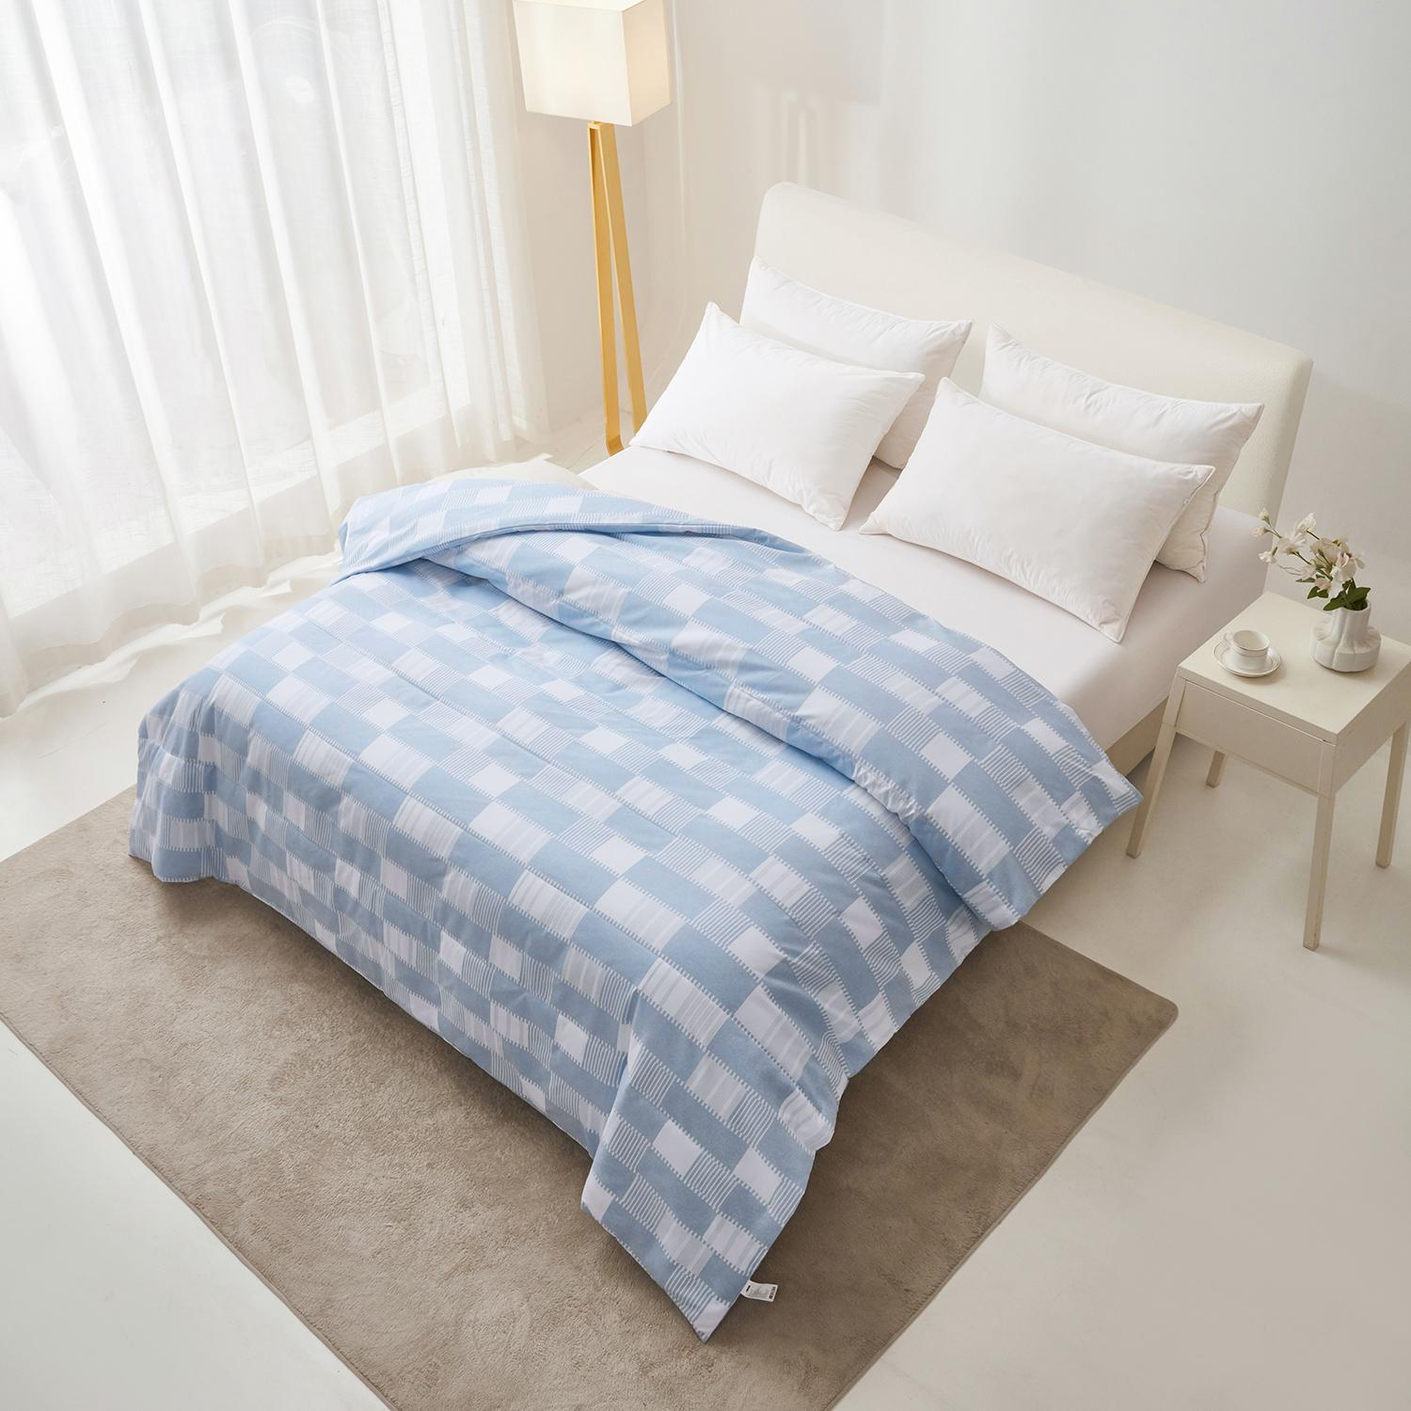
29 | BEDCOVER | 10570607/BED COVER MICROFIBER (C) YAEL BLUE
29 | BEDCOVER | 10570608/BED COVER MICROFIBER (D) YAEL BLUE
30 | BEDCOVER | 10570609/BED COVER MICROFIBER (B) YAEL BROWN | COKLAT, PUTIH | 100% POLIESTER | INFORMA | 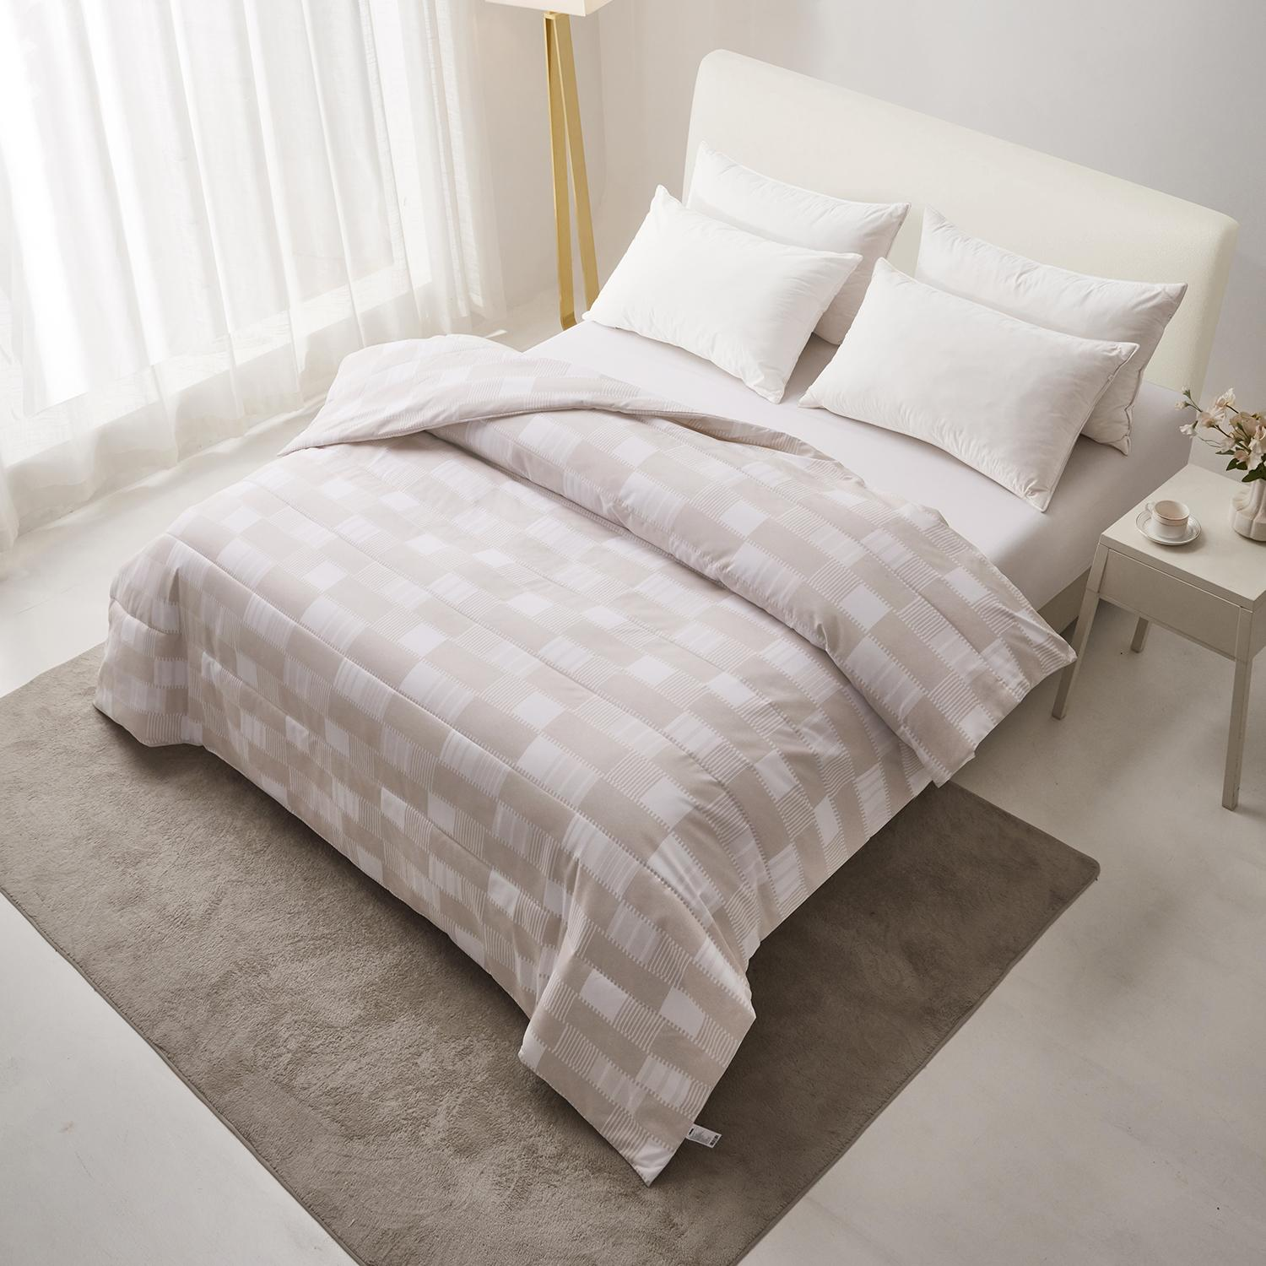
30 | BEDCOVER | 10570610/BED COVER MICROFIBER (C) YAEL BROWN
30 | BEDCOVER | 10570611/BED COVER MICROFIBER (D) YAEL BROWN
31 | BEDCOVER | 10570612/BED COVER MICROFIBER (B) YOEL NAVY | BIRU, PUTIH | 100% POLIESTER | INFORMA | 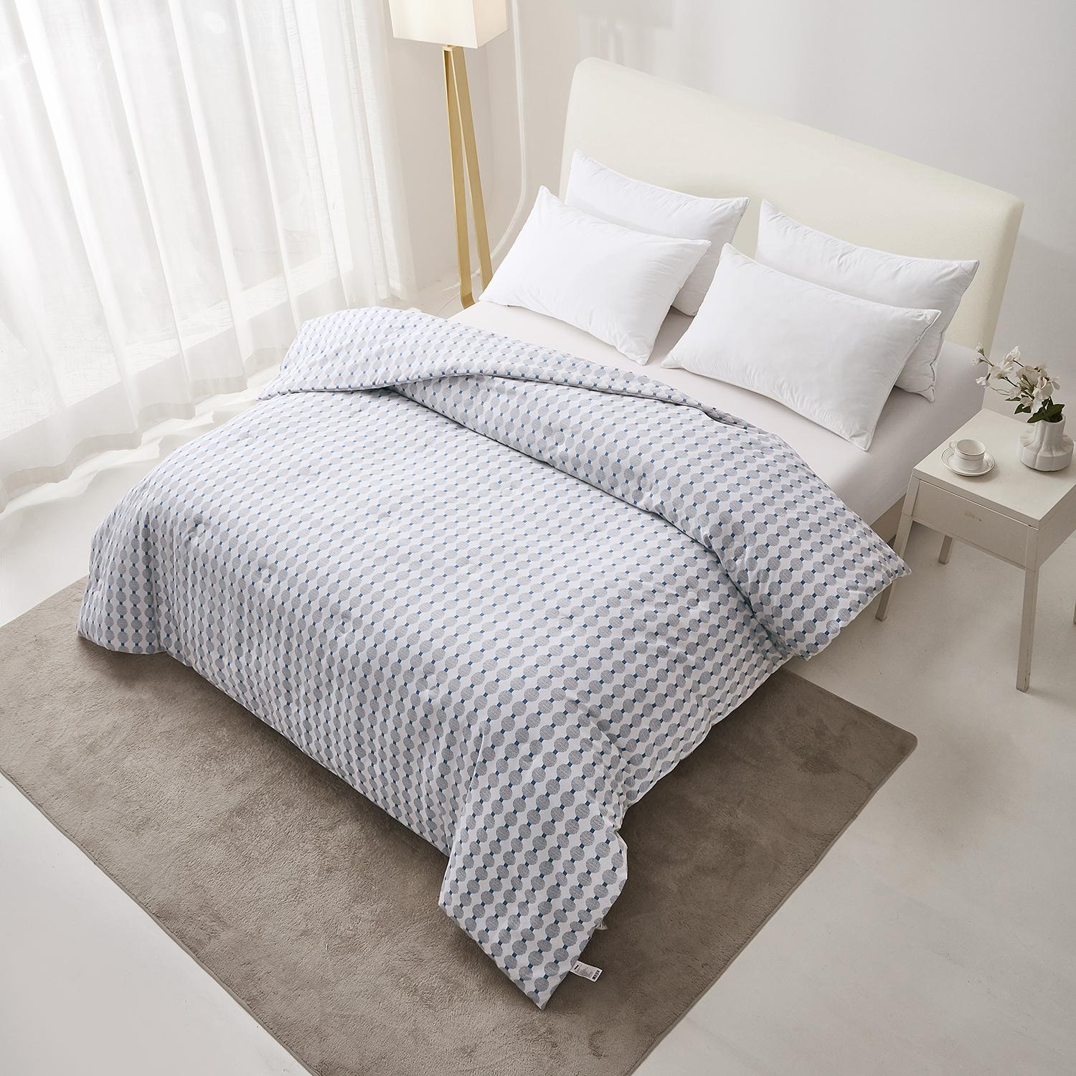
31 | BEDCOVER | 10570613/BED COVER MICROFIBER (C) YOEL NAVY
31 | BEDCOVER | 10570614/BED COVER MICROFIBER (D) YOEL NAVY
32 | BEDCOVER | 10570615/BED COVER MICROFIBER (B) YOEL GREEN | HIJAU, PUTIH | 100% POLIESTER | INFORMA | 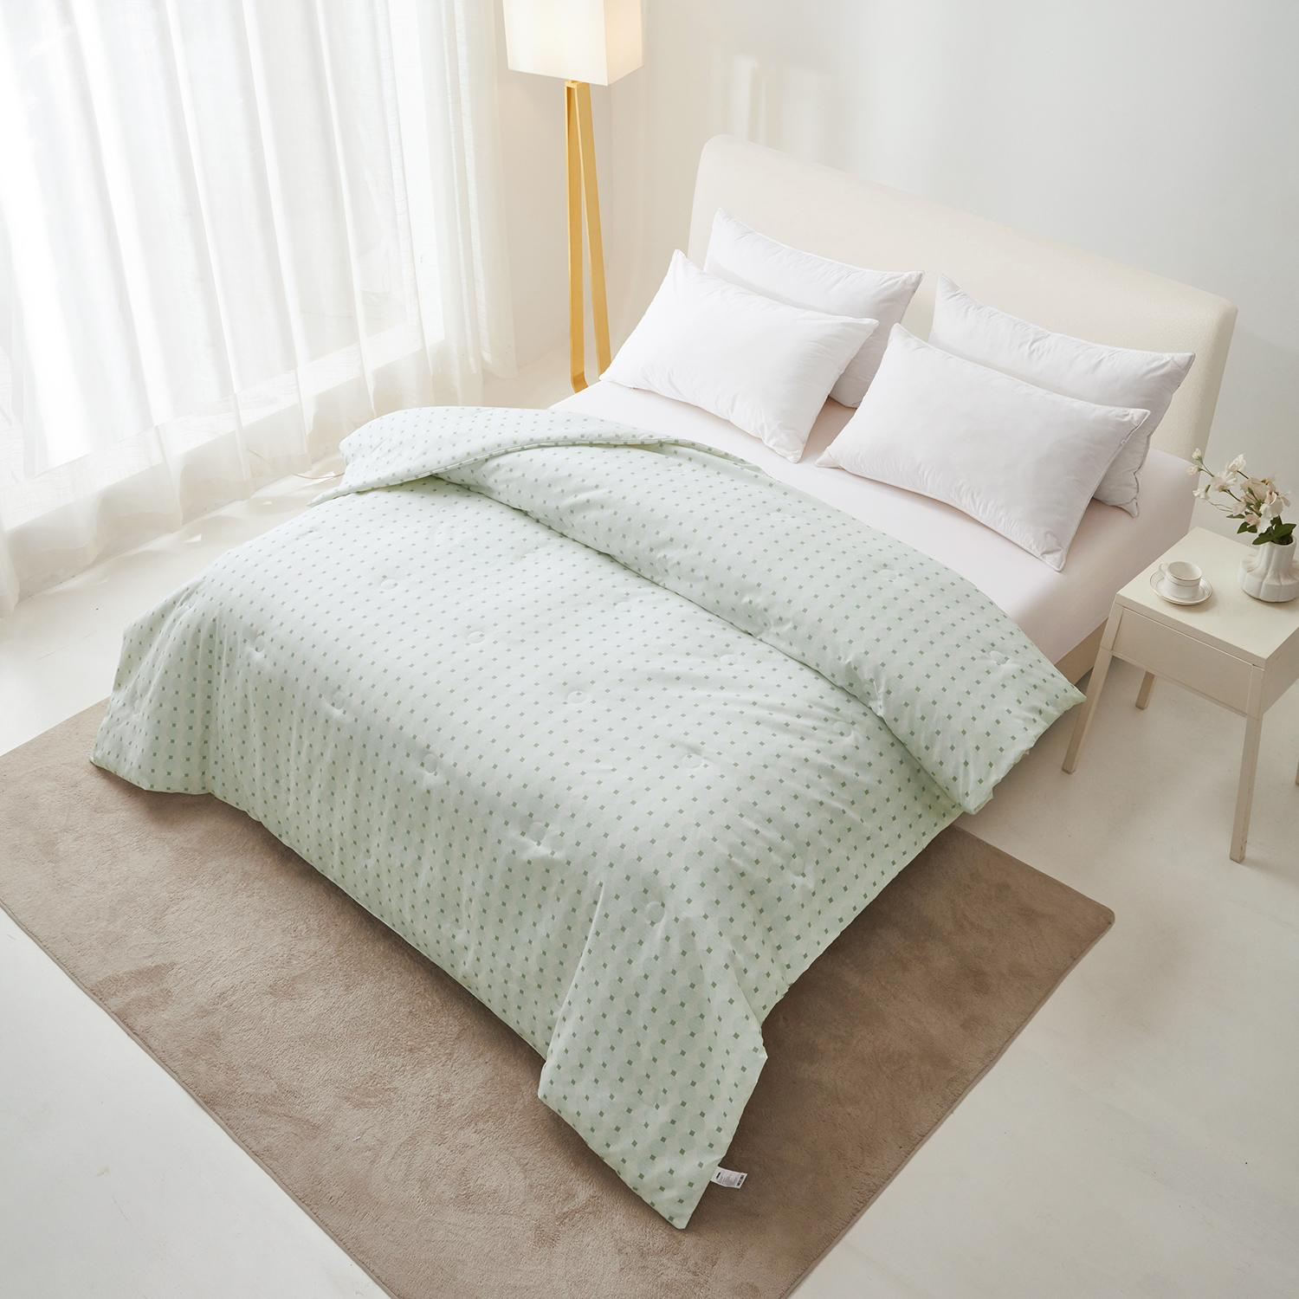
32 | BEDCOVER | 10570616/BED COVER MICROFIBER (C) YOEL GREEN
32 | BEDCOVER | 10570617/BED COVER MICROFIBER (D) YOEL GREEN
33 | BEDCOVER | 10570618/BED COVER MICROFIBER (B) YOEL BROWN | COKLAT, PUTIH | 100% POLIESTER | INFORMA | 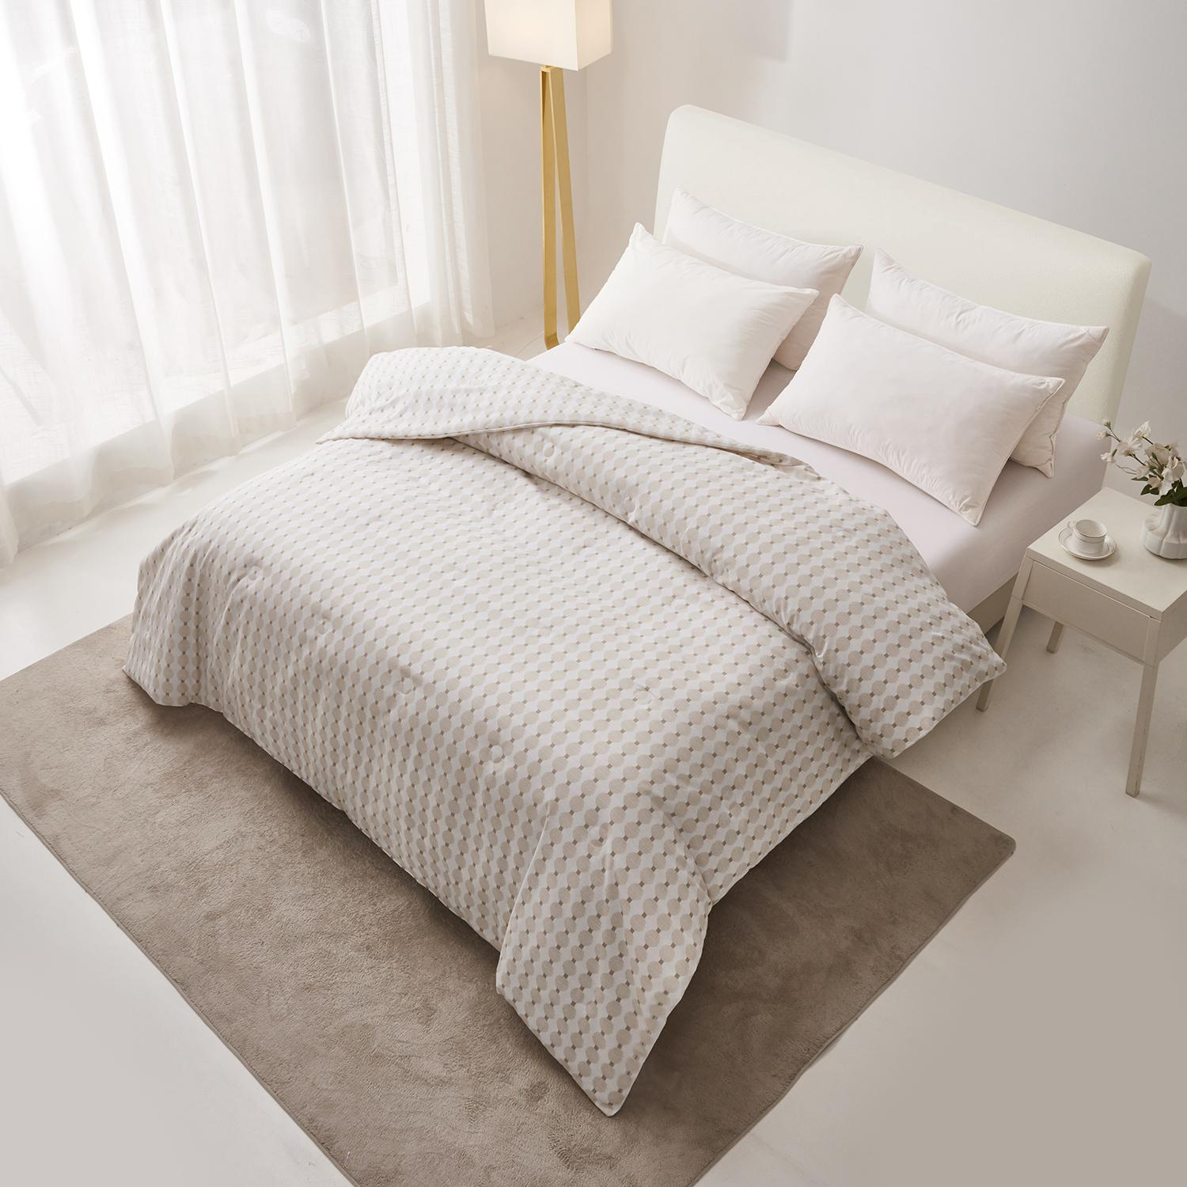
33 | BEDCOVER | 10570619/BED COVER MICROFIBER (C) YOEL BROWN
33 | BEDCOVER | 10570620/BED COVER MICROFIBER (D) YOEL BROWN

Please be informed that this report is issued under the following conditions:
Harap diketahui bahwa laporan ini diterbitkan dengan ketentuan sebagai berikut:
- Test/calibration result in the form of official report will be issued immediately after testing/calibration has been completed.
Hasil pengujian/kalibrasi dalam bentuk laporan resmi akan diterbitkan segera setelah pengujian/kalibrasi selesai dilakukan.
- Unless otherwise specified by the Client, this report shall only contain technical evaluation results conducted by PT QUALIS INDONESIA. In the event of a requirement to submit analysis, interpretation of the results, opinions and/or professional recommendations expressed thereupon, then these shall be indicated PT QUALIS INDONESIA in writing and additional fee, if applicable, borne by the Client.
Laporan ini hanya berisi hasil evaluasi teknis yang dilakukan oleh PT QUALIS INDONESIA kecuali diminta sebaliknya oleh Klien. Dalam hal diperlukannya penyampaian analisis, interpretasi terhadap hasil, pendapat dan/atau rekomendasi profesional, maka semua perlu disampaikan secara tertulis kepada PT QUALIS INDONESIA dan jika ada biaya tambahan maka akan dibebankan kepada Klien.
- This report applies to the sample of the specific product/equipment given at the time of its testing/calibration. The results are not used to indicate or imply that they are applicable to other similar items. In addition, such results must not be used to indicate or imply that PT QUALIS INDONESIA approves, recommends or endorses the manufacturer, supplier or user of such product/equipment, or that PT QUALIS INDONESIA in any way “guarantees” the later performance of the product/equipment. Unless otherwise stated in this report, no tests were conducted to determine long term effects of using the specific product/equipment.
Laporan ini berlaku untuk sampel produk/peralatan tertentu yang diajukan pada saat pengujian/kalibrasi. Segala hasil tidak dapat digunakan untuk menunjukkan atau menyiratkan bahwa hasil evaluasi sampel berlaku untuk barang serupa lainnya. Selain itu, hasil tersebut tidak dapat digunakan untuk menunjukkan atau menyiratkan bahwa PT QUALIS INDONESIA menyetujui, merekomendasikan atau mengesahkan pabrikan, pemasok atau pengguna produk/peralatan tersebut, atau bahwa PT QUALIS INDONESIA dalam bentuk apapun “menjamin” kinerja produk/peralatan untuk seterusnya. Kecuali dinyatakan lain dalam laporan ini, tidak ada pengujian yang dilakukan untuk menentukan efek jangka panjang penggunaan produk/peralatan yang dimaksud.
- The sample/s mentioned in this report is/are submitted/supplied/manufactured by the Client. PT QUALIS INDONESIA therefore assumes no responsibility for the accuracy of information on the brand name, model number, origin of manufacture, consignment or any other information supplied.
Sampel yang dicantumkan dalam laporan ini diserahkan/disediakan/diproduksi oleh Klien. Oleh karena itu, PT QUALIS INDONESIA tidak bertanggung jawab atas keakuratan informasi tentang nama merek, nomor model, asal-usul pembuatan, pengiriman atau informasi lainnya apapun yang diberikan.
- Additional copies of the report are available to the Client at an additional fee. No third party can obtain a copy of this report through PT QUALIS INDONESIA, unless the Client has authorized PT QUALIS INDONESIA in writing to do so.
Salinan tambahan dari laporan ini tersedia untuk Klien dengan biaya tambahan. Tidak ada pihak ketiga yang dapat memperoleh salinan laporan ini melalui PT QUALIS INDONESIA, kecuali Klien telah memberi kuasa kepada PT QUALIS INDONESIA secara tertulis untuk melakukannya.
- PT QUALIS INDONESIA may at its sole discretion add to or amend the conditions of the report at the time of report issuance. Such report and additions or amendments shall be binding on the Client.
Atas kebijakannya sendiri, PT QUALIS INDONESIA dapat menambah atau mengubah ketentuan laporan pada saat penerbitan laporan. Laporan dan penambahan atau amandemen tersebut bersifat mengikat untuk Klien.
- All copyright in the report shall remain with PT QUALIS INDONESIA and the Client shall, upon payment of PT QUALIS INDONESIA’s fees for the carrying out of the tests/calibrations, be granted the permission to use or publish the report to the third parties subject to the terms and conditions herein, provided that PT QUALIS INDONESIA is always at its absolute discretion entitled to impose such terms and conditions on the report as it sees relevant.
Seluruh hak cipta atas laporan tetap menjadi milik PT QUALIS INDONESIA dan setelah pembayaran biaya pelaksanaan pengujian/kalibrasi kepada PT QUALIS INDONESIA, Klien akan diberikan ijin untuk menggunakan atau mempublikasikan laporan kepada pihak ketiga dengan syarat dan ketentuan sebagaimana yang tertera dalam laporan ini, dengan catatan bahwa atas pertimbangan mutlaknya, PT QUALIS INDONESIA berhak memberlakukan syarat dan ketentuan yang dimaksud pada laporan yang dianggap relevan.
- Nothing in this report shall be interpreted to mean that PT QUALIS INDONESIA has verified or ascertained any endorsement or marks from any other testing authority or bodies that may be found on that sample.
Tidak ada hal apapun dalam laporan ini yang dapat ditafsirkan bahwa PT QUALIS INDONESIA telah memverifikasi atau memberikan pengesahan atau tanda dari otoritas atau badan pengujian lain yang mungkin ditemukan pada sampel tersebut.
- This report shall not be reproduced in parts and no reference shall be made by the Client to PT QUALIS INDONESIA, or to the report or results furnished by PT QUALIS INDONESIA in any advertisements or sales promotion.
Laporan ini tidak diperkenankan untuk dicetak ulang secara sebagian dan Klien tidak diperkenankan untuk membuat referensi terhadap PT QUALIS INDONESIA dalam iklan atau promosi penjualan, atau terhadap laporan atau hasil yang diterbitkan oleh PT QUALIS INDONESIA

