# 消融实验：分支数以及卡数的影响

# RepSeg_D2_6G

# 0.实验结论

1）基于RepSeg6G进行分支重要性试验，基础3分支（3x3/1x1/shotcut）。 额外加入1x3/3x1 2分支后，涨点0.3%，额外加入conv1x1_conv3x3/conv1x1_avg3x3 2分支后，涨点0.23%。额外加入1x3/3x1/conv1x1_conv3x3/conv1x1_avg3x3 4分支后涨点0.71% 。加入更多分支可以微弱涨点，但是不明显。猜测原因：虽然使用更多分支，但是没有引入非线性，因此涨点不明显。

2）之前的实验可复现，基于RepVGG6G进行了2个结构的复现实验，实验1复现前后75.93->75.78，实验2复现前后76.77->76.61。

3）可以基于RepSeg的代码激活3分支进行类RepVGG的实验：a. RepVGG-7-4_ERFHead2-2， 77.04， RepSeg(RepVGG3分支)-7-4_ERFHead2-2，76.86，性能相当。b. RepVGG-7-4-PSPHead_160K，74.68，RepSeg(RepVGG3分支)-7-4_PSPHead_160K，74.47 ，性能也相当。c. RepVGG-7-4-PSPHead_320K，74.88, RepSeg(RepVGG3分支)-7-4_PSPHead_320K，75.70 ，性能也相当(虽有涨点，认为是波动影响)。

4）基于RepSeg进行多卡实验，batchsize和学习率保证不变的条件下，使用pytorch1.9.0及seed=0，8卡相对2卡性能下降了1.15%，猜测可能的原因是，卡数(线程数)及num_worker影响了样本的采样顺序，导致收敛的精度不一样。暂容许这种存在。

5）在batchsize和学习率保证不变的条件下，随机初始化，增加1倍的迭代次数（160K->320K），性能提升1个点。且迭代次数降低1倍（160K->80K），性能下降很严重，4%。证明了在随机初始化时增加迭代次数的重要性。

# 1. RepSeg: Baseline

**Torch1.6.0：**

Python: 3.7.10

PyTorch: 1.6.0

TorchVision: 0.7.0

OpenCV: 4.5.2

**MMCV: 1.3.4**

MMCV Compiler: GCC 8.3

MMCV CUDA Compiler: 10.2

**MMSegmentation: 0.13.0+66b0525**

|  |  |  |  |  |  |
| --- | --- | --- | --- | --- | --- |
| EXP | crop_size/train_size=1024*512, test_size：1024x2048  seed=0, deterministic=False, **torch1.6.0**+mmseg0.13.0  cityscapes_RepSeg_D2-2-4-8-16_6G_7-14-16-64-128-ppm128_512x1024_320k_scratch_syncbn_noaux | | | | |
| lr+iter | batch_size | miou | 参数 | exp_name |
| **1** | **syncbn lr=0.01 320k** | **b16_g2_s8_w4** | **76.54** | RepSeg_bmseg: 7-14  RepSeg_PSPHead  noaux  with ppm | **cityscapes_RepSeg_D2-2-4-8-16_6G_7-14-16-64-128-ppm128_512x1024_320k_scratch_syncbn_noaux.py** |
| 2 | syncbn lr=0.01 320k | b16_g8_s2_w2 | 74.70 | RepSeg_bmseg: 7-14  RepSeg_PSPHead  noaux  with ppm | cityscapes_RepSeg_D2-2-4-8-16_6G_7-14-16-64-128-ppm128_512x1024_320k_scratch_syncbn_noaux_b8x2.py |
| 由“repseg复现及试验调参”exp1~5，基于pytorch1.9.0及seed=0，卡数影响了1.15%，还是有影响，  但是比“pytorch1.6.0+不约束seed”影响小，猜测原因有一下2点：  1）随机初始化方式不一样，  2）卡数多少及num_worker的数量影响了样本的采样顺序，导致收敛的精度不一样 | | | | | |
| 3 | bn lr=0.01 320k | b16_g8_s2_w2 | 70.80 | RepSeg_bmseg: 7-14  RepSeg_PSPHead  noaux  with ppm | cityscapes_RepSeg_D2-2-4-8-16_6G_7-14-16-64-128-ppm128_512x1024_320k_scratch_bn_noaux_b8x2.py |
| 再次验证syncbn相对bn在卡数相对较少时，还是非常有用的 | | | | | |

# 2.RepVGG: Baseline

Python: 3.7.10

PyTorch: 1.6.0

TorchVision: 0.7.0

OpenCV: 4.5.2

MMCV: 1.3.4

MMCV Compiler: GCC 8.3

MMCV CUDA Compiler: 10.2

MMSegmentation: 0.13.0+66b0525

|  |  |  |  |  |  |  |
| --- | --- | --- | --- | --- | --- | --- |
| EXP | crop_size/train_size=1024*512, test_size：1024x2048  seed=0, deterministic=False, **torch1.6.0**+mmseg0.13.0  **RepVGG_6G**_7-14-16-64-128-ppm128_512x1024_320k_scratch | | | | |  |
| lr+iter | batch_size | miou | 参数 | exp ft. | exp_name. |
| **1** | **syncbn lr=0.01 320k** | **b16_g2_s8_w4** | **75.93** | RepVGG_bmseg: 5-12  RepVGG_PSPHead  no aux  with ppm | **RepVGG_6G_7-14-16-64-128-ppm128_512x1024_320k_scratch** | cityscapes_RepVGG_6G_7-14-16-64-128-ppm128_512x1024_320k_scratch_syncbn_aux.py |
| 实验1可复现，复现点数，75.78，见“repvgg复现及试验调参”EXP0 | | | | | |  |
| 2 | syncbn lr=0.01 320k | b16_g2_s8_w4 | 75.62 | RepVGG_bmseg: 5-12  RepVGG_ERFHead: 2-2  aux(drop0)  no ppm | **RepVGG_6G**_5-12-16-64-128_noppm_erfhead-2-2_128_64_16_512x1024_320k_scratch_syncbn_aux  3个反卷积代替interpolate，backbone的4个repblock移到decoder中，syncbn + aux | cityscapes_RepVGG_6G_5-12-16-64-128_noppm_erfhead-2-2_128_64_16_512x1024_320k_scratch_syncbn_aux.py |
| 3 | syncbn lr=0.01 320k | b16_g2_s8_w4 | 76.77 | RepVGG_bmseg: 5-12  RepVGG_PSPHead  aux(drop0)  with ppm | RepVGG_6G_5-12-16-64-128_ppm128-2346_erfhead-2-2_128_64_16_512x1024_320k_scratch_syncbn_aux  3个反卷积代替interpolate，backbone的4个repblock移到decoder中，syncbn +PPM128-2346+ aux | cityscapes_RepVGG_6G_5-12-16-64-128_ppm128-2346_erfhead-2-2_128_64_16_512x1024_320k_scratch_syncbn_aux.py |
| 实验3可复现，复现点数，76.61，见“repvgg复现及试验调参”EXP1，  另外， EXP2和EXP3说明在大分辨率下ppm很重要 | | | | | |  |

# 3.repseg复现及试验调参

**Torch1.9.0：**

Python: 3.7.10

**PyTorch: 1.9.0+cu102**

**TorchVision: 0.10.0+cu102**

OpenCV: 4.5.2

**MMCV: 1.3.8**

MMCV Compiler: GCC 8.3

MMCV CUDA Compiler: 10.2

**MMSegmentation: 0.13.0+66b0525**

**1）卡数+迭代次数+学习率的影响**

|  |  |  |  |  |  |  |
| --- | --- | --- | --- | --- | --- | --- |
| EXP | crop_size/train_size=1024*512, test_size：1024x2048  seed=0, deterministic=False, **torch1.9.0**+mmseg0.13.0  cityscapes_RepSeg_D2-2-4-8-16_6G_7-14-16-64-128-ppm128_512x1024_320k_scratch_syncbn_noaux | | | | | |
| num | lr+iter | batch_size | miou | 参数 | time | exp_name |
| 1 | syncbn lr=0.01 320k | b16_g2_s8_w4 | 75.91 | RepSeg_bmseg: 7-14  RepSeg_PSPHead  noaux  with ppm | 3.25d | RepSeg_D2_6G_320k_syncbn_b16_g2_s8_w4.py |
| 2 | syncbn lr=0.01 320k | b16_g2_s8_w4 | 待running  做个收尾工作 | RepSeg_bmseg: 5-12  RepSeg_ERFHead:2-2  noaux  ppm |  |  |
| 3 | syncbn lr=0.01 320k | b16_g2_s8_w8 | 75.83 | RepSeg_bmseg: 7-14  RepSeg_PSPHead  noaux  with ppm | 3.5d | RepSeg_D2_6G_320k_syncbn_b16_g2_s8_w8.py |
| 4 | syncbn lr=0.01 320k | b16_g8_s2_w2 | 75.08 | RepSeg_bmseg: 7-14  RepSeg_PSPHead  noaux  with ppm | 1.5d | RepSeg_D2_6G_320k_syncbn_b16_g8_s2_w2.py |
| 5 | syncbn lr=0.01 320k | b16_g4_s4_w4 | **76.23** | RepSeg_bmseg: 7-14  RepSeg_PSPHead  noaux  with ppm | 2d | RepSeg_D2_6G_320k_syncbn_b16_g4_s4_w4.py |
| 由“repseg复现及试验调参”exp1~5，基于pytorch1.9.0及seed=0，卡数影响了1.15%，还是有影响，  猜测主要原因是：1）卡数多少及num_worker的数量影响了样本的采样顺序，导致收敛的精度不一样 | | | | | | |
| 6 | syncbn lr=0.01 160k | b16_g4_s4_w4 | 75.17 | RepSeg_bmseg: 7-14  RepSeg_PSPHead  noaux  with ppm | 1d | log_RepSeg_D2_6G_320k_syncbn_b16_g4_s4_w4_160k_torch1.9.0 |
| EXP6相对EXP5低了近1个点，进一步证明，迭代次数增加的好处。 | | | | | | |
| 7 | syncbn lr=0.02 160k | b16_g4_s4_w4 | 75.23 | RepSeg_bmseg: 7-14  RepSeg_PSPHead  noaux  with ppm | 1d | RepSeg_D2_6G_320k_syncbn_b16_g4_s4_w4_160k_lr0.02.py |
| EXP7相对EXP6学习率增加，性能基本无影响，说明初始学习率影响并不太大 | | | | | | |
| 8 | syncbn lr=0.01 80k | b16_g4_s4_w4 | 71.58 | RepSeg_bmseg: 7-14  RepSeg_PSPHead  noaux  with ppm | 12h | RepSeg_D2_6G_320k_syncbn_b16_g4_s4_w4_80k.py |
| EXP8说明在随机初始化且迭代次数不够的情况下，性能很差 | | | | | | |

|  |  |  |  |  |  |  |
| --- | --- | --- | --- | --- | --- | --- |
| EXP | crop_size/train_size=1024*512, test_size：1024x2048  seed=0, deterministic=False, **torch1.9.0**+mmseg0.13.0  cityscapes_RepSeg_D2-2-4-8-16_6G_7-14-16-64-128-ppm128_512x1024_320k_scratch_syncbn_noaux | | | | | |
| num | lr+iter | batch_size | miou | 参数 | time | exp_name |
| 1 | syncbn lr=0.01 320k | b16_g4_s4_w4 | **76.23** | RepSeg_bmseg: 7-14  RepSeg_PSPHead  noaux  ppm | 2d | RepSeg_D2_6G_320k_syncbn_b16_g4_s4_w4.py |
| 2 | syncbn lr=0.01 320k | b16_g4_s4_w4 | 75.44 | RepSeg_bmseg: 7-14  RepSeg_PSPHead  aux(drop0)  ppm | 2d | RepSeg_D2_6G_320k_syncbn_b16_g4_s4_w4_aux0.1_7-14.py_torch1.9.0 |
| EXP2相对EXP1说明AUX的dropout基本无影响，另一方面，性能有波动，波动还比较大 | | | | | | |
| 3 | syncbn lr=0.01 320k | b16_g4_s4_w4 | 75.24 | RepSeg_bmseg: 7-14  RepSeg_ERFHead:2-2  aux0.1  ppm | 2d | log_RepSeg_D2_6G_320k_syncbn_b16_g4_s4_w4_aux_5-12-erf2-2_torch1.9.0 |
| 4 | syncbn lr=0.01 320k | b16_g4_s4_w4 | 76.54 | RepSeg_bmseg: 5-12  RepSeg_ERFHead:2-2  aux0.1  ppm |  | log_RepSeg_D2_6G_320k_syncbn_b16_g4_s4_w4_aux0.1_erf2-2-real5-12_torch1.9.0 |
| EXP3点数完全不应该只有75.24， 波动影响，  EXP4相对EXP1性能有提升，说明了逐步上采样有好处，  相对“repvgg复现及试验调参”的exp5有微弱涨点，进一步说明多分支带来的收益不明显 | | | | | | |

# 4.repseg不同分支影响

|  |  |  |  |  |  |
| --- | --- | --- | --- | --- | --- |
| EXP | crop_size/train_size=1024*512, test_size：1024x2048  seed=0, deterministic=False, **torch1.9.0**+mmseg0.13.0  cityscapes_RepSeg_D2-2-4-8-16_6G_7-14-16-64-128-ppm128_512x1024_320k_scratch_syncbn_noaux  **lr+iter：syncbn lr=0.01 160k， batch_size：b16_g4_s4_w4** | | | | |
| num | 分支数 | miou | time |  | exp_name |
| 1 | conv3x3 conv1x1 shotcut  conv1x1_conv3x3  conv1x1_avg3x3  conv1x3 conv3x1  更多分支有用？ | 75.17 | 1d | RepSeg_bmseg: 7-14  RepSeg_PSPHead  noaux  ppm | log_RepSeg_D2_6G_320k_syncbn_b16_g4_s4_w4_160k_torch1.9.0 |
| 2 | conv3x3 conv1x1 shotcut | 74.46 | 1d | RepSeg_bmseg: 7-14  RepSeg_PSPHead  noaux  ppm | log_RepSeg_D2_6G_320k_syncbn_b16_g4_s4_w4_160k_repvgg3_torch1.9.0 |
| 3 | conv3x3 conv1x1 shotcut  +aux(drop=0)， aux基本无用 | 74.47 |  | RepSeg_bmseg: 7-14  RepSeg_PSPHead  aux(drop0)  ppm | log_RepSeg_D2_6G_320k_syncbn_b16_g4_s4_w4_160k_repvgg3_aux_torch1.9.0 |
| 4 | conv3x3 conv1x1 shotcut  conv1x3 conv3x1 | 74.76 | 1d | RepSeg_bmseg: 7-14  RepSeg_PSPHead  noaux  ppm | log_RepSeg_D2_6G_320k_syncbn_b16_g4_s4_w4_160k_repvgg3_1x3_3x1_torch1.9.0 |
| 5 | conv3x3 conv1x1 shotcut  conv1x1_conv3x3  conv1x1_avg3x3 | 74.69 | 1d | RepSeg_bmseg: 7-14  RepSeg_PSPHead  noaux  ppm | log_RepSeg_D2_6G_320k_syncbn_b16_g4_s4_w4_160k_dbb5_torch1.9.0 |
| EXP1~5，基于RepSeg6G进行分支重要性试验，基础3分支（3x3/1x1/shotcut）。 额外加入1x3/3x1 2分支后，涨点0.3%，额外加入conv1x1_conv3x3/conv1x1_avg3x3 2分支后，涨点0.23%。额外加入1x3/3x1/conv1x1_conv3x3/conv1x1_avg3x3 4分支后涨点0.71% 。加入更多分支可以微弱涨点，但是不明显。理由：虽然使用更多分支，但是没有引入非线性。 | | | | | |
| 6 | 补充实验：conv3x3 conv1x1 shotcut, 320k, 看后面是在repseg分支还是repvgg分支上继续做实验 | 75.70 |  | RepSeg_bmseg: 7-14  RepSeg_PSPHead  noaux  ppm | log_RepSeg_D2_6G_320k_syncbn_b16_g4_s4_w4_320k_repvgg3_torch1.9.0 |
| EXP6相对EXP2，增加1倍的迭代次数后涨1个点，进一步证明增加迭代次数的有效性。  EXP6相对“repvgg复现及试验调参”的EXP3的74.88涨点点（波动影响），进一步证明增加迭代次数的有效性。 | | | | | |
| 7 | 补充实验：conv3x3 conv1x1 shotcut, 320k, 看后面是在 | 76.86 |  | RepSeg_bmseg: 7-14  RepSeg_ERFHead: 2-2  with aux(drop0.1)  ppm | log_RepSeg_D2_6G_320k_syncbn_b16_g4_s4_w4_back0_aux0.1_erf2-2-b7-14_repvgg3_torch1.9.0 |
| EXP7相对“repvgg复现及试验调参”的EXP4(77.04)，差不多，证明repseg分支继续做类repvgg的实验 | | | | | |

# 5.repvgg复现及试验调参

**RepVGG vs RepSeg（试验复现），RepSeg不应该比RepVGG差呀**

|  |  |  |  |  |  |
| --- | --- | --- | --- | --- | --- |
| EXP | crop_size/train_size=1024*512, test_size：1024x2048  seed=0, deterministic=False, **torch1.9.0**+mmseg0.13.0  RepSeg基础配置：  cityscapes_RepSeg_D2-2-4-8-16_6G_7-14-16-64-128-ppm128_512x1024_320k_scratch_syncbn_noaux  lr+iter：syncbn lr=0.01 160k， batch_size：b16_g4_s4_w4  RepVGG基础配置：  cityscapes_RepVGG_6G_7-14-16-64-128-ppm128_512x1024_320k_scratch_syncbn_aux.py | | | | |
| num | 分支数 | miou | 参数 | time | exp_name |
| 0 | lr+iter: syncbn lr=0.01 320k， batch_size：b16_g2_s8_w4 | 75.78  (75.93) | RepVGG_bmseg: 5-12  RepVGG_PSPHead  aux(drop0)  with ppm | 2d | log_cityscapes_RepVGG_6G_7-14-16-64-128-ppm128_512x1024_320k_scratch_syncbn_aux_b16_g2_s8_w4_torch1.9.0 |
| 复现了RepVGG baseline1, 75.93 | | | | | |
| 1 | lr+iter: syncbn lr=0.01 320k， batch_size：b16_g2_s8_w4 | 76.61  (76.77) | RepVGG_bmseg: 5-12  RepVGG_ERFHead: 2-2  aux(drop0)  no ppm | 2d | log_cityscapes_RepVGG_6G_5-12-16-64-128_ppm128-2346_erfhead-2-2_128_64_16_512x1024_320k_scratch_syncbn_aux_b16_g2_s8_w4_torch1.9.0  3个反卷积代替interpolate，backbone的4个repblock移到decoder中，syncbn +PPM128-2346+ aux |
| 复现了RepVGG baseline2, 76.77 | | | | | |
| 2 | lr+iter: syncbn lr=0.01 320k， batch_size：b16_g4_s4_w4 | 75.29 | RepVGG_bmseg: 5-12  RepVGG_PSPHead  aux(drop0)  with ppm | 1d | log_RepVGG_6G_7-14-16-64-128-ppm128_320k_lr0.01_b16_g4_s4_w4_aux_torch1.9.0 |
| 3 | lr+iter: syncbn lr=0.01 320k， batch_size：b16_g4_s4_w4 | 76.38 | RepVGG_bmseg: 5-12  RepVGG_ERFHead: 2-2  aux(drop0.1)  with ppm |  | RepVGG_6G_7-14-16-64-128-ppm128_320k_lr0.01_b16_g4_s4_w4_aux0.1_real6G_erf2-2_torch1.9.0 |
| EXP2，再次说明卡数的多少有一定影响，  EXP3相对EXP2，说明erfhead确实有涨点 | | | | | |
| 4 | lr+iter: syncbn lr=0.01 320k， batch_size：b16_g4_s4_w4 | 74.88 | RepVGG_bmseg: 7-14  RepVGG_PSPHead  aux(drop0.1)  with ppm | 1d | log_RepVGG_6G_7-14-16-64-128-ppm128_320k_lr0.01_b16_g4_s4_w4_aux0.1_real7-14_torch1.9.0 |
| 5 | lr+iter: syncbn lr=0.01 320k， batch_size：b16_g4_s4_w4 | 77.04 | RepVGG_bmseg: 7-14  RepVGG_ERFHead: 2-2  aux(drop0.1)  with ppm |  | RepVGG_6G_7-14-16-64-128-ppm128_320k_lr0.01_b16_g4_s4_w4_aux0.1_falk6G_erf2-2_torch1.9.0 |
| EXP4/5，网络波动影响，且erfhead确实有涨点 | | | | | |
| 6 | lr+iter: syncbn lr=0.01 160k， batch_size：b16_g4_s4_w4 | 74.58 | RepVGG_bmseg: 5-12  RepVGG_PSPHead  aux(drop0)  with ppm | 12h | log_RepVGG_6G_7-14-16-64-128-ppm128_160k_lr0.01_b16_g4_s4_w4_aux_torch1.9.0 |
| 7 | lr+iter: syncbn lr=0.01 160k， batch_size：b16_g4_s4_w4 | 74.68  多加layer收益甚微呀 | RepVGG_bmseg: 7-14  RepVGG_PSPHead  aux(drop0)  with ppm |  | log_RepVGG_6G_7-14-16-64-128-ppm128_160k_lr0.01_b16_g4_s4_w4_aux0_7-14 |
| 8 | lr+iter: syncbn lr=0.01 160k， batch_size：b16_g4_s4_w4 | 73.73 | RepVGG_bmseg: 5-12  RepVGG_PSPHead  no aux  with ppm | 12h | log_RepVGG_6G_7-14-16-64-128-ppm128_160k_lr0.01_b16_g4_s4_w4_noaux_torch1.9.0 |
| 9 | lr+iter: syncbn lr=0.01 160k， batch_size：b16_g4_s4_w4 | 74.17 | RepVGG_bmseg: 7-14  RepVGG_PSPHead  no aux  with ppm |  | log_RepVGG_6G_7-14-16-64-128-ppm128_160k_lr0.01_b16_g4_s4_w4_noaux_7-14_torch1.9.0 |
| EXP6~9，证明多加4个block影响很小  EXP8相对EXP6掉点较多，不能说明什么，认为是网络波动的影响。 | | | | | |

# 6.CMD

RepSeg(VGG): **AUX (mIoU未知)**

backbone=dict( type='RepSeg_bmseg', num_blocks=[7, 14],)

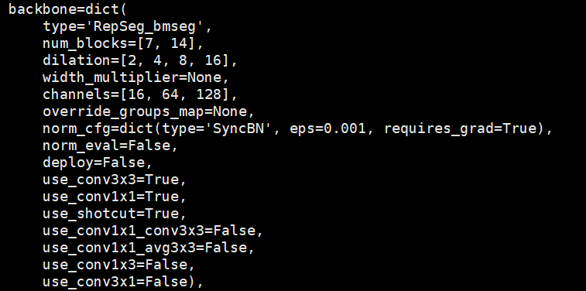

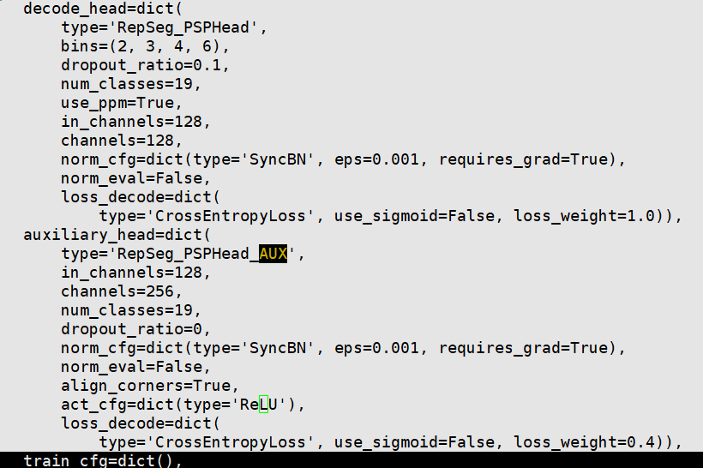

RepSeg(VGG): **noAUX(74.76)**

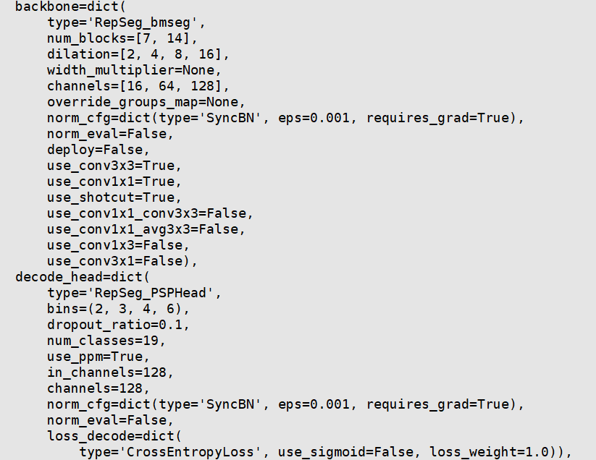

RepVGG (**73.73) NoAUX**

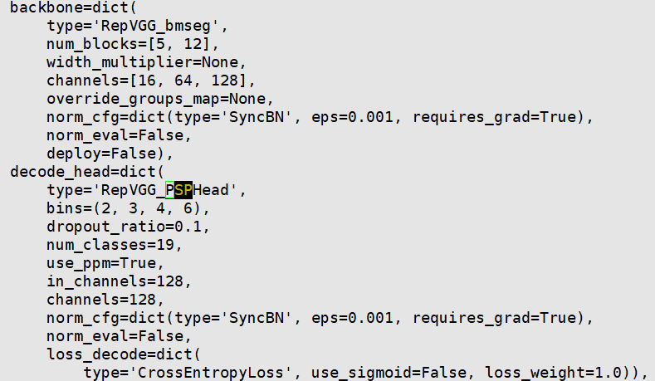

RepVGG (**74.58) AUX**

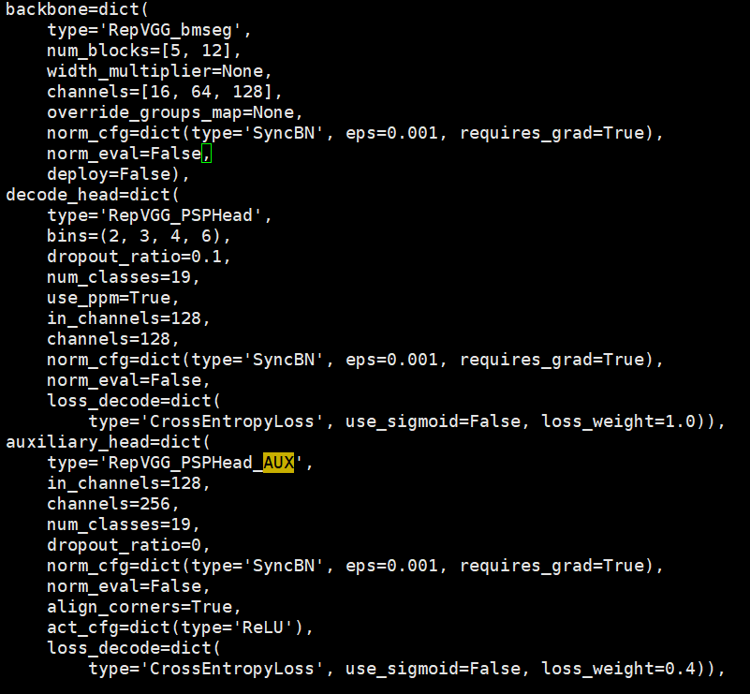

命令行：

conda activate ll-torch19

cp -rf /home/llei/project/new_semseg/mmsegmentation_8155_double/configs/repseg_gpus /home/llei/project/city_semseg/mmsegmentation/configs/

RepVGG_6G_7-14-erf2-2, repvgg增加运算量：

CUDA_VISIBLE_DEVICES=0,1,2,3 PORT=6077 ./tools/dist_train.sh ./configs/repvgg_gpus/RepVGG_6G_7-14-16-64-128-ppm128_320k_lr0.01_b16_g4_s4_w4_aux0.1_falk6G_erf2-2.py 4 --seed=0 >log_RepVGG_6G_7-14-16-64-128-ppm128_320k_lr0.01_b16_g4_s4_w4_aux0.1_falk6G_erf2-2_torch1.9.0 2>&1 &

CUDA_VISIBLE_DEVICES=4,5,6,7 PORT=8889 ./tools/dist_train.sh ./configs/repseg_gpus/RepSeg_D2_6G_320k_syncbn_b16_g4_s4_w4_320k_repvgg3.py 4 --seed=0 >log_RepSeg_D2_6G_320k_syncbn_b16_g4_s4_w4_320k_repvgg3_torch1.9.0 2>&1 &