# 静态手势动作定义和标准

# 手势动作要求：

**（1）不要晃动，保持手势稳定>1s**

**（2）角度：手轮廓与地面基本平行（假设坐姿端正时，则手轮廓和肩基本平行），角度误差需小于30度**

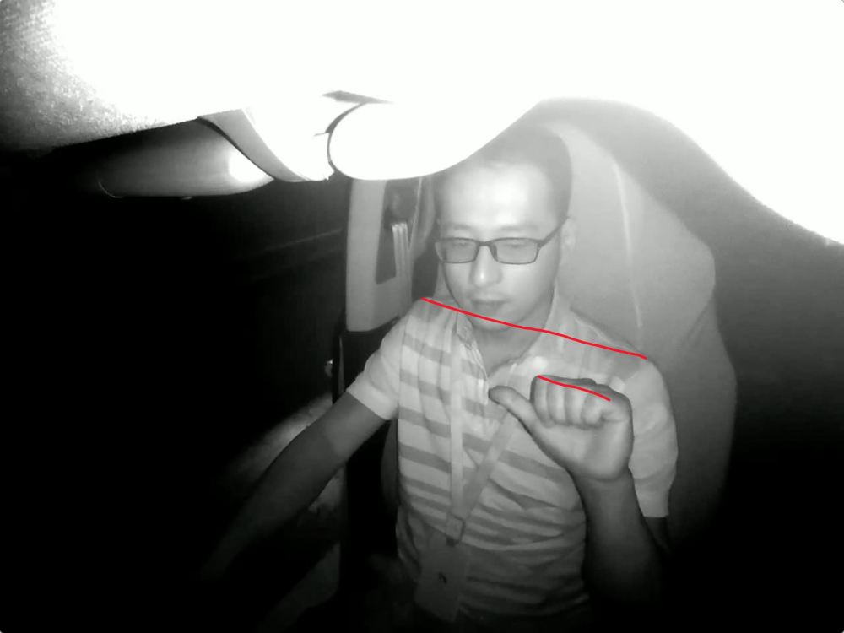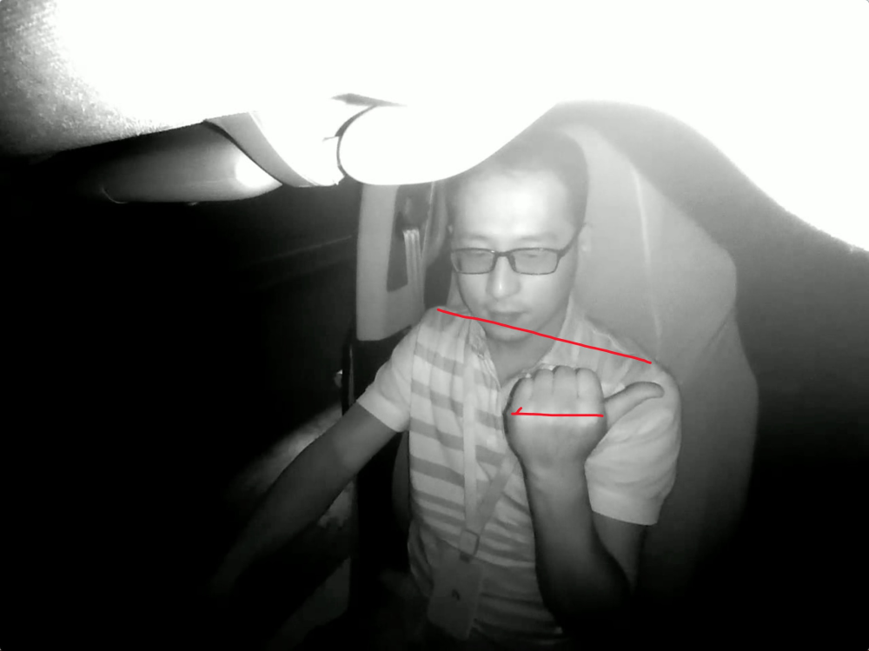

**（3）区域：手抬起区域在一定范围内：胸部以上，眼睛以下，等肩高度；距离躯干前方40cm内，右肩右侧20cm以内。如下所示区域；**

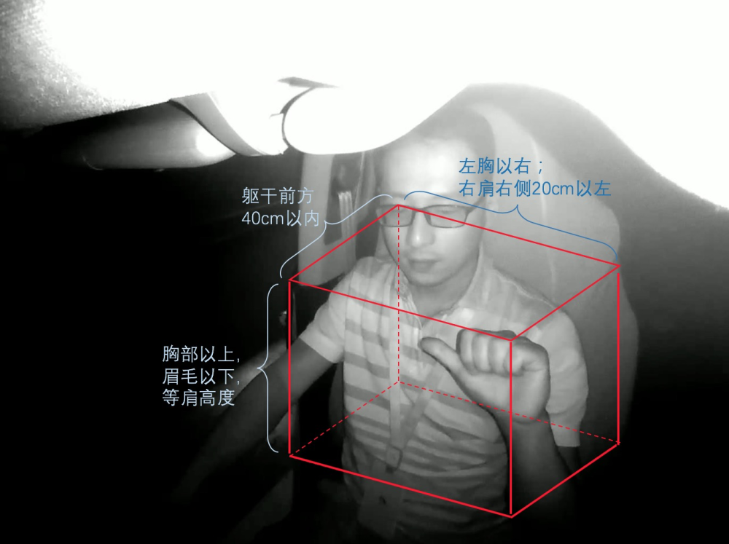

***​***

# 标准/困难样本定义：

## 嘘手势可以左右手做，其他手势仅支持右手！！！

## 0.嘘：

### a.标准动作:

**保证能清晰看见食指放在嘴唇（中间）上，手掌朝左/右**

|  |  |
| --- | --- |
| [MISSING IMAGE: images_2019-08-07-rgb-afternoon-car-1-right-rose_001470.png, images_2019-08-07-rgb-afternoon-car-1-right-rose_001470.png ] | [MISSING IMAGE: images_2019-08-01-rgb-afternoon-bj-station-left-and-right-gd_002184.png, images_2019-08-01-rgb-afternoon-bj-station-left-and-right-gd_002184.png ] |

### b.可识别动作：

**头部和相机可以成一定夹角，但是需要保证嘴部，食指清晰可见**

|  |  |  |
| --- | --- | --- |
| [MISSING IMAGE: images_2019-08-07-rgb-afternoon-car-1-left-wjh_002200.png, images_2019-08-07-rgb-afternoon-car-1-left-wjh_002200.png ] | [MISSING IMAGE: images_vs_20200312-131531_35.jpg, images_vs_20200312-131531_35.jpg ] | [MISSING IMAGE: images_2019-07-29-rgb-afternoon-car-1-left-and-right_005130.png, images_2019-07-29-rgb-afternoon-car-1-left-and-right_005130.png ] |

### c.不可识别/干扰/边界动作：

**遮挡嘴部；角度过大；食指放在嘴角；手背朝前；悬空，不贴像嘴部；**

**模糊/噪声；其他手指**

|  |  |  |
| --- | --- | --- |
| [MISSING IMAGE: images_4_yibiao_ground_002373.png, images_4_yibiao_ground_002373.png ] | [MISSING IMAGE: , ] | [MISSING IMAGE: images_1_yibiao_ground_002976.png, images_1_yibiao_ground_002976.png ] |
| [MISSING IMAGE: images_3_yibiao_ground_002136.png, images_3_yibiao_ground_002136.png ] |  |  |

### d.待定：

戴口罩可能会影响模型识别精度

|  |  |
| --- | --- |
| [MISSING IMAGE: JinYan_56_RearviewMirror_RGB_JinYan_44.jpg, JinYan_56_RearviewMirror_RGB_JinYan_44.jpg ] | [MISSING IMAGE: JinYan_58_Foreward_RGB_JinYan_66.jpg, JinYan_58_Foreward_RGB_JinYan_66.jpg ] |

## 1.666:

### a.标准动作:

**保证能清晰看见小拇指和大拇指，且大拇指/小拇指于垂直方向有一定夹角，手掌/手背朝前均可​**

|  |  |
| --- | --- |
| [MISSING IMAGE: images_2019-08-07-rgb-afternoon-car-1-right-rose_007020.png, images_2019-08-07-rgb-afternoon-car-1-right-rose_007020.png ] | [MISSING IMAGE: images_2019-07-30-rgb-afternoon-station-right-lh_004630.png, images_2019-07-30-rgb-afternoon-station-right-lh_004630.png ] |

### b.可识别动作：

|  |  |  |
| --- | --- | --- |
| [MISSING IMAGE: images_2019-08-07-rgb-afternoon-car-2-right-wjh_006970.png, images_2019-08-07-rgb-afternoon-car-2-right-wjh_006970.png ] | [MISSING IMAGE: images_vs_20200311-134915_80.jpg, images_vs_20200311-134915_80.jpg ] | [MISSING IMAGE: images_vs_20200331-180132_4855.jpg, images_vs_20200331-180132_4855.jpg ] |
| [MISSING IMAGE: 666_2_Foreward_IR_666_44.jpg, 666_2_Foreward_IR_666_44.jpg ] |  |  |

### c.不可识别/干扰/边界动作：

**手掌/手背朝向地面；手指仅部分可见/完全不可见；严重遮挡**

|  |  |  |  |
| --- | --- | --- | --- |
| [MISSING IMAGE: images_vs_20200312-161919_220.jpg, images_vs_20200312-161919_220.jpg ] | [MISSING IMAGE: images_vs_20200330-174202_435.jpg, images_vs_20200330-174202_435.jpg ] | [MISSING IMAGE: images_vs_20200331-144401_1865.jpg, images_vs_20200331-144401_1865.jpg ] | [MISSING IMAGE: , ] |
| [MISSING IMAGE: images_vs_20200331-153755_1880.jpg, images_vs_20200331-153755_1880.jpg ] | [MISSING IMAGE: images_vs_20200312-101853_370.jpg, images_vs_20200312-101853_370.jpg ] | [MISSING IMAGE: images_2019-07-30-rgb-afternoon-station-left-lh_003160.png, images_2019-07-30-rgb-afternoon-station-left-lh_003160.png ] | [MISSING IMAGE: images_1_yibiao_ground_001764.png, images_1_yibiao_ground_001764.png ] |
| [MISSING IMAGE: images_2019-07-30-rgb-afternoon-station-right-lh_000590.png, images_2019-07-30-rgb-afternoon-station-right-lh_000590.png ] | [MISSING IMAGE: images_2019-08-26-ir-night-station-right_007670.png, images_2019-08-26-ir-night-station-right_007670.png ] | [MISSING IMAGE: images_2019-08-28-ir-afternoon-car-2-left-and-right_012110.png, images_2019-08-28-ir-afternoon-car-2-left-and-right_012110.png ] | [MISSING IMAGE: 666_70_Foreward_RGB_666_44.jpg, 666_70_Foreward_RGB_666_44.jpg ] |

## 2.v:

### a.标准动作:

**保证能够看见中指和食指并成一定夹角，且于垂直方向成一定夹角​**

|  |  |
| --- | --- |
| [MISSING IMAGE: images_2019-07-30-rgb-afternoon-station-right-rose_002220.png, images_2019-07-30-rgb-afternoon-station-right-rose_002220.png ] | [MISSING IMAGE: V_3_RearviewMirror_RGB_V_154.jpg, V_3_RearviewMirror_RGB_V_154.jpg ] |

### b.可识别动作：

|  |  |  |  |
| --- | --- | --- | --- |
| [MISSING IMAGE: images_4_yibiao_cheku_001791.png, images_4_yibiao_cheku_001791.png ] | [MISSING IMAGE: images_2019-08-05-rgb-night-station-right-xp_002370.png, images_2019-08-05-rgb-night-station-right-xp_002370.png ] | [MISSING IMAGE: images_2019-09-24-ir-morning-station-left-and-right-whf_022270.png, images_2019-09-24-ir-morning-station-left-and-right-whf_022270.png ] | [MISSING IMAGE: images_vs_20200311-134915_1095.jpg, images_vs_20200311-134915_1095.jpg ] |
| [MISSING IMAGE: images_vs_20200312-101348_215.jpg, images_vs_20200312-101348_215.jpg ] | [MISSING IMAGE: images_2019-08-05-rgb-night-station-right-xp_002480.png, images_2019-08-05-rgb-night-station-right-xp_002480.png ] |  |  |

### c.不可识别/干扰/边界动作：

**水平比V；食指和中指夹角不明显；手指不能完全可见；严重遮挡**

|  |  |  |  |
| --- | --- | --- | --- |
| [MISSING IMAGE: , ] | [MISSING IMAGE: , ] | [MISSING IMAGE: images_vs_20200312-121347_160.jpg, images_vs_20200312-121347_160.jpg ] | [MISSING IMAGE: images_vs_20200330-174202_560.jpg, images_vs_20200330-174202_560.jpg ] |
| [MISSING IMAGE: images_vs_20200312-103746_210.jpg, images_vs_20200312-103746_210.jpg ] | [MISSING IMAGE: images_vs_20200311-105026_290.jpg, images_vs_20200311-105026_290.jpg ] |  |  |

## 3.比心：

### a.标准动作:

**清晰可见食指和拇指且成交叉状态,指背朝前。手势不可有过大姿态角**

|  |  |
| --- | --- |
| [MISSING IMAGE: images_2019-08-01-rgb-afternoon-bj-station-left-and-right-gd_001736.png, images_2019-08-01-rgb-afternoon-bj-station-left-and-right-gd_001736.png ] | [MISSING IMAGE: images_2019-08-09-ir-afternoon-bj-car-left-and-right-ll_000890.png, images_2019-08-09-ir-afternoon-bj-car-left-and-right-ll_000890.png ] |

### b.可识别动作：

|  |  |  |
| --- | --- | --- |
| [MISSING IMAGE: BiXin_7_Foreward_IR_BiXin_66.jpg, BiXin_7_Foreward_IR_BiXin_66.jpg ] | [MISSING IMAGE: images_vs_20200311-110247_145.jpg, images_vs_20200311-110247_145.jpg ] | [MISSING IMAGE: images_vs_20200331-161427_695.jpg, images_vs_20200331-161427_695.jpg ] |
| [MISSING IMAGE: images_vs_20200331-105945_2065.jpg, images_vs_20200331-105945_2065.jpg ] | [MISSING IMAGE: BiXin_11_RearviewMirror_RGB_BiXin_110.jpg, BiXin_11_RearviewMirror_RGB_BiXin_110.jpg ] | [MISSING IMAGE: images_vs_20200312-180332_225.jpg, images_vs_20200312-180332_225.jpg ] |

### c.不可识别/干扰/边界动作：

比心手势由于是细微手指动作，因此要求手势要严格按照标准动作执行，否则视为无效手势。

|  |  |  |  |
| --- | --- | --- | --- |
| [MISSING IMAGE: BiXin_3_Foreward_IR_BiXin_176.jpg, BiXin_3_Foreward_IR_BiXin_176.jpg ] | [MISSING IMAGE: BiXin_27_Foreward_IR_BiXin_44.jpg, BiXin_27_Foreward_IR_BiXin_44.jpg ] | [MISSING IMAGE: BiXin_41_Foreward_RGB_BiXin_88.jpg, BiXin_41_Foreward_RGB_BiXin_88.jpg ] | [MISSING IMAGE: BiXin_41_RearviewMirror_RGB_BiXin_22.jpg, BiXin_41_RearviewMirror_RGB_BiXin_22.jpg ] |
| [MISSING IMAGE: BiXin_42_RearviewMirror_IR_BiXin_88.jpg, BiXin_42_RearviewMirror_IR_BiXin_88.jpg ] | [MISSING IMAGE: images_vs_20200311-105005_315.jpg, images_vs_20200311-105005_315.jpg ] | [MISSING IMAGE: images_vs_20200311-110247_1260.jpg, images_vs_20200311-110247_1260.jpg ] | [MISSING IMAGE: images_vs_20200312-101348_525.jpg, images_vs_20200312-101348_525.jpg ] |
| [MISSING IMAGE: images_vs_20200312-103746_310.jpg, images_vs_20200312-103746_310.jpg ] | [MISSING IMAGE: images_vs_20200312-105550_440.jpg, images_vs_20200312-105550_440.jpg ] | [MISSING IMAGE: images_vs_20200312-121015_270.jpg, images_vs_20200312-121015_270.jpg ] | [MISSING IMAGE: images_vs_20200312-122600_270.jpg, images_vs_20200312-122600_270.jpg ] |
| [MISSING IMAGE: images_vs_20200312-194612_450.jpg, images_vs_20200312-194612_450.jpg ] | [MISSING IMAGE: images_vs_20200312-152952_255.jpg, images_vs_20200312-152952_255.jpg ] | [MISSING IMAGE: images_vs_20200312-160154_180.jpg, images_vs_20200312-160154_180.jpg ] | [MISSING IMAGE: images_vs_20200312-152731_200.jpg, images_vs_20200312-152731_200.jpg ] |

## 4.ok:

### a.标准动作:

**保证清晰可见中指，无名指，小拇指以及大拇指和食指相连成“O”，手掌朝左/前**

|  |  |
| --- | --- |
| [MISSING IMAGE: images_2_yibiao_ground_001554.png, images_2_yibiao_ground_001554.png ] | [MISSING IMAGE: OK_13_RearviewMirror_RGB_OK_66.jpg, OK_13_RearviewMirror_RGB_OK_66.jpg ] |

### b.可识别动作：

|  |  |  |  |
| --- | --- | --- | --- |
| [MISSING IMAGE: OK_3_RearviewMirror_RGB_OK_88.jpg, OK_3_RearviewMirror_RGB_OK_88.jpg ] | [MISSING IMAGE: OK_24_Foreward_RGB_OK_154.jpg, OK_24_Foreward_RGB_OK_154.jpg ] | [MISSING IMAGE: OK_29_Foreward_RGB_OK_66.jpg, OK_29_Foreward_RGB_OK_66.jpg ] | [MISSING IMAGE: OK_77_Foreward_IR_OK_44.jpg, OK_77_Foreward_IR_OK_44.jpg ] |
| [MISSING IMAGE: images_1_yibiao_cheku_001686.png, images_1_yibiao_cheku_001686.png ] | [MISSING IMAGE: images_2019-07-29-rgb-afternoon-car-2-right_006100.png, images_2019-07-29-rgb-afternoon-car-2-right_006100.png ] |  |  |

### c.不可识别/干扰/边界动作：

“O”型不可见；手背朝前；三个手指不能完全可见；动作处于过渡状态

|  |  |  |  |
| --- | --- | --- | --- |
| [MISSING IMAGE: OK_38_RearviewMirror_RGB_OK_22.jpg, OK_38_RearviewMirror_RGB_OK_22.jpg ] | [MISSING IMAGE: images_vs_20200311-105005_390.jpg, images_vs_20200311-105005_390.jpg ] | [MISSING IMAGE: images_vs_20200311-110055_370.jpg, images_vs_20200311-110055_370.jpg ] | [MISSING IMAGE: images_vs_20200312-124606_280.jpg, images_vs_20200312-124606_280.jpg ] |
| [MISSING IMAGE: images_vs_20200312-152638_550.jpg, images_vs_20200312-152638_550.jpg ] | [MISSING IMAGE: images_5_yibiao_ground_000864.png, images_5_yibiao_ground_000864.png ] | [MISSING IMAGE: images_2019-07-30-rgb-night-station-right_000380.png, images_2019-07-30-rgb-night-station-right_000380.png ] |  |

## 5.比赞：

### a.标准动作:

**保证清晰可见大拇指，且大拇指需要垂直，不允许明显倾斜**

|  |  |
| --- | --- |
| [MISSING IMAGE: Good_8_Foreward_RGB_Good_22.jpg, Good_8_Foreward_RGB_Good_22.jpg ] | [MISSING IMAGE: images_2019-08-07-rgb-afternoon-car-2-right-rose_001140.png, images_2019-08-07-rgb-afternoon-car-2-right-rose_001140.png ] |

### b.可识别动作：

|  |  |  |  |
| --- | --- | --- | --- |
| [MISSING IMAGE: Good_3_Foreward_IR_Good_176.jpg, Good_3_Foreward_IR_Good_176.jpg ] | [MISSING IMAGE: Good_2_Foreward_IR_Good_44.jpg, Good_2_Foreward_IR_Good_44.jpg ] | [MISSING IMAGE: Good_2_RearviewMirror_IR_Good_22.jpg, Good_2_RearviewMirror_IR_Good_22.jpg ] | [MISSING IMAGE: Good_5_Foreward_IR_Good_22.jpg, Good_5_Foreward_IR_Good_22.jpg ] |
| [MISSING IMAGE: Good_10_RearviewMirror_RGB_Good_88.jpg, Good_10_RearviewMirror_RGB_Good_88.jpg ] |  |  |  |

### c.不可识别/干扰/边界动作：

大拇指明显出现倾斜；手部出现明显倾斜；严重遮挡；大拇指部分可见

|  |  |  |  |
| --- | --- | --- | --- |
| [MISSING IMAGE: Good_38_Foreward_RGB_Good_22.jpg, Good_38_Foreward_RGB_Good_22.jpg ] | [MISSING IMAGE: Good_87_RearviewMirror_IR_Good_66.jpg, Good_87_RearviewMirror_IR_Good_66.jpg ] | [MISSING IMAGE: Good_111_RearviewMirror_RGB_Good_110.jpg, Good_111_RearviewMirror_RGB_Good_110.jpg ] | [MISSING IMAGE: images_vs_20200311-105026_550.jpg, images_vs_20200311-105026_550.jpg ] |
| [MISSING IMAGE: Good_85_Foreward_RGB_Good_22.jpg, Good_85_Foreward_RGB_Good_22.jpg ] | [MISSING IMAGE: images_1_yibiao_ground_000345.png, images_1_yibiao_ground_000345.png ] | [MISSING IMAGE: images_vs_20200331-115258_1160.jpg, images_vs_20200331-115258_1160.jpg ] | [MISSING IMAGE: images_vs_20200312-131531_465.jpg, images_vs_20200312-131531_465.jpg ] |

## 6.握拳：

### a.标准动作:

**保证五个手指收紧，手掌朝前**

|  |  |
| --- | --- |
| [MISSING IMAGE: images_2019-07-28-rgb-afternoon-parlour-right-coat_002520.png, images_2019-07-28-rgb-afternoon-parlour-right-coat_002520.png ] | [MISSING IMAGE: Fist_6_Foreward_RGB_Fist_22.jpg, Fist_6_Foreward_RGB_Fist_22.jpg ] |

### b.可识别动作：

|  |  |  |  |
| --- | --- | --- | --- |
| [MISSING IMAGE: images_vs_20200331-115258_1390.jpg, images_vs_20200331-115258_1390.jpg ] | [MISSING IMAGE: images_2019-07-28-rgb-afternoon-parlour-left_003610.png, images_2019-07-28-rgb-afternoon-parlour-left_003610.png ] | [MISSING IMAGE: images_vs_20200311-105005_800.jpg, images_vs_20200311-105005_800.jpg ] | [MISSING IMAGE: Fist_12_Foreward_IR_Fist_22.jpg, Fist_12_Foreward_IR_Fist_22.jpg ] |

### c.不可识别/干扰/边界动作：

手背朝前；姿态角过大；指背朝前；拳低朝前；拳顶朝前

|  |  |  |  |
| --- | --- | --- | --- |
| [MISSING IMAGE: images_2019-08-01-rgb-afternoon-bj-station-left-and-right-zw_002480.png, images_2019-08-01-rgb-afternoon-bj-station-left-and-right-zw_002480.png ] | [MISSING IMAGE: images_2019-07-28-rgb-afternoon-parlour-right_004070.png, images_2019-07-28-rgb-afternoon-parlour-right_004070.png ] | [MISSING IMAGE: images_vs_20200311-140958_815.jpg, images_vs_20200311-140958_815.jpg ] | [MISSING IMAGE: images_vs_20200312-152952_665.jpg, images_vs_20200312-152952_665.jpg ] |
| [MISSING IMAGE: Fist_42_RearviewMirror_RGB_Fist_22.jpg, Fist_42_RearviewMirror_RGB_Fist_22.jpg ] | [MISSING IMAGE: images_vs_20200331-162922_940.jpg, images_vs_20200331-162922_940.jpg ] | [MISSING IMAGE: images_vs_20200312-152952_675.jpg, images_vs_20200312-152952_675.jpg ] | [MISSING IMAGE: images_vs_20200331-142937_570.jpg, images_vs_20200331-142937_570.jpg ] |
| [MISSING IMAGE: images_1_yibiao_ground_001419.png, images_1_yibiao_ground_001419.png ] |  |  |  |

## 7.比五：

### a.标准动作:

**保证五个手指可见，且手指之间需要分开，手掌朝外，手指垂直**

|  |  |
| --- | --- |
| [MISSING IMAGE: images_1_yibiao_cheku_001221.png, images_1_yibiao_cheku_001221.png ] | [MISSING IMAGE: images_2019-07-28-rgb-afternoon-parlour-right-coat_001200.png, images_2019-07-28-rgb-afternoon-parlour-right-coat_001200.png ] |

### b.可识别动作：

|  |  |  |  |
| --- | --- | --- | --- |
| [MISSING IMAGE: 5_2_Foreward_IR_5_22.jpg, 5_2_Foreward_IR_5_22.jpg ] | [MISSING IMAGE: 5_47_Foreward_RGB_5_66.jpg, 5_47_Foreward_RGB_5_66.jpg ] | [MISSING IMAGE: images_vs_20200331-160413_2750.jpg, images_vs_20200331-160413_2750.jpg ] | [MISSING IMAGE: images_vs_20200312-122600_750.jpg, images_vs_20200312-122600_750.jpg ] |

### c.不可识别/干扰/边界动作：

手掌朝向左右；手背朝前；严重遮挡；五指紧贴；手指水平地面；五指并未展开

|  |  |  |  |
| --- | --- | --- | --- |
| [MISSING IMAGE: images_vs_20200312-115757_820.jpg, images_vs_20200312-115757_820.jpg ] | [MISSING IMAGE: images_vs_20200312-143859_480.jpg, images_vs_20200312-143859_480.jpg ] | [MISSING IMAGE: images_3_yibiao_cheku_001188.png, images_3_yibiao_cheku_001188.png ] | [MISSING IMAGE: images_4_yibiao_ground_003444.png, images_4_yibiao_ground_003444.png ] |
| [MISSING IMAGE: images_2019-07-28-rgb-afternoon-parlour-right_005660.png, images_2019-07-28-rgb-afternoon-parlour-right_005660.png ] | [MISSING IMAGE: images_2019-07-28-rgb-afternoon-parlour-right-coat_001340.png, images_2019-07-28-rgb-afternoon-parlour-right-coat_001340.png ] | [MISSING IMAGE: images_2019-07-30-rgb-afternoon-station-left-wjh_004870.png, images_2019-07-30-rgb-afternoon-station-left-wjh_004870.png ] | [MISSING IMAGE: images_2019-08-26-ir-afternoon-station-right_007040.png, images_2019-08-26-ir-afternoon-station-right_007040.png ] |
| [MISSING IMAGE: images_vs_20200312-164408_800.jpg, images_vs_20200312-164408_800.jpg ] | [MISSING IMAGE: images_vs_20200331-180132_5565.jpg, images_vs_20200331-180132_5565.jpg ] |  |  |

## 8.其他

### a.标准动作:

**除了10种有效手势外的其他手势，**

## 9.向左：

### a.标准动作:

**大拇指清晰可见且水平于地面，手掌朝前**

|  |  |
| --- | --- |
| [MISSING IMAGE: Left_13_RearviewMirror_RGB_Left_22.jpg, Left_13_RearviewMirror_RGB_Left_22.jpg ] | [MISSING IMAGE: images_2019-07-28-rgb-afternoon-parlour-right-coat_002670.png, images_2019-07-28-rgb-afternoon-parlour-right-coat_002670.png ] |

### b.可识别动作：

|  |  |  |  |
| --- | --- | --- | --- |
| [MISSING IMAGE: images_2019-07-29-ir-night-bj-room-left-and-right-zw_003330.png, images_2019-07-29-ir-night-bj-room-left-and-right-zw_003330.png ] | [MISSING IMAGE: images_2019-07-30-rgb-afternoon-station-right-lh_001270.png, images_2019-07-30-rgb-afternoon-station-right-lh_001270.png ] | [MISSING IMAGE: images_2019-07-29-rgb-afternoon-car-2-left-and-right-2_002430.png, images_2019-07-29-rgb-afternoon-car-2-left-and-right-2_002430.png ] | [MISSING IMAGE: train_1029_wj_hand_6272.jpg, train_1029_wj_hand_6272.jpg ] |
| [MISSING IMAGE: train_1111_boyang_hand1_660.jpg, train_1111_boyang_hand1_660.jpg ] | [MISSING IMAGE: train_1202_wq_hand1_1425.jpg, train_1202_wq_hand1_1425.jpg ] |  |  |

### c.不可识别/干扰/边界动作：

指背朝前；手背朝前；大拇指不能完全清晰可见；大拇指与地面成较大角度

|  |  |  |  |
| --- | --- | --- | --- |
| [MISSING IMAGE: images_2019-07-29-rgb-afternoon-car-2-left-and-right_007770.png, images_2019-07-29-rgb-afternoon-car-2-left-and-right_007770.png ] | [MISSING IMAGE: images_2019-08-01-rgb-afternoon-bj-station-left-and-right-gd_000672.png, images_2019-08-01-rgb-afternoon-bj-station-left-and-right-gd_000672.png ] | [MISSING IMAGE: images_2019-08-01-rgb-afternoon-bj-station-left-and-right-gd_002392.png, images_2019-08-01-rgb-afternoon-bj-station-left-and-right-gd_002392.png ] | [MISSING IMAGE: images_2019-09-09-ir-afternoon-car-1-left-and-right-flq_006990.png, images_2019-09-09-ir-afternoon-car-1-left-and-right-flq_006990.png ] |
| [MISSING IMAGE: train_1029_gd_hand_1_140.jpg, train_1029_gd_hand_1_140.jpg ] | [MISSING IMAGE: train_1029_gd_hand_1_2150.jpg, train_1029_gd_hand_1_2150.jpg ] | [MISSING IMAGE: train_1029_gd_hand_2_715.jpg, train_1029_gd_hand_2_715.jpg ] | [MISSING IMAGE: images_4_yibiao_cheku_001098.png, images_4_yibiao_cheku_001098.png ] |
| [MISSING IMAGE: , ] | [MISSING IMAGE: , ] | [MISSING IMAGE: , ] |  |

## 10.向右：

### a.标准动作:

**大拇指清晰可见且水平于地面，手背朝前**

|  |  |
| --- | --- |
| [MISSING IMAGE: Right_12_RearviewMirror_RGB_Right_22.jpg, Right_12_RearviewMirror_RGB_Right_22.jpg ] | [MISSING IMAGE: images_1_yibiao_cheku_001062.png, images_1_yibiao_cheku_001062.png ] |

### b.可识别动作：

|  |  |  |  |
| --- | --- | --- | --- |
| [MISSING IMAGE: images_1_yibiao_cheku_002049.png, images_1_yibiao_cheku_002049.png ] | [MISSING IMAGE: Right_78_Foreward_IR_Right_132.jpg, Right_78_Foreward_IR_Right_132.jpg ] | [MISSING IMAGE: images_2019-07-29-rgb-afternoon-car-1-left-and-right_003970.png, images_2019-07-29-rgb-afternoon-car-1-left-and-right_003970.png ] | [MISSING IMAGE: images_2019-08-01-rgb-afternoon-bj-station-left-and-right-gd_000800.png, images_2019-08-01-rgb-afternoon-bj-station-left-and-right-gd_000800.png ] |
| [MISSING IMAGE: images_2019-08-07-rgb-afternoon-car-2-right-wjh_002600.png, images_2019-08-07-rgb-afternoon-car-2-right-wjh_002600.png ] | [MISSING IMAGE: Right_26_Foreward_IR_Right_22.jpg, Right_26_Foreward_IR_Right_22.jpg ] | [MISSING IMAGE: Right_89_RearviewMirror_IR_Right_88.jpg, Right_89_RearviewMirror_IR_Right_88.jpg ] |  |

### c.不可识别/干扰/边界动作：

|  |  |  |  |
| --- | --- | --- | --- |
| [MISSING IMAGE: images_4_yibiao_cheku_001080.png, images_4_yibiao_cheku_001080.png ] | [MISSING IMAGE: images_4_yibiao_ground_001683.png, images_4_yibiao_ground_001683.png ] | [MISSING IMAGE: images_2019-07-29-rgb-afternoon-car-2-right_007060.png, images_2019-07-29-rgb-afternoon-car-2-right_007060.png ] | [MISSING IMAGE: images_2019-08-28-ir-afternoon-station-left-and-right-gyb_004880.png, images_2019-08-28-ir-afternoon-station-left-and-right-gyb_004880.png ] |
| [MISSING IMAGE: images_2019-07-28-rgb-night-room-left_000580.png, images_2019-07-28-rgb-night-room-left_000580.png ] | [MISSING IMAGE: images_2019-07-30-rgb-afternoon-station-left-lh_001790.png, images_2019-07-30-rgb-afternoon-station-left-lh_001790.png ] | [MISSING IMAGE: images_1_yibiao_ground_002730.png, images_1_yibiao_ground_002730.png ] | [MISSING IMAGE: Right_89_RearviewMirror_RGB_Right_22.jpg, Right_89_RearviewMirror_RGB_Right_22.jpg ] |
| [MISSING IMAGE: , ] | [MISSING IMAGE: , ] | [MISSING IMAGE: , ] |  |

<https://yuque.antfin-inc.com/zppdqz/tg1g0l/grvty6>

# MIFA交付动作标准：

***\*\*\*MIFA仅输出嘘和V两种手势\*\*\****

## 嘘：

参考上述标准样本嘘手势定义

## V:

参考上述标准样本V手势定义

遮挡sampers:

|  |  |  |  |  |
| --- | --- | --- | --- | --- |
| 50% | 40% | 30% | 20% | 10% |
| [MISSING IMAGE: image.png, image.png ] | [MISSING IMAGE: image.png, image.png ] | [MISSING IMAGE: image.png, image.png ] | [MISSING IMAGE: image.png, image.png ] | [MISSING IMAGE: image.png, image.png ] |

# 手势测试：

**1.尽量覆盖全场景，低光/光线正常/光线充足**

**2.测试动作需要保持稳定>1s**

**3.测试视频/人员>30**

**当前测试样本：**

**20个独立视频，13人**