'<div.*?author">.*?<a.*?<img.*?>(.*?)</a>.*?<div.*?'+

'content">(.*?)<!--(.*?)-->.*?</div>(.*?)<div class="stats.*?class="number">(.*?)</i>'

‘<div .*? author clearfix">(.*?)<a.*?>(.*?)</a> ’

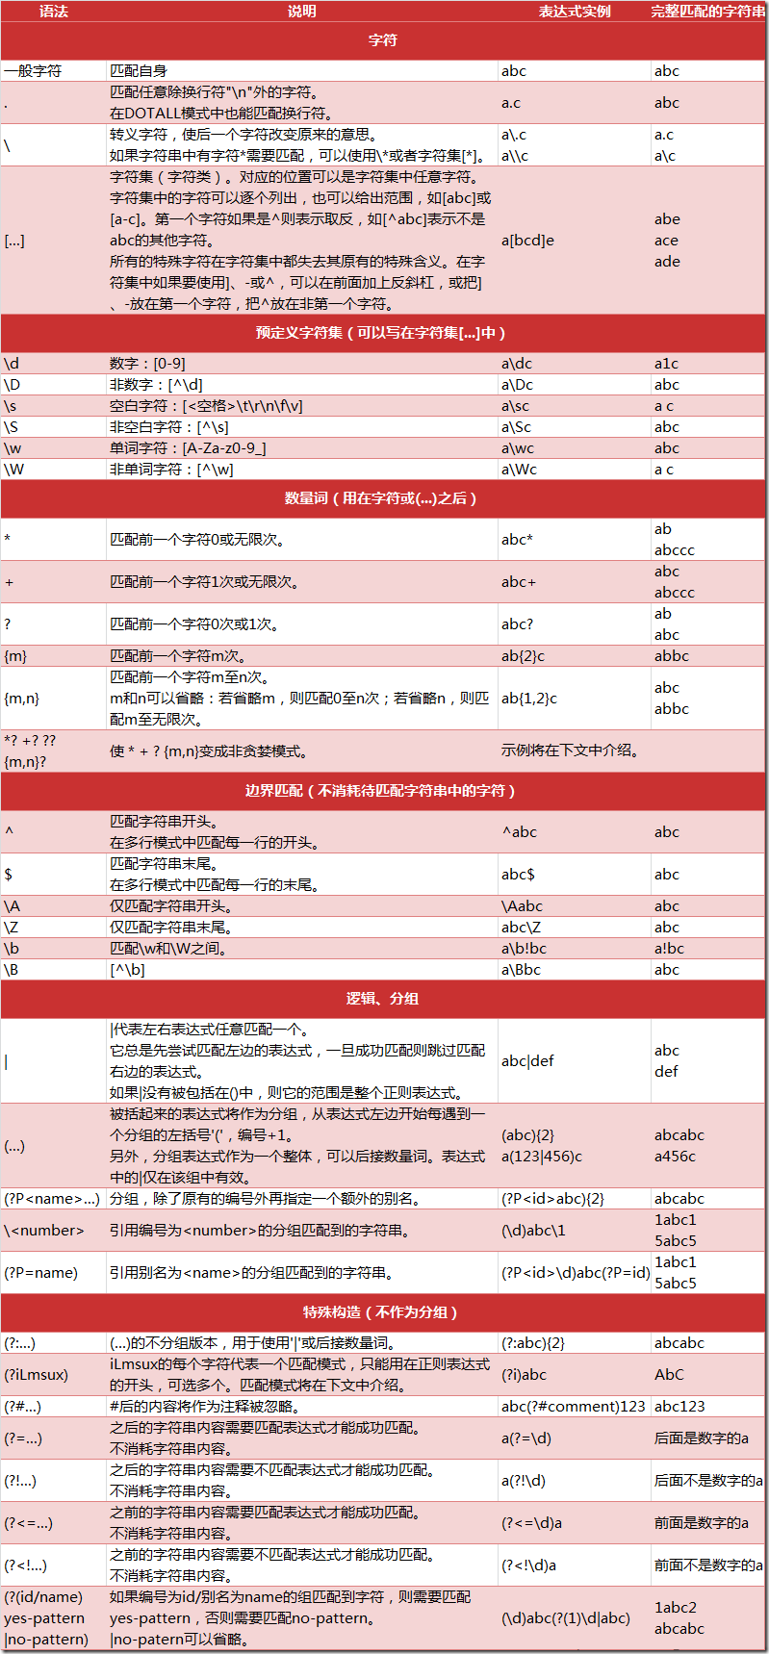

<div class="article block untagged mb15" id="qiushi_tag_118263284">

<div class="author clearfix">

<a href="/users/23331917/" target="_blank" rel="nofollow"> 超链接

<img src="http://pic.qiushibaike.com/system/avtnew/2333/23331917/medium/2016121917193368.JPEG" alt="傻晴°">

</a>

<a href="/users/23331917/" target="_blank" title="傻晴°">

<h2>傻晴°</h2>

</a>

<div class="articleGender womenIcon">24</div>

</div>

<a href="/article/118263284" target="_blank" class="contentHerf">

<div class="content">

<span>笑死在街上了，今早走路去上班，遇一开车的帅比要载我过去，就上车了，下车刚想说谢谢，帅比开口道:你好，十块钱！！！！</span>

</div>

</a>

<div class="stats">

<span class="stats-vote"><i class="number">1646</i> 好笑</span>

<span class="stats-comments">

<span class="dash"> · </span>

<a href="/article/118263284" data-share="/article/118263284" id="c-118263284" class="qiushi_comments" target="_blank">

<i class="number">40</i> 评论

</a>

</span>

</div>

<div id="qiushi_counts_118263284" class="stats-buttons bar clearfix">

<ul class="clearfix">

<li id="vote-up-118263284" class="up">

<a href="javascript:voting(118263284,1)" class="voting" data-article="118263284" id="up-118263284" rel="nofollow">

<i></i>

<span class="number hidden">1668</span>

</a>

</li>

<li id="vote-dn-118263284" class="down">

<a href="javascript:voting(118263284,-1)" class="voting" data-article="118263284" id="dn-118263284" rel="nofollow">

<i></i>

<span class="number hidden">-22</span>

</a>

</li>

<li class="comments">

<a href="/article/118263284" id="c-118263284" class="qiushi_comments" target="_blank">

<i></i>

</a>

</li>

</ul>

</div>

<div class="single-share">

<a class="share-wechat" data-type="wechat" title="分享到微信" rel="nofollow">微信</a>

<a class="share-qq" data-type="qq" title="分享到QQ" rel="nofollow">QQ</a>

<a class="share-qzone" data-type="qzone" title="分享到QQ空间" rel="nofollow">QQ空间</a>

<a class="share-weibo" data-type="weibo" title="分享到微博" rel="nofollow">微博</a>

</div>

<div class="single-clear"></div>

</div>

<div class="author clearfix">(.*?)</div>.*?

<a href=.*?<div class="content"><span>(.*?)</span>.*?</div>.*?</a>

<div class="content">

<span>高中语文老师上课喜欢拖堂。。。。有次语文课正上着，下课铃声响起，照例语文老师打算拖堂:“今天这铃是打早了吧？我怎么觉得这节课这么短？咱们再上一会吧”却听角落幽幽地传来一句话:“老师，要知道快乐的时光总是短暂的！”结果这次老师一高兴，没拖堂就下课了。</span>

</div>