Unit II: Spring Boot Core and Backend Development L - 3 Hours
Spring MVC – Annotation - Spring Core: Inversion of Control and Dependency Injection – Auto wired - BeanFactory- Spring Boot Web Stack (Servlet-based Architecture) - Object-Relational Mapping Related Annotations - Data Access Layer using Spring Data JPA. RESTful API Design and Development - Exception Handling and Validation – Spring Security Implementation.

Introduction
Imagine a restaurant where the kitchen (model) prepares the food, the waitress (controller) takes orders from the customers and delivers the food to them, and the dining area (view) is where the customers eat the food.
In Spring MVC, the model represents the data of the application, the controller handles user requests and updates the model, and the view renders the model data to the user.

Introduction
Spring MVC is a web application framework that follows the Model-View-Controller (MVC) design pattern. The MVC pattern separates the application into three main components: model, view, and controller.

What is Spring MVC?
Spring MVC is a lightweight and flexible framework that provides a wide range of features, including:
- Request handling
- View Resolution
- Data binding and validation
- Exception handling

Why use Spring MVC?
Spring MVC is a popular choice for developing web applications because it offers a number of advantages, including:
- It is easy to use and learn.
- It is scalable and can be used to build small to large-scale web applications.
- It is flexible and can be customized to meet the specific needs of your application.
- It is well-supported and has a large community of users.

Key features of Spring MVC
Some of the key features of Spring MVC include:
- DispatcherServlet: The DispatcherServlet is the central component of Spring MVC. It is responsible for routing incoming requests to the appropriate controllers.
- Controllers: Controllers are responsible for handling user requests and updating the model.
- Views: Views are responsible for rendering the model data to the user.
- Handler mappings: Handler mappings map requests to controllers.
- View resolvers: View resolvers determine the view that should be used to render the model data.
- Locale resolvers: Locale resolvers determine the locale that should be used to render the view. (Locale means a set of parameters that defines the user’s language, which comes from the client side).

Spring MVC architecture
The MVC pattern separates the application into three main components: model, view, and controller.
- Model: The model represents the data of the application. It can be anything from a simple POJO to a complex database entity.
- View: The view is responsible for rendering the model data to the user. It can be a JSP file, a Thymeleaf template, or even a REST API endpoint.
- Controller: The controller is responsible for handling user requests and updating the model. It can perform tasks such as validating input, calling business logic, and redirecting the user to another page.

How does Spring MVC work?
Press enter or click to view image in full size
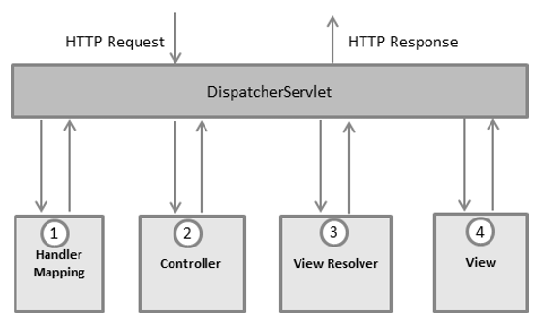

Let’s simplify how Spring MVC works by considering the above image as a reference & below examples;
- The Request-Response Cycle:
- Imagine a web browser sends a request for a specific webpage or resource to a Spring MVC-based web application.
- The web server, such as Apache Tomcat, receives this request.
- Imagine URL: “http://example.com/home"
2. The DispatcherServlet:
- At the heart of Spring MVC is the DispatcherServlet. It acts as the gatekeeper.
- When a request arrives, the DispatcherServlet receives the request for the “/home” URL and takes charge of routing it to the right controller.
3. The URL Mapping:
- URL mapping is like a map that tells the DispatcherServlet which part of your code should handle this request.
- For example, a URL like /home this could be mapped to a controller that shows the home page.
4. The Controller:
- Once the DispatcherServlet knows where to send the request, it sends it to the right controller. Let’s say there’s a controller named “HomeController” for handling the home page.
- The controller is like the traffic police for your web application.
- It receives the request, processes it, and prepares data to show in the response.
5. The Model:
- In Spring MVC, the data that’s going to be shown on the webpage is stored in something called a “Model.”
- Assume in the “HomeController,” a Model is used to store data like the message “Welcome to our website!”. The controller fills this container with the necessary data.
6. The View:
- Now, the DispatcherServlet figures out which “View” should be used to render the Model. Consider the “home.jsp” as the View for the home page.
- The View is the HTML template that holds the structure of the webpage.
- It’s where the data from the Model is inserted to create the final page.
7. The Response:
- Finally, the DispatcherServlet sends the View with the filled-in Model data back to the web server.
- The web server sends this page as a response to the user’s browser.
- Finally, the user’s browser displays the home page with the message “Welcome to our website!”
Spring MVC annotations

Spring Annotations are a very important part of the architecture which help in every way to tell spring at what stages what things to do while they are annotated with specific needs. Some of the important annotations are ;

1. @Controller:
- Annotates a class as a Spring MVC controller.
- Handles HTTP requests, processing, and returning data.
Example: Let’s create a simple controller that maps a URL to a method. When a user accesses “/hello,” it returns a “Hello, World!” message.
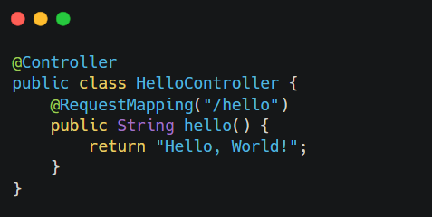
Img controller class
2. @RestController:
- A specialized version of @Controller.
- Automatically serializes response data to JSON or XML.
- Ideal for building RESTful web services.
Example: A REST controller that returns JSON data. When you access “/api/greet,” it returns a JSON response.
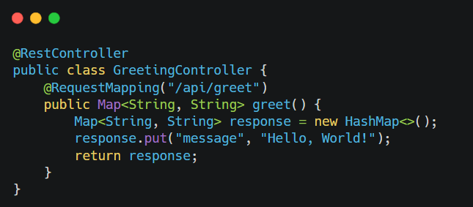
Img REST controller class
3. @RequestMapping:
- Maps a method or class to a specific URL or URL patterns.
- Specifies the HTTP methods (GET, POST, etc.) that the method can handle.
Example: Mapping a method to a specific URL and specifying the HTTP method.
Press enter or click to view image in full size
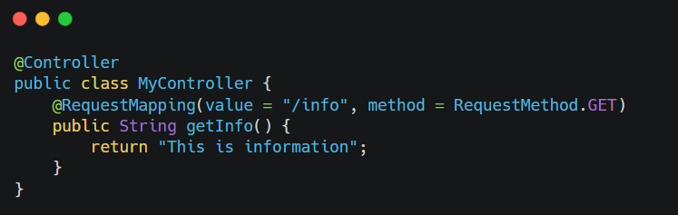
Img Req Mapping
4. @RequestParam:
- Binds a request parameter to a method parameter.
- Allows you to extract data from query parameters or form data.
Example: Extracting a request parameter value and using it in a method.
Press enter or click to view image in full size
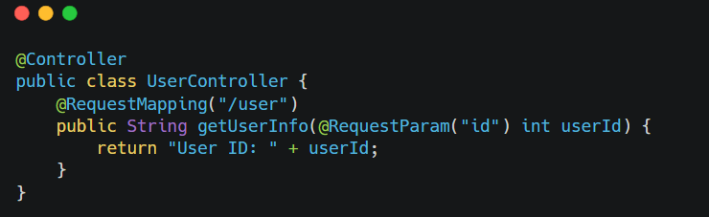
Img Req Param
5. @RequestBody:
- Binds the HTTP request body to a method parameter.
- Useful when dealing with POST or PUT requests with JSON or XML data.
Example: Handling a POST request with JSON data and binding it to a Java object.
Press enter or click to view image in full size
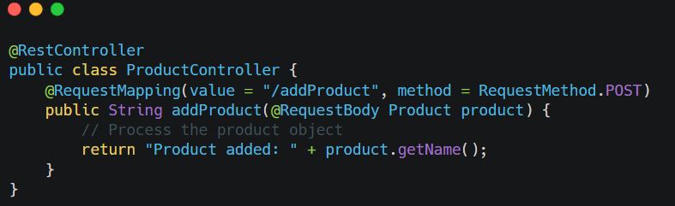
Img Req Body
6. @ResponseBody:
- Indicates that a method’s return value should be used as the HTTP response body.
- Useful for returning data directly to the client as JSON or XML.
Example: Returning data as JSON in a RESTful controller.
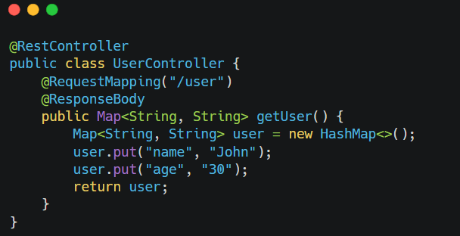
Img Res Body
7. @ResponseStatus:
- Sets the HTTP response status code and reason.
- Defines the response status when a controller method is successfully executed.
- Example: Setting a custom HTTP status code and reason in a controller method.
Press enter or click to view image in full size
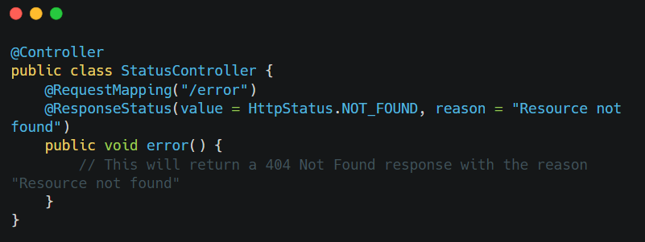
Img Res Status
These annotations are essential tools in Spring MVC for defining and controlling the behavior of web application’s controllers, request handling, and response generation.

Simple maven project to illustrate spring core annotations

Core Annotations like:
- @Component
- @Autowired
- @Configuration
- @ComponentScan
No web, no Tomcat — just a console application.

🎯 Goal
Output:
Engine Started
Car is running
Using Spring annotations (no XML).

🟢 STEP 1 – Create Simple Maven Project
In Eclipse:
File → New → Maven Project
✔ Tick: Create simple project (skip archetype selection)
Click Next
Fill:
Field | Value
Group Id | com.example
Artifact Id | spring-core-demo
Packaging | jar
Version | 1.0
Finish.

🟢 STEP 2 – Add Spring Dependency (pom.xml)
Replace your pom.xml with:
<project xmlns="http://maven.apache.org/POM/4.0.0"
xmlns:xsi="http://www.w3.org/2001/XMLSchema-instance"
xsi:schemaLocation="http://maven.apache.org/POM/4.0.0
http://maven.apache.org/xsd/maven-4.0.0.xsd">

<modelVersion>4.0.0</modelVersion>

<groupId>com.example</groupId>
<artifactId>spring-core-demo</artifactId>
<version>1.0</version>

<dependencies>

<!-- Spring Context (contains core annotations support) -->
<dependency>
<groupId>org.springframework</groupId>
<artifactId>spring-context</artifactId>
<version>5.3.30</version>
</dependency>

</dependencies>

</project>
Right click → Maven → Update Project

🟢 STEP 3 – Project Structure
src/main/java
Create package:
com.example

🟢 STEP 4 – Create Engine Class
package com.example;

import org.springframework.stereotype.Component;

@Component
public class Engine {

public void start() {
System.out.println("Engine Started");
}
}

🟢 STEP 5 – Create Car Class (Using @Autowired)
package com.example;

import org.springframework.beans.factory.annotation.Autowired;
import org.springframework.stereotype.Component;

@Component
public class Car {

@Autowired
private Engine engine;

public void drive() {
engine.start();
System.out.println("Car is running");
}
}

🟢 STEP 6 – Create Configuration Class
package com.example;

import org.springframework.context.annotation.ComponentScan;
import org.springframework.context.annotation.Configuration;
@Configuration
@ComponentScan(basePackages = "com.example")
public class AppConfig {
}

🟢 STEP 7 – Main Class
package com.example;

import org.springframework.context.ApplicationContext;
import org.springframework.context.annotation.AnnotationConfigApplicationContext;

public class App {
public static void main(String[] args) {
ApplicationContext context =
new AnnotationConfigApplicationContext(AppConfig.class);

Car car = context.getBean(Car.class);
car.drive();
}
}

▶ Run
Right click → Run As → Java Application

🎉 Output
Engine Started
Car is running

🧠 What This Demonstrates
Annotation | Purpose
@Component | Creates Spring Bean
@Autowired | Injects dependency
@Configuration | Configuration class
@ComponentScan | Scans package for beans

⭐ Viva Answer
Spring Core annotations allow us to define and inject beans without XML configuration using annotations like @Component and @Autowired.
Task 8: Create a simple Employee Management module using Spring Core. Demonstrate Inversion of Control and Dependency Injection using annotations such as @Component and @Autowired. Use BeanFactory to manage beans and store employee data in memory

Below is a simple Spring Core (console) Employee Management module that demonstrates:
- IoC (Inversion of Control): Spring creates/manages objects (beans)
- DI (Dependency Injection): EmployeeService gets EmployeeRepository injected using @Autowired
- Uses annotations: @Component, @Autowired, @Configuration, @ComponentScan
- Uses BeanFactory explicitly (not “Run on Server”, no Tomcat)
- Stores employee data in-memory (HashMap)

1) Maven pom.xml
<project xmlns="http://maven.apache.org/POM/4.0.0"
xmlns:xsi="http://www.w3.org/2001/XMLSchema-instance"
xsi:schemaLocation="http://maven.apache.org/POM/4.0.0
https://maven.apache.org/xsd/maven-4.0.0.xsd">
<modelVersion>4.0.0</modelVersion>
<groupId>com.example</groupId>
<artifactId>spring-employee-core</artifactId>
<version>1.0</version>

<properties>
<maven.compiler.source>17</maven.compiler.source>
<maven.compiler.target>17</maven.compiler.target>
</properties>

<dependencies>
<!-- Spring Core + IoC container -->
<dependency>
<groupId>org.springframework</groupId>
<artifactId>spring-context</artifactId>
<version>5.3.30</version>
</dependency>
</dependencies>
</project>
2) Package structure
Create package: com.example.emp
com.example.emp
├─ AppConfig.java
├─ MainApp.java
├─ Employee.java
├─ EmployeeRepository.java
└─ EmployeeService.java

3) Employee.java (Model)

package edu.Task_8;

public class Employee {
private int id;
private String name;
private String department;

public Employee() { }

public Employee(int id, String name, String department) {
this.id = id;
this.name = name;
this.department = department;
}

public int getId() { return id; }
public void setId(int id) { this.id = id; }

public String getName() { return name; }
public void setName(String name) { this.name = name; }

public String getDepartment() { return department; }
public void setDepartment(String department) { this.department = department; }

@Override
public String toString() {
return "Employee{id=" + id + ", name='" + name + "', dept='" + department + "'}";
}
}

4) EmployeeRepository.java (In-memory storage) — @Component

package edu.Task_8;

import java.util.*;
import org.springframework.stereotype.Component;

@Component
public class EmployeeRepository {
private final Map<Integer, Employee> store = new HashMap<>();

public void save(Employee e) {
store.put(e.getId(), e);
}

public Employee findById(int id) {
return store.get(id);
}

public List<Employee> findAll() {
return new ArrayList<>(store.values());
}

public boolean deleteById(int id) {
return store.remove(id) != null;
}
}

5) EmployeeService.java (Business layer) — @Component + @Autowired DI

package edu.Task_8;

import org.springframework.beans.factory.annotation.Autowired;
import org.springframework.stereotype.Component;

import java.util.List;

@Component
public class EmployeeService {

private final EmployeeRepository repo; // Dependency

// ✅ Constructor Injection (preferred)
@Autowired
public EmployeeService(EmployeeRepository repo) {
this.repo = repo;
}

public void addEmployee(int id, String name, String dept) {
repo.save(new Employee(id, name, dept));
}

public Employee getEmployee(int id) {
return repo.findById(id);
}

public List<Employee> getAllEmployees() {
return repo.findAll();
}

public boolean removeEmployee(int id) {
return repo.deleteById(id);
}
}

6) AppConfig.java — enables component scanning

package edu.Task_8;

import org.springframework.context.annotation.ComponentScan;
import org.springframework.context.annotation.Configuration;

@Configuration
@ComponentScan(basePackages = "edu.Task_8")
public class AppConfig { }

7) MainApp.java — Use BeanFactory to manage beans

package edu.Task_8;

import org.springframework.context.ApplicationContext;
import org.springframework.context.annotation.AnnotationConfigApplicationContext;

public class App
{
public static void main( String[] args )
{
ApplicationContext context = new AnnotationConfigApplicationContext(AppConfig.class);

// ✅ Get service bean (DI happens automatically)
EmployeeService service = context.getBean(EmployeeService.class);

// --- Demo operations ---
service.addEmployee(101, "Anand", "CSE");
service.addEmployee(102, "Divya", "ECE");
service.addEmployee(103, "Ravi", "IT");

System.out.println("All Employees:");
service.getAllEmployees().forEach(System.out::println);

System.out.println("\nFind Employee 102:");
System.out.println(service.getEmployee(102));

System.out.println("\nDelete Employee 101:");
System.out.println("Deleted? " + service.removeEmployee(101));

System.out.println("\nAll Employees After Delete:");
service.getAllEmployees().forEach(System.out::println);
}
}

Expected Output (sample)
All Employees:
Employee{id=101, name='Anand', dept='CSE'}
Employee{id=102, name='Divya', dept='ECE'}
Employee{id=103, name='Ravi', dept='IT'}

Find Employee 102:
Employee{id=102, name='Divya', dept='ECE'}

Delete Employee 101:
Deleted? true

All Employees After Delete:
Employee{id=102, name='Divya', dept='ECE'}
Employee{id=103, name='Ravi', dept='IT'}

Task 9: Develop a basic Spring MVC application using annotation-based configuration. Create a controller to accept user requests and display employee details using the MVC flow without XML configuration.

Below is a basic Spring MVC application using annotation-based configuration only (✅ no web.xml, ✅ no Spring XML). It accepts a user request and displays employee details through the MVC flow.
This uses Spring Boot + Spring MVC + Thymeleaf so you can run it as a normal Java app (no external Tomcat setup).

Package structure
Edu.Task_9
├─ Task9Application.java
├─ Employee.java
├─ EmployeeRepository.java
└─ EmployeeController.java
resources/templates
├─ home.html
└─ employee.html
Pom.xml

<?xml version="1.0" encoding="UTF-8"?>
<project xmlns="http://maven.apache.org/POM/4.0.0" xmlns:xsi="http://www.w3.org/2001/XMLSchema-instance"
xsi:schemaLocation="http://maven.apache.org/POM/4.0.0 http://maven.apache.org/xsd/maven-4.0.0.xsd">
<modelVersion>4.0.0</modelVersion>
<parent>
<groupId>org.springframework.boot</groupId>
<artifactId>spring-boot-starter-parent</artifactId>
<version>4.0.2</version>
<relativePath/> <!-- lookup parent from repository -->
</parent>
<groupId>com.example</groupId>
<artifactId>Task_9</artifactId>
<version>0.0.1-SNAPSHOT</version>
<name>Task_9</name>
<description>Demo project for Spring Boot</description>
<url/>
<licenses>
<license/>
</licenses>
<developers>
<developer/>
</developers>
<scm>
<connection/>
<developerConnection/>
<tag/>
<url/>
</scm>
<properties>
<java.version>21</java.version>
</properties>
<dependencies>
<dependency>
<groupId>org.springframework.boot</groupId>
<artifactId>spring-boot-starter-thymeleaf</artifactId>
</dependency>
<dependency>
<groupId>org.springframework.boot</groupId>
<artifactId>spring-boot-starter-webmvc</artifactId>
</dependency>

<dependency>
<groupId>org.springframework.boot</groupId>
<artifactId>spring-boot-starter-thymeleaf-test</artifactId>
<scope>test</scope>
</dependency>
<dependency>
<groupId>org.springframework.boot</groupId>
<artifactId>spring-boot-starter-webmvc-test</artifactId>
<scope>test</scope>
</dependency>
</dependencies>

<build>
<plugins>
<plugin>
<groupId>org.springframework.boot</groupId>
<artifactId>spring-boot-maven-plugin</artifactId>
</plugin>
</plugins>
</build>

</project>

Employee.java

package edu.Task_9;

public class Employee {
private int id;
private String name;
private String dept;

public Employee() {}
public Employee(int id, String name, String dept) {
this.id = id;
this.name = name;
this.dept = dept;
}

public int getId() { return id; }
public void setId(int id) { this.id = id; }

public String getName() { return name; }
public void setName(String name) { this.name = name; }

public String getDept() { return dept; }
public void setDept(String dept) { this.dept = dept; }
}

EmployeeController.java

package edu.Task_9;

import org.springframework.beans.factory.annotation.Autowired;
import org.springframework.stereotype.Controller;
import org.springframework.ui.Model;
import org.springframework.web.bind.annotation.*;

@Controller
public class EmployeeController {

@Autowired
private EmployeeRepository repo;

// Home page to enter employee id
@GetMapping("/")
public String home() {
return "home";
}

// MVC flow: request -> controller -> model -> view
@GetMapping("/employee")
public String getEmployee(@RequestParam("id") int id, Model model) {
Employee emp = repo.findById(id);

if (emp == null) {
model.addAttribute("error", "Employee not found for ID: " + id);
return "employee";
}

model.addAttribute("emp", emp);
return "employee";
}
}
EmployeeRepository.java

package edu.Task_9;

import org.springframework.stereotype.Component;

import java.util.Map;

@Component
public class EmployeeRepository {

// In-memory employee data
private final Map<Integer, Employee> store = Map.of(
101, new Employee(101, "Anand", "CSE"),
102, new Employee(102, "Divya", "ECE"),
103, new Employee(103, "Ravi", "IT")
);

public Employee findById(int id) {
return store.get(id);
}
}

Task9Application.java

package edu.Task_9;

import org.springframework.boot.SpringApplication;
import org.springframework.boot.autoconfigure.SpringBootApplication;

@SpringBootApplication
public class Task9Application {

public static void main(String[] args) {
SpringApplication.run(Task9Application.class, args);
}

}

home.html

<!DOCTYPE html>
<html>
<head><title>Employee Search</title></head>
<body>
<h2>Employee Management (Spring MVC)</h2>

<form action="/employee" method="get">
Enter Employee ID:
<input type="number" name="id" required />
<button type="submit">Search</button>
</form>

<p>Try IDs: 101, 102, 103</p>
</body>
</html>

employee.html

<!DOCTYPE html>
<html xmlns:th="http://www.thymeleaf.org">
<head><title>Employee Details</title></head>
<body>

<h2>Employee Details</h2>

<p th:if="${error != null}" th:text="${error}" style="color:red;"></p>

<div th:if="${emp != null}">
<p><b>ID:</b> <span th:text="${emp.id}"></span></p>
<p><b>Name:</b> <span th:text="${emp.name}"></span></p>
<p><b>Department:</b> <span th:text="${emp.dept}"></span></p>
</div>

<a href="/">Back</a>

</body>
</html>

Execution Steps:

✅ Step 1) Run the application
- Open the main class (the one with @SpringBootApplication)
Example: Task9Application.java
- Right-click → Run As → Java Application
(or “Spring Boot App” if that option exists)
✅ In Console you must see something like:
- Tomcat started on port 8080

✅Step 2) Open in browser
Home page
- http://localhost:8080/

✅ Correct folder check (views must be here)
Make sure HTML files are exactly in:
- src/main/resources/templates/home.html
- src/main/resources/templates/employee.html

✅ Step 3) Stop the server
In Eclipse Console:
- Click the red stop button ⏹

If port 8080 is busy
Create / edit:
src/main/resources/application.properties
Add:
server.port=8081
Then open:
- http://localhost:8081/

Output:
In Eclipse Console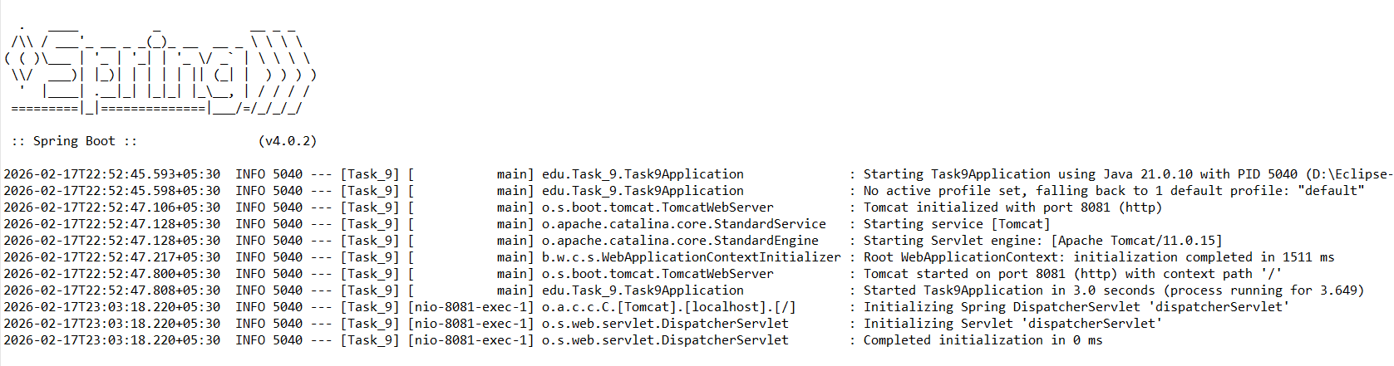
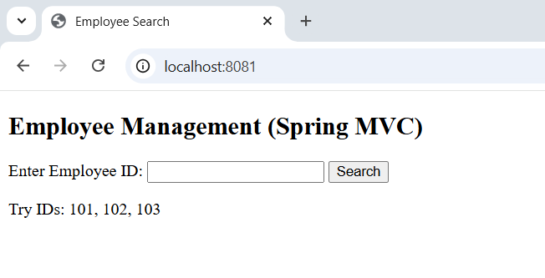

After entering the ID 101:

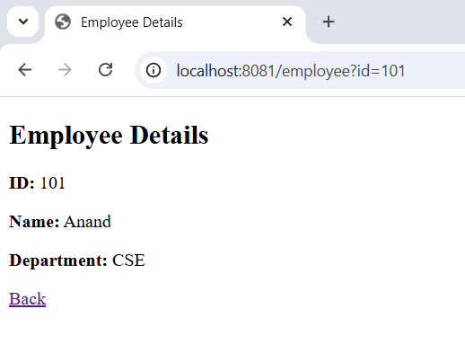

After entering the ID 105:

