🌿 EcoNext Sustainable E-Commerce Platform
EcoNext — Order Management, Fulfillment & Physical Shipment Operations Guide
End-to-End Operational Manual: Customer Order Placement → Order Confirmation → Warehouse Picking & Packing → Physical Shipment Provisioning → Carrier Dispatch & Linehaul → Live GPS Telemetry Checkpoints → Out for Delivery → Cryptographic Delivery OTP / Email Dispatch → Verified Customer Handover
Target Audience: Fulfillment Hub Operators, Warehouse Staff, Logistics Drivers, Admin Team | Document Version: 2.4.0 (Production Release)
Core Services: Order Operations (Port 8083), Django Backend, Spring API Gateway (Port 8080) | Event Architecture: Kafka Bus + Redis Cache + STOMP Live WebSocket
Security & Verification: 6-Digit Redis Delivery OTP, JWT RBAC, Full Audit Trail | Date of Publication: September 2026

1. Executive Summary & Architecture Overview
The EcoNext Operations & Fulfillment System provides an enterprise-grade, real-time workflow for handling orders after a customer completes checkout. Built on a resilient microservices architecture, the system combines strict transactional database consistency (MySQL) with sub-second event streaming (Apache Kafka) and push-based real-time telemetry (STOMP WebSockets) to synchronize warehouse staff, logistics linehaul drivers, admin managers, and end customers.
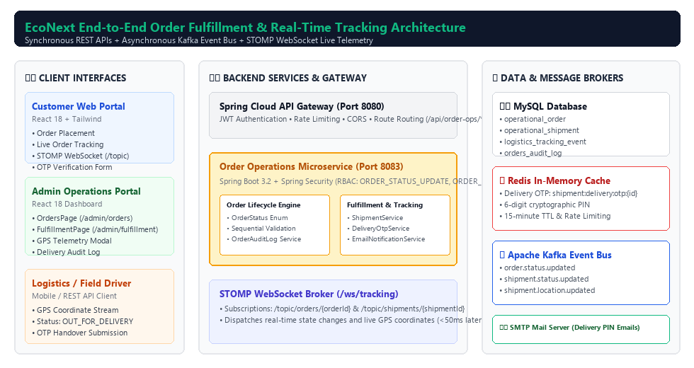
Figure 1.1: High-Level Architecture & Asynchronous Event Streaming Data Pipeline
Key Architectural Pillars:
- • Dual-Entity Separation: Decouples commercial purchase semantics (OperationalOrder) from physical transit semantics (OperationalShipment). An order can have dedicated shipments and containers.
- • Deterministic State Machines: Sequential, forward-only status graphs in both backend controllers and frontend portals prevent invalid workflow skips.
- • Cryptographic Delivery Handover: Zero-trust package delivery verified via 6-digit numeric OTP generated in Redis (15-min TTL) and dispatched through SMTP HTML email.
- • Sub-Second Telemetry Broadcast: Live vehicle GPS coordinates published via Kafka topic shipment.location.updated and broadcast to STOMP destination /topic/shipments/{id}.
- • Full Audit Compliance: Every single status change, note, and GPS ping records staff ID, username, and timestamp in MySQL orders_audit_log.
2. End-to-End Operational Lifecycle & State Machines
The EcoNext platform orchestrates order fulfillment through two synchronized state machines: the Order Lifecycle and the Physical Shipment Lifecycle. Below is the exact transition matrix and operational criteria required for each stage.
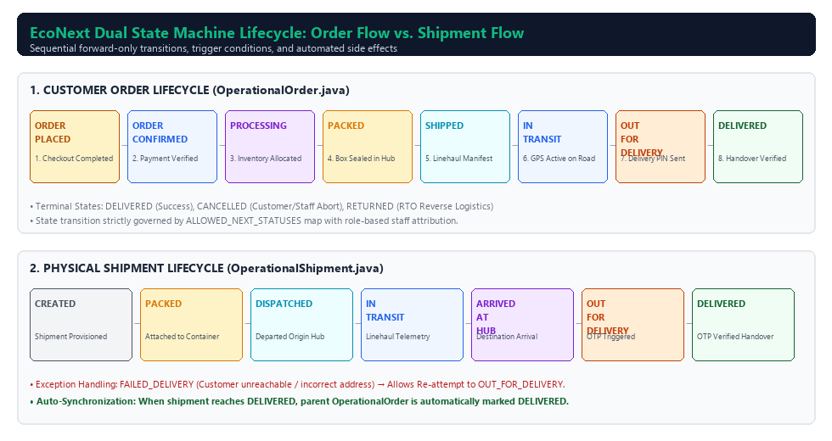
Figure 2.1: Dual State Machine Lifecycle — Order Status vs. Physical Shipment Status
Stage # | Order Status | Shipment Status | Triggering Event / Action | System Side Effects
1 | ORDER_PLACED | None | Customer checks out via web portal; initial record saved. | Stock reserved; confirmation notification triggered.
2 | ORDER_CONFIRMED | None | Staff verifies payment in OrdersPage.jsx and clicks 'Confirm Order'. | Emits Kafka order.status.updated; moved to warehouse queue.
3 | PROCESSING | None | Warehouse operator begins picking inventory items from shelves. | Pick-list generated; barcode validation active.
4 | PACKED | CREATED | All SKUs verified in box; Staff creates physical shipment in FulfillmentPage.jsx. | Shipment number #SHP-xxxxx allocated; weight recorded.
5 | SHIPPED | DISPATCHED | Package loaded onto linehaul carrier vehicle and departs hub. | Carrier manifest closed; tracking link activated.
6 | IN_TRANSIT | IN_TRANSIT / ARRIVED_AT_HUB | Carrier in linehaul transit; GPS telemetry checkpoints submitted. | Live STOMP coordinates pushed to customer map.
7 | OUT_FOR_DELIVERY | OUT_FOR_DELIVERY | Shipment assigned to local delivery driver; operator clicks 'Send Out for Delivery'. | DeliveryOtpService generates 6-digit PIN in Redis; sends HTML email.
8 | DELIVERED | DELIVERED | Driver/Customer submits valid 6-digit PIN at door. | Redis key cleared; order marked completed; audit log sealed.

3. Role-Based Access Control & Staff Permissions
To ensure compliance, separation of duties, and security, the Order Operations Microservice enforces strict Spring Security method-level authorization (@PreAuthorize).
Staff Role | Spring Security Authority | Allowed Portal Functions & Endpoints | Access Restrictions
System Admin | ROLE_ADMIN | Full access to all order status transitions, shipment creation, container management, and manual OTP overrides. | None (Superuser privilege).
Order Manager | ORDER_STATUS_UPDATE, ORDER_READ | Confirm orders, update order status (PATCH /api/order-ops/orders/{id}/status), view customer orders and audit logs. | Cannot delete shipments or alter system configurations.
Warehouse Staff | ORDER_PROCESS, ORDER_READ | Scan inventory items, transition orders to PACKED, create physical shipments (POST /api/order-ops/shipments). | Cannot cancel orders or issue financial refunds.
Logistics Driver | ORDER_STATUS_UPDATE | Update GPS coordinates (PATCH /shipments/{id}/location), set OUT_FOR_DELIVERY, submit delivery OTP. | Cannot modify order items, pricing, or customer profiles.

4. Step-by-Step Operator Manual & Web Interfaces
This section details the precise clicks, screen workflows, inputs, and system behaviors for each stage of order fulfillment. Each step features high-resolution web page mockups with red highlighted mouse pointer cursors (👆 / ↖) and numbered action badges.
Step 1: Customer Order Placement & Checkout (ORDER_PLACED)
Workflow Description: The customer selects sustainable products on the EcoNext store, proceeds to checkout, and completes payment. Upon successful payment authorization, the system assigns a unique reference number (e.g., ORD-10042) and sets the initial state to ORDER_PLACED.
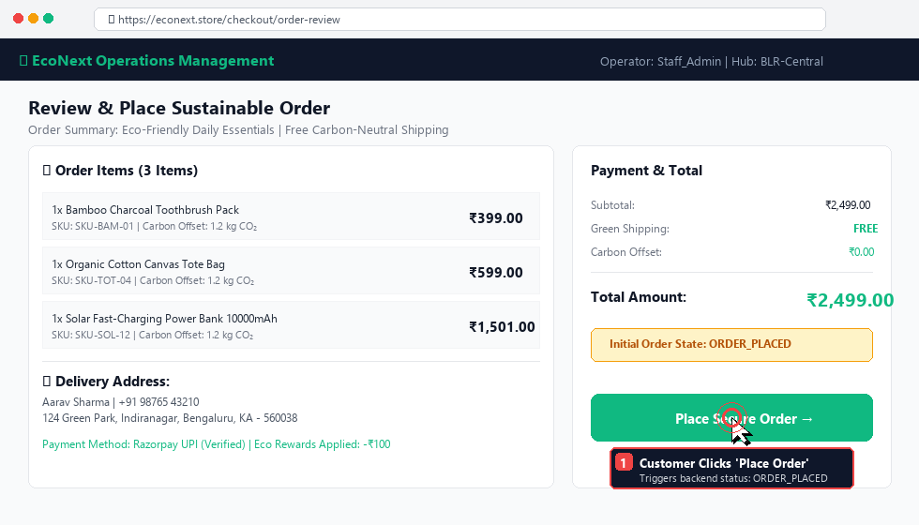
Screenshot 1: Customer Checkout Screen — Mouse Pointer clicking 'Place Secure Order' to initiate ORDER_PLACED state
- 1. Check that the order reference number (ORD-10042) is generated and total matches cart line items.
- 2. Verify that customer shipping address and phone number are complete.
- 3. Confirm that payment status is verified via Razorpay webhook or card gateway.
Step 2: Admin Order Confirmation in OrdersPage (/admin/orders)
Workflow Description: Order management staff log in to the EcoNext Admin Portal and navigate to Orders (/admin/orders). The operator reviews the incoming orders queue, inspects order items, and clicks the blue 'Confirm Order' action button. This executes PATCH /api/order-ops/orders/{id}/status with status: ORDER_CONFIRMED.
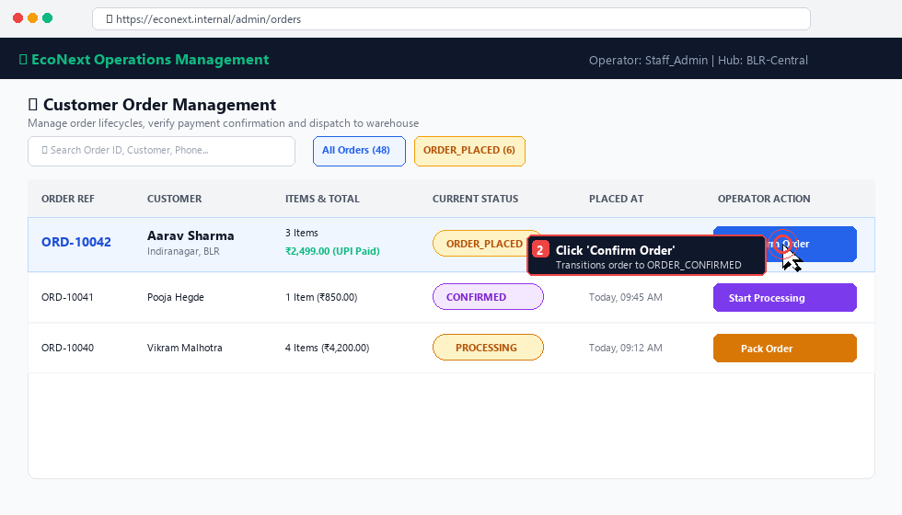
Screenshot 2: Admin Orders Management Portal — Mouse Pointer clicking blue 'Confirm Order' button
💡 STATE MACHINE AUTOMATION
When 'Confirm Order' is clicked, the system records the logged-in staff username (e.g., Staff_Admin) in the audit log and fires a Kafka message on order.status.updated. The next allowed action button automatically updates to purple 'Start Processing'.

Step 3: Warehouse Picking, Packing & Packaging Verification
Workflow Description: Warehouse packing personnel open the order detail page. The operator transitions the order to PROCESSING to generate the physical pick-list. After scanning all product SKUs (e.g., Bamboo Toothbrush, Canvas Bag, Solar Charger) and sealing them in an eco-friendly cardboard box (BOX-ECO-992), the operator clicks the orange 'Pack Order' button to transition status to PACKED.
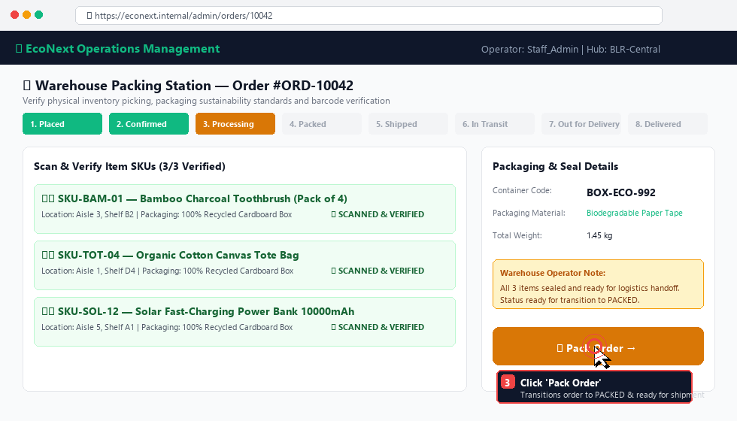
Screenshot 3: Warehouse Packing Station — Mouse Pointer clicking orange 'Pack Order' button
- • Packaging Standard: Use 100% post-consumer recycled corrugated boxes with water-activated paper tape.
- • Labeling: Affix barcode shipping label containing order reference and destination hub code.
- • Weight Check: Verify total packed package weight (e.g., 1.45 kg) matches estimated manifest weight within ±5%.
Step 4: Fulfillment Hub — Physical Shipment Provisioning
Workflow Description: Once an order reaches PACKED, it appears in the 'Orders Awaiting Fulfillment' queue on the Fulfillment page (/admin/fulfillment). The fulfillment manager opens the 'Provision Physical Shipment' modal dialog, selects the carrier (e.g., EcoExpress Carbon-Neutral), assigns the vehicle number (KA-01-EQ-9124), designates origin/destination hubs, and clicks 'Create Physical Shipment'.
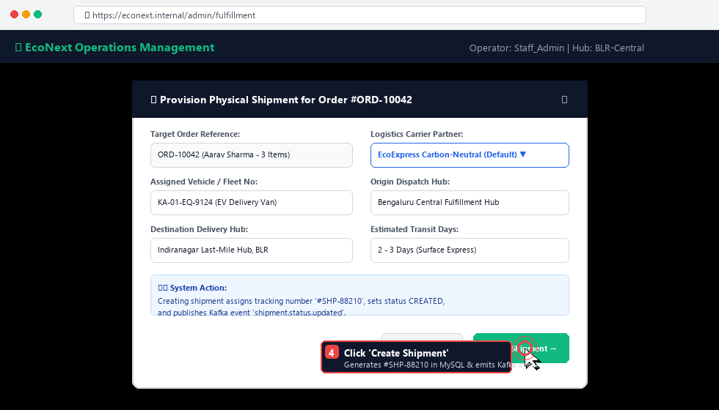
Screenshot 4: Fulfillment Hub Provisioning Modal — Mouse Pointer clicking 'Create Shipment' button
📦 PHYSICAL SHIPMENT PROVISIONING API
Creating a physical shipment calls POST /api/order-ops/shipments, which assigns a tracking number (#SHP-88210), creates a record in operational_shipment table with status CREATED, and links all order items.

Step 5: Shipment Dispatch & Real-Time GPS Telemetry Updates
Workflow Description: As the carrier vehicle departs the fulfillment hub, the shipment transitions from DISPATCHED to IN_TRANSIT. During highway transit or linehaul stops, logistics operators or automated GPS transponders send live milestone coordinates (latitude, longitude, checkpoint name) via the GPS Telemetry Modal or the API (PATCH /api/order-ops/fulfillment/shipments/{id}/location).
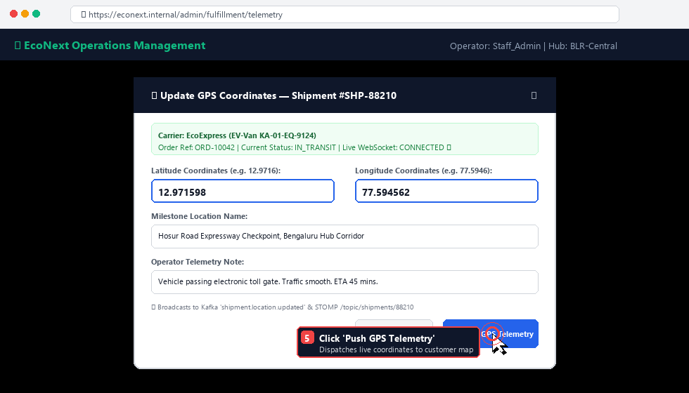
Screenshot 5: Real-Time GPS Telemetry Modal — Mouse Pointer clicking blue 'Push GPS Telemetry' button
- 1. Operator enters latitude: 12.971598 and longitude: 77.594562 with checkpoint note.
- 2. Spring Boot persists record into logistics_tracking_event table.
- 3. Event published to Kafka topic shipment.location.updated.
- 4. WebSocket STOMP broadcaster pushes payload to subscribed clients at /topic/shipments/{id} and /topic/orders/{orderId} with zero delay (<50ms).
Step 6: 'Out for Delivery' Transition & Automated Delivery OTP Email
Workflow Description: When the vehicle reaches the destination last-mile hub, the shipment is handed to the local courier driver (e.g., Ramesh Kumar, DRV-901). The operator transitions the shipment status to OUT_FOR_DELIVERY. This triggers the DeliveryOtpService, which automatically generates a secure 6-digit PIN in Redis and dispatches an HTML email notification to the customer.
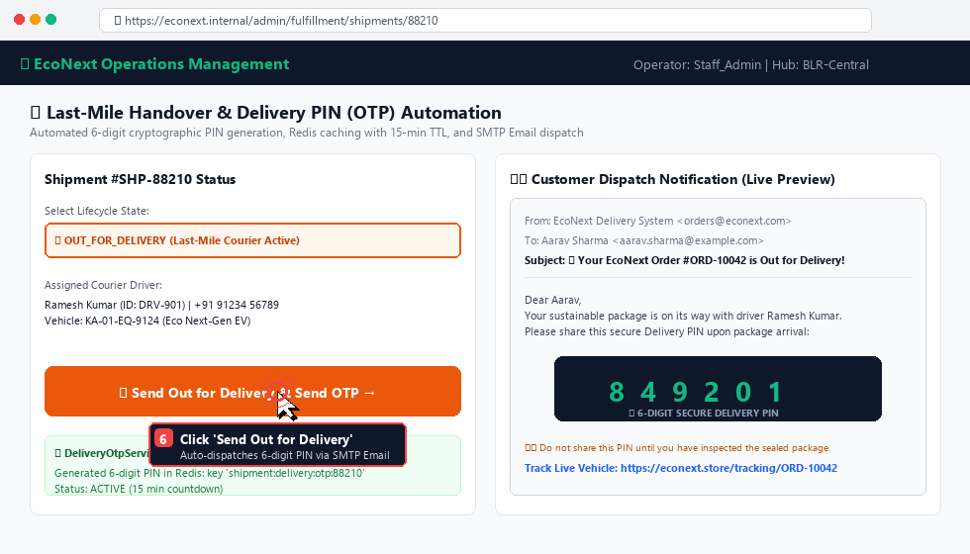
Screenshot 6: Out for Delivery & Delivery OTP Notification — Mouse Pointer clicking 'Send Out for Delivery'
🔐 SECURITY SPECIFICATION: DELIVERY OTP / PIN
• Storage: Redis key shipment:delivery:otp:{shipmentId}
• Value: 6-digit cryptographic numeric PIN (e.g., 849201)
• Expiration: 15 minutes (900 seconds) Time-To-Live (TTL)
• Rate Limiting: Maximum 5 verification attempts before lockout

Step 7: Customer Live Tracking Portal & Google Maps Navigation
Workflow Description: The customer accesses their live tracking dashboard at https://econext.store/tracking/ORD-10042. The React customer frontend establishes a live STOMP connection to /ws/tracking, displaying the real-time vehicle location, carrier info, and a direct clickable button '🗺️ Open in Google Maps' (https://www.google.com/maps?q=12.971598,77.594562).
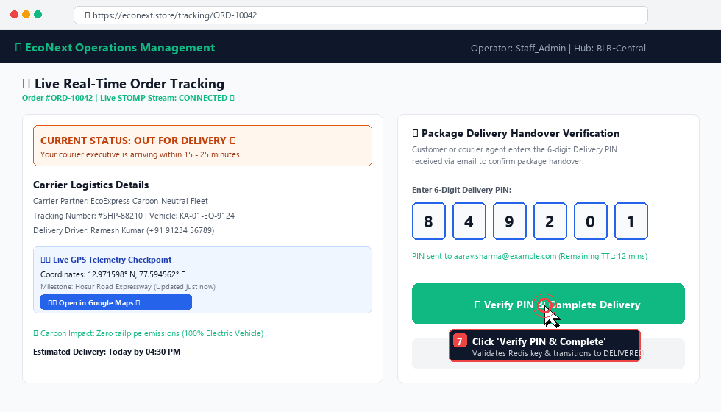
Screenshot 7: Customer Live Tracking Screen — Mouse Pointer entering Delivery PIN and clicking 'Verify PIN & Complete Delivery'
- • Live Status: Real-time progress bar reflecting current status (OUT_FOR_DELIVERY).
- • Carrier Info: Driver name, phone number, vehicle registration number, and carbon offset rating.
- • GPS Maps: Direct external link to Google Maps with exact vehicle GPS coordinates.
- • Verification: Secure 6-digit PIN input box for package handover verification.
Step 8: Secure Handover Verification & Audit Trail Completion
Workflow Description: When the delivery agent arrives at the customer address with the package:
1. The customer shares the 6-digit PIN (849201).
2. The driver or customer enters the PIN and submits verification (POST /api/order-ops/fulfillment/shipments/{id}/verify-delivery-otp).
3. Backend verifies the PIN against Redis, transitions shipment to DELIVERED, automatically transitions order to DELIVERED, and writes an immutable audit record.
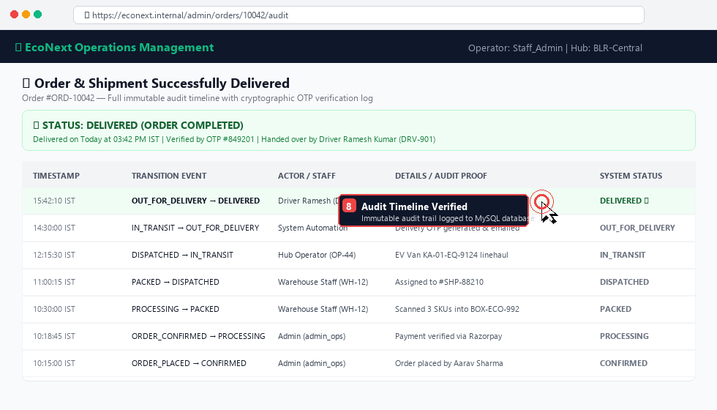
Screenshot 8: Order Completed & Audit Log — Mouse Pointer displaying completed audit trail and verified delivery token
5. Exception Handling, Retries & Failed Deliveries
During physical logistics operations, anomalies such as customer unavailability, incorrect delivery pins, or vehicle breakdowns may occur. Below are standard operating procedures (SOP) for handling edge cases:
Scenario / Exception | Root Cause / Symptom | Standard Operating Procedure (SOP) | System State Transition
Customer Unavailable at Delivery | Customer unreachable by phone or not present at address. | Driver clicks 'Report Delivery Exception'. Staff enters reason note. Package returned to local hub for re-attempt next business day. | OUT_FOR_DELIVERY → FAILED_DELIVERY
Expired or Missing Delivery PIN | Customer did not receive email or 15-minute Redis TTL expired. | Operator or driver clicks 'Resend Delivery PIN to Email' in portal or triggers POST /shipments/{id}/delivery-otp/send. New PIN generated. | Refreshes Redis TTL to 15 mins; sends new email.
Invalid PIN / Rate Limiting Lockout | 5 consecutive incorrect PIN entries submitted. | Redis key temporarily locked. Hub manager must verify customer government ID / order invoice and perform admin authorization override. | Logged to audit log with Admin staff attribution.
Vehicle Breakdown / Route Diversion | Linehaul EV van encounters mechanical failure or road closure. | Operator submits new GPS coordinates with note 'Route diverted via Highway 44'. Customer tracking UI reflects updated ETA automatically. | Status remains IN_TRANSIT; new location logged.
6. Complete Operational API Reference
All operational endpoints are hosted by the Order Operations Microservice (Port 8083) and routed via the Spring Cloud API Gateway (Port 8080).
HTTP Method & Route | Required Role / Scope | Request Payload / Parameters | Description & Response
GET /api/order-ops/orders | ORDER_READ | status, search, page, size | Search and filter customer orders with pagination.
PATCH /api/order-ops/orders/{id}/status | ORDER_STATUS_UPDATE | {"nextStatus": "PROCESSING", "note": "..."} | Transition order status with staff attribution in audit log.
POST /api/order-ops/shipments | ORDER_PROCESS | {"targetOrderId": 10042, "carrierName": "...", "vehicleNumber": "..."} | Provision physical shipment and allocate order items.
PATCH /api/order-ops/shipments/{id}/status | ORDER_STATUS_UPDATE | ?status=OUT_FOR_DELIVERY | Transition shipment status; auto-triggers OTP if OUT_FOR_DELIVERY.
PATCH /api/order-ops/shipments/{id}/location | ORDER_STATUS_UPDATE | {"latitude": 12.9716, "longitude": 77.5946, "locationName": "..."} | Post GPS telemetry milestone; broadcasts over Kafka & STOMP.
POST /api/order-ops/shipments/{id}/delivery-otp/send | Public / Staff | None (Path variable shipment ID) | Generate 6-digit PIN in Redis and send HTML email to customer.
POST /api/order-ops/shipments/{id}/delivery-otp/verify | Public / Staff | {"otp": "849201"} or query ?otp=849201 | Verify PIN, mark shipment DELIVERED, synchronize order.
GET /api/order-ops/orders/{id}/timeline | ORDER_READ | Path variable order ID | Retrieve immutable audit trail of all historical transitions.
7. Messaging & Live STOMP WebSocket Channels
EcoNext uses Apache Kafka for asynchronous inter-service messaging and STOMP WebSockets for real-time frontend push notifications.
Channel / Topic | Type & Protocol | Publisher | Subscribers / Consumers | Payload Content
order.status.updated | Kafka Event | Order Operations Microservice | Catalog, Notification Service, Django | orderId, fromStatus, toStatus, staffId, timestamp
shipment.status.updated | Kafka Event | Order Operations Microservice | WebSocket Gateway, Analytics Engine | shipmentId, orderId, status, carrier, trackingNo
shipment.location.updated | Kafka Event | Order Operations Microservice | WebSocket Gateway Broadcaster | shipmentId, lat, lon, locationName, timestamp
/topic/orders/{orderId} | STOMP WebSocket | WebSocket Gateway | Customer Tracking UI (OrderTrackingPage.js) | Real-time order milestone updates and live GPS pushes.
/topic/shipments/{shipmentId} | STOMP WebSocket | WebSocket Gateway | Admin Fulfillment UI (FulfillmentPage.jsx) | Live vehicle telemetry, hub arrival, and driver events.
8. Operations Staff FAQ & Quick Reference
Q: What happens if an operator tries to skip a state (e.g. ORDER_PLACED directly to DELIVERED)?
A: The backend state machine in OperationalOrderService.java strictly validates ALLOWED_NEXT_STATUSES. Any illegal jump throws an IllegalStateException with a 400 Bad Request error. The UI only enables valid next-state buttons.
Q: Can multiple physical shipments be created for a single order?
A: Yes. The OperationalShipment entity has a Many-to-One relationship with OperationalOrder. If items must ship from different regional warehouses, separate shipments can be provisioned with distinct carriers, tracking numbers, and vehicles.
Q: What happens if the customer does not have access to their email during delivery?
A: The delivery driver or hub operator can click 'Resend Delivery PIN' in the portal. If the customer is completely without internet/email, an authorized Admin operator can inspect the active OTP status endpoint or verify customer identity documents and enter the PIN on behalf of the customer with full audit attribution.
Q: How does the Google Maps link generate in the customer tracking page?
A: When GPS telemetry is updated (latitude, longitude), the customer tracking page (OrderTrackingPage.js) dynamically formats the direct Google Maps URL: https://www.google.com/maps?q={latitude},{longitude}, allowing one-click navigation.
📞 ESCALATION MATRIX & SUPPORT CONTACTS
• Central Fulfillment Desk: ext. 4012 | email: ops-hub@econext.internal
• IT & Microservices On-Call: ext. 9901 | Slack: #econext-prod-ops
• Logistics Fleet Dispatch: ext. 3302 | Emergency Driver Hotline: +91 (800) 555-ECO-1

