**Lab Report: 209L – 01 Ngyuen**

**Gene Drumheller**

**Lab Partner: Armen Dzulfayan**

**Experiment 7**

**Power Measurements**

**Objectives:** to measure and calculate the power dissipation in a RLC circuit

**Equipment’s Used:**

* Oscilloscope
* AC Voltage Generator
* Multimeter
* Capacitor-Inductor Meter
* Clip leads
* BNC Cables
* Inductor
* Resistors
* Capacitors

**Prelab:**

Attached at end of the report.

**Lab:**

Nominal value of resistor 1 = 865.0 Ω

Nominal value of resistor 2 = 10.0 Ω

Measured value of resistor 1 = 858.74 Ω

Measured value of resistor 2 = 11.76 Ω

%difference = $\frac{Measured-Nominal}{Nominal} x 100 \%, R1= -0.72\%, R2=17.6\%$

Nominal Value of Inductor = 0.1H

Nominal capacitor value = 0.1 uF

Measured capacitor value = 0.103 uF

%difference = $\frac{Measured-Nominal}{Nominal} x 100 \%, C1=3\%$

Value of Capacitor more than 10 times greater than C = 1.66 uF

Value of Capacitor more than 10 times smaller than C = 0.0098 uF

Table 1: Measurement of parts

|  |  |  |  |
| --- | --- | --- | --- |
|  | Measured | Nominal | %difference |
| Resistor 1 | 858.74 Ω | 865 Ω | -0.72% |
| Resistor 2 | 11.74 Ω | 10 Ω | 17.6 % |
| Inductor | n/a | 0.1 H | n/a |
| Capacitor 1 | 0.103nF | 0.1uF | 3% |
| Capacitor 2 | 1.66 uF | > 0.1uF * 10 | n/a |
| Capacitor 3 | 0.0098 uF | < 0.1uF / 10 | n/a |

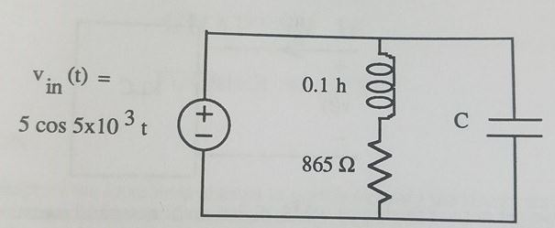

Figure 1: Circuit 1 drawn in lab manual

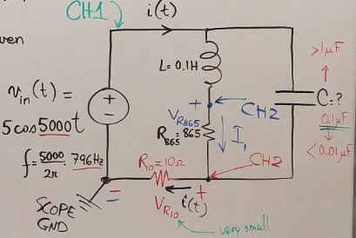

Figure 2: Circuit 1 drawn by our Professor

Calculation for Capacitor 1 = 0.1uF

Voltage used = 10Vpp  
Frequency used = 5000/2π = 796Hz

Using Frequency domain,

$$R=865Ω, Z_{L}=j500, Z_{C}=\frac{1}{j5000C}$$

$$Parallel Circuit: \frac{1}{Zin(Jw)}= \frac{1}{R+Z_{L} }+\frac{1}{Z_{C}}$$

$$\frac{1}{Zin(J5000)}= \frac{1}{865+j500 }+j5000C$$

$$\frac{1}{Zin(J5000)}= \frac{1}{865+j500 }* \frac{865-j500}{865-j500 }+j5000C$$

$$\frac{1}{Zin(J5000)}= \frac{865-j500}{{\left(865\right)}^{2}-{\left(j500\right)}^{2} }+j5000C$$

$$\frac{1}{Zin(J5000)}= 8.67x{10}^{-4}-j\left(5x{10}^{-4}\right)+j5000C$$

$$if C=0.1uF, then -j\left(5x{10}^{-4}\right)+j5000C=0$$

$$\frac{1}{Zin(J5000)}= 867x{10}^{-4}$$

$$Zin\left(J5000\right)=1.15kΩ∠0°$$

$$I\left(j5000\right)=\frac{V_{in}}{Z_{in}}=\frac{5}{1.15k}=4.33mA∠0°$$

$$Power Factor \left(pf\right)=\cos\left(θ_{v}-θ_{i}\right)=\cos\left(0°\right)=1$$

$$Pavg=\frac{V*I}{2}*pf=\frac{5*4.33*{10}^{-3}}{2}*1=10.8mW$$

$$Pdiss=\frac{V^{2}}{2*R_{865}}=10.8mW, V=4.322Vpp$$

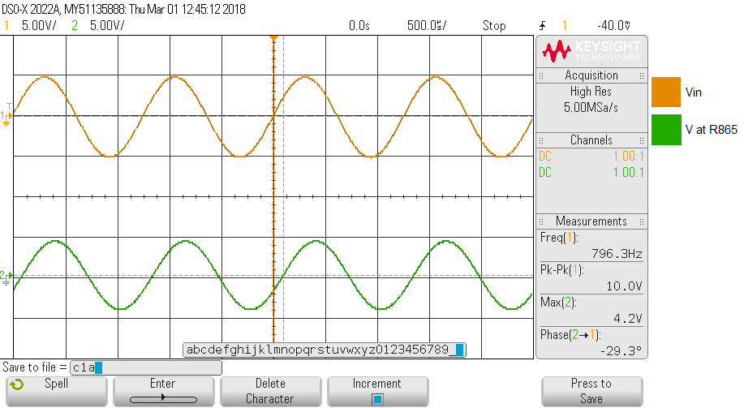

Graph 1: Measurements of Vin(t) and VR865t) at F = 796HZ, C = 0.1uF

Vin(t) = 10.0Vpp, Vr865(t) = 4.2Vpp, Voltage Phase = -29.3°

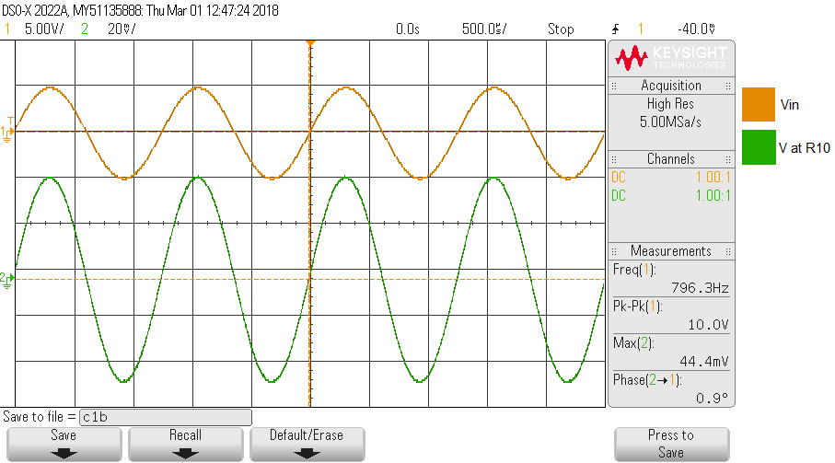

Graph 2: Measurements of Vin(t) and VR10(t) at F = 796HZ, C = 0.1uF

Vin(t) = 10.0Vpp, Vr10(t) = 44.4mVpp, Voltage Phase = 0.9°

Calculation for C 10 times greater than 0.1uF $$\frac{1}{Zin(J5000)}= 8.67x{10}^{-4}-j\left(5x{10}^{-4}\right)+j5000C$$

$$C=1.66uF$$

$$\frac{1}{Zin(J5000)}= 8.67x{10}^{-4}+j0.0078$$

$$Zin\left(J5000\right)=14.07-j126.64=127.42Ω∠-1.46°$$

$$I\left(j5000\right)=\frac{V_{in}}{Z_{in}}=\frac{5}{14.07-j126.64}=3.92mA∠1.46°$$

$$Power Factor \left(pf\right)=\cos\left(θ_{v}-θ_{i}\right)=\cos\left(-1.46°\right)=0.999$$

$$avg=\frac{V*I}{2}*pf=\frac{5*3.92*{10}^{-3}}{2}*.999=9.8mW$$

$$Pdiss=\frac{V^{2}}{2*R_{865}}=9.8mW, V=4.117Vpp$$

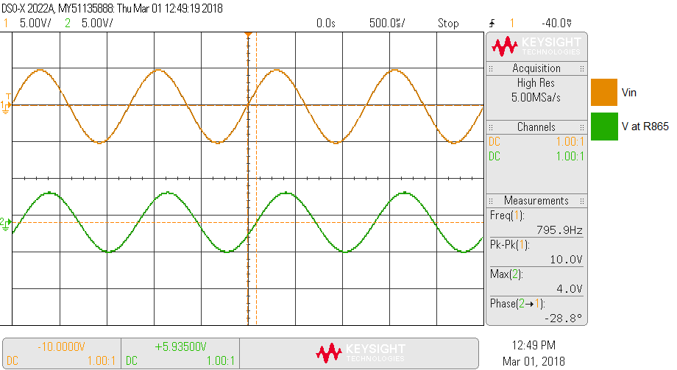

Graph 3: Measurements of Vin(t) and VR865t) at F = 796HZ, C = 1.66uF

Vin(t) = 10.0Vpp, Vr865(t) = 4.0Vpp, Voltage Phase = -28.8°

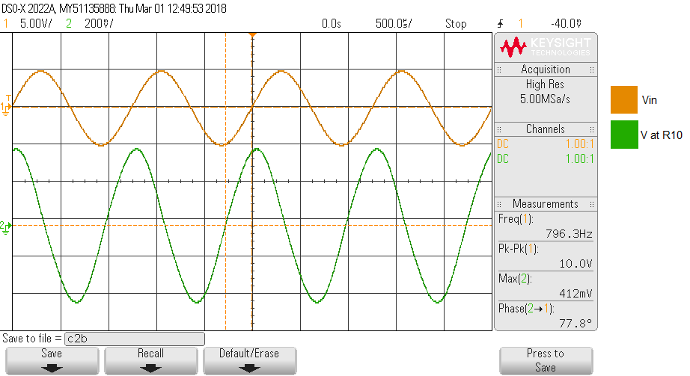

Graph 4: Measurements of Vin(t) and VR10(t) at F = 796HZ, C = 1.66uF

Vin(t) = 10.0Vpp, Vr10(t) = 412mVpp, Voltage Phase = 77.8°

Calculation for C 10 times smaller than 0.1uF $$\frac{1}{Zin(J5000)}= 8.67x{10}^{-4}-j\left(5x{10}^{-4}\right)+j5000C$$

$$C=0.0098uF$$

$$\frac{1}{Zin(J5000)}= 8.67x{10}^{-4}-j0.000451$$

$$Zin\left(J5000\right)=907.76+j472.2=1023Ω∠27.48°$$

$$I\left(j5000\right)=\frac{V_{in}}{Z_{in}}=\frac{5}{907.76+j472.2}=4.886mA∠-27.48°$$

$$Power Factor \left(pf\right)=\cos\left(θ_{v}-θ_{i}\right)=\cos\left(27.48°\right)=0.888$$

$$avg=\frac{V*I}{2}*pf=\frac{5*4.886*{10}^{-3}}{2}*.888=10.85mW$$

$$Pdiss=\frac{V^{2}}{2*R_{865}}=10.85mW, V=4.331Vpp$$

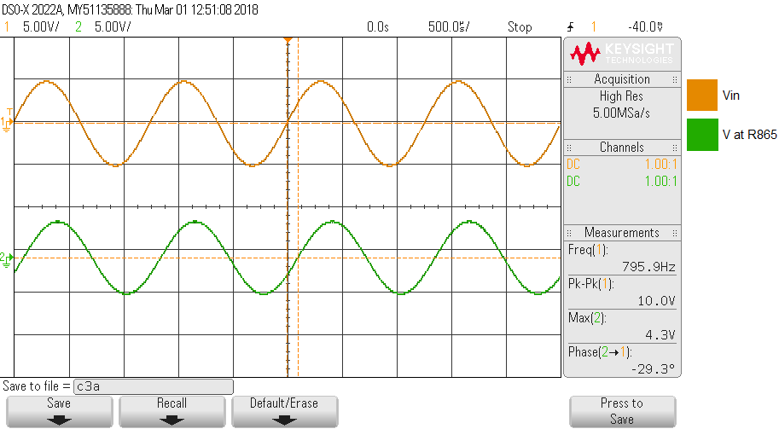

Graph 5: Measurements of Vin(t) and VR865t) at F = 796HZ, C = 0.0098uF

Vin(t) = 10.0Vpp, Vr865(t) = 4.3Vpp, Voltage Phase = -29.3°

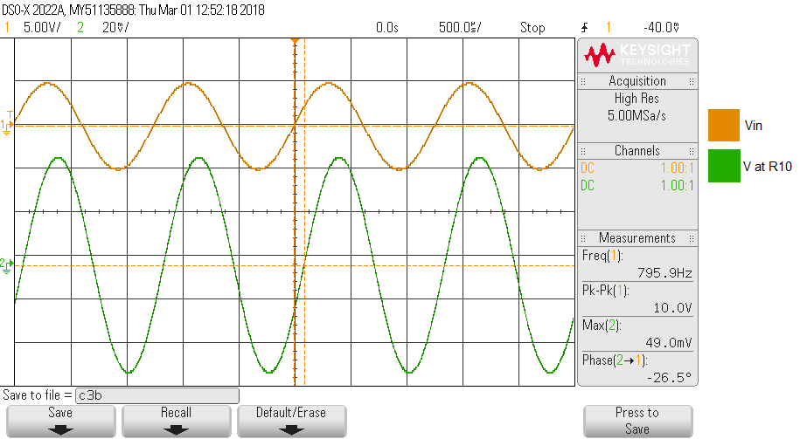

Graph 6: Measurements of Vin(t) and VR10(t) at F = 796HZ, C = 0.0098uF

Vin(t) = 10.0Vpp, Vr10(t) = 49.0mVpp, Voltage Phase = -26.5°

Table 2: Summary of Graph

|  |  |  |  |  |  |
| --- | --- | --- | --- | --- | --- |
| C (uF) | F (hz) | Vin (Vpp) | Vr865 (Vpp) | Vr10 (Vpp) | Phase at R10 |
| 0.1 | 796 | 10 | 4.2 | 0.044 | 0.9° |
| 1.66 | 796 | 10 | 4.0 | 0.412 | 77.8° |
| 0.0098 | 796 | 10 | 4.3 | 0.049 | -26.5° |

**Post Lab:** Attached at end of lab report