**Lab Report: 209L – 01 Ngyuen**

**Gene Drumheller**

**Experiment 1**

**The Sinusoidal Steady State Responses of First Order RC Circuits**

**Objectives:** To calculate, measure and analyze the steady state forced response of a RC circuit using an AC source.

**Prelab:**

Part 1)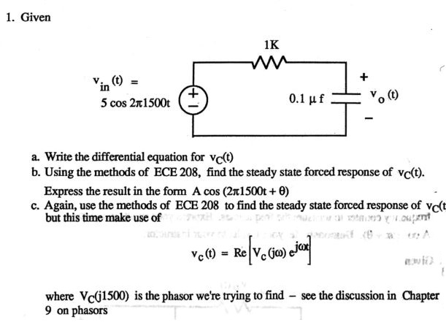

$$V_{s}=5cos2π1500t, R=1kΩ, and C=0.1µf$$

$$i_{R}=i_{c} and I= \frac{V}{R}$$

$$i_{R}= \frac{V_{s}-V_{c}}{R}, and i_{C}=C\frac{{dV}_{c}}{dt}$$

$$\frac{V_{s}-V_{c}}{R}=C\frac{{dV}_{c}}{dt}$$

$$C\frac{{dV}_{c}}{dt}= \frac{1}{R}V_{s}-\frac{1}{R}V_{c}$$

$\frac{{dV}_{c}}{dt}= \frac{1}{RC}V_{s}-\frac{1}{RC}V_{c}$

$\frac{{dV}_{c}}{dt}+\frac{1}{RC}V_{c} = \frac{1}{RC}V_{s}$

$$\frac{{dV}_{c}}{dt}+{10}^{4}V_{c}=\left(5x{10}^{4}\right)cos⁡(2π1500t)$$

b)

$$Forced Response= V^{'}f+ \frac{1}{RC}Vf= \frac{1}{RC}V_{s}$$

$$Vf=Acos\left(2π1500t+ ϕ\right)$$

$$V^{'}f+ \frac{1}{RC}Vf= \frac{1}{RC}V_{s}$$

$$-A2π1500sin\left(2π1500t+ ϕ\right)+ {10}^{4}Acos\left(2π1500t+ ϕ\right)=\left(5x{10}^{4}\right)cos⁡(2π1500t)$$

$$From trig identity:BcosX+DsinX= \sqrt{B^{2}+D^{2}}cos⁡(X+\tan^{-1}\left(\frac{-D}{B}\right))$$

$$\sqrt{{({10}^{4}A)}^{2}+{(-3000πA)}^{2}}\cos\left(2π1500t+ϕ+\tan^{-1}\left(\frac{3000πA}{{10}^{4}A}\right)\right)=\left(5x{10}^{4}\right)cos⁡(2π1500t)$$

$$13741.41Acos\left(2π1500t+ϕ+\frac{π}{4}\right)=\left(5x{10}^{4}\right)cos⁡(2π1500t)$$

$$13741.41A=\left(5x{10}^{4}\right), and ϕ+\frac{π}{4}=0$$

$$A=3.639, and ϕ=-\frac{π}{4}$$

$$Vf=3.639cos⁡(2π1500t-\frac{π}{4})V$$

c)

$Forced Response=Vf=Acos\left(2π1500t+ ϕ\right)=Re[Ae^{jϕ}e^{jwt}]$

$$Euler^{'}sRelation:Ke^{jd}=Kcos\left(d\right)+jKsin(d)$$

$$Vf=Ae^{j\left(2π1500t+ϕ\right)}+j0 and V_{s}=\left(5x{10}^{4}\right)e^{j\left(2π1500t\right)}$$

$$Vf= Ae^{j\left(2π1500t+ϕ\right)}=Re\left[Ae^{j\left(2π1500t+ϕ\right)}\right]=Re[Ae^{j2π1500t}e^{jϕ}]$$

$$V_{s}=\left(5x{10}^{4}\right)e^{j\left(2π1500t\right)}=Re[\left(5x{10}^{4}\right)e^{j\left(2π1500t\right)}]$$

$$Forced Response= V^{'}f+ \frac{1}{RC}Vf= \frac{1}{RC}V_{s}$$

$$Re\left[j2π1500tAe^{j2π1500t}e^{jϕ}\right]+Re\left[{10}^{4}e^{j2π1500t}e^{jϕ}\right]=Re[\left(5x{10}^{4}\right)e^{j2π1500t}]$$

$$Simplify=\left({10}^{4}+j2π1500t\right)Ae^{jϕ}=5x{10}^{4}$$

$$Ae^{jϕ}= \frac{5x{10}^{4}}{{10}^{4}+j2π1500t}=2.65-2.50j=3.64∠-\frac{π}{4}$$

$$=Re[3.64e^{-j\frac{π}{4}}e^{j1500t}]V$$

Part 2) 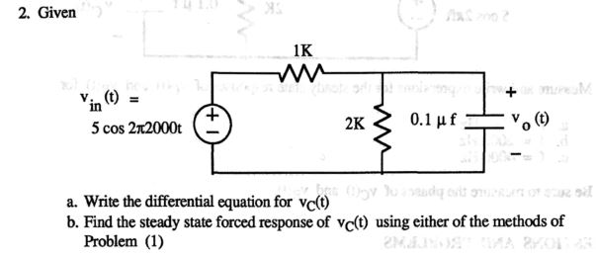

a)

$$V_{s}=5cos2π2000t, R_{1}=1kΩ, R_{2}=2kΩ and C=0.1µf$$

$$V_{s}-{i_{1}R}_{1}-V_{C}$$

$$i_{1}=i_{2}+i_{3}, i_{2}=\frac{V_{c}}{R_{2}}, i_{3= }C\frac{dV_{c}}{dt}$$

$$V_{s}- R_{1}\left(\frac{V_{c}}{R_{2}}+C\frac{dV_{c}}{dt}\right)-V_{C}=0$$

$$\frac{dV_{c}}{dt}+\left(\frac{1+\frac{R_{1}}{R_{2}}}{R_{1}}\right)V_{c}= \frac{1}{R_{1}C}V_{s}$$

$$\frac{dV_{c}}{dt}+(1.5x{10}^{4})V_{c}=\left(5x{10}^{4}\right)cos⁡(2π2000t)$$

2)

$$Forced Response= V^{'}f+ \frac{1}{RC}Vf= \frac{1}{RC}V_{s}$$

$$Vf=Acos(2π2000t+ ϕ)$$

$$-A2π2000\sin\left(2π2000t\right)+15000Acos\left(2π2000t\right)=50000cos⁡(2π2000t)$$

$$From trig identity:BcosX+DsinX= \sqrt{B^{2}+D^{2}}cos⁡(X+\tan^{-1}\left(\frac{-D}{B}\right))$$

$$19568.97Acos\left(2π2000t+ ϕ+39.95°\right)=50000cos⁡(2π2000t)$$

$$A=2.56, and ϕ= -39.95°$$

$Vf=2.56cos⁡(2π2000t-39.95°$)V

**Lab Procedure:**

Circuit 1

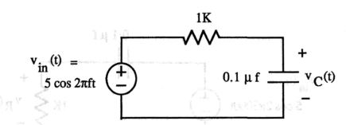

Circuit 2

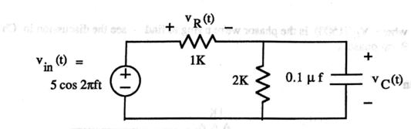

Table 1:

|  |  |  |  |
| --- | --- | --- | --- |
|  | Theoretical value | Measured value | Percent error |
| R1 | 1000Ω | 999.1Ω | 0.09% |
| R2 | 1000Ω | 995.2Ω | 0.48% |
| R3 | 1000Ω | 993.5Ω | 0.65% |
| C1 | 0.1µF | 0.101µF | -1.00% |

Note: R2 and R3 were connected in series to create a 2kΩ resistance.

Calculation:

$$\%error=\frac{theoretical value-measured value}{theoretical value} x 100$$

$$\%error of R1=\frac{1000-999.1}{1000} x 100=0.09\%$$

$$\%error of R2= \frac{1000-995.2}{1000} x 100=0.48\%$$

$$\%error of R3= \frac{1000-993.5}{1000} x 100=0.65\%$$

$$\%error of C1=\frac{0.1-0.101}{ 0.1} x 100=-1\%$$

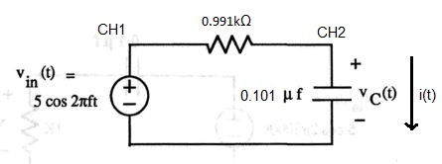

Circuit 1 with measured values

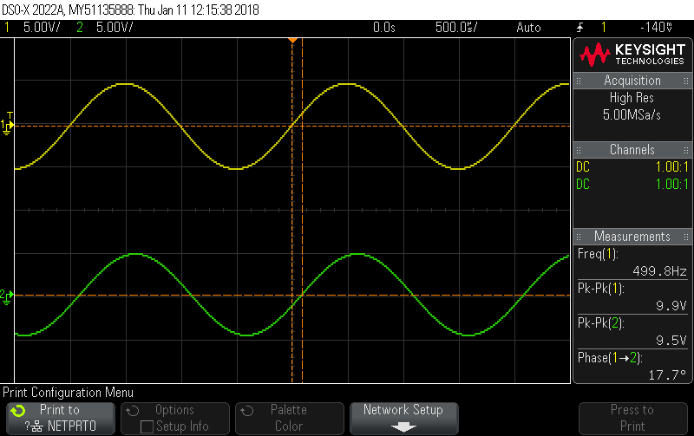

Graph 1: Measurements of Vin(t) = 10Vpp, Vc(t) = 9.5Vpp, Frequency = 500Hz

Pk-Pk(1) = Input voltage = 5cos(2π500t) = 10Vpp.

Pk-Pk(2) = Voltage across the Capacitor = 9.5Vpp = 4.75Vp

Phase(1->2) = The phase in negative = -17.7°

**Vc(t) = 4.75cos(2π500t – 17.7°)V**

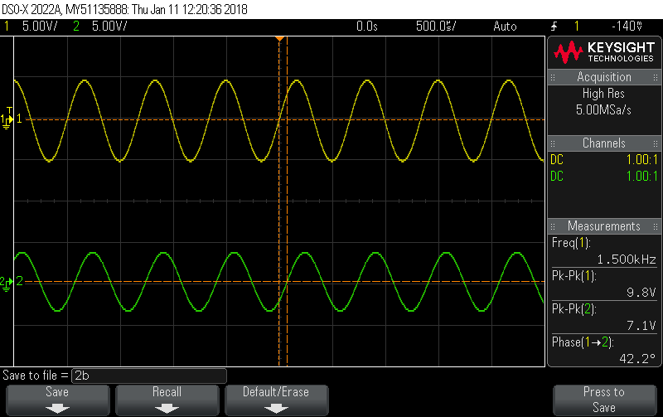

Graph 2: Measurements of Vin(t) = 10Vpp, Vc(t) = 7.1Vpp, Frequency = 1500Hz

Pk-Pk(1) = Input voltage = 5cos(2π1500t) = 10Vpp.

Pk-Pk(2) = Voltage across the Capacitor = 7.1Vpp = 3.55Vp

Phase(1->2) = The phase in negative = -42.2°

**Vc(t) = 3.55cos(2π1500t – 42.2°)V**

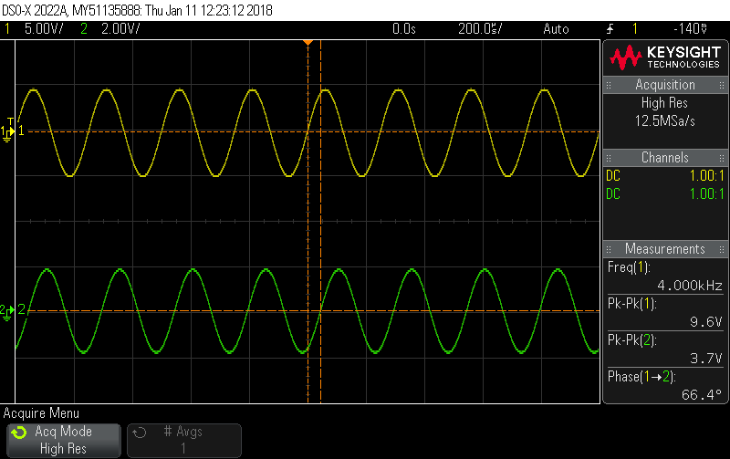

Graph 3: Measurements of Vin(t) = 10Vpp, Vc(t) = 3.7Vpp, Frequency = 4000Hz

Pk-Pk(1) = Input voltage = 5cos(2π4000t) = 10Vpp.

Pk-Pk(2) = Voltage across the Capacitor = 3.7Vpp = 1.85Vp

Phase(1->2) = The phase in negative = -66.4°

**Vc(t) = 1.85cos(2π4000t – =66.4)V**

Table 2:

|  |  |  |  |  |  |  |
| --- | --- | --- | --- | --- | --- | --- |
|  | Frequency | Vin-pp | Vc-pp | Vc-p | Phase | A cos(2πFt + ϕ) form |
| Graph 1 | 500Hz | 10V | 9.5V | 4.75V | -17.7° (lagging) | 4.75cos(2π500t – 17.7°)V |
| Graph 2 | 1500Hz | 10V | 7.1V | 3.55V | -42.2° (lagging) | 3.55cos(2π1500t – 42.2°)V |
| Graph 3 | 4000Hz | 10V | 3.7V | 1.85V | -66.4° (lagging) | 1.85cos(2π4000t – 66.4°)V |

Result from Prelab part 1 at 1500Hz = $3.639cos⁡(2π1500t-\frac{π}{4})$, which is very close to measure from graph. This suggest the calculation is correct.

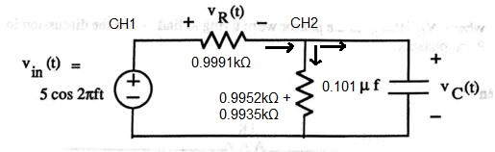

Circuit 2 with measured values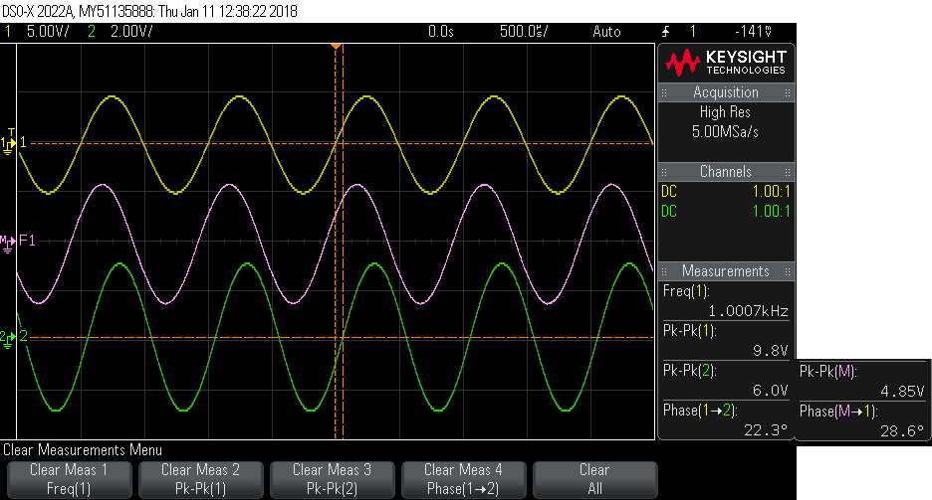

Graph 4: Measurements of Vin(t) = 10Vpp, Vc(t) = 6.0Vpp, Vr(t) = 4.85Vpp, Frequency = 1000Hz

Pk-Pk(1) = Input voltage = 5cos(2π1000t) = 10Vpp.

Pk-Pk(2) = Voltage across the Capacitor = 6.0Vpp = 3.00Vp

Pk-Pk(M) = Voltage across the Resistor (2kΩ) = 4.85Vpp = 2.425Vp

Phase(1->2) = The phase of Capacitor in negative = -22.3°

Phase(M -> 1) = The phase of Resistor (2kΩ) in positive = 28.6°

**Vc(t) = 2.425cos(2π1000t – 22.3°)V**

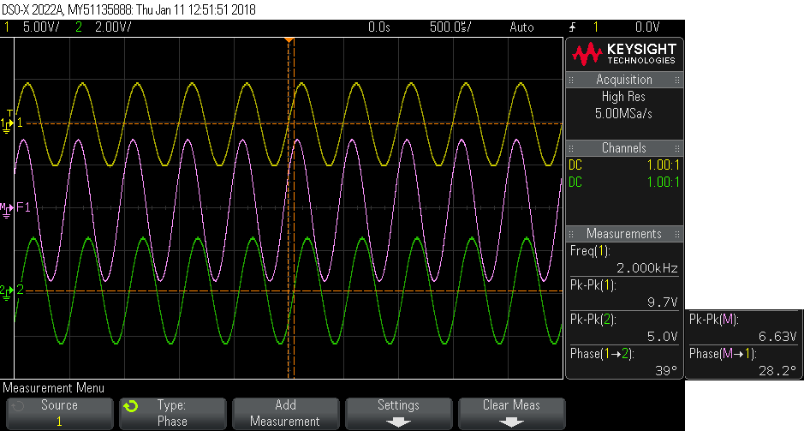

Graph 5: Measurements of Vin(t) = 10Vpp, Vc(t) = 5.0Vpp, Vr(t) = 6.63Vpp, Frequency = 2000Hz

Pk-Pk(1) = Input voltage = 5cos(2π2000t) = 10Vpp.

Pk-Pk(2) = Voltage across the Capacitor = 5.0Vpp = 2.50Vp

Pk-Pk(M) = Voltage across the Resistor (2kΩ) = 6.63Vpp = 3.315Vp

Phase(1->2) = The phase of Capacitor in negative = -39.0°

Phase(M -> 1) = The phase of Resistor (2kΩ) in positive = 28.2°

**Vc(t) = 2.50cos(2π2000t – 39.0°)V**

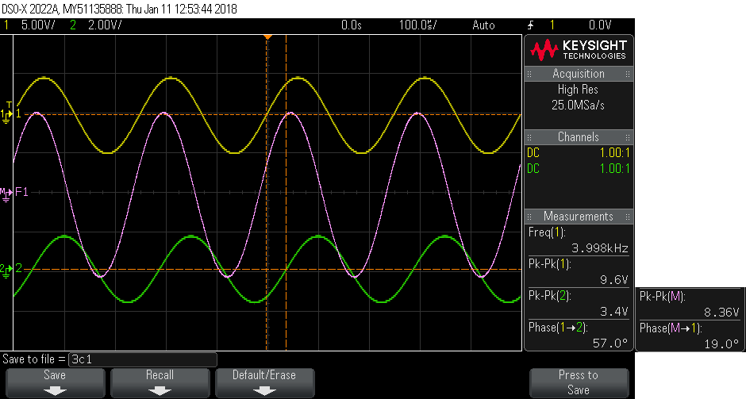

Graph 6: Measurements of Vin(t) = 10Vpp, Vc(t) = 3.4Vpp, Vr(t) = 8.36Vpp, Frequency = 4000Hz

Pk-Pk(1) = Input voltage = 5cos(2π4000t) = 10Vpp.

Pk-Pk(2) = Voltage across the Capacitor = 3.4Vpp = 1.7Vp

Pk-Pk(M) = Voltage across the Resistor (2kΩ) = 8.36Vpp = 4.18Vp

Phase(1->2) = The phase of Capacitor in negative = -57.0°

Phase(M -> 1) = The phase of Resistor (2kΩ) in positive = 19.0°

**Vc(t) = 1.7cos(2π4000t – 57.0°)V**

Table 3:

|  |  |  |  |  |  |  |
| --- | --- | --- | --- | --- | --- | --- |
|  | Frequency | Vin-pp | Vc-pp | Vc-p | Phase | A cos(2πFt + ϕ) form |
| Graph 4 | 1000Hz | 10V | 6.0V | 3.0V | -22.3° (lagging) | 3.0cos(2π1000t – 22.3°)V |
| Graph 5 | 2000Hz | 10V | 5.0V | 2.5V | -39.0° (lagging) | 2.5cos(2π2000t – 39.0°)V |
| Graph 6 | 4000Hz | 10V | 3.4V | 1.7V | -57.0° (lagging) | 1.7cos(2π4000t – 57.0°)V |

Result from Prelab part 2 at 2000Hz = $2.56cos⁡(2π2000t-39.95°$), which is very close to measure from graph. This suggest the calculation is correct.

**Post Labs**

Question 1) Find the percentage difference between the calculated and measured values of Vc(t)

1. For Circuit 1 when f = 1500Hz

Calculated value = $3.639cos⁡(2π1500t-\frac{π}{4})V$

Measured value = $3.55cos(2π1500t – 42.2°)V$

$$\%error of Vp= \frac{3.639-3.55}{3.639} x 100=2.45\%$$

$$\%error of φ= \frac{-45.0-(-42.2)}{-45.0} x 100=6.22\%$$

1. For Circuit 2 when f = 2000Hz

Calculated value = $2.56cos⁡(2π2000t-39.95°$)V

Measured value = $2.5cos(2π2000t – 39.0°)V$

$$\%error of Vp= \frac{2.56-2.5}{2.56} x 100=2.34\%$$

$$\%error of φ= \frac{-39.95-(-39.0)}{-39.95} x 100=2.38\%$$

Question 2) What happened to the magnitude and phase of Vc(t) as frequency f increased?

In both circuits, as the frequency increased, the magnitude decreases and the lag becomes more further apart.

Question 3) Given

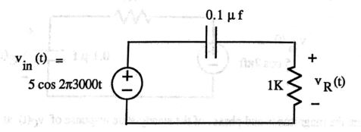

1. Write the differential equation for Vr(t)
2. Find the steady state response of Vr(t)